Contents
Strategic Planning
Overview
Strategic Planning Framework
Core Ideology of the St. Ignatius Public Schools
The Hedgehog Concept
Core Purpose of the St. Ignatius Public Schools
Core Values of the St. Ignatius Public Schools
20 Year Planning Horizon
Envisioned Future of the St. Ignatius Public Schools
Big Audacious Goal
Vision
5-10 Year Planning Horizon
Assumptions Regarding the Relevant Future
Assumptions about the future
5-10 Year Planning Horizon
Mega Issues
Knowledge-Based Decision Making Questions
Five Year Planning Horizon
Outcome-Oriented Goals and Strategic Objectives
Goals of the St. Ignatius Public School District
Goal Area 1: Student Achievement
Goal Area 2: Leadership
Goal Area 3: Facilities
Goal Area 4: Community / Communications
Goal Area 5: Student Centered Positive Climate and Culture
Goal Area 6: Resources Accountability and Certainty

Approved by the St. Ignatius School Board #28 on November 17, 2015

Strategic Planning

Overview
The St. Ignatius Public School District (St. Ignatius Public Schools) has created a new direction for the school district to strategically focus its resources on identified wants, preferences, and needs of its community. As part of this process, St. Ignatius Public Schools has begun a strategic planning and thinking process that will lead to a stronger and more vital school district. This process will be ongoing as St. Ignatius Public Schools moves into the future. This Strategic Plan is intended to help St. Ignatius Public Schools in focusing its resources in a manner that will best benefit the students enrolled in St. Ignatius Public Schools.
The St. Ignatius Board of Trustees, Staff Leadership Team, staff and community members began the strategic planning and thinking process necessary to fit with its commitment to students, to community engagement, to moving the District forward and to utilizing a knowledge-based decision making process.
As part of its preparation for planning strategically, St. Ignatius Public Schools brought in staff from the Montana School Boards Association with expertise in strategic planning for public schools to help facilitate the group through the initial strategic planning process.
On August 16, 2011, the St. Ignatius School District Board of Trustees formally adopted its new strategic plan.
St. Ignatius Public Schools view the process of strategic planning as an ongoing process within the school system. This is not a "strategic planning project" that is completed. Adoption of a plan is an affirmation of the general intent and direction articulated by the Core Ideology, Envisioned Future and Goals and Strategic Objectives. It is understood that progress toward achieving identified strategic objectives will be assessed at least annually, and the plan will be updated based on achievement and changes in the needs of the students served by St. Ignatius Public Schools.

Strategic Planning Framework
The framework used by the St. Ignatius Public Schools for its strategic planning process was adapted from a model developed by Jim Collins, author of “Built to Last” and “Good to Great.” The Board and Staff Leadership Team focused on five different planning horizons, starting with the long term issues first to provide focus on shorter term efforts.
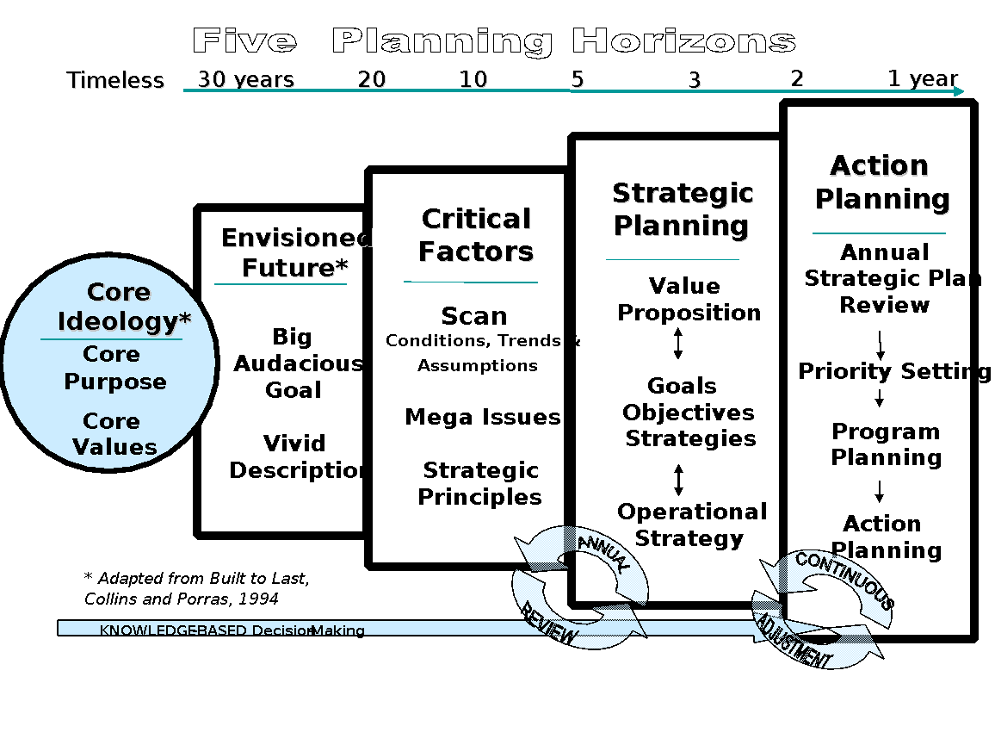

Core Ideology of the St. Ignatius Public Schools
Core ideology describes a school district's consistent identity that transcends all changes related to its relevant environment. It consists of two elements - core purpose - the school district's reason for being - and core values - essential and enduring principles that guide a school district. Envisioned future conveys a concrete yet unrealized vision for the school district. It consists of a big audacious goal - a clear and compelling catalyst that serves as a focal point for effort - and a vivid description - vibrant and engaging descriptions of what it will be like to achieve the big audacious goal.

The Hedgehog Concept
In developing the Envisioned Future of St. Ignatius Public Schools and ensuring the future success of the District, it is important that the focus of the District be centered around: (1) What we are the Best at; (2) What we are Passionate About; and (3) What Drives our Resource Engine as more fully illustrated below:

Core Purpose of the St. Ignatius Public Schools
The Core Purpose of St. Ignatius Public Schools is to provide a quality education within a safe, caring environment that provides students with the necessary tools to be successful in their future roles in life with a sense of purpose.
- We are committed to prepare students to think critically, solve problems creatively and communicate effectively by offering high quality curriculum, programs and services.
- We meet the needs of students and enhance their skills through individualized instruction with an emphasis on development of each student’s potential.
- We instill a love for lifelong learning.
- We teach and model the importance of pride, respect, responsibility, integrity and excellence.

Core Values of the St. Ignatius Public Schools
The Core Values of St. Ignatius Public Schools are:

- Pride – St. Ignatius Public Schools values taking pride and honor in our accomplishments and our endeavors, whether those accomplishment/endeavors are academic, athletic, other extra-curricular activities or other achievements of our students, staff, district and community. We remain loyal to the cause and have unfettered conviction in pursuit of setting a standard of excellence for our District.

- Integrity- St. Ignatius Public Schools values integrity. We believe that honesty is the best policy. We believe in showing respect and professionalism towards others even in situations where there are strong differences of opinion, values or views.

- Trust – St. Ignatius Public Schools values trust, cooperation and fairness. We believe that a culture of openness, tolerance and acceptance of others is vital to our success.

- Positive Environment – St. Ignatius Public Schools values a positive environment for all that is safe, supporting, welcoming and that provides student, staff and community members with a sense of belonging, caring and compassion. We believe that students need a positive environment if they are to succeed.

- Communication – We value the input and involvement of our stakeholders (parents, community members, staff, and the Board). We believe it is important to both recognize and celebrate our successes. We believe that strong leadership is critical to the success of our students.

20 Year Planning Horizon

Envisioned Future of the St. Ignatius Public Schools

Big Audacious Goal
- St. Ignatius Public Schools is regarded as “the crown jewel” of public schools.

Vision
- Setting the Standard
  - We set the standard by which other schools of similar size are measured.
  - We come together each day to improve the lives of our students, staff and community.
  - 100% of our students graduate and continue pursuing their life interests and goals.
  - Our campus atmosphere is a safe and inviting where everyone feels welcome.
  - We have a waiting list of students and staff who want to be a part of our educational experience.
- Quality Education and Programming for the Benefit of our Students
  - We provide a superior learning environment by which curricula is executed through consistent individualized instruction with rigor, diligence and fidelity.
  - We offer differentiated instruction to the maximum the potential of each student.
  - We have created an individualized learning plan for each student that encompasses their strengths, struggles/needs and long-term goals.
  - We have instilled in our students the value of competition and preparing for the challenges and successes in life.
  - We have programs and services that flow effortlessly and consistently through each grade level.
  - We offer opportunities for students to be positively involved in activities and carrying that forward into the future.
  - We have phenomenal arts, music, and language programs.
  - We have a successful speech and debate team.
  - We have excellent vocational programming for students.
  - We have successful athletic programs.
  - We use data and measurable testing standards that prove our students are succeeding.
  - Our students are well prepared for their career/life choices.
- Well-educated and well-Prepared Staff
  - Our staff facilitates the exchange of knowledge and information to our students.
  - We have research based training for our staff.
- Pride and Involvement of our Parents and Community
  - We have created an environment where students, staff and our community want to come and in which everyone takes great pride.
  - Our parents and community members are highly involved in our school and school activities.
  - Every person in the community takes responsibility for the students’ success.
  - The Indian Education Committee is actively assisting parents in school involvement.
  - We regularly review our strategic plan and update it annually with input from parents, the community, staff and students.
- Facilities
  - We have state-of-the-art facilities that meet the future needs of our students.
  - Our master building plan has been implemented, including a new gym and auditorium.

5-10 Year Planning Horizon

Assumptions Regarding the Relevant Future
In order to make progress against the 20 year Envisioned Future, St. Ignatius Public Schools must constantly anticipate the strategic factors likely to affect its ability to succeed, and to assess the implications of those factors. This process of building foresight about the future will help St. Ignatius Public Schools to constantly recalibrate its view of the relevant future, a basis upon which to update the strategic plan on an annual basis. As the outcome-oriented goals that will form the basis of the long-range strategic plan will be based on this foresight, annual review of these statements will be an appropriate method of determining and ensuring the ongoing relevance of the strategic plan.
Creating the Assumptions - during the Strategic Planning Process, the St. Ignatius School Board, Staff Leadership Team, staff and community members made many assumptions about the future. While many different assumptions were made, what follows are those assumptions that are likely to have the greatest influence on the development of St. Ignatius Public Schools' Strategic Plan.

Assumptions about the future

Demographics
- Enrollment will remain stable.
- Economic disparity will continue to exist.
- Educational opportunities for the tribal community will lead to greater student enrollment.
- Graduation rates will continue to as parental involvement continues.
- The population in the community will stay stable.
- Growth in the valley will continue. Growth will come from people who have jobs elsewhere, but hopefully, they will live here and enroll their kids
- Tribal Government support for students will increase.
- The home school population will remain the same.
- There will see a transition in teaching staff due to retirement.
- There will be an increase in diverse student population.

Business/Economic Climate
- Existing farmland will be subdivided into residential developments.
- With online opportunities, people will be able to live in the community and work from anywhere.
- Unless county planning helps to encourage planned growth, we’re going to stay in an economically depressed area. If we don’t have infrastructure, we won’t have the opportunities.
- There will be increased opportunities, but it is unknown as to whether St. Ignatius will benefit from these opportunities.
- The skilled labor force will fluctuate in the community.
- Land will continue to be expensive. As a result, we won’t have the housing availability similar to Missoula and Polson.

Legislation/Regulation
- Educational funding at the state and federal level will need to be restructured.
- Federal government will continue to lag behind on the distribution of impact aid funds.
- There will be a statewide re-distribution of coal, timber and oil and gas revenue.
- There will continue to be mandates and strings attached to funding.
- The “Band-Aid” mentality will continue until the next major crisis.
- Educators and trustees will be the ones that will fix the funding and educational problems. This will also take community involvement.
- There will be a trend towards nationalization of standards.
- We will continue to see unfunded mandates.
- School funding will continue to plague us.

Technology /Science
- Technology changes will continue at a rapid pace.
- There will be a movement towards one to one computing.
- Technology will continue to impact the STEM (Science, Technology, Engineering and Math) field of science.
- The District will need to look at providing more technology course to meet the emerging trends.
- There will be a movement away from traditional textbooks.

Politics and Social Values
- Social networking and technology will provide students with information that will impact the political process.
- Social networks are emerging as a basic form of communication.
- We will continue to see limited parental involvement.
- Parents will continue to rely on the schools to care for their children
- We will continue to see social issues that negatively impact students, including but not limited to, drug problems, poverty, teenage pregnancy, etc.
- Parents will continue to put their standard of living as a priority leaving little time for community/school involvement.

5-10 Year Planning Horizon

Mega Issues
Mega issues are issues of strategic importance, which represent choices the school district will need to make in defining the ultimate direction of its long-range plan. These issues represent potential impediments to achievement of the Envisioned Future, and form a basis for dialogue about the choices facing the school district. These questions can serve as an ongoing "menu" of strategic issues that, using a knowledge-based approach in gathering insights relative to St. Ignatius Public Schools’ strategic position and directional choices for each of the issues, can be used by the Board to create regular opportunities for strategic dialogue about the future issues facing the school district.
Note: The mega-issue questions are not necessarily arranged in priority order.

Mega-Issue Questions for consideration by the District:
- How can we effectively engage the support of the community to enhance parental support of the educational system and subsequently improve student outcomes?

- How can we broaden the awareness to all employees of the District the importance of delivering a consistent, high quality education to the students regardless of background or capabilities?

- What can we do to encourage and support at-risk students to become fully engaged in (completing) their educational program?

- How do we instill the value of education?

- What can we do to decrease the use of alcohol, tobacco and other drugs (ATODs)?

- As a district, what do we need to do to stay in front of the continued advancements in technology and science as it pertains to the culture of our students?

- How do we adjust with the continued uncertainty of funding?

  - MEGA ISSUES: Reviewed and updated on November 4, 2015.

Knowledge-Based Decision Making Questions
The Board should prioritize the above-referenced mega issues and decide which of these issues require immediate attention on the part of the Board. Once the identified mega-issues are prioritized, the Board will set aside time at scheduled meetings to analyze a particular mega issue. At such meetings, the Board's primary focus will be on the mega-issue at hand. All other business (routine or otherwise) will be conducted at the end of the meeting once the dialogue and deliberation on the mega-issue has been concluded for that meeting. When analyzing mega issues, the Board will utilize a knowledge-based decision making process. This will keep the focus of the Board on relevant factors to consider as it develops strategies to overcome particular impediments/barriers that may impact the Board's strategic direction. The Board will analyze mega-issues by answering the following questions:

- What do we know about the wants, needs and preferences of our constituents that are relevant to this decision?

- What do we know about the current realities and evolving dynamics facing our constituents/community that is relevant to this decision?

- What do we know about the capacity/strategic position of our school district that is relevant to this decision?

- What are the ethical implications of our choices?

Five Year Planning Horizon

Outcome-Oriented Goals and Strategic Objectives
The following thinking represents goals for the next five years. They are areas in which St. Ignatius Public Schools will explicitly state the conditions or attributes it wants to achieve. These outcome statements will define, "what will constitute future success." The achievement of each goal will move the school district toward realization of its Envisioned Future.
Strategic Objectives provide direction and actions on how the school district will accomplish its articulated goals. All strategies included in the strategic plan should be considered accomplishable at some point in the future. Strategic Objectives are reviewed annually by the St. Ignatius School Board, Staff Leadership Team, and faculty.

Goals of the St. Ignatius Public School District

Goal Area 1: Student Achievement
Statement of Intended Outcome, Five years: St. Ignatius Public Schools has academic and extra-curricular programs that emphasize and enhance student achievement. Our programs and services provide a seamless transition from grade to grade with a full recognition of individual student needs and skills and the provision of differentiated instruction to address both the needs of students and enhance the skills of students.

Strategic Objectives – Two Year Plan:

- We will vertically align the K-12 core (math, language and science) curriculum. With math beginning 2015/16.
- We will continue to horizontally align by building and courses (K-5, 6-8, 9-12).
- We will continue to coordinate all school schedules for enhancement of teaching and learning.
- We will make AYP District-wide.
- We will utilize formative assessment tools.
- Our Smarter Balance Scores will be at or above state average.
- We will continue to monitor and refine the Strategic Plan.
- We will research best practices student achievement.
- We will ensure that we are offering co and extra-curricular activities that provide students with positive experiences to enhance our overall programming.
- Emphasize District resources to ensure that every student can read by 3rd grade.

Goal Area 2: Leadership
Statement of Intended Outcome, Five years: St. Ignatius Public Schools has successfully implemented systematic professionalism at all levels from the Board, administration, staff and students. We have created a culture where there are open lines of honest communication at all levels. As a result, we have greater collaboration and cooperation from all stakeholders. We have a highly qualified and well-trained staff. We have implemented a progressive program of professional development with measurable benchmarks and accountability. As a result of our efforts, we have effectively marketed the positive attributes of our school system and offer a competitive package for the recruitment and retention of staff and desirable programming for students.

Strategic Objectives – Two Year Plan:

- The Leadership Team will continue to report back to the board monthly on the progress toward goals.
- We will continue implementing district-wide shared leadership, including researching best practices for enhancing student achievement.
3. We will implement a professional development plan for the Board,
4. We will develop a systematic program of gathering feedback from graduates and existing students on whether student needs are being met.

Goal Area 3: Facilities
Statement of Intended Outcome, Five Years: St. Ignatius Public Schools has facilities that are conducive to learning and meeting the needs of our students. We have a program in place for making continual improvements to our facilities to ensure that our facilities remain relevant, state-of-the art, equipped with the necessary technology to meet the needs of our staff and students. Our school is THE center of our community.

Strategic Objectives – Two Year Plan:

- The Buildings and Grounds committee will identify and prioritize the current and anticipated needs of the district.
- We will continue to develop a partnerships with outside entities/individuals to assist with the facilities/equipment needs of the District through financial support or volunteerism.
- We will assess the facility needs of the District on an ongoing basis.

Both Goal Area 4: Community / Communications
Statement of Intended Outcome, Five Years: Through the efforts of St. Ignatius Public Schools and the community, we have jointly created a strong sense of pride in our schools and community. Community members are highly engaged in our schools, our vision and our activities. Parents understand the importance of being engaged in the education of their children.

Strategic Objectives – Two Year Plan:

- We will continue with a program of improved, effective communications with the community.
- We will continue our strategies to mobilize the community and get them more involved in our school and our programming.
- We will create an inviting environment that encourages volunteerism and people visiting our schools.
- We will research what other Montana districts have done to engage the community and parents, including the possibility of parent resource centers, outreach programs, home visits, etc.
- We will implement co and extra-curricular programs that enhance the lives of our students.
- We will continue to organize community activities that attract the community and parents to our schools for activities and events.
- We will take the initiative to develop stronger relationships and greater collaboration with the IEC/Tribal Education Department.
- We will research avenues to enhance the Adult Ed program.

Goal Area 5: Student Centered Positive Climate and Culture
Statement of Intended Outcome, Five Years: St. Ignatius Public Schools has created a climate and culture that is centered on students and that promote a safe, positive environment, fosters positive interactions at all levels and makes all students, staff, parents and community members feel welcome. We understand that the climate and culture at our schools impacts the future of every student.

Strategic Objectives – Two Year Plan:

- We will ensure that we are continually creating an environment where students feel a sense of belonging.
- We will create a safe and welcoming school for students, staff, parents and the community.
- We will take measures to improve staff morale.
- We will continue with MBI/Graduation Matters process and initiatives district wide.

Goal Area 6: Resources Accountability and Certainty
Statement of Intended Outcome, Five Years: St. Ignatius Public Schools understands that we have limited financial and human resources and we have successfully maximized the resources that we do have. As a result of our tenacity, we have maximized every dollar to ensure that we are putting our resources into our identified areas of priority.

Strategic Objectives – Two-Year Plan:

- We will continue to analyze the amount of money that needs to be set aside to ensure that our facilities meet the ongoing needs of our students and staff.
- We will conduct ongoing analysis of anticipating trends that might impact the financial future condition of the District.
- We will provide annual training for the Board on school finance and building a school budget.
- We will examine other sources of funding and/or human resources.

