Quarter 1
Instructional Week | Standard(s) | Academic Vocabulary | Resources | Sample Assessment Question | Opportunities for Writing
August 17-  August 21  August 24- August 28  How can we compare physical properties of samples of matter? | 4.P.2.1 Compare the physical properties of samples of matter: (strength, hardness, flexibility, ability to conduct heat, ability to conduct electricity, ability to be attracted by magnets, reactions to water and fire).  Will Be Able To:  -Identify through observation the properties of matter that can be measured according to the materials they are made of.  -Test the properties (strength, hardness, flexibility, ability to conduct heat, ability to conduct electricity, ability to be attracted by magnets, reactions to water and fire)  Will Know:  -Properties of matter and how they can test for the following properties (strength, hardness, flexibility, ability to conduct heat, ability to conduct electricity, ability to be attracted by magnets, freezing point, boiling point, density, solubility, states of the matter) | solid, liquid, gas, freeze, condensation,  evaporation  Matter, hardness, flexibility, physical change, reaction, conduction, dissolve, properties | Matter  Study Jams: Properties of Matter  Interactive Matter Web Sites  Properties of Matter  Structure and Properties of Matter  Effective Science Stations  Formative Assessment Probes-  Ice Cubes in a Bag (V1-p49)  Is It Matter? (V1-p79) Lemonade (V1-p55)  The Rusty Nails (V1-p91)  Can You Pick It Up With a Magnet? (PS-V2-p115) Does a Magnet Pick Up Any Kind of Metal? (PS-V2-p119)  What Happens If You Use the Other End of the Magnet? (PS-V2-p127)  Can It Be Electrically Charged? (PS-V2-p23) | Ruth mixed a mystery powder in water and the powder seems to disappear. What has happened to the powder? | Draw a cartoon that shows how a drop of water would change within the states of matter..  Explain the following examples in terms of physical or chemical changes: breaking a pencil in two; water freezing and forming ice; frying an egg; burning wood; leaves turning color in the fall
August 31- September 11  September 14 – September 18  How can tests can be conducted to identify properties of rocks and minerals? | 4.P.2.2 Explain how minerals are identified using tests for the physical properties of hardness, color, luster, cleavage and streak.  Will Be Able To:  -Describe properties such as color, luster, and cleavage of a mineral  -Know how to perform tests for hardness,luster, and streak of different minerals  -Use MOHs scale to compare hardness of minerals  Will Know:  -Meaning of properties such as color, luster, and cleavage of a minera  -Criteria for identifying objects as minerals (solid, inorganic, of natural occurrence with fixed chemical formula and specific atomic arrangement) | Color, rough, smooth  Hardness, streak, luster,  cleavage, bands, grainy, organic, inorganic, MOHs scale | Science Kids: Mineral Properties  Geology for Kids  Mineral Virtual Lab  Rock and Mineral Classification  Mineral Resources  StudyJams Interactive Activities  Minerals, Rocks, and Soils  Brainpop: Mineral Identification  The Zone: Minerals | Which property do geologist most often use to tell minerals apart?  A student uses a coin to scrape against a rock. Which property is being studied?  Scientist use a scale from 1-10 (Mohs) to show the hardness of a mineral, what would be the hardest? | If you could make a new mineral explain how you would use the different properties to make  yours unique?  You are walking with your friend, and you come across a rock. Explain the steps you would take to identify your rock sample.
September 21 – September 28  September 29 - October 1  How do you classify rocks based on their formation? | 4.P.2.3 Classify rocks as metamorphic, sedimentary or igneous based on their composition, how they are formed  and the processes that create them.  Will Be Able To:  -Classify/sort rocks  -Describe the types of rocks and how they are formed.  Will Know:  -Rocks are different than minerals  -Rocks are tested based on physical properties.  -Rock formation is a process.  -Water, heat, and pressure change or affect rock formation  -Explain and incorporate key vocabulary in writing in all subject areas. | sedimentary, igneous, metamorphic, molten  rock cycle, cementing, pressing, Earth’s crust, magma, lava, crystallization  sediment, volcanic, intrusive, extrusive | StudyJams Interactive Activities  Rock Game  Rock Cycle  Rock and Mineral Virtual Lab  Harcourt: Rock Cycle  The Zone: Rock Cycle | Which rock forms from melted rock - either from magma below Earth's crust of from lava above it?  Metamorphic rocks form deep inside Earth from other types of rocks. Which forces produce metamorphic rocks? | Explain how metamorphic rocks are part of the rock cycle. In your explanation, be sure to include  • the features that make each rock type different  • the processes that result in the formation of each rock type
October 2 –  October 8  October 9 – October 14  How does distance impact a magnetic field?  What is a magnetic field and how can you prove it is there?  How do I know if an object contains iron? | 4.P.1.1 Explain how magnets interact with all things made of iron and with other magnets to produce motion without touching them.  Will Be Able To:  -Label the parts of the magnet  -Predict which objects contain iron  -Classify the effects of size, shape, type, and distance a magnet has on an object  -Move objects without touching them with the help of magnets  -Create a compass  Will Know:  -Explain and how magnets interact to produce motion  -Explain the difference between like and unlike poles  -Understand the cause of Northern Lights (Aurora Borealis)  -How to use the compass, including the basic knowledge of the cardinal points | Magnetic field, electromagnet, attract, repel, poles (north and south), iron filings,  compass, proton, electron | Brain Pop Magnetism (Username: Springhill PW: Springhill)  Magnet Games  Magnets and Springs  Study Jams Magnets Slideshow  Magnet Man Resource  Magnet resource | Does distance strengthen or weaken a magnet's ability to attract a piece of iron?  Where is the pushing or pulling force of a magnet strongest? | What do you observe about the materials that are attracted to a magnet?  Explain how you would tell someone to determine which way is North using a  compass?
October 15 – October 20 | Review
Ongoing  Resources/  PBL | Livebinder:  4th Grade Live Binder  Experiments:  Listed under 4th Grade Science Folder  Graphic Organizers:  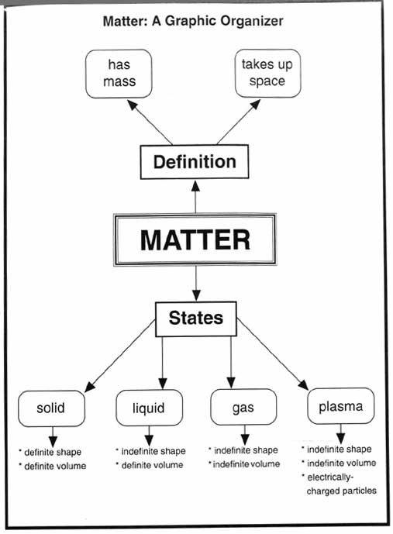  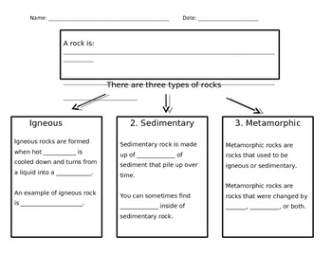  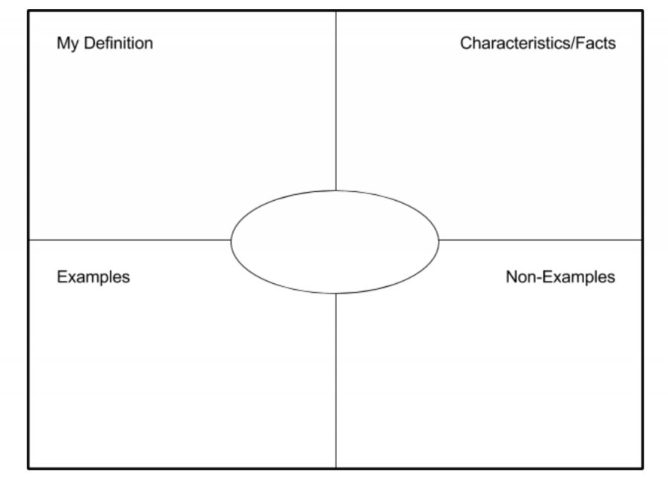 | Glossary:  Harcourt Online Glossary  Printables:  Essential Questions- Printable | Science Links:  E-Learning Resource for kids  Quizlet Review:  Quizlet: Flash Card test | Formative Questions:  Energy Question Bank | Big Universe:  Rockin Rocks by Christine Petersen  Magnetism by Mari Schuh  What are Minerals by Natalie Aloian  Mighty Minerals by Christine Petersen
Quarter 2
Instructional Week | Standard(s) | Academic Vocabulary | Resources | Sample Assessment Question | Opportunities for Writing
October 22 - October 28  How can an electrical charge push or pull objects away?  How can an electric current control an object’s movement? | 4.P.1.2 Explain how electrically charged objects push or pull on other electrically charged objects and produce motion.  Will Be Able To:  -Build electromagnets  -Use electromagnets to produce magnetic field and attract objects  -Explain the differences between magnets and electromagnets  Will Know:  -That an object that has been electrically charged pulls or pushes on all other charged objects  -Electrical charges can result in attraction, repulsion or electrical discharge. | Discharge, charge, positive charge, negative charge, neutral, attraction, repulsion, electron, proton, atom, static electricity,  kinetic energy, potential energy | Brain Pop Electromagnets  Electricity and Electromagnet Interactive  Electric Circuit | Which materials would allow electricity easily through it?  What is the name of the crackle you hear when you touch a doorknob after rubbing your feet across a carpet?  If you rub two balloons over a piece of wool, what will happen when you hold them close together? | Stormy weather has caused the electricity to go out. You cannot use your TV, computer, refrigerator, lights or anything else than runs on electricity. Write a story about one day without electricity  The student imagines he/she is the engineer for a manufacturer of holiday lights. He must explain in a letter to his supervisor the advantages of using lights wired in parallel rather than in series circuits...
October 29 – November 3  How can energy be converted (transformed) from one form to another? | 4.P.3.1 Recognize the basic forms of energy (light, sound, heat, electrical, and magnetic) as the ability  to cause motion or create change.  Will be able to:  - Distinguish and identify categories of energy (potential and kinetic)  -Recognize the basic forms of energy (light, sound, heat, electrical and magnetic)  - Explain the nature of the energy transfer and identify each form  Will Know:  -Basic forms of energy: light, heat, sound, electrical and energy of motion.  -Electricity flowing through an electric circuit produces magnetic effects.  -Electric circuit with battery to bulb to bell transfers the energy to their surroundings as light, sound and heat. | mechanical energy, heat energy, light energy, chemical energy, transfer (energy), solar energy, sound energy, vibration  “MELTS”  Mechanical  Electrical  Light  Thermal  Sound | Study Jams Video Light and Sound  Energy Transfer Video  Energy Transfer Activity Links  Virtual Lab  Energy Transfer Game- Gold Burger to Go  Brain Pop Electricity  Brainpop Static Electricity  Brain Pop Electric Circuit  Magnets and Circuits  Circuit Video  Formative Assessment Probes:  Can It Reflect Light? (V1-p25) ShadowSize(K-2V-p79) Apple In the Dark (V1-p31)  Birthday Candles (V1-p37)  Mirror on the Wall (V3-p51)  One Wire or Two? (PS-V2-p53)  How Can You Light the Bulb? (PS-V2-p59) | What can you use to convert electrical energy to light energy?  The sun changes nuclear energy into what forms of energy?  Why does it feel hotter in the sun than in the shade? | How does the flow of energy change to make a television work?
November 4 - November 6  November 9– November 13  How can you change the direction that light travels?  How can the material of an object affect light energy? | 4.P.3.2 Recognize that light travels in a straight line until it strikes an object or travels from one medium to another, and that light can be reflected, refracted, and absorbed.  Will be able to:  -Recognize how light travels and what happens once it strikes the object  - Distinguish objects by their properties when the light strikes them as transparent, translucent or opaque  -Explain what happens when the light is reflected, refracted or absorbed.  Will Know:  -Light as form of energy and its properties  -How to explain reflection, refraction, and absorption of light | refraction, reflection, absorption, transparent, translucent, opaque, rays, wavelength, spectrum, prism | Bending Light Interactive  Study Jams Light Absorption  Bending Light Simulation  How we see  Light and Dark  Light and Shadow  Science Clips Light and Dark | What part of a camera refracts light?  When light hits a mirror, what happens to most of the light? | A straw is dropped into a glass of water. The straw seems to be bent. Explain what is happening to the straw.  Consider what might happen when the same straw is dropped into a glass of Kool-Aid.
November 16 – November 20  How can I compare fossils to one another and to living organisms? | 4.E.2.1 Compare fossils (including molds, casts, and preserved parts of plants and animals) to one another and to  living organisms.  Will Be Able To:  -Identify the type of fossils (mold, cast, trace)  -Compare fossils to one another and to living organisms  -Explain what fossils tell about previous plant and animal life  Will Know:  -Fossils are evidence of living organisms that once existed on Earth.  -Fossils share some characteristics based on where, how, and from what they formed.  -Some organisms that lived long ago are similar to existing organisms, but some are quite different.  -Organisms that are alive today, will, under the right conditions, leave fossil evidence. | imprint, mold, cast,  amber, tar, frozen, fossils, erosion, weathering, petrified, extinct, fossilized, sedimentary rocks, paleontologist | Study Jams: Fossil Slideshow  The Zone: Fossils  Formative Assessment Probes:  Mountain Age (V1-p169) Beach Sand (V1-p163) Where Does Oil Come From? (V4-p151) Mountaintop Fossil (V2-p165)  Is It a Fossil? (EEnS-p91)  Is It Erosion? (EEnS-p99) Can a Plant Break Rocks? (EEnS-p103)  Grand Canyon (EEnS-p107) | Why do scientists study fossils?  What does a fish fossil show about the place where it was found? | If you found a fern fossil in the dessert, explain how the environment has changed.  Imagine you are climbing a  mountain and find a fish fossil.  What can you infer happened?
November 23 – December 1  December 2 - December 7  How have plants and animals changed over time?  What can we learn about prehistoric plants and animals by fossil?  How can compare and contrast prehistoric plants and animals to today’s organisms?  How can we use fossils to determine the conditions in which prehistoric plants and animals lived? | 4.E.2.2 Infer ideas about Earth’s early environments from fossils of plants and animals that lived long ago.  Will Be Able To:  -Infer ideas about the Earth’s early environment from fossils of plants and animals that lived long ago  -Explain how fossil records help us understand Earth’s early history  Will Know:  -Fossils are a reliable evidence of extinct and prehistoric organisms  -That studying fossils we learn not just about organisms that existed in that time, but also about their environment  -That studying fossils helps scientists understand the Earth’s history | imprint, mold, cast,  amber, tar, frozen, fossils, erosion, weathering, petrified, extinct, fossilized, sedimentary rocks, paleontologist |  | Why do paleontologists compare fossils to existing plants and animals today? | How can a scientist tell what kinds of environmental conditions existed in prehistoric times?
December 8 - December 11  December 14 - December 18  How can the Earth’s surface change slowly?  How can the Earth’s surface change rapidly? | 4.E.2.3 Give examples of how the surface of the earth changes due to slow processes such as erosion and weathering, and rapid processes such as landslides, volcanic eruptions, and earthquakes.  *touch on  4.L.1.3 Explain how humans can adapt their behavior to live in changing habitats (e.g., recycling wastes, establishing rain gardens, planting trees and shrubs to prevent flooding and erosion).  Will Be Able To:  -Recognize if changes to the Earth’s surface is a slow or rapid change  -Explain how changes occur and what contributes to these changes  -Use science vocabulary with accuracy  Will Know:  -The surface of the Earth changes over time  -Factors that contribute to these changes  -That changes may develop slowly or occur rapidly | Erosion, weathering, deposition, gravity, wind, waves, glaciers, acid rain,deltas, sand dunes, canyons  “WWWI”  Water  Wind  Waves  Ice | Shaping Earth's Surface  Brain Pop: Erosion  Brain Pop: Weathering  Weathering and Erosion  Erosion  Shape it up: Erosion  Shaping the Earth: Interactive Lesson | How does deposition change the Earth’s surface over long periods of time?  which type of erosion moves the most rock on Earth’s surface? | Write a poem about certain elements of Earth that have changed over time.  Write a story that begins with humans returning to Earth. The planet had been destroyed and after centuries the planet was becoming habitable again. What happens next?
On going resources/PBL | Rock PBL  My Pet Rock  Live Binder:  4th Grade Live Binder  Experiments:  Listed under 4th Grade Science Folder  Nasa: Earth  Graphic Organizers:  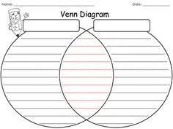  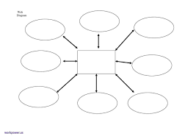 | Science Links:  E-Learning Resource for kids  Nasa: Earth  Study Ladder |  |  | Big Universe:  What is Electricity by Ron Aloian  What are Electrical Circuits by Ron Aloian  Electricity in the Real World by Sarah E. Ward  Light. Energy we can see by Julie K. Lundgren  Light in the Real World by Robin Koontz  Energy All Around by Buffy Silverman  Fossil and Rocks by Kimberly Hutmacher  Soil Erosion and how to Prevent it by Natalie Hyde  Erosion by Shirley Duke

Quarter 3
Instructional Week | Standard(s) | Academic Vocabulary | Resources | Sample Assessment Question | Opportunities for Writing
January 7 – January 12  January 13 - January 15  How does the rotation of the earth influence day and night? | 4.E.1.1 Explain the cause of day and night based on the rotation of Earth on its axis.  *touch on seasons, to review from 3rd and front load for 5th  Will Be Able To:  -Show connecting points of axis to day and night  -Explain the causes of day and night  -Use relevant science vocabulary  Will Know:  - Earth rotates on its axis  -Rotation causes day and night  - Length of the day and night | North pole, south pole, axis, rotation, revolution, orbit, prime meridian, Eastern Hemisphere, Western Hemisphere, cardinal directions | BrainPop: Seasons  Study Jams: A Day on Earth  NASA: Seasons  Day and Night Interactive  Day and Night  Sheppard Software:Seasons  solar system scope  Formative Assessment Probes:  What Causes Night and Day? (AS-p21)  Chinese Moon (AS-p123)  Gazing at the Moon (V1-p177)  Going Through a Phase (V1-p183)  Earth or Moon Shadow? (AS-p103)  Crescent Moon (AS-p127)  Darkness at Night (V2-p171)  Emmy's Moon and Stars (V2-p177)  Moonlight (V4-p161) | What causes day and night on Earth?  How long does it take the moon on its axis to make on rotation? | How would the world change if the Earth rotated on its true north axis?
January 19– January 22  January 25 – February 2  How does the moon’s orbit affect it appearance?  Why does the moon appear to change during the month? | 4.E.1.2 Explain the monthly changes in the appearance of the moon, based on the moon’s orbit around the Earth.  Will be able to:  -Explain the monthly changes in the appearance of the moon  -Explain how the orbit of the moon differs from the orbit of Earth around the sun.  -Analyze changes in the appearance of the moon  -Create illustrations of the moon to show the sequence of moon phases  Will Know:  -That the moon rotates and revolves around the Earth.  -The appearance of the moon changes in a specific pattern and repeats this sequence over the course of approximately 28 days. | axis, rotate, revolve, orbit, phase, reflect, waxing, waning, gibbous, crescent, last quarter, first quarter, full moon, new moon  Optional Enrichment Vocab:  lunar eclipse, solar eclipse, blood moon, harvest, moon, blue moon | Farmers Almanac  BrainPop: Solstice and Equinox  Moon Phases  Phases of the moon  Moon Phase Challenge  Moon Activities and Challenge  Earth, Sun,and Moon  YouTube: Phases of the Moon  YouTube: Phases of the Moon Rap  YouTube: 8 Phases and I Know 'Em | Why does the moon appear to change during the month?  What is the position of the Moon in relation to the Earth and Sun during a full moon? | Write a poem that describes your favorite phase of the moon.  Draw a cartoon illustrating the 28 day lunar cycle, as if you were the moon.
February 3– February 8  How are changes to an organism’s environment harmful? … beneficial? | 4.L.1.1 Give examples of changes in an organism’s environment that is beneficial to it and some that are harmful.  *touch on biomes  Will be able to:  -Give examples of how an organism’s situation changes when distinctive factors are applied  -Determine how a population can be affected by various factors  -Analyze cause and effect relationships of a food chain and food web and determine the sources of energy  -Evaluate a food chain and a food web  -Give examples of how populations are impacted by changes in the environment  Will Know:  -For any environment, some kinds of plants and animals survive and some do not  -When an insect population grows, bird populations that eat that insect grow as well. When it decreases, the insect population decreases.  -Factors that determine how well an organism can survive in their environment | Ecosystem, habitat, food web, food chain, herbivore, carnivore, omnivore, predator, prey, producer, consumer, decomposer, population, community, organism needs | Brainpop: Food Fight Game  Sheppard Software: Animal Games  YouTube: Habitats  YouTube: Habitat Informative  Formative Assessment Probes:  Global Warming (V4-p143)  Functions of Living Things (V1-p147)  Is It "Fitter"? (V4-p119) Senses (K-2V1-p35  ) Is It Food for Plants? (V2-p113) | Which niche does an animal with sharp teeth most likely fill?  How do decomposers help other organisms in an ecosystem?  In what order do a hawk, grass, and rabbit form a food chain in a meadow? | Draw and explain an example of a food chain or food web and circle the organism in the chain or web that is the main source of matter and energy for the other organisms.
February 9 - February 12  How do animal instincts help them survive?  How do animals respond to changes in their environment? | 4.L.1.2 Explain how animals meet their needs by using behaviors in response to information received from the environment.  Will Be Able To:  -Define what needs animals have based on their environment  -Explain how animals meet their needs using their behavior in response to information received from the environment  -Define behavior as learned or inherited  Will Know:  -Animal behavior depends on animal needs  -Animals have 2 types of behavior - inherited and learned  -Difference between learned and inherited behavior | extinct, endangered, adaptation, camouflage, mimicry, inherited behavior, learned behavior, structural behavior, instinct  generation, migration, hibernation | Brainpop: Ecology Behavior: Migration | Sharks are great swimmers because of which body structure had to be adapted?  Which of the following is the ability of an animal to fit into its surroundings? | Wild animals are very different from house pets. Think about the animals you have read about. Write to explain the differences between a wild animal’s life and a house pet’s life.
February 15- February 19  How do humans adapt their behavior to a change in their environment? | 4.L.1.3 Explain how humans can adapt their behavior to live in changing habitats (e.g., recycling wastes, establishing rain gardens, planting trees and shrubs to prevent flooding and erosion).  Will Be Able To:  -Research the changing environment  -Analyze the changes in the environment in connection human behavior  -Describe how humans adapt their behavior to preserve their environment  Will Know:  -Humans can adapt their behavior in order to conserve the materials and preserve the ecological systems that they depend on for survival | Extinct, adapt, endangered, ecosystem, grasslands, desert, rain forest, rivers, ponds, oceans, biomes, recycle, reduce, reuse, pollution, deforestation | Biomes Glossary  Reduce, Reuse, Recycle  Blue Planet Biomes  Ocean Garbage Patch  Great Pacific Garbage Patch | What is the benefit of planting trees on the perimeter of your farm?  Why would someone cut the plastic rings that a six pack of soda comes in to save the environment and/ or protect the sea life? | Write new lyrics to the tune of row row row a boat, that would help someone learn about reduce, reuse, and recycle?
February 22 –  February 26  Why do some organisms become endangered or extinct and others do not?  How does a particular environment affect how a species looks or acts?  How do habitat changes influence animal population?  How do species adaptations give advantages to the species for survival? | 4.L.1.4 Explain how differences among animals of the same population sometimes give individuals an advantage in surviving and reproducing in changing habitats.  Will Be Able To:  -Explain the importance of animal adaptations in changing habitats  -Explain how new adaptations become an advantage in surviving  Will Know:  -Habitats can change  -Animals have to adapt to survive  -Certain differences in same populations will give individuals an advantage in surviving and reproducing in changing habitats | Life cycle, traits, community, population, extinct, endangered, competition, camouflage, adaptation, mimicry, inherited behavior, instinct behavior, learned behavior | Brainpop: Ecology and Behavior Camouflage  Animal Adaptations  Quizlet: Adaptations- Vocab | How do animals use physical adaptations to survive? | Wild animals are very different from house pets. They need to be treated differently. Think about how life is different for wild animals. Now pretend you are a wild animal and write about life from your point of view.  There are many endangered species. You are on a committee to build a wildlife sanctuary. Write about your favorite endangered species and why you would work to protect it.
March 1 –  March 5 | Flex Days to review
On going resources/ PBL | PBL:  Zoo Animal PBL  created by: Jennifer Mahler  Live Binder:  4th Grade Live Binder  Experiments:  Listed under 4th Grade Science Folder | Science Links:  Nasa: Earth  Nature Works: Videos for entire quarter  Earth Hour  Graphic Organizers:  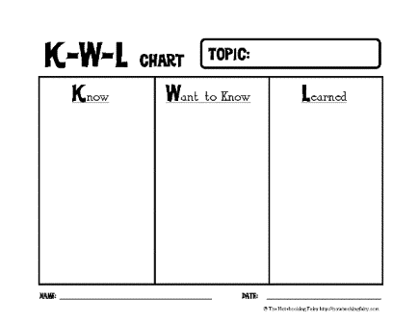  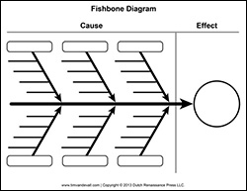 | Formative Assessments:  NCDPI:  Formative Assessment Probes  Foldables:  Food Chains and Consumers | Animal Unit:  Animal Adaptation  Ecosystem chart created by Shelby Smith located in resource/ Fourth Nine Weeks folder | Big Universe:  Inside Ecosystems and Biomes by Debra J. Housel  Restoring Wetlands by Jeanne Sturm  Going Green by David and Patricia Armentrout  Why Plants Become Extinct by Julie K. Lundgren  What is a Food Chain by Bobbie Kalman  Food Chains and Webs by Jacqueline Langille Bobbie Kalman  What’s the Difference by Suzanne Slade & Joan Waites

Quarter 4
Instructional Week | Standard(s) | Academic Vocabulary | Resources | Sample Assessment Question | Opportunities for Writing
March 8 - March 12  March 15 – March 19  How can we classify items to provide energy and materials for survival, growth and repair of the body? | 4.L.2.1 Classify substances as food or non-food items based on their ability to provide energy and materials for survival, growth and repair of the body.  Will Be Able To:  -Classify substances as food or nonfood  -Determine their nutritional value.  Will Know:  -The role food plays in:  Survival, growth, and repair of the body | Survival, want, need, healthy, nutrients, carbohydrates, vitamins, minerals, proteins, fats, sugar, calories, starch  Caloric intake, chemical energy | Choose My Plate  Brain Pop: Nutrition  Brainpop: Sort Nutrition  Formative Assessment Probes:  Catching a Cold (V4-p125) Is It Food? (V4-p91) | Which types of foods will be in the grains food group?  When trying to add protein to your diet, which foods would you choose? | Who are some healthy famous people that you look up to? These could be Olympic athletes, movie stars, or anyone at all. What do you think they do to remain healthy and in good physical shape?  The experts recommend that kids like you should get about half an hour of activity most days of the week. Are you as active as you should be? If so, what are some of the things you do to keep moving during the day? If not, what are some ways in which you could add more activity to your life?
March 22-March 26  March 29 - April 1  (4 day week)  (April 2- April 11- Spring Break)  How do vitamins, minerals and exercise interact to maintain a healthy body? | 4.L.2.2 Explain the role of vitamins, minerals and exercise in maintaining a healthy body.  Will be able to:  -Explain the role of vitamins and  minerals in maintaining a healthy body.  -Describe how exercise is crucial to maintaining a healthy body  Will Know:  -Humans  have needs for vitamins,  minerals, and exercise in order to remain healthy.  -Vitamins  and minerals are found in healthy foods, as well as dietary supplements.  -Movement is essential for the growth, development and  maintenance of the human body and its systems. | Vitamin, mineral, calcium, protein, iron, zinc, vitamin A,  Vitamin C, Vitamin D, carbohydrates, proteins, fats, sugar, calories, starch | Brainpop: Body Weight  Food Groups | What is an effect of regular exercise?  What are some examples of activities for physical fitness? | Write a menu and exercise plan for a healthy day.  What does the word “healthy” mean to you? Do you think you fit the definition or that you need to do some work to get there? What are the things you would have to do to reach that point?
April 12 - May 14 | Flex days for teaching, and review
May 17 – May 28 | EOG Testing
After EOG Testing | Experiments:  Listed under 4th Grade Science Folder  Graphic Organizers:  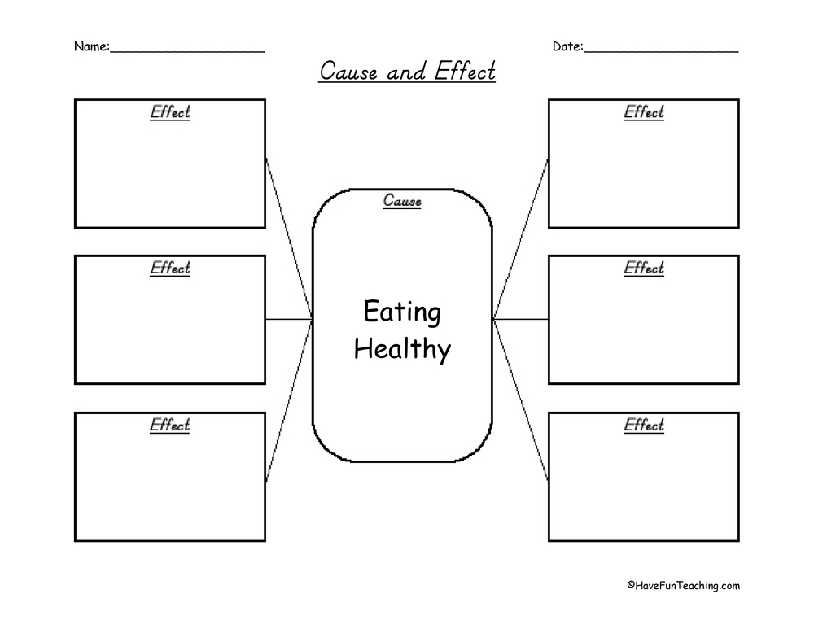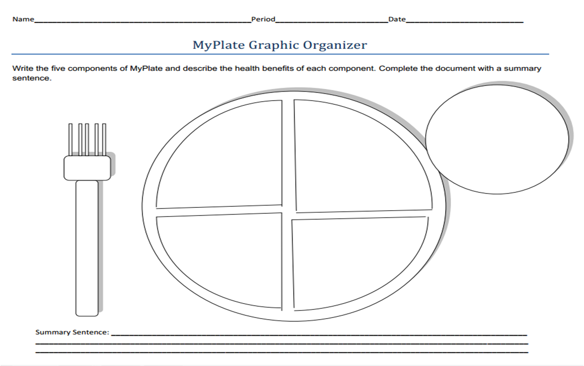  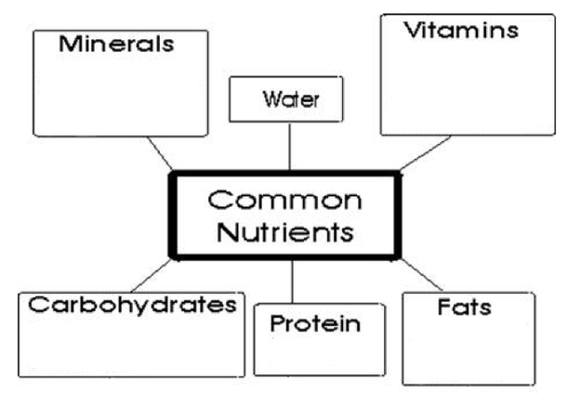 | Foldable:  Food Foldable  Food Unit with Foldables | Extension for after EOG :  Cloud Matching  Cloud Games  Water Cycle  Interactive Body Systems  Skeletal Game |  | Big Universe:  Why we need Minerals by James Bow  Food and Nutrition  by Jane Katirgis  Growing Good Food  by Anne Flounders  Why We Need Vitamins  by Marina Cohen  Glorious Grains  Vital Vegetables  Fabulous Fruits  Delicious Dairy  Marvelous Meats  Outstanding Oils and Wonderful Water  by John Burstein

