Kindergarten E-Learning Choice Board
NOVEMBER
Please pick at least 2 activities each day to complete. Try to complete and explore new activities each day and then it is ok to repeat activities! Most importantly, HAVE FUN TOGETHER!

Row 1 | Go on a nature walk with your family. Look for signs of Autumn.  Gather pretty leaves, acorns, or other interesting items.  Draw a picture of your walk in your kindergarten journal. Have a grown-up help write the story. | Scholastic Clifford’s My Big World:  What Goes Crunch in Autumn?  https://mybigworld.scholastic.com/issues/2020-21/110220.html | Practice reading and writing our Kindergarten sight words (I, like, the, and see, to, a. we). Look for these words in books, magazines, newspapers, etc. | Play the fun math game Roll and Record. If you want to play a more challenging version of the game, use 2 dice and add the numbers together to write the total number! | Scholastic Let’s Find Out  Hooray For Veterans!  Hooray for Veterans!  https://letsfindout.scholastic.com/issues/2020-21/110120.html
Row 2 | Scholastic Clifford’s My Big World:  Goggle, Gobble, Wild Turkey  https://mybigworld.scholastic.com/issues/2020-21/110120.html | 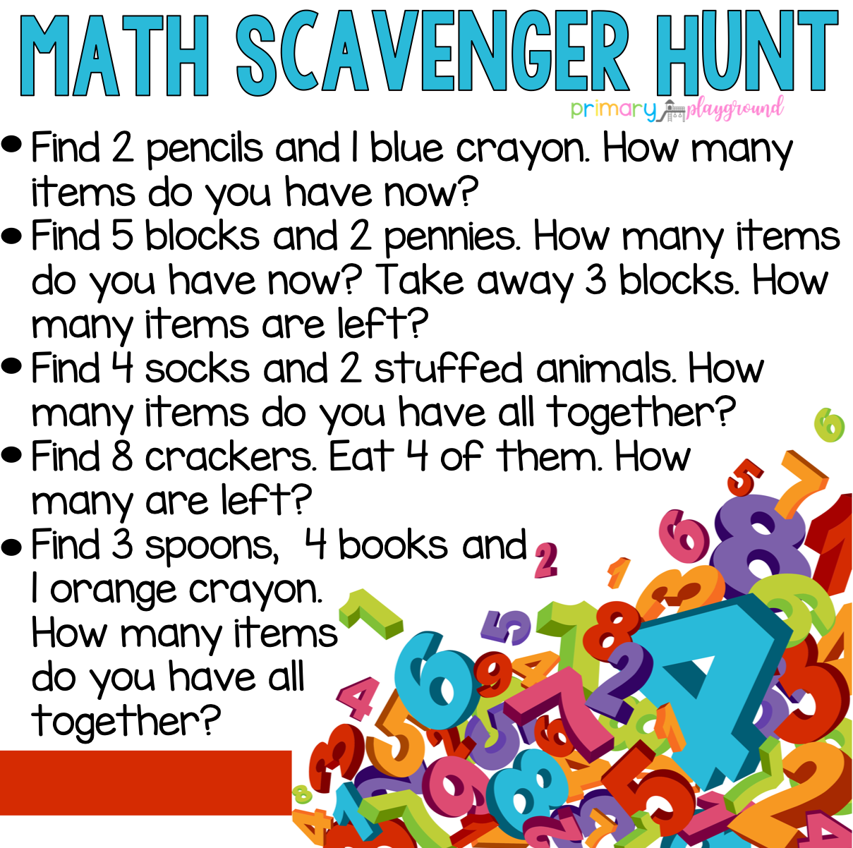  https://www.facebook.com/PrimaryPlayground/photos/a.503425483179616/1255465754642248/?type=3 | Explore the alphabet game on Starfall  Starfall Main Image ABCs Index  Practice saying the alphabet with the Jolly Phonics sounds and actions  See if you can name all of the Alhafriends! Listen to the song for help:  https://www.youtube.com/watch?v=2_cX4j_9fUU | Have a grown-up read you a book. Talk about the different parts of the book….front cover, back cover, title page, and talk about what the author and illustrator do. Help your grown-up turn the pages and show them where to start reading on each page. | Gather your family members together to have fun doing the Turkey Hokey Pokey:  https://www.youtube.com/watch?v=VxfajHBG9Rg  Practice learning to identify your left and right
Row 3 | Shape Shadow Match  https://www.education.com/game/match-sight-words  Try to draw or create shapes with playdough. | Listen to “Down By The Bay.” After listening to the song, make up some of your own rhymes.  https://www.youtube.com/watch?v=jAjhLexlrDc  Example….  “Did you ever see a star driving a car down by the bay.” | Work on identifying beginning sounds. Have a grown-up say the following words out loud to you one at a time. You will then tell your grown up what sound you hear at the beginning of each word.  Bear, mix, rug, dog, flower, top, net, green, dog | Scholastic  Let’s Find Out:  A Heart Full of Thanks  https://letsfindout.scholastic.com/issues/2020-21/110220.html | Missing Number Activity:  Write the following on a sheet of paper, on a wipe off board, or out on your driveway with sidewalk chalk and have your child fill in the missing number….  8, ___,10  7, ___,9  10, ___,12  6, ___,8
Row 4 | Alphabet Mud Puddle Game:  https://www.education.com/game/alphabet-mud-puddles/  Write the letters in the alphabet like this:  Aa Bb Cc Dd Ee Ff Gg Hh  and so on | Select one of our kindergarten sight words:  I, like, the, and see, to, a. We  Have a grown-up set a timer for 1 minute and see how many times you can write that word!  Play again with another word. Which word did you write more times? | Make a card for someone you are thankful for. Draw a nice picture and have a grown-up help as you write the words you want to say. Give the card to that special someone; it will make them so happy! | Write your numbers 1-20 as best as you can!  Count by 10’s to 100  Sing along with” The Big Numbers” song:  https://www.youtube.com/watch?v=e0dJWfQHF8Y | Enjoy making this tasty Thanksgiving Snack Mix recipe:  https://lifemadesimplebakes.com/thanksgiving-snack-mix/  With a spoon or measuring cup, scoop the mix into bowls or baggies for everyone to enjoy!

Daily Tasks:
*Complete 1 or 2 pages in monthly Math Journal
*Complete 1 page in the Jolly Phonics Journal (write the letter, circle the letter in words, color picture)
*Review the Jolly Phonics Sound Book (name the letter, produce the sound, and make the action)
*Practice printing first and last name with only the first letter of each name printed with a capital letter
*Read a book with a family member. What is the setting? Who are the characters? What happened at the beginning, middle, and end of the story? Did you like the book? Why?
*Count objects with 1 to 1 correspondence:
*Count to 100 and beyond
*IXL Math for 15 minutes
*Go for a short wellness walk with a grown up
*Play a game, make a puzzle, or have fun playing with toys: be creative and have fun and clean up when you are finished playing!

Kindergarten Standards
Develops Alphabetic Awareness Understands How Print Works
Demonstrates Comprehension of a Story Read Aloud Learning Sounds That Letters Make
Talks With Others Attempts to Scribble/Write Letters
Listens and Responds to Others Learning to Follow Directions
Is Learning to Count Learning About Shapes
Separates Objects by Similarities and Differences Learning that Objects Can Be
Measured
Learning to Manipulate Objects with Hands and Fingers Shows Persistence
Makes Explanations about Science

Life Skills
Participates Willingly in Class Respects School and Classroom Rules
Listens to and Follows Directions Works Cooperatively
Initiates Own Play Activities Asks for Assistance When Needed
Respects Peers/Adults Is An Attentive Listener
Makes Appropriate Choices During Free Time Responsible for Personal Belongings
Responsible for Personal Hygiene Speaks in Complete Sentences
Demonstrates Self Control Plays Well With Others

