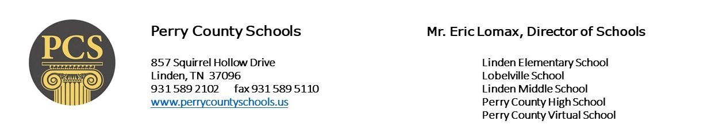

Perry County Virtual School Application for AUGUST 2021 ENROLLMENT
Applications are now being accepted for the Perry County Virtual School –August 2021 semester. Completing this application does not guarantee a position in the Perry County Virtual School, as the PCVS is not an open enrollment school. If you are not accepted into the Virtual School you are still eligible to enroll in our traditional schools. Each individual student must fill out an application. Please return to Ashley Carroll at Perry County Board of Education or submit by email to acarroll@perrycountyschools.us
Student Name: _______________________________________ Age: __________________
Grade level in 2021-22 school year: _____________________
Parent/Guardian Name: _________________________________________________
Address: ___________________________________________________
Phone: _____________________________________
Parent Email address for enrollment notification: _____________________________________________
Student email address (if different from parents) for class login to be sent: ___________________________
Last School Attended: _______________________________________________
*Please attach your last report card or transcript to this application
Do you have access to a computer, printer & reliable internet at home (circle one): YES or NO
Have you previously been suspended or expelled from a school (circle one): YES or NO
Would you & your parent/guardian be willing to sign a Virtual School Contract that confirms your will complete work independently and with academic honesty while refraining from any type of cheating (circle one) : YES or NO

________________________________________ _______________________________________
Parent/Guardian Signature Student Signature

