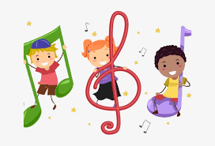

October 27, 2020
Dear Parents,
I wanted to get this information out, as I think there has been some confusion. The school is currently on a 3-week rotation for the students doing the hybrid model. As the music teacher, I am working with both students doing this model as well as those that are doing remote only learning. The music assignments that are posted in Schoology are for all students, (this means that you should complete all music assignments posted in your Schoology account). Hybrid students are getting assignments to cover only the 2-weeks in the 3-week cycle, that I do not see them in person. Remote only students are getting assignments that go with what is covered in the hybrid model and given at 3-week intervals to keep all grades and classes learning the same things at the same time.
Please submit all Assignments back through Schoology as that is where I get notification of an assignment being turned in, with over 400 students I may not see an assignment somewhere else.
Sincerely,
Ms. Messer
La Merced Music Teacher

