2021 Conservation Essay Contest
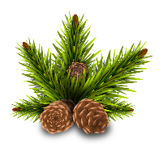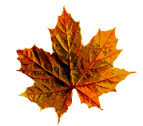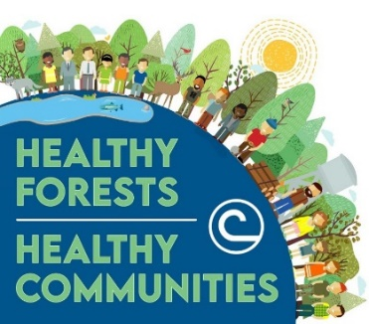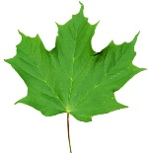
Live Oak Soil and Water Conservation District No. 323
200 East Bowie Street, Suite C
George West, Texas 78022
(361) 449-2241 Ext. 3
Contact Person: Sherry M. Kosarek, District Clerk
Sherry.kosarek@tx.nacdnet.net

Subject: “Healthy Forests = Healthy Communites”
_____ Junior Essay: Ages 13 and under – Maximum of 300 words.
_____ Senior Essay: Ages 14 to 18 – Maximum of 500 words.

Name of Student: __________________________________________________
School: ___________________________________________________________
Grade: ________________________ Teacher: ___________________________

All entries must meet the following specifications:
- Your essay must be typed.
- The title of your essay must be: “Healthy Forests = Healthy Communities”.
- Include soil and water conservation practices as they relate to the topic.
- Make the writing interesting to the reader and that the ideas are clear and easy to follow.
- Check your work for correct spelling, capitalization, punctuation and grammar.

Essays will be judged by the Live Oak SWCD. The overall top junior and senior essay winners will advance to the Area III Competition. The first, second and third place winners will be recognized and rewarded.

ALL ENTRIES MUST BE DELIVERED TO THE LIVE OAK SWCD OFFICE at 200 East Bowie Street, Suite C – George West, Texas.

DEADLINE: All entries must be received by December 11, 2020.

