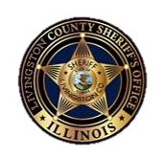
Halloween Safety
Keeping your family safe!
Sheriff Tony O. Childress
Trick-or-treating tips:
- A responsible adult should always accompany children ages 12 and under.
- Ensure costumes fit well, are flame retardant, and to not restrict eyesight.
- Wear reflective clothing and/or carry a light or glow stick.
- Never enter a home without permission and only approach homes that are well-lit.
- Bring all treats home before eating. Eat only factory-wrapped treats unless you know the giver well.
- Be cautious near streets and intersections.
- Say NO and GET AWAY from any person or situation making you feel scared, uncomfortable, or confused. Be sure to tell a trusted adult!
Covid-19 Halloween Safety Information:
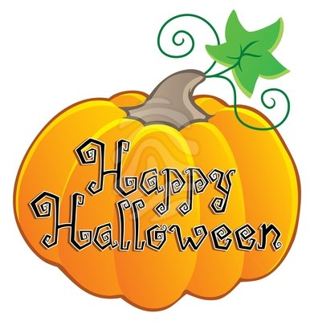
The Illinois Department of Public Health recommends the following:
Trick-or-treaters:
- Maintain social distancing and wear proper face covering.
- Trick-or-treat in household groups only.
- Wash hands before consuming foods.
Residents:
- Consider leaving treats in bags for individuals to avoid repetitive touching.
- Leave Treats in an area where social distancing can be followed.
- Consider safe alternatives such as parties at home, schools, or community events.
Guidelines available at https://www.pontiac.org/DocumentCenter/View/2734/093020-Halloween-Guidance
Visit www.livingstoncountysheriff.com to search for registered sex offenders in your area. Child sex offenders are prohibited from participating in Trick-or-treating or distributing items to children on Halloween.

