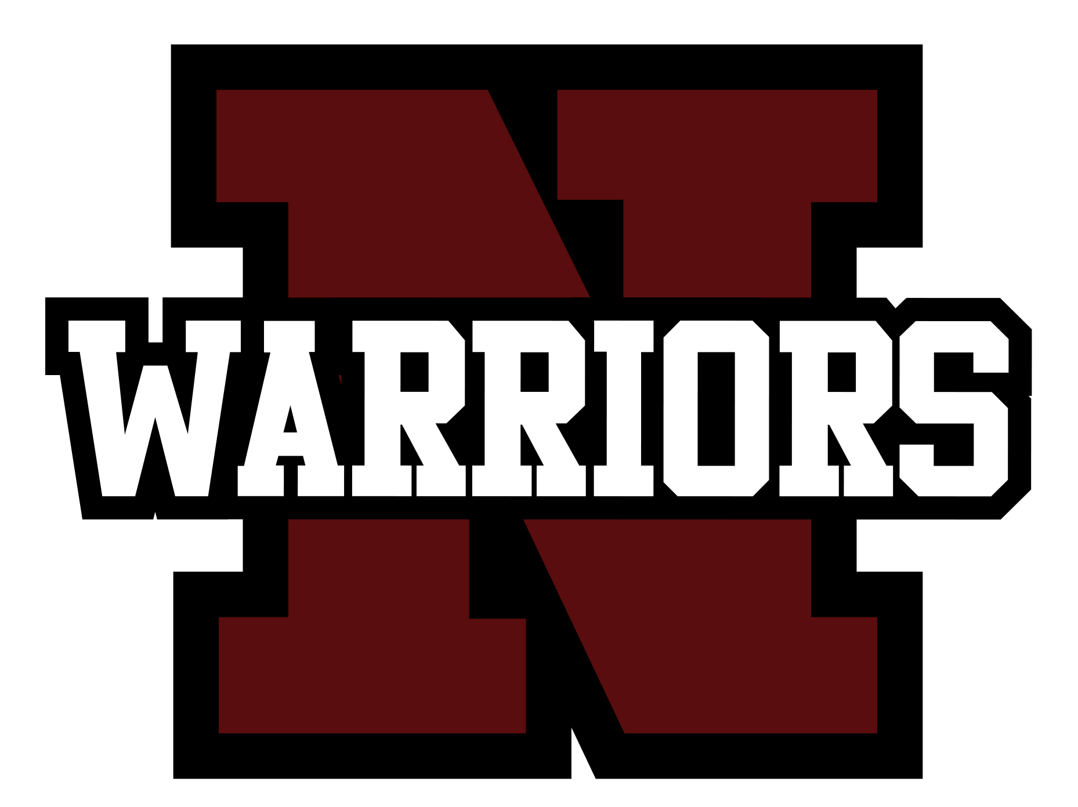
October 14, 2020
Hello Warriors! As we’ve reached the mid-point of our first quarter, I wanted to update our parents and guardians on how the reopening of school has been. Generally, I am very pleased with this first step we’ve taken to return to school. It’s been amazing to see many of our students in the building and to see and hear the rest in classrooms virtually.

The well-being of our students, staff, and Warrior Nation is our top priority. In these first five weeks of school we’ve had many successes and have been able to:
- Provide free lunch and breakfast to any and all students,
- Navigate a hybrid system with half of our student body in person for 2-days while the other half attends virtually and then flip-flop groups later in the week,
- Balance in-person and remote instruction and learning,
- Support our Tri-County Technical students attending in-person all week,
- Resume a modified athletic schedule,
- Provide laptops to all students and hotspots for those who need one to access the internet.
AREAS IN WHICH WE NEED YOUR CONTINUED SUPPORT:
- ATTENDANCE:
  - Thank you to the many parents who have notified us your child is not feeling well and will not be attending in person. Please continue to call or email us if your child is out, and remember that any and all students can join remotely from home if they’re sick.
  - Use the Self-screening tool to assess if your child is well enough to go to school--please keep sick students at home.
  - For online classes, students are expected to participate and stay logged in for the whole class. Students who leave before the end of the class or do not respond to teacher prompts will be marked absent for the class.
- REMOTE LEARNING:
  - Cameras should be turned on during class time so teachers can visually monitor that students are in attendance and actively participating in class, and allow teachers to see if students may need support.
  - Students who have selected to attend in-person, unless sick, are expected to report to school and not make day-to-day choices about being remote or in-person. Teachers are working hard to prepare for a certain # of students in person, so students need to come to school.
  - The RSU 19 Technology Department is readily available to help with any technology challenges. Please contact them immediately at tech@rsu19.net if you need support so your student is not missing class time.
  - Students should be aware that All school rules apply during remote instruction.

- GRADING:
  - Teachers have resumed typical grading procedures. Work needs to be turned in on time and meet standards. Enclosed is the 1st Quarter Progress Report. Please contact individual teachers if you have questions about your child’s grade.
  - Guidance counselors are in the process of meeting individually with seniors to review their status towards graduation. Please confirm with your senior that they have received an invitation from their counselor and that they meet with them at their scheduled time.
  - Remediation from last spring. We have put into place opportunities for students to recover incomplete grades from last spring. If you have questions about your child’s progress or plan, please email their guidance counselor.
  - If you do not have your Infinite Campus log in which allows you to check student grades and attendance, email tech@rsu19.net to get your information.

OTHER ITEMS:
- Student Led Conferences: Our fall Student Led Conferences will be held virtually and hosted by each student’s adviser this year. During the week of November 16, advisers will send you an invitation to confirm a date and time for both you and your student to review their 1st Quarter progress. This format will include just you, your student, and the adviser. If you would like to talk to a specific teacher, please reach out to that teacher via email anytime.
- Hometown Health: Our School Based Health Center is now OPEN for students to be seen during the school day! Just fill out the SBHC enrollment form and send it back to the office. The provider is on-site Tuesday and Thursday. Appointments range from Well Child Checks, Same Day Appointments (ear ache, sore throat,etc), to immunization updates! We also offer behavioral health via telehealth! For more information contact Penny Townsend at penny.townsend@hhcme.org or 355-3508.
- Winter Athletics: No decisions have been made regarding winter sports.
- Clubs & Groups: Our various clubs and groups are continuing to operate, either virtually or by running activities/events that align with health protocols. Encourage your child to join in!
- Updated Contact Information: Do we have your correct phone number, email and physical mailing address? If not, please let us know so you receive notifications from us!
- Social Media: Please like the official Nokomis Facebook and Twitter accounts where we are celebrating many of the cool things our students are doing along with sending out official school notifications. We use these sites to push out information and not forums for Q & A or to debate. There are other community-run and school-focused social media sites, and while sometimes questions and comments asked or posed get accurate responses, many times there is inaccurate or misleading information provided. If you have any questions, please, feel free to email me, mnadeau@rsu19.net or call the Main Office, 207-368-4354. We want to do our best in supporting you and our school community with information..

SCHOOL STATUS: Please take a moment to complete this brief survey to let us know your preference for attending school for your child, ranging from remote only, to hybrid, to the possibility of coming for 4-days in-person each week. We’ll use this information to determine our next steps and inform if/when we can make any changes to your child’s status. LINK: http://bit.ly/19HYBRID

Again, thank you for all of your support in making our return to in-person school as smooth as possible. We sure do make a great team!

Go Warriors!

Sincerely,

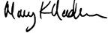

Mary Nadeau, Principal

Enclosures

