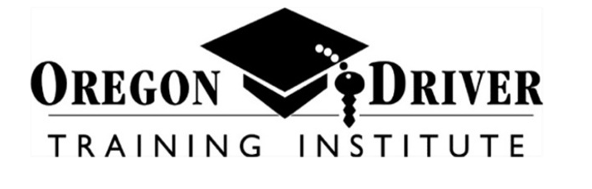  Driver Ed  Winter 2021  Junction CIty High School  January 5th - March 4th  Tuesday and Thursday  5:30-7:30pm  *No class: 01/14 or 01/19  Register online at oregondrivertaining.com  Scholarships Available!!  Tuition as low as $75!  - 32 hours class time (online VIA Zoom)  - 6 hours driving  - 6 hours observing  - ODOT & DMV Approved Course  - Instructors are ODOT & DMV certified  - Students 15-17 who pass the course will receive a certificate that waives the driving portion of the licensing process  - The first class session is a MANDATORY TEEN/PARENT MEETING |  |  | Program Details  Scheduling  The schedule provided is for class time only, 6 behind-the-wheel lessons will be scheduled with the instructor outside of class time & will extend beyond the last class date.  Requirements  - Students must obtain  their permit prior to registration  - PERMIT NUMBER & ISSUE DATE ARE REQUIRED AT TIME  OF REGISTRATION  - Students must have a minimum of 15 hours of driving practice prior to their first  behind-the-wheel lesson  Payment:  -Debit/Credit Card payment due at time of registration  *Students who can provide  proof of free/reduced lunch  are eligible to receive a $75  discount  $425
IMPORTANT TUITION INFORMATION
The Driver Education program is a self-supporting program. The cost of the program is shared by student tuition and state reimbursement. To be eligible for state reimbursement, thus receiving the listed tuition price, the student must be 15-17 years of age and have a valid Oregon permit. If a student is 18 years old, turns 18 prior to completing the program, obtains their license prior to completing the program, or they drop the course, they are NOT eligible for state reimbursement and must pay the additional tuition amount of $210.

