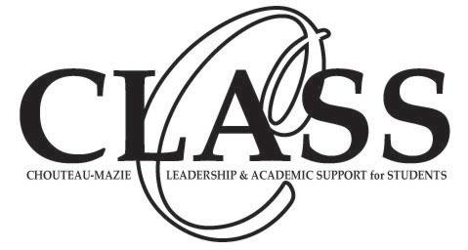

Foundation Grant Application Criteria

- Total grant application not to exceed $500
- Original application and 4 copies and any backup information must be submitted for consideration.
- Grant request for Chouteau-Mazie School District only
- Funding not available from federal, state or local sources
- Teacher salaries, workshop expenses or payments not eligible
- Any school employee is eligible to apply.
- Incomplete applications will not be considered.
- Deadline for application submission: September 29th
- The application must be given to your building principal for approval and they will turn in your completed application to the Administration Building for the foundation.
- All monies must be appropriated by: January 31
- Grant application must be typed.
- The Teacher of the Year will automatically receive a $500 CLASS Foundation Grant.

P.O. Box 138, Chouteau, OK 74337

CLASS Grant Application Form
Cover Sheet

Thank you for your interest in the CLASS Foundation’s Grant Program. To insure anonymity during the selection process, PLEASE put your name and your school’s name ONLY on this cover sheet. Please submit one copy of this cover sheet with four copies of the application. Thank you

Applicant’s Name Date

Phone # Building Position

Project Title Total Budget

Is this project being funded by any other resources? Yes No

Your signature indicates that you believe this project meets the criteria of the CLASS Grant Program and that to your knowledge, funding from other sources is not available.

Signature of Building Principal Applicant’s Signature
CLASS Grant Application Form

Project Title Date

- What major need does this project address?

- Describe your project. (What are your objectives, materials, methods? What will the project accomplish? Give an example if necessary)

- Give a time schedule of events.

- Approximately how many students will be affected by this project? Address both directly and indirectly. Will it be shared with other classes? Will it be used for multiple years?
- How will you determine whether your goals have been achieved and your project was successful?

- Detail your budget request. Include specific information such as kinds of materials and equipment needed, source of supplies, costs and total.
Description | Item # | Unit Cost | Quantity | Total
Total Cost: $_____________

CLASS
Upon Completion of your Project

- You will be required to submit a presentation board or poster for the Foundation to use during community and fundraising events. Failure to submit this item will make you ineligible to apply for and receive future grants the following year.

- Make sure you keep receipts from materials purchased with grant monies.

- Should you have money remaining , it should be returned to the Foundation.

- The Foundation is not responsible for project expenses that exceed the awarded amount.

- The materials purchased with the grant monies awarded to you shall remain property of Chouteau-Mazie Public Schools upon completion of the project and the materials will remain in the school to which the grant was awarded.

- Please try to promote and give credit to the CLASS Foundation when you get publicity for your project.

Thank you for your participation!

