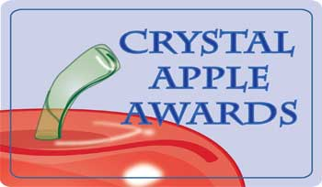

2023 Crystal Apple Awards Nominations OPEN!

Do you know an amazing teacher in Eastern Oregon?
Or a paraeducator or school secretary going the extra mile?
Or any school district employee doing great work for student success?

Nominate them for a Crystal Apple Award!

Anyone can nominate using this link:
https://forms.imesd.k12.or.us/crystal_apple_nomination_form.

Who is eligible to be nominated? Any school district employee (district staff, teachers, educational assistants, secretaries, custodians, cafeteria staff, etc.)

Who can nominate? Anyone – students, teachers, administrators, classified staff, parents, community members, etc.

Nomination Deadline is April 1, 2023.
For more information or to see lists of previous winners, visit the Crystal Apple page on the InterMountain ESD website at: https://www.imesd.k12.or.us/page/crystal-apple-awards

