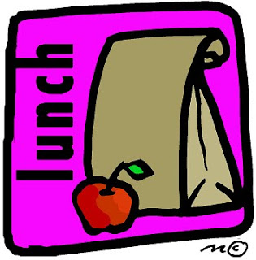 Dear Whiting Parents,

We are making plans for the return of students to in person learning! Being that we will have virtual and in person students, I wanted to send you some information on meals for your students. The USDA has approved a waiver for school meals making all meals free until funding is depleted or December 31, 2020. This means that if you have a virtual student, you can request meals for the week by filling out the online request form. It is located on the School City of Whiting website Home page under meal distribution. Please fill this out weekly by Thursday night 8p.m. We will distribute these meals to parents every Monday afternoon from 4p.m. – 5p.m. on the Nathan Hale playground off of New York Ave. If your child is attending hybrid learning, you cannot pick up meals for the week.
If your student is attending in person hybrid learning, meals at school are free. Your student will receive a choice of a hot or cold lunch every school day. Nathan Hale students will be provided a cold breakfast in the classroom free of charge. Middle School and High School students may come to the MS/HS cafeteria from 7:10a.m. until 7:30a.m. and receive a cold breakfast free to the student. For the days that your hybrid student is e-learning, you may fill out the hybrid request form (fill out once for the entire hybrid learning time) and we will send a breakfast and lunch home for the next day with your student. The hybrid request form is attached to this letter and it is also available online on the School City of Whiting website. If you have any questions, please call the cafeteria office at 219-473-0961.
Thank you,
Christine Lerma, Food Service Director
School City of Whiting

In accordance with Federal civil rights law and U.S. Department of Agriculture (USDA) civil rights regulations and policies, the USDA, its Agencies, offices, and employees, and institutions participating in or administering USDA programs are prohibited from discriminating based on race, color, national origin, sex, disability, age, or reprisal or retaliation for prior civil rights activity in any program or activity conducted or funded by USDA. Persons with disabilities who require alternative means of communication for program information (e.g. Braille, large print, audiotape, American Sign Language, etc.), should contact the Agency (State or local) where they applied for benefits. Individuals who are deaf, hard of hearing or have speech disabilities may contact USDA through the Federal Relay Service at (800) 877- 8339. Additionally, program information may be made available in languages other than English. To file a program complaint of discrimination, complete the USDA Program Discrimination Complaint Form, (AD-3027) found online at: http://www.ascr.usda.gov/complaint_filing_cust.html, and at any USDA office, or write a letter addressed to USDA and provide in the letter all of the information requested in the form. To request a copy of the complaint form, call (866) 632-9992. Submit your completed form or letter to USDA by: mail: U.S. Department of Agriculture Office of the Assistant Secretary for Civil Rights 1400 Independence Avenue, SW Washington, D.C. 20250- 9410; fax: (202) 690-7442; or email: program.intake@usda.gov. This institution is an equal opportunity provider.

