Williston Public School District #1
And
Williams County School District #8
Reorganized as
Williston Basin School District #007

Vision Statement

The vision of Williston Public School District #1 is to welcome and celebrate the individuality of the students, staff, parents, and community. We educate with passion in a safe and respectful environment. We strive to educate with the highest level of technology. We pledge to prepare students to graduate and achieve personal success.

The Vision of Williams County School District #8 is Excellence in Education.

The vision of both school boards and the reason for the creation of this plan is to ensure that all students within the boundaries of WPSD #1 and Williams County School District #8 have access to educational programs that are of the highest quality and are being delivered in an efficient and fiscally responsible manner.

The school boards of both districts agree that this plan has been developed with the future needs of the region in mind.

.

- Table of Contents
I. Table of Contents
II. Abstract
III. School District Name
IV. Timeline
V. Effective Date
VI. School District Boundary
VII. District Size and Enrollment
VIII. Facilities
IX. Curriculum
X. Staffing
• Administration
• Faculty and Professional Staff
• Ancillary and Support Staff
XI. School Board
XII. Student Transportation
XIII. Other Governmental Agencies
• Special Education Unit
• Career and Technical Education Center
• Regional Education Association
• ITV Consortium
XIV. Financial Consideration
• Taxable Valuation and Tax Levy
• Bonded and Other Indebtedness
• Disposition of Assets
• Liabilities
• Disposition of Property
• Proposed Budget

Appendices
• Property Legal Descriptions
• Williams County Reorganization Board Hearing Minutes
• Williston Public School District #1 Board Voting Record
• Williams County School District #8 Board Voting Record
• County Hearing Notices
• Preliminary 2020-2021 Certificate of Levy

II. Abstract

This document represents the plan of reorganization of the Williston Public School District #1 (WPSD #1) and the Williams County School District #8 (D8) to create a new school district as allowed by NDCC 15.1-12. The two districts are contiguous, with the entirety of both districts located in Williams County. All properties of WPSD #1 and of D8, after the Voluntary Land transfers, are included in this reorganization plan.

The Williston Basin School District #007 will include all property currently within the boundaries of the WPSD #1 and D8 after the Voluntary Land transfers. The plan proposes that upon the effective date of reorganization, school operations will cease and that all educational programming and services will be delivered in the existing facilities. All grade level curriculum and educational services currently offered will be provided to all students in Williston Basin School District #007.

III. School District Name

Upon the effective date the new school district formed as a result of the reorganization of the WPSD #1 and D8 districts will be known as Williston Basin School District #007.

IV. Reorganization Timeline

Wednesday, August 12, 2020: Reorganization Plan turned into the Williams County School Superintendent Designee (County Superintendent). Upon receiving the plan, County Superintendent to schedule and publish notice of a public hearing for the Williams County Committee for School Annexations, Dissolutions and Reorganizations (County Committee) regarding the plan, with the public hearing to be scheduled within 60 days of filing of the plan with the County Superintendent.
Monday, August 17, 2020: The County Superintendent works with the Williston Herald to publish notice of the public hearing in the newspaper. (Notice to be published at least 14 days before the public hearing, but place notice at least 1 day prior due to possibility of the newspaper forgetting to publish the notice).
Friday, August 21, 2020: Notice of the public hearing to be published in the Williston Herald (Williston Herald publishes on Wednesday, Friday, and Sunday).
Wednesday, Sept. 9, 2020: The County Committee holds a public hearing on the plan. The County Committee shall approve or deny the plan. If the plan is approved by the County Committee, the County Superintendent forwards all public hearing materials to the ND State Board of Education (State Board) for final approval.
The packet of information and the minutes from the County Committee public hearing are sent to the State Board by September 15 for the reorganization plan to go on to the State Board’s October meeting agenda. If the information is sent to the State Board after September 15, then the Reorganization Plan will be placed on the State Board’s agenda for the November meeting. The State Board usually meets the 3rd Monday of every month, except July and December.
Monday, Oct. 19, 2020: The State Board Meeting (provided the packet of information and the minutes from the County Committee public hearing have been sent to the State Board by September 15). At least 14 days before its meeting on the plan, the State Board must publish notice, in the official newspaper of the county, of the meeting at which it will consider the reorganization plan.
Once the plan passes at the State Board meeting and the County Superintendent receives notice from the State Board that the plan was approved, the County Superintendent calls for a special election to be held between July 1st and December 31st of the year in which the plan was approved by the State Board. Both the County Superintendent and the school district clerk/business managers have responsibilities regarding conducting the special election.
Thursday, Oct. 29, 2020: Election Ballots must be available for distribution. (40 days before election date).
Sunday, Nov. 22, 2020: School Board must publish a notice in the Williston Herald at least 14 days before the election stating the time and place of the election and the purpose of the vote.
Tuesday, Dec. 8, 2020: Election Day: The vote for both school districts needs to pass by a majority vote.
V. Effective Date

The effective date of the Williston Basin School District #007 will be July 1, 2021.

VI. School District Boundary

The Williston Basin School District #007 will consist of all property within the current boundaries of the WPSD #1 and D8 (after the Voluntary Land transfers) school districts and boundary lines between the two will be eliminated and perimeter boundaries of the two shall serve as the new boundary for the reorganized district. Requests to annex property will be subject to all procedures and requirements in NDCC 15.1-12.

Prior to the reorganization effective date, the D8 school board worked with surrounding Williams County School Boards to develop a plan for the Voluntary transfer of land. If on the effective date of the reorganization, mutually acceptable plans have not been approved and land is not transferred, said land will remain part of the Williston Basin School District #007.

Following are the maps of WPSD #1 and D8 districts:
- WPSD #1 and D8 before Voluntary Land transfer
- WPSD #1 and D8 after Voluntary Land transfer
- WPSD #1 and D8 new boundary lines
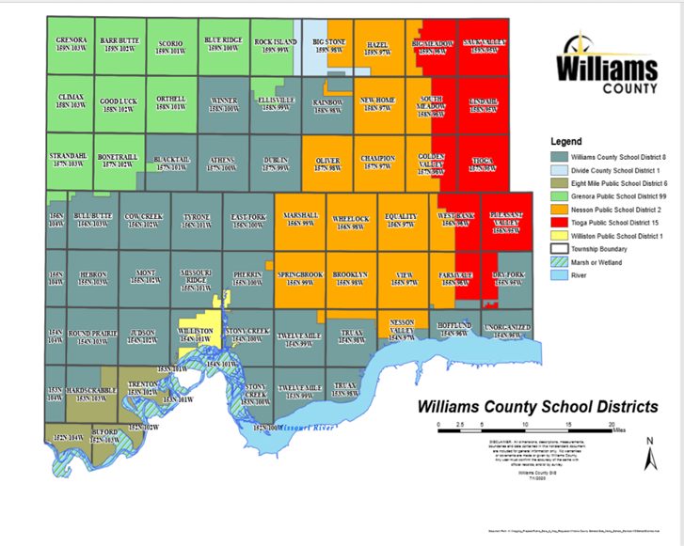

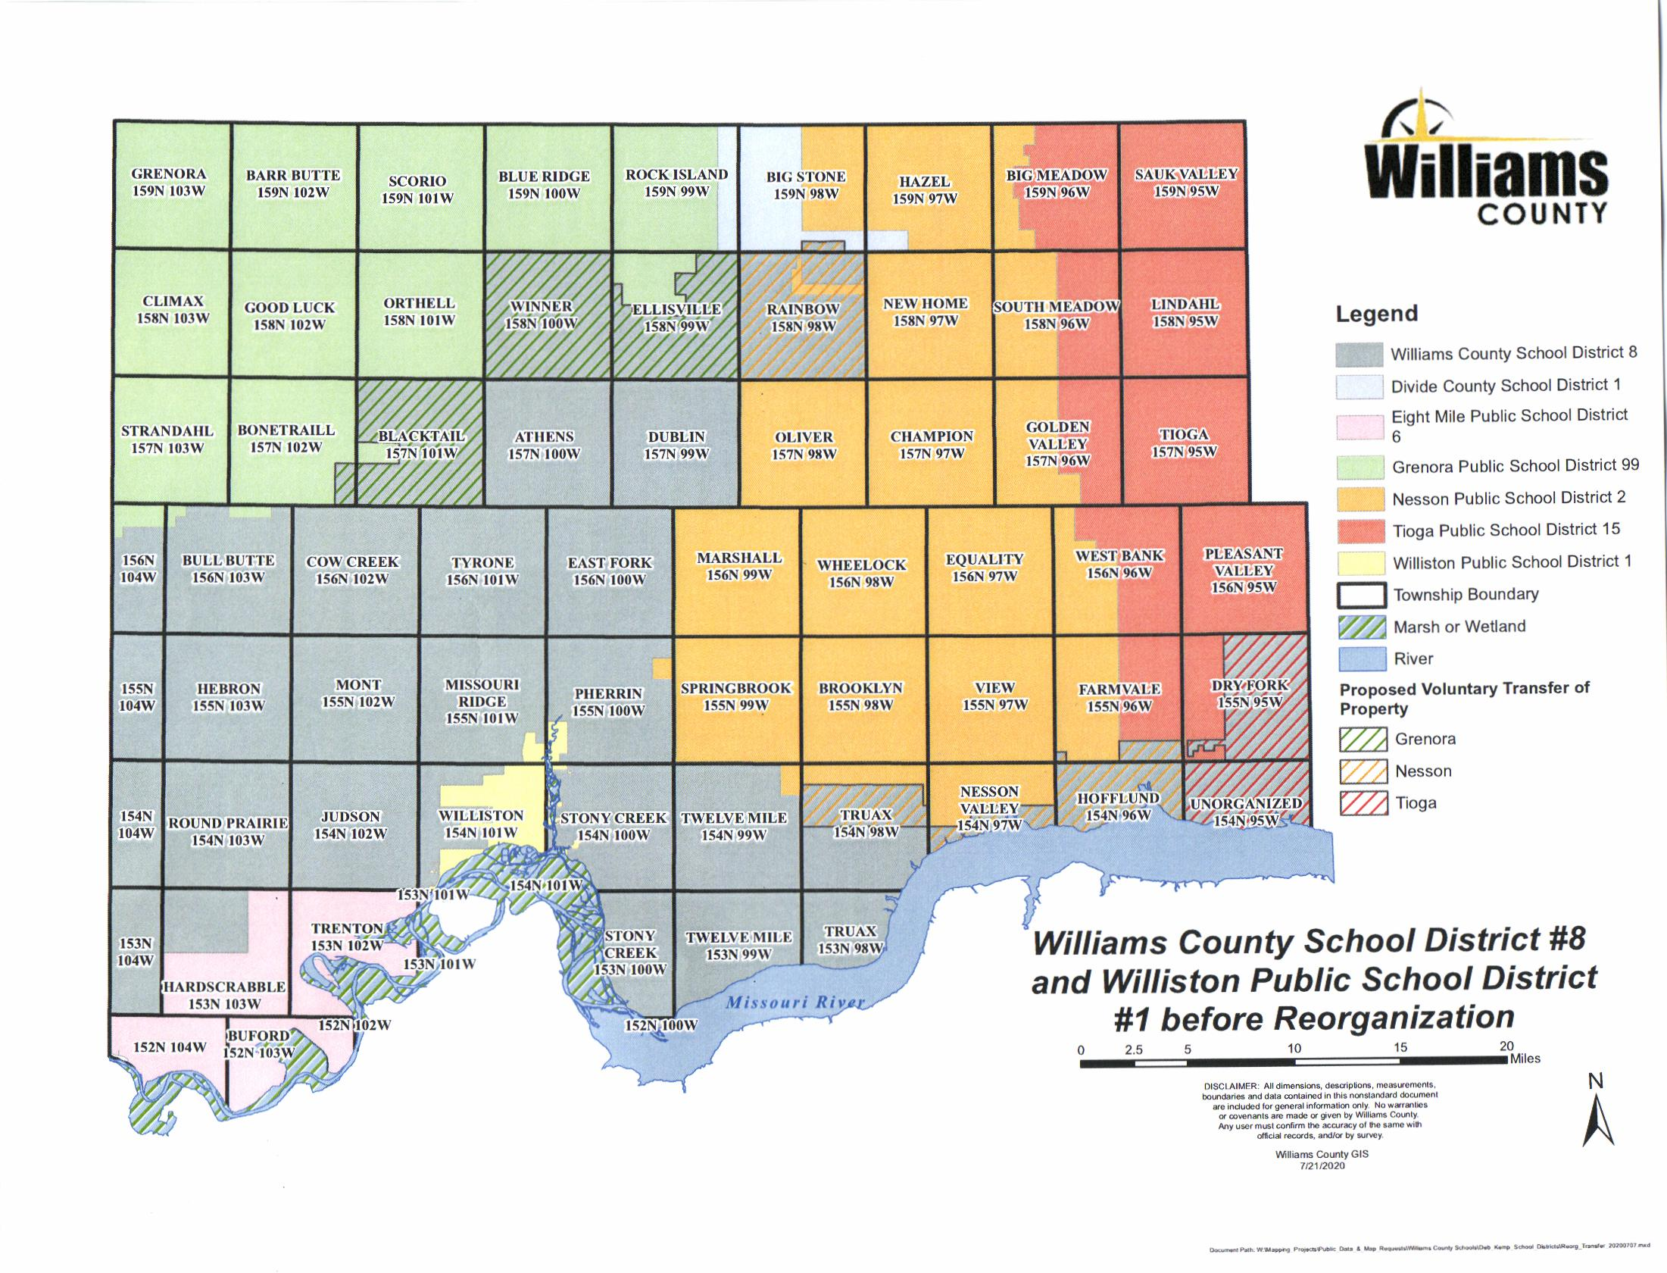
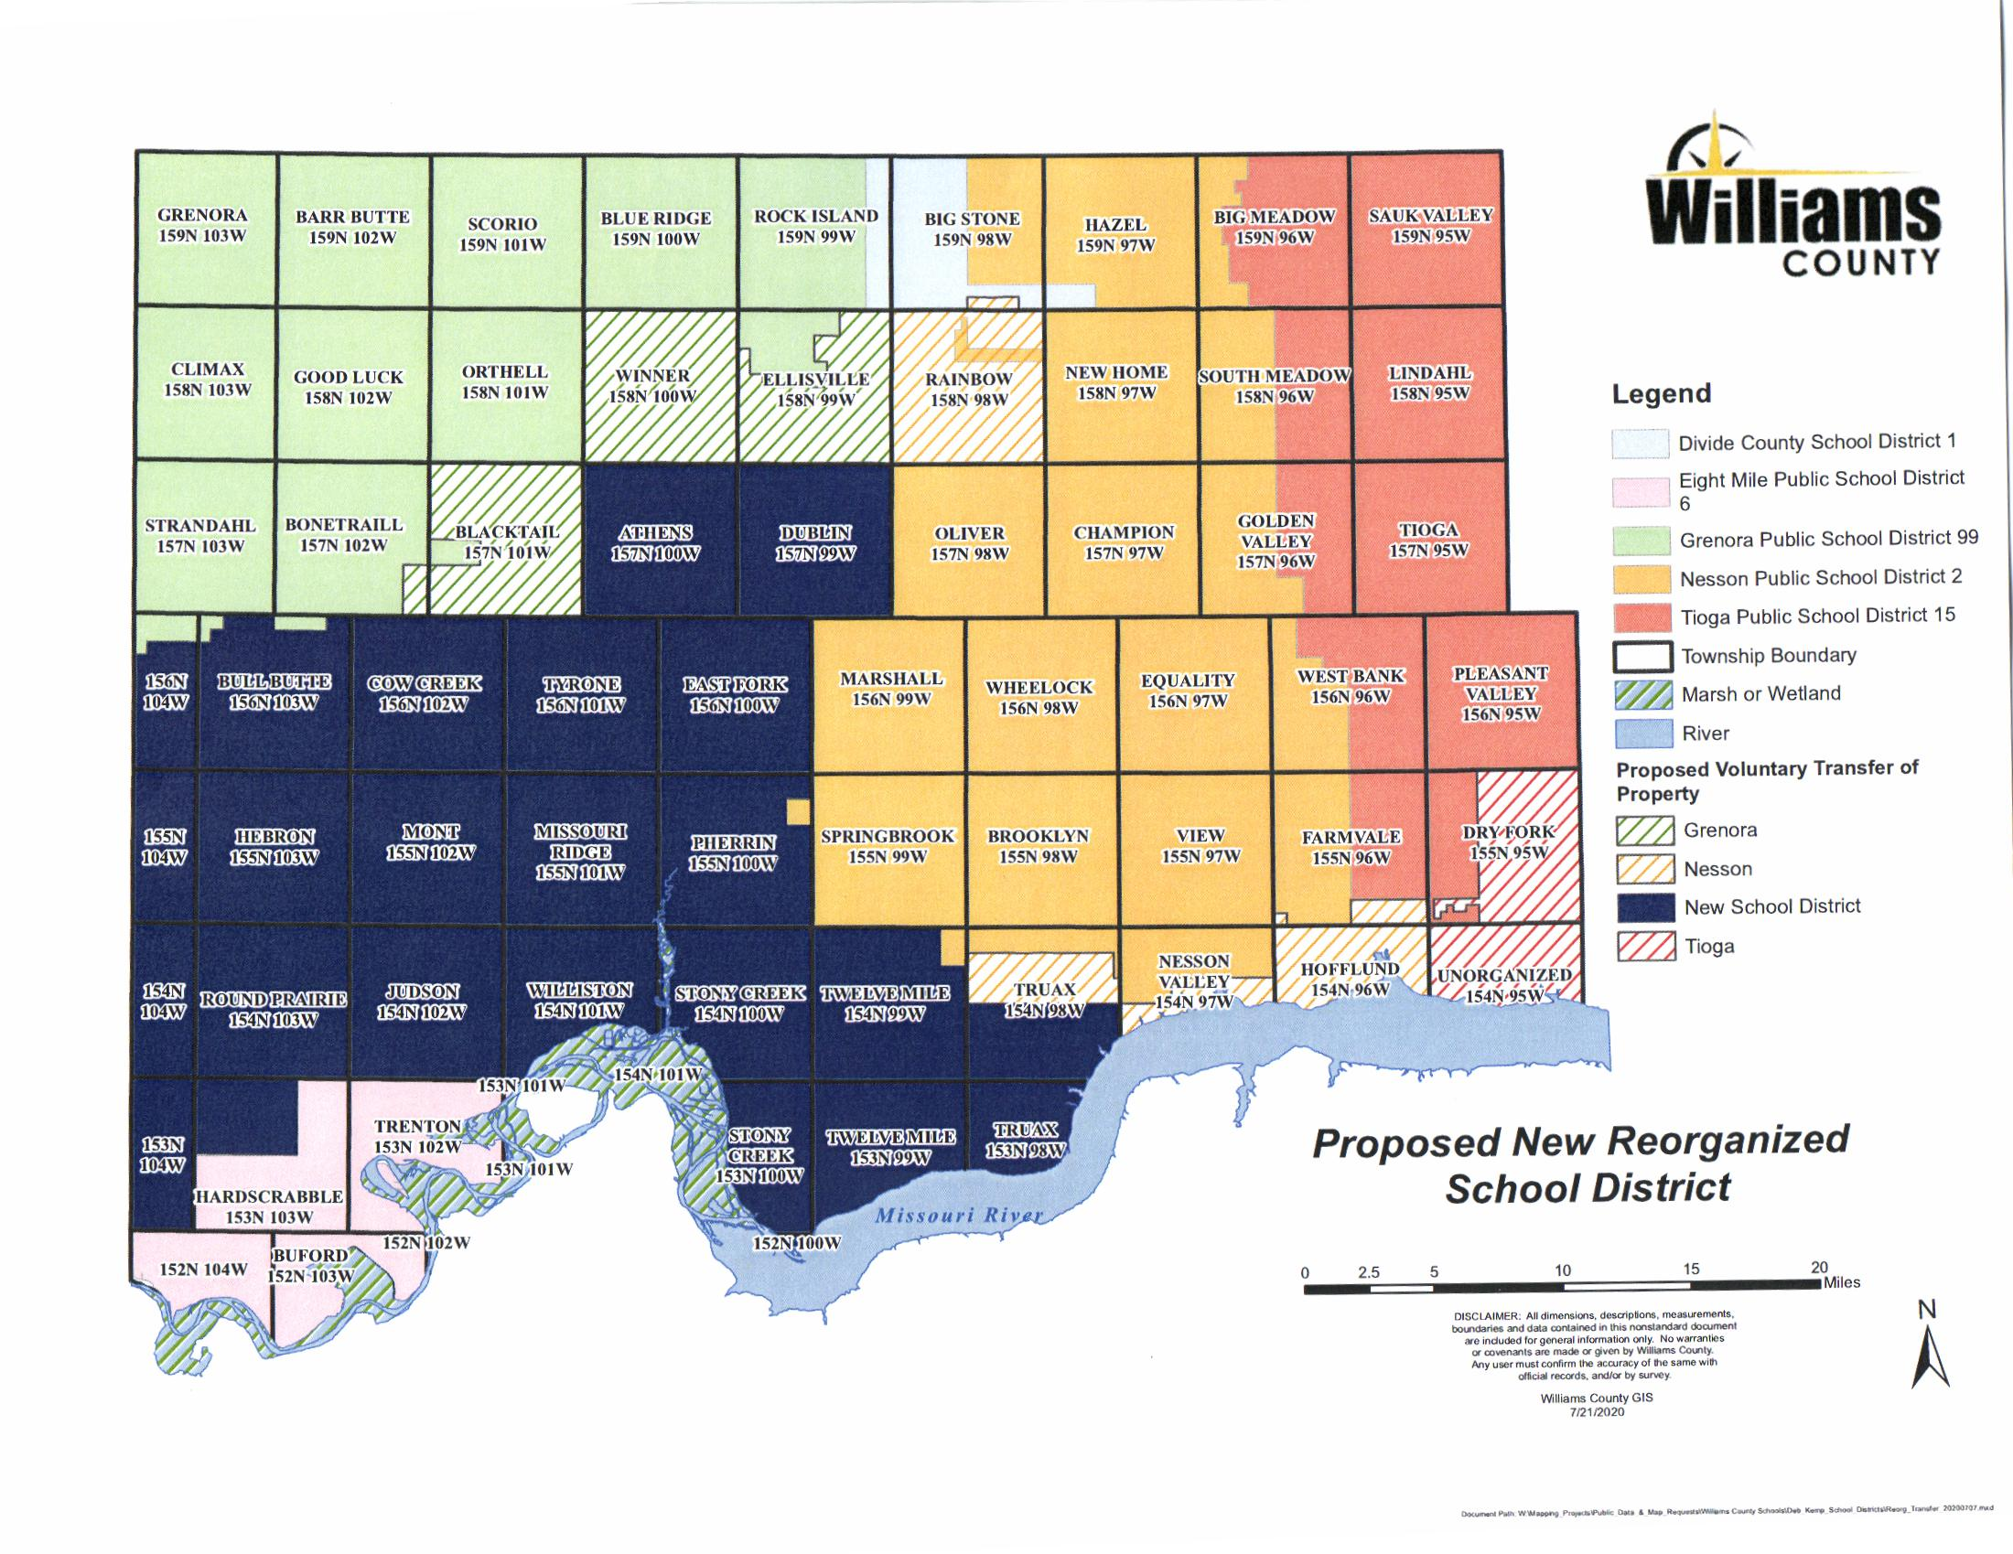
VII. District Size and Enrollment

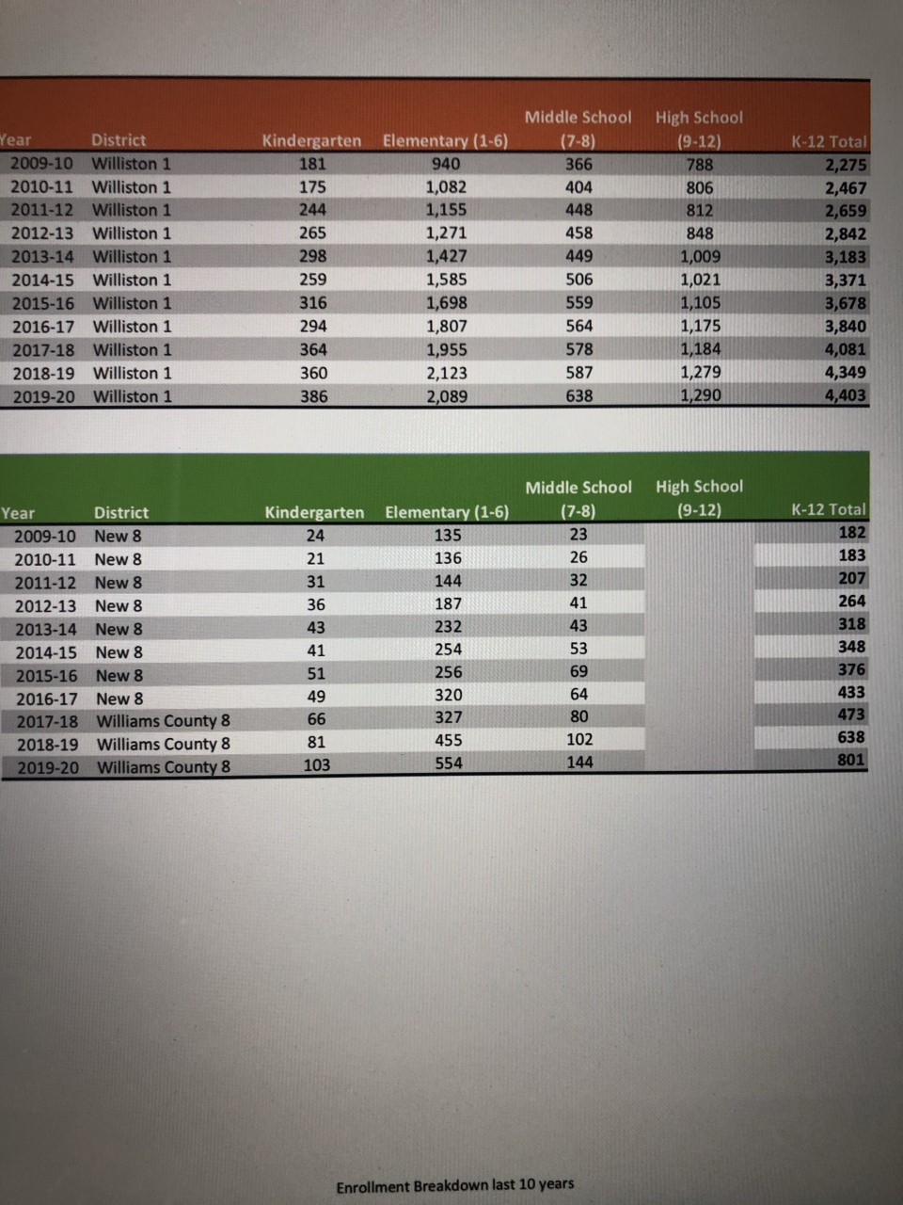

Williston Basin School District #007 10-year Projected K-12 Enrollment

*Projection methodology - 10-year projected enrollment will trend similarly to the 10- year prior trend of the district's combined enrollments. This may or may not hold true but is used only for estimating purposes.

2021-2022 | 2022-2023 | 2023-2024 | 2024-2025 | 2025-2026 | 2026-2027 | 2027-2028 | 2028-2029 | 2029-2030 | 2030-2031 | 2031-2032
6,256 | 6,636 | 7,019 | 7,381 | 7,760 | 8,135 | 8,509 | 8,884 | 9,257 | 9,630 | 10,002

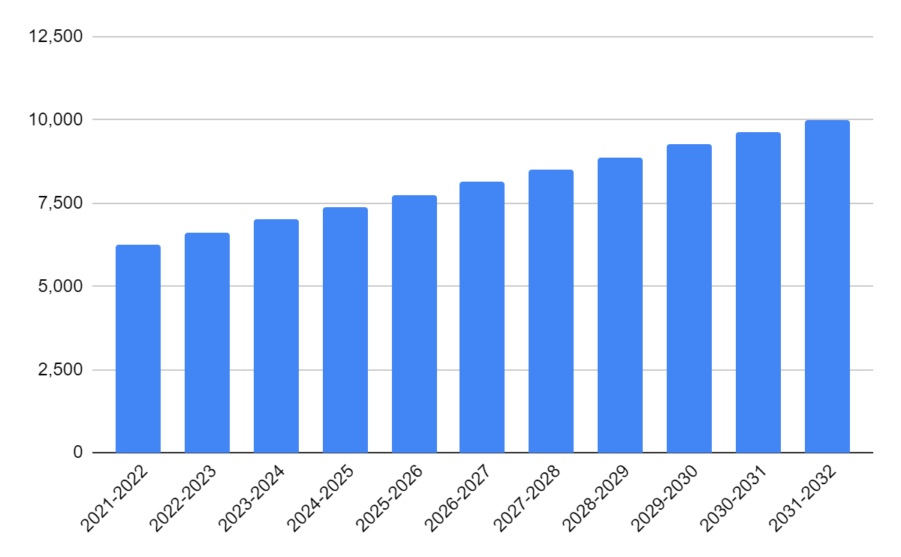

VIII. Facilities

Intended Use of Buildings

District Office Personnel and employees will use both WPSD #1 and D8 District Offices and bus barns in accordance with superintendent recommendations.

WPSD #1 and D8 will be using all facilities for K-12 instruction. Here are the current grade level configurations for each school:

- Williston High School: 9-12
- Del Easton Alternative School: 10-12
- Williston Middle School: 7th and 8th
- Missouri Ridge School: 3-8
- Bakken Elementary: 5th and 6th
- ASB Innovation Academy: 5-8
- Wilkinson Elementary School: K-4
- Lewis & Clark Elementary School: K-4
- Hagan Elementary School: K-4
- McVay Elementary School: K-4
- Rickard Elementary School: K-4
- Garden Valley Elementary School: K-2
- Round Prairie Elementary School: K-5

Historically, enrollments in each district have shown substantial growth. However, the COVID-19 Pandemic may impact enrollment for the 2020-2021 school year. We will continue to use RSP enrollment projections to monitor this. The basic assumption will be that enrollment will increase for years to come. The Williston Basin School District #007 will determine scope and sequence of building schools. The Williston Basin School District #007 will engage immediately in the process of strategic planning with equity as the top priority.

Prior to the effective date of this reorganization plan, both WPSD #1 and D8 are operational school districts. WPSD #1 is a K-12 district. D8 is a K-8 district. WPSD #1 accepts D8 students at Williston High School. Each district independently maintains school buildings for the delivery of educational services. Upon reorganization and establishment of the Williston Basin School District #007, educational services will be delivered in the current facilities.

Currently, there is no planned expansion of new or existing buildings. Assessment on a yearly basis of current and future enrollment trends, will dictate future construction of any new school buildings.

We will ensure usage of all buildings to maximize space and opportunities for all students to meet 21st century learning needs. Existing structures will need to be continuously improved.
The Williston Basin School District #007 will use all buildings to maximize space and opportunities for all students to meet current and future learning needs. Existing structures will be continually evaluated for updating needs and presented to the school board as they perspire.

Location and Current Condition WPSD #1

Williston District 1 is the largest district in the county with eight buildings - five elementary schools, an intermediate school, a middle school, and a high school - that serve 4,728 students in grades PreK through 12 as of the 2019/2020 school year. This district has seen a large influx of student population over the last few years, and it is evident that it is still struggling to keep up with the increase from a facilities standpoint. There are life safety, building code, and security issues at most of the buildings in the district that need to be addressed, and many finishes throughout the district are showing their age. Almost all buildings are at or exceeding their capacity, and there are many temporary modular buildings in the district, with six of the eight buildings hosting temporary modular buildings on site. These temporary modular buildings account for 27% of all elementary space and 10% of all district space. Wilkinson Elementary and McVay Elementary Schools have the largest temporary modular building presence at 25% and 75% of their square footage, respectively. This long-term reliance on temporary modular buildings for space is a concern as they are not ideal learning environments and should not be long-term solutions. Williston District 1 has a new Innovation Academy under construction to be completed in the fall of 2020 and has a capacity of roughly 400 students. This building is not yet online and was not included. When the building becomes available, it will impact the capacity of both Bakken Elementary and Williston Middle School. Capacity calculations have been included in Appendix 1.2 for the Innovation Academy to inform an understanding of the district capacity better.

Hagan Elem
- K-4
- SF: 48,545gsf
  - Permanent: 40,400sf
  - Portables: 8,145sf
- # Classrooms (specials included)
  - Permanent: 17
  - Portables: 8
Hagan Elementary is a K-4 elementary school in Williston District 1 of Williams County. The building comprises an original building from 1984 and a temporary modular building installed on-site in 2011. Overall, the condition of both buildings is good, and the building is well maintained. The building has experienced an increase in student population over the last several years, and the administration is adapting to accommodate the growth through the use of non-traditional spaces such as hallways, storage closets, and locker rooms as educational space for smaller groups.
The administration has done a good job updating space as they can, while some are showing wear on original finishes and fixtures. The kitchen is up to date and meets commercial kitchen standards, and technology has been updated throughout the building. Some noticeable concerns in the building are the items that do not meet ADA compliance, such as door hardware and toilet rooms attached to classrooms. The building is also not sprinkled, which creates a potential life safety concern. Finally, other safety and security concerns include a malfunctioning security camera system and a lack of a secure entry vestibule near the administration offices. While the building utilizes a buzzer and camera system to allow visitors entry into the building after classes have begun, the primary entry point is down the hall from the administration, and potential threats would have access to the building before interacting with staff. Administration does not use the entry adjacent to them for visitors as the parking lot’s proximity to the playground has created vehicle traffic safety concerns for students.

The administration is making accommodations to meet the needs of its student population. They are utilizing every nook and cranny as educational space, whether it is ideal or not. Typical classrooms in the original building are well-sized, and strategic finish updates would make them into great 21st- Century education spaces. The building utilizes technology that has become standard in most districts and is integrating it into the curriculum through the use of digital teaching walls, sound field audio systems, and a 1 to 1 device policy for students. The classrooms housed in the temporary modular building are slightly undersized; however, they seem to meet staff and student needs. Temporary modular buildings are not ideal learning environments in general and are intended to be a temporary solution for overcrowding. The eight classrooms housed there make up 44% of the classroom space on site, which is concerning. The shared gymnasium and cafeteria space create scheduling conflicts, and the adjacency of these noisy spaces to SPED instructional space, whose students often require a quieter learning environment, is a concern.

Our capacity calculations found that the building has a Capacity as Used of 385 students. When factoring in the educational adequacy of individual spaces, that capacity drops to an ideal capacity of 214 students, based on the methodology previously outlined. Data provided by RSP & Associates shows a 2019/2020 enrollment of 485 students, over double the ideal capacity. These numbers suggest that the building is well over its capacity for the student population.

Steps for improvement include: addressing life safety, code, and security issues, updating finishes as many are approaching the end of their lifespan, and addressing the need to accommodate the growing student population more permanently by transitioning out of the temporary modular spaces.

Lewis & Clark Elem
- K-4
- SF: 35,705gsf
  - Permanent: 29,625sf
  - Portables: 6,080sf
- # Classrooms (specials included)
  - Permanent: 12
  - Portables: 5
Lewis & Clark Elementary is a K-4 elementary school in Williston District 1 of Williams County. The building comprises an original building from 1952, and five temporary modular buildings installed on-site in 1980. The condition of both buildings is good, with some of the newest permanent spaces in the district for this age level with the 2004 gym addition. The building is well maintained.
The administration has done a good job updating space as they can, while some are showing wear on original finishes and fixtures. The administrative area and library have gone through recent finish updates, and technology has been updated throughout the building. The 2004 gym addition is an asset to the building and is in good condition. Some noticeable concerns in the building are the items that do not meet ADA compliance, such as door hardware and toilet rooms attached to classrooms. The building systems need attention as the building is only partially sprinkled, the alarm system regularly malfunctions, and the district reports power capacity issues resulting in blown fuses and circuits regularly; all of these are potential life-safety concerns. The building has several fixtures and finishes that need updating and is reaching the end of their useful lives, including several areas of potential asbestos in floors and ceilings that should be tested, windows that are cracked, and which present condensation issues, and areas of the roof that leak. Finally, other safety and security concerns include a malfunctioning security camera system and a lack of secure entry vestibule. The building utilizes a buzzer and camera system to allow visitors entry into the building after classes have begun, and the main entrance is adjacent to the administrative offices.
The administration is forward-thinking in meeting the needs of their student population. Furniture and other collaborative items spill into the hallways, and while a potential safety hazard, this speaks to their need for more small collaborative spaces common in 21st - Century education. Typical classrooms in the original building are well-sized, and strategic finish updates would make them into excellent 21st - Century education spaces. The building utilizes technology that has become standard in most districts and is integrating it into the curriculum through the use of digital teaching walls, sound field audio systems, and a 1 to 1 device policy for students. The classrooms housed in the temporary modular buildings are generally well-sized for their use and appear to meet the needs of staff and students. Temporary modular buildings are not ideal learning environments in general and are intended to be a temporary solution for overcrowding. The five temporary modular buildings comprise 17% of space on site.
Our capacity calculations found that the building has a Capacity as Used of 300 students. When factoring in the educational adequacy of individual spaces, that capacity drops to an ideal capacity of 219 students, based on the methodology previously outlined. Data provided by RSP & Associates shows a 2019/2020 enrollment of 269 students, well above the ideal capacity. These numbers suggest that the building is at or above capacity for what the building can support.
Steps for improvements include: addressing life safety, code, and security issues, updating finishes as many are approaching the end of their lifespan, and several areas should be tested for hazardous materials, and address the need to accommodate the growing student population more permanently by transitioning out of the temporary modular spaces.

Wilkinson Elem
- K-4
- SF: 30,610sf
  - Permanent: 23,060sf
  - Portables: 7,550sf
- # Classrooms (specials included)
  - Permanent: 12
  - Portables: 7
Wilkinson Elementary is a K-4 elementary school in Williston District 1 of Williams County. The building comprises an original building from 1962 and eight temporary modular buildings installed on-site in 1980. Overall, the condition of both buildings is fair, with the original building showing its age and the temporary modular buildings are at the end of their useful life cycle.
The administration has done a good job updating space as they can in small ways with new paint and engaging activities for students. The playground equipment has been recently updated, and technology has been updated throughout the building. Some noticeable concerns in the building are the items that do not meet ADA compliance, such as door hardware, toilet rooms attached to classrooms, and ramps that do not have proper railings in place. The building is not sprinkled, which creates a potential life safety concern. The building has several fixtures and finishes that need updating and is reaching the end of useful life, including several areas of potential asbestos in floors and ceilings that should be tested. The temporary modular buildings contain failing building systems, have experienced water infiltration, and have experienced settlement issues. Finally, other safety and security concerns include a lack of secure entry vestibule. The building utilizes a buzzer and camera system to allow visitors entry into the building after classes have begun, and the main entry is adjacent to the administrative offices.
It is evident that the administration has a desire to create a vibrant space to meet the needs of its student population. Furniture and other collaborative items spill into the hallways, and while a potential safety hazard, this speaks to their need for additional small collaborative spaces common in 21st-century education. Typical classrooms in the original building are well sized with flexible furniture in use. These rooms have great potential; addressing the lack of natural light and strategic finish updates would make them into great 21st-century education spaces. The building utilizes technology that has become standard in most districts and is integrating it into the curriculum through the use of digital teaching walls, sound field audio systems, and a 1 to 1 device policy for students. The classrooms housed in the temporary modular buildings are generally well-sized for their use and seem to meet the needs of staff and students. Temporary modular buildings are not ideal learning environments in general and are intended to be a temporary solution for overcrowding. The eight temporary modular buildings comprise 25% of space on site.
Our capacity calculations found that the building has a Capacity as Used of 214 students. When factoring in the educational adequacy of individual spaces, that capacity stays level at the ideal capacity of 214 students, based on the methodology previously outlined. This is primarily because specials, like music, SPED, and the library are housed in the modular buildings. Data provided by RSP & Associates shows a 2019/2020 enrollment of 310 students, well above the ideal capacity. These numbers suggest that the building is at or above capacity for what the building can support.
Steps for improvements include addressing life safety, code, and security issues, updating finishes as many are approaching the end of their lifespan and are showing wear, particularly the items needing abatement, and address the need to accommodate the growing student population more permanently by transitioning out of the temporary modular spaces.

McVay Elem
- K-4
- SF: 51,840gsf
  - Permanent: 20,830sf
  - Portables: 31,010sf
- # Classrooms (specials included)
  - Permanent: 6
  - Portables: 24

McVay Elementary is a K-4 elementary school in Williston District 1 of Williams County. The building comprises an original building from 1964, and three large temporary modular buildings installed on-site in 2012. The condition of both buildings is good, with the temporary modular buildings being some of the newest in the district. The building is well maintained.
The administration has done a good job updating items around the building as they can in meaningful ways. The exterior brick and temporary modular buildings are in overall good condition, playground equipment was updated in 2012, carpet has been updated in some classrooms, and technology has been updated throughout the building. Some noticeable concerns in the building are the items that do not meet ADA compliance, such as door hardware in the original building, toilet rooms attached to classrooms in the original building, and access to the second floor is impaired as the lift on site is broken. The building systems need attention as the original building is not sprinkled, and the district reports power capacity issues resulting in blown fuses and circuits regularly; all of these are potential life-safety concerns. The building has several fixtures and finishes that need updating and is beginning to show their age, including a playground with poor drainage and lighting that leaves it unusable at certain times of the year. Finally, other safety and security concerns include a lack of secure entry vestibule, though the entry sequence is better than at other buildings in the district. The building utilizes a buzzer and camera system to allow visitors entry into the building after classes have begun, and the main entrance is adjacent to the administrative offices.

It is evident that the administration has a desire to create a vibrant space to meet the needs of their student population with engaging activities for students throughout the building. Typical classrooms in the original building are well-sized; however, classrooms in the temporary modular buildings are undersized, though they seem to meet the needs of staff and students. All rooms have adequate access to natural light, and some flexible furniture is being used for collaboration. The building utilizes technology that has become standard in most districts and is integrating it into the curriculum through the use of digital teaching walls, sound field audio systems, and a 1 to 1 device policy for students. The classrooms housed in the temporary modular buildings are a majority of the teaching stations on-site at 80%. Temporary modular buildings are not ideal learning environments in general and are intended to be a temporary solution for overcrowding. The three temporary modular buildings comprise 55% of space on- site and are a concern.

Our capacity calculations found that the building has a Capacity as Used of 535 students. When factoring in the educational adequacy of individual spaces, that capacity stays level at an ideal capacity of 107 students, based on the methodology previously outlined. This is primarily because so many teaching stations are housed in modular buildings. Data provided by RSP & Associates shows a 2019/2020 enrollment of 438 students, above the ideal capacity. These numbers suggest that the building has some capacity for how it is currently used; however, given the number of teaching stations in temporary modular buildings, the building is well above what the building capacity can support.
Steps for improvements include life safety, code, and security issues, as a priority, updating finishes as many are approaching the end of their lifespan and are showing wear, and address the need to accommodate the growing student population more permanently by transitioning out of the temporary modular spaces.
Rickard Elem
- K-4
- SF: 30,610sf
  - Permanent: 31,215sf
  - Portables: 3,090sf
- # Classrooms (specials included)
  - Permanent: 18
  - Portables: 2
Rickard Elementary is a K-4 elementary school in Williston District 1 of Williams County. The building comprises an original building from 1951 and two temporary modular buildings installed on site. The condition of both buildings is fair, with both the original building and the temporary modular buildings showing their age.
The administration has done a good job updating items around the building as they can in meaningful ways. Improvements include a replacement of the roof and water heater, and technology throughout the building. Some noticeable concerns in the building are the items that do not meet ADA compliance, such as door hardware, toilet rooms attached to classrooms, ramps that do not have proper railings in place, and some secondary entry sidewalks. The building systems need attention as the building is not sprinkled, the alarm system regularly malfunctions; all of these are potential life-safety concerns. The building has several fixtures and finishes that need updating and is reaching the end of useful life; including several areas of potential asbestos in floors and ceilings that should be tested, ceilings with noticeable water damage, and a playground with poor drainage and lighting that leaves it unusable at certain times of the year. The administration has also expressed concerns for allergens and general indoor air quality as well as previous rodent infestations. Finally, other safety and security concerns include a malfunctioning security camera system and a lack of secure entry vestibule. The building utilizes a buzzer and camera system to allow visitors entry into the building after classes have begun, and the main entry is adjacent to the administrative offices.
It is evident that the administration has a desire to create a vibrant space to meet the needs of its student population. Furniture and other collaborative items spill into the hallways, and while a potential safety hazard, this speaks to their need for additional small collaborative spaces common in 21st-century education. Typical classrooms in the original building are well sized with flexible furniture in use. These rooms have great potential; addressing the lack of natural light and strategic finish updates would make them into great 21st-century education spaces. The building utilizes technology that has become standard in most districts and is integrating it into the curriculum through the use of digital teaching walls, sound field audio systems, and a 1 to 1 device policy for students. The classrooms housed in the temporary modular buildings are few, and house three SPED classrooms and the music classrooms. While their size is adequate, the flow through the SPED space is not ideal. Temporary modular buildings are not ideal learning environments in general and are intended to be a temporary solution for overcrowding. The two temporary modular buildings comprise 10% of space on site.
Our capacity calculations found that the building has a Capacity as Used of 291 students. When factoring in the educational adequacy of individual spaces, that capacity drops to an ideal capacity of 278 students, based on the methodology previously outlined. This is primarily because specials, like music and SPED, are housed in the modular buildings. Data provided by RSP & Associates shows a 2019/2020 enrollment of 335 students, above the ideal capacity. These numbers suggest that the building is above the capacity for what the building can support.
Steps for improvements include life safety, code, and security issues, as a priority, updating finishes as many are approaching the end of their lifespan and are showing wear, particularly the items needing abatement, and address the need to accommodate the growing student population more permanently by transitioning out of the temporary modular spaces.
Bakken Elem
- 5-6
- SF: 140,430gsf
  - 1st: 66,720sf w/ fieldhouse
  - 2nd: 41,405sf
  - 3rd: 66,720sf
- # Classrooms (specials included)
  - Permanent: 53

Bakken Elementary is a 5-6 elementary school in Williston District 1 of Williams County. The building comprises an original building from 1956 and was the old high school before the new high school opening in 2016. The building underwent a renovation at that time to accommodate the change to the student population at the building. It is also connected to Williston Middle School, which was built in 2003. There are no temporary modular buildings in use at Bakken Elementary. Overall, the condition of the building is good. The building is well maintained.

The administration has done a good job updating items around the building to be appropriate for the age group in the building and make necessary updates to the original building. Some areas of the building have had asbestos issues addressed, and the administration is aware of the rest and plans to address them as they are able. Other building updates include fire separation doors added in 2003, wall repair in 2016, significant-finish and equipment upgrades to the auditorium in the last five years, and new kitchen equipment in 2003. Some noticeable concerns in the building are the items that do not meet ADA compliance, such as door hardware in the original building, and some toilet rooms throughout the building. The building systems need attention as the building is only partially sprinkled, and the district reports power capacity issues resulting in blown fuses and circuits regularly; all of these are potential life-safety concerns. It should also be noted that the alarm system is connected to Williston Middle School. The building has several fixtures and finishes that need updating and is beginning to show their age or reach the end of useful life, including exterior windows, several areas of potential asbestos in floors and ceilings that should be tested, the roof, and water damaged ceilings and windows. Finally, other safety and security concerns include a lack of secure entry vestibule. The building utilizes a buzzer and camera system to allow visitors entry into the building after classes have begun, and the main entrance is adjacent to the administrative offices.

The administration has adjusted well to a building not initially meant for the age of the student population. It is unique to have a dedicated performing arts space on-site at this grade level, and it is a benefit to students to have access to these types of facilities. Typical classrooms are generally well-sized and seem to meet the needs of staff and students. The media center is large and implements flexible use options. The building utilizes technology that has become standard in most districts and is integrating it into the curriculum through the use of digital teaching walls, sound field audio systems, and a 1 to 1 device policy for students. There is no playground on site, which is not uncommon for this in-between age group and is a policy issued to be addressed by the district. Currently, Williston Middle School occupies several classrooms on the Bakken Elementary side of the building to address their capacity issues. This is not ideal, and separation between schools would be an improvement.

Our capacity calculations found that the building has a Capacity as Used of 964 students. When factoring in the educational adequacy of individual spaces, that capacity drops to an ideal capacity of 865 students, based on the methodology previously outlined. Data provided by RSP & Associates shows a 2019/2020 enrollment of 647 students. These numbers suggest that the building has some capacity in its current use and its ideal capacity.
Steps for improvements should include addressing life safety, code, and security issues as a priority and updating fixtures and finishes as many are showing wear or reaching the end of useful life.

Innovation Academy
- 5-8
- SF: 37,760gsf
  - 1st: 22,100sf
  - 2nd: 15,660sf
- # Classrooms (specials included)
  - Permanent: 25 (4 teaching spaces per commons)

Williston Middle School (w/renovated CTE)
- 7-8
- SF: 97,275gsf
  - 1st: 56,300sf
  - 2nd: 16,515sf
  - 3rd: 16,515sf
  - Portables: 7,945sf
- # Classrooms (specials included)
  - Permanent: 33
  - Portables: 6
Williston Middle School is a 7-8 school in Williston District 1 of Williams County. The building comprises an original building from 2003 and a temporary modular building installed on- site in 2012. It is connected to Bakken Elementary School, which was the old high school before the new high school opening in 2016. The building is currently undergoing a renovation to be completed in the fall of 2020. Overall, the condition of the building is good, and it is one of the newest buildings in the district.
The administration has done a good job keeping the building in top condition and adjusting to growing capacities. The exterior brick and windows are in overall good condition, with only minor leaks reported over the media center. Some interior finishes are starting to show minor wear and could be replaced soon; other areas have already begun to be updated. Williston Middle School is one of the only buildings in the district to be fully equipped with a sprinkler system. It should be noted that the alarm system is connected to Bakken Elementary School. Finally, other safety and security concerns include a lack of secure entry vestibule, though the entry sequence is better than at other buildings in the district. The building utilizes a buzzer and camera system to allow visitors entry into the building after classes have begun, and the main entrance is adjacent to the administrative offices.
It is evident that the administration is working to adjust to the influx of students in recent years and are adapting the building to fit their needs by enclosing open spaces into more traditional classrooms and using non=traditional spaces for smaller classes. It is unique to have a dedicated performing arts space on-site at this grade level, and it is a benefit to students to have access to these types of facilities. Typical classrooms are generally well-sized with good natural light and seem to meet the needs of staff and students. The building utilizes technology that has become standard in most districts and is integrating it into the curriculum through the use of digital teaching walls, sound field audio systems, and a 1 to 1 device policy for students. Vehicular circulation is a concern with a high level of congestion. The cafeteria is undersized for the student population and the number of lunch shifts, causing strain on the building. Currently, Williston Middle School occupies several classrooms on the Bakken Elementary side of the building to address their capacity issues. This is not ideal, and separation between schools would be an improvement. The classrooms housed in the temporary modular make up 8% of space on site. Temporary modular buildings are not ideal learning environments in general and are intended to be a temporary solution for overcrowding.
Our capacity calculations found that the building has a Capacity as Used of 826 students, once the current remodel is complete. When factoring in the educational adequacy of individual spaces, that capacity drops to an ideal capacity of 638 students, based on the methodology previously outlined. Data provided by RSP & Associates shows a 2019/2020 enrollment of 640 students. These numbers suggest that the building will have some additional capacity once the renovation is complete in fall 2020.
Steps for improvements include addressing the minor improvements needed and addressing the need to accommodate the growing student population more permanently by transitioning out of the temporary modular spaces.

Williston High School (with Commons Addition)
- 9-12
- SF: 208,804gsf
  - 1st: 130,214sf
  - 2nd: 31,060sf
  - 3rd: 28,530sf
  - CTE: 20,000sf
- # Classrooms (specials, CTE included)
  - Permanent: 59
Williston High School is a 9-12 school in Williston District 1 of Williams County. The building was built in 2016 and has multiple additions in progress planned for completion in 2020. Also, on-site is a dedicated CTE building and new athletic fields. The condition of the building is excellent, and it is the latest building in the district.
The administration has done an excellent job keeping the building in top condition and adjusting to growing capacities. As the building is under five years old, there are no significant condition concerns, and the building is still in its new, or like new, condition. The building is fully sprinkled and utilizes a secure entry vestibule, in addition to a buzzer and camera system to allow visitors entry into the building after classes have begun.
It is evident that the administration is working to adjust to the influx of students in recent years and are adapting the building to fit their needs by enclosing open spaces and using non- traditional spaces for smaller classes. They have also addressed this influx by planning for the current building addition. It is unique to have a dedicated CTE building on-site with such robust programs and facility space; it is a benefit to students to have access to these types of facilities. Typical classrooms are generally well-sized with good natural light and seem to meet the needs of staff and students. The building utilizes technology that has become standard in most districts and is integrating it into the curriculum through the use of digital teaching walls, sound field audio systems, and a 1 to 1 device policy for students. Vehicular circulation is a concern with a high level of congestion. The cafeteria is undersized for the student population and number of lunch shifts, causing strain on the building, though the current addition underway should address this concern. Some circulation issues are present, and these should also be rectified in the new additions.
Our capacity calculations found that the building has a Capacity as Used of 1,290 students. When factoring in the educational adequacy of individual spaces, that capacity drops to an ideal capacity of 1,206 students, based on the methodology previously outlined. Data provided by RSP & Associates shows a 2019/2020 enrollment of 1,272 students. These numbers suggest that once the building additions are complete that Williston High School will have some capacity in both how it is currently used and in its ideal capacity.
Steps for improvements include addressing circulation issues noted and accommodating the growing student population.

D8
District 8 is the second-largest district in the county with three buildings - two elementary schools and one intermediate school - that serve a total of 778 students in grades PreK - 8 as of the 2019/2020 school year. Missouri Ridge School is currently undergoing an addition to be completed in 2020. After either grade, students must enroll in a neighboring K-12 district to complete their high school education. A majority of the students enroll at Williston High School in Williston District 1. There are life safety, code, and security issues at both elementary buildings that need to be addressed. Both elementary schools are primarily composed of temporary modular buildings that are not connected, resulting in students having to go outside to access other parts of the building, this creates a concern given the cold North Dakota climate. Temporary modular buildings make up 55% of the square footage on-site at Round Prairie Elementary and 71% of the square footage on site at Garden Valley Elementary. This high reliance on temporary modular buildings for space is a concern as they are not ideal learning environments and should not be long term solutions. Missouri Ridge School is new within the last few years and has no significant concerns and should serve students well for years to come. The capacity calculations done as part of this study identified Round Prairie Elementary as under capacity while Garden Valley Elementary and Missouri Ridge School are at or above capacity.
Round Prairie Elementary is a K-2 elementary school in District 8 of Williams County. The building comprises an original building from 1992 and two temporary modular buildings installed on site. Overall, the condition of all buildings is fair.
The administration has done a good job utilizing the space available on site and keeping the interiors in good condition. The playground equipment is in good condition, and new carpet has been recently installed throughout all buildings There is a secure entry sequence in place with a buzzer and camera system to allow visitors entry into the building after classes have begun, and the main entrance is adjacent to the administrative offices. Some noticeable concerns in the building are the items that do not meet ADA compliance, such as door hardware in the original building, and access to the main entrance is via stair and is not accessible, though accessible entry to the building is available through the north door on the other side of the building. The kitchen is open to the main serving area, does not meet commercial kitchen standards, and is a potential safety hazard to students. The building has several areas of damage to note on all three buildings, with the temporary modular building housing the library being in the roughest shape.
The administration is using available space well. Typical classrooms throughout all buildings are undersized; however, they seem to meet the needs of staff and students in the building. All rooms have adequate access to natural light, and some flexible furniture is being used for collaboration. The building utilizes technology that has become standard in most districts and is integrating it into the curriculum through the use of digital teaching walls and a 1 to 1 or 1 to 2 device policy for students depending on grade. The classrooms housed in the temporary modular buildings are a majority of the teaching stations on-site at 73%. Temporary modular buildings are not ideal learning environments in general and are intended to be a temporary solution for overcrowding. The two temporary modular buildings comprise 55% of space on-site and are a concern. While the majority of teaching stations are in temporary modular buildings, given the low enrollment numbers at Round Prairie, the temporary modular building sits mainly vacant except for use as a physical education space. All classes are currently held in the original building. Access to specials is a concern as students must go outside to access the library, and there is no gymnasium on site. The room in the temporary modular building used for physical education is not adequate for planned activities.
Our capacity calculations found that the building has a Capacity as Used of 227 students. When factoring in the educational adequacy of individual spaces, that capacity drops an ideal capacity of 49 students, based on the methodology previously outlined. This is primarily because so many teaching stations are available in the modular buildings. Data provided by RSP & Associates shows a 2019/2020 enrollment of 27 students, well below both capacity figures. These numbers suggest that the building has some capacity for how it is currently used.
Steps for improvements include life safety, code, and security issues, as a priority, updating finishes as many are approaching the end of their lifespan and are showing wear, and address the need to accommodate the growing student population more permanently by transitioning out of the temporary modular spaces.

Round Prairie consists of three buildings. One building that is approximately 8,364 sq. ft. that consists of classrooms and kitchen/dining that was built in 1992. The kitchen area should be remodeled and brought up to date with commercial appliances and better serving and food prep area along with adding more seating. One building is a modular that is approximately 9,520 sq. ft. of classroom space. One building is an older one room building that is approximately 917 sq. ft. of classroom space. Round Prairie has no gymnasium and needs to have one added.

Garden Valley Elementary is a PK-2 elementary school in District 8 of Williams County. The building comprises an original building from 1990 and four temporary modular buildings installed on site. Overall, the condition of all buildings is fair.
The administration has done a good job utilizing the space available on site and keeping the interiors in good condition. The playground equipment is in good condition, new carpet has been recently installed throughout all buildings, and portions of the roof have been replaced within the last ten years. Some noticeable concerns in the building are the items that do not meet ADA compliance, such as door hardware in the original building, and the outdoor connections between buildings. The building does not have a sprinkling system, and the limited parking on-site is unpaved, unstriped with a lack of exterior lighting. The building has several areas of damage to note on all buildings. Finally, other safety and security concerns include a lack of a secure entry vestibule. The building utilizes a buzzer and camera system to allow visitors entry into the building after classes have begun, and the main entrance is down the hall from the administrative office.
The administration is using available space well. Typical classrooms throughout all buildings are undersized; however, they seem to meet the needs of staff and students in the building. All rooms have adequate access to natural light, and some flexible furniture is being used for collaboration. The building utilizes technology that has become standard in most districts and is integrating it into the curriculum through the use of digital teaching walls and a 1 to 1 or 1 to 2 device policy for students depending on grade. The classrooms housed in the temporary modular buildings are a majority of the teaching stations on-site at 62%. Temporary modular buildings are not ideal learning environments in general and are intended to be a temporary solution for overcrowding. The four temporary modular buildings comprise 71% of space on-site and are a significant concern. Access to specials is a concern as students must go outside to access the library, the music room, and there is not a gymnasium on site. The space in the temporary modular building adjacent to the kitchen used for physical education is not adequate for planned activities. It is also not accessible from the inside of the building, and students must go outside to use the ramp to gain accessible access. There are also egress concerns from this building as one of the doors is blocked by the ramp handrail.
Our capacity calculations found that the building has a Capacity as Used of 260 students. When factoring in the educational adequacy of individual spaces, that capacity drops an ideal capacity of 75 students, based on the methodology previously outlined. This is primarily because so many teaching stations are housed in modular buildings. Data provided by RSP & Associates shows a 2019/2020 enrollment of 251 students, well above the ideal capacity. These numbers suggest that the building is functioning well for how it is currently used but is above capacity for ideal learning environments.
Steps for improvement are addressing the need to accommodate the student population in a more permanent manner and transition out of the large percentage of temporary modular space. The administration should also address life safety, code, and security issues, repairing areas with exterior damage.
Garden Valley consists of five buildings. One building is approximately 5,696 sq. ft. consisting of classrooms and kitchen that was built in 1990. The kitchen area needs to be remodeled and enlarged for better food prep, cooking, and serving. Attached to that building through a short hall is a modular building that is approximately 2,160 sq. ft. and serves as the gym/dining area. One building is a modular that is approximately 9,520 sq. ft. of classroom space. One building is a modular that is approximately 2,160 sq. ft. of classroom space. One building is approximately 900 sq. ft. of classroom space. Garden Valley needs to have a gymnasium added or remove the modulars to build a new permanent school. One of the modulars is currently under a year-to-year lease.
Missouri Ridge School is a 3-8 school in District 8 of Williams County. The building was recently built in 2018 and has an addition in progress planned for completion in 2020. Overall, the condition of the building is great, and it is the newest building in the district. The building is well maintained.
The administration has done a good job keeping the building in top condition and adjusting to growing capacities. As the building is under two years old, there are no significant condition concerns, and the building is still in its new, or like new, condition. The building is fully sprinkled and utilizes a secure entry vestibule, in addition to a buzzer and camera system to allow visitors entry into the building after classes have begun.
It is evident that the administration is working to create quality space for students and are planning for the future with the current addition under construction. Typical classrooms are generally well-sized with good natural light and seem to meet the needs of staff and students. The building contains a dedicated STEM Lab, which is in line with current 21st-century educational programming, and it is a benefit to students to have access to this type of space. The building utilizes technology that has become standard in most districts and is integrating it into the curriculum through the use of digital teaching walls, sound field audio systems, and a 1 to 1 device policy for students.
Our capacity calculations found that the building has a Capacity as Used of 467 students. When factoring in the educational adequacy of individual spaces, that capacity stays level at 467 students, based on the methodology previously outlined. Data provided by RSP & Associates shows a 2019/2020 enrollment of 500 students. The building is above capacity in both how it is currently used and in its ideal capacity.
Steps for improvement include addressing the growing student population.
Missouri Ridge is approximately 75,000 sq. ft., constructed in 2017. There is a second building/shop that is approximately 3,000 sq. ft. area. Missouri Ridge sits on 40 acres that was intended for expansion.
Stony Creek consists of a one room building the district 8 owns the land under. Three modular buildings that need to be removed since they sit on leased property. One other modular is owned by a private individual along with working out the possibility of a second. These two modulars are above and beyond the first three modulars talked about.
District #8 District Office is in the city of Williston that consists of an office space and is approximately 2,700 sq. ft. space. The shop/bus barn next to the district office is approximately 6,912 sq. ft. which is also serving as our warehouse shipping and receiving. There is a three-story house also located next to the district office that is approximately 3,916 sq. ft. of living space.
IX. Curriculum

The Williston Basin School District #007 will have open enrollment for the 2021-2022 School year. Beginning in the 2022-2023 school year, the new superintendent will evaluate enrollment trends and make an annual recommendation to the Williston Basin School District #007 School Board.

The PK-12 curriculum to be offered by the Williston Basin School District #007 will reflect that which is currently offered at WPSD #1 and D8.

The Williston Basin School District #007 will provide a curriculum for PK-6 and middle school students as required by NDCC 15.1-21. This shall include but is not limited to instruction in English language arts, mathematics, social studies, science, physical education, and health. The PK-6 and middle school curriculum and instructional supports may also include but are not limited to the areas of counseling, special education, music, art, technology, media and library services, and/or other offerings approved by the State of North Dakota and as determined by the Board. Additionally, the middle school curriculum may include offerings in career and technical education.

The Williston Basin School District #007 will provide a curriculum for high school students as required by NDCC 15.1-21. This shall include but is not limited to the minimum required course offerings in English language arts, mathematics, science, social studies, health, physical education, music, foreign language, AP or dual credit, and career and technical education.

On or before February first of the year in which the reorganization becomes effective, the board of the Williston Basin School District #007 shall hold a public hearing to present the curriculum and course offerings.

X. Staffing

The newly elected school board will make decisions about the hiring of licensed staff (teachers, principals, and other licensed professional personnel) for Williston Basin School District #007 based upon recommendations from the superintendents of WPSD #1 and D8. On or before February first of the year in which the reorganization becomes effective, the board of the reorganized school district shall hold a public hearing to present staff positions required to be filled during the coming school year.

As is required in NDCC 15.1-12, all licensed faculty and staff of WPSD #1 and D8 will be non-renewed effective at the conclusion of the 2020-21 school year. On or after March 31 of the year of the effective date of reorganization, all licensed staff in D8 and WPSD #1 will receive a Notice of Contemplated Nonrenewal and an Agreement to Reduction in Force form. Beginning the 2021-2022 school year, the newly elected School Board of Williston Basin School District #007 will approve all new hires using the following procedures for filling administrative, licensed and certified staff, and ancillary and support staff.

Administration
The newly elected School Board of Williston Basin School District #007 will offer the superintendent position to the current Williston Public School District #1 superintendent and negotiate in good faith the terms and conditions of his contract. The newly elected school board will also select a business manager. The Williston Basin School District #007 high school, middle schools, and elementary schools will each be assigned principals based upon need and to meet the requirements of state law, school accreditation standards, and locally determined priorities. The superintendent of the Williston Basin School District #007 school district will recommend required administrative assignments for the 2021-22 school year to the Williston Basin School District #007 School Board. Beginning the 2021-2022 school year, the Williston Basin School District #007 School Board will offer contracts for vacant positions first to the current full-time principals of WPSD #1 and of D8 for the same or similar position held in their former school and as recommended by the superintendent. When more than one full-time administrator is licensed and/or credentialed for a principal position the Williston Basin School District #007 superintendent will make the determination as to which employee(s) will be recommended to the Board.

Licensed and Certified Professional Staff
Williston Basin School District #007 will employ existing Full Time Equivalents (FTE) of licensed personnel for the 2021-22 school year. Numbers of FTE will be evaluated on an annual basis by personnel committee and administrative recommendations.

As is required in NDCC 15.1-12, all licensed faculty and staff of WPSD #1 and D8 will be non-renewed effective at the conclusion of the 2020-21 school year. The superintendent of the Williston Basin School District #007 will recommend required staffing and specific teaching assignments for the 2021-22 school year to the Williston Basin School District #007 School Board. Williston Basin School District #007 School Board will offer contracts for vacant positions first to the current faculty and professional staff from WPSD #1 and D8 for the same or similar position held in their former school and as recommended by the superintendent. When more than one employee is licensed and/or credentialed for a position the Williston Basin School District #007 superintendent will make the determination as to which employee will be recommended to the Board. Staff who are currently employed in shared or part-time contracts will be eligible only for the FTE portion of the contract for which they served.

Support Staff
The superintendent will recommend offering support staff positions in the Williston Basin School District #007 to the employees of WPSD #1 and D8 currently holding those positions, as needed. The Williston Basin School District #007 board will consider whether and how to transfer the support staff’s years of service and accumulated leave.

XI. School Board

The School Board of the Williston Basin School District #007 will consist of seven members. The Board will consist of members from within the boundaries of the newly reorganized district. All patrons residing within the boundaries of the newly reorganized district are eligible to vote for all board positions.

All members will be elected, and initial terms will be established under the following criteria:

- Two members from outside the city limits of Williston.
  - Top vote-getter will receive 4-year term
  - Next highest vote-getter will receive a 3-year term.
- Five members will be at large.
  - Top 3 vote-getter will receive 4-year term
  - Next 2 highest vote-getters will receive a 3-year term.

After initial terms have been served, all subsequent elections will be for four-year terms with the above makeup of board members.

XII. Student Transportation

The Williston Basin School District #007 will provide busing as follows: Busing will be determined by the Superintendent, Transportation Director, School Board, number of buses the district owns, and the availability of bus drivers. The Superintendent, Transportation Director and School Board will look at servicing all areas as equally as possible with priority given in the following order:
- Legally required transportation.
- Students living outside the city limits.
- Students living inside city limits being bused to schools outside city limits.
- Remaining students in the district.
- Students residing outside the district.
As buses become full, students will be placed on a waiting list with the exception of legally required transportation. The waiting list will be first on, first served with using the above priority order.
XIII. Other Governmental Agencies

The Williston Basin School District 007 will be a member of and receive services from the following educational service providers:
• WilMac Special Education Cooperative

• Great Northwest (REA)

XIV. Financial Consideration
2019 Taxable Valuations for WPSD #1 and D8

FY19 | Taxable Valuation | Taxable Value Per Pupil
WPSD #1 | $118,542,060 | $26,941.38
D8 | $130,035,969 | $161,135.03

2019 Tax Levies for WPSD #1 and D8

FY19 | Gen Fund | Tuition | Misc | Special Assess | Spec Res | Build Fund | Sinking & Interest | Total Levy | Est. Total Revenue
WPSD #1 | 76.86 | 0 | 12 | 7.5 | 3 | 10 | 17 | 126.36 | $14,979,974.70
D8 | 52.01 | 13.84 | 7.69 | 0 | 0 | 10 | 0 | 83.54 | $10,863,479.69

Estimated Combined Local Revenue and Tax Levy for Williston Basin School District #007
FY20 | Taxable Valuation | Taxable Value Per Pupil
Williston Basin School District #007 | $228,808,852 | $45,570.37

Local Revenue | General Fund | Misc | Special Assess | Building Fund | Sinking & Interest | Total Levy | Est. Total Revenue
WPSD #1 | 70 | 12 | 3 | 10 | *19.69 | 114.69 | $13,595,588.90
D8 | 70 | 12 | 3 | 10 |  | 95 | $10,475,345.20
Williston Basin School District #007 |  |  |  |  |  |  | $24,070,934.10

The estimated mill rates for Williston Basin School District #007 on the effective date of reorganization is based upon the best available data regarding taxable valuations, anticipated budget needs, and North Dakota School Finance Laws in effect at the time the plan was developed. Actual tax levies for the operation of Williston Basin School District 007 will be determined during the budget development process and approved by the newly elected school board.

*Former WPSD#1 residents will have an additional 19.69 mills based on the valuation of the former district.

Bonded and Other Indebtedness

The schedules attached disclose the current indebtedness of both districts. The sinking and interest levy required to service this debt will be incurred by only former WPSD #1 taxpayers. All other listed debt will be incurred by both Districts including the Certificate of Indebtedness and Building Fund Bonds.

Any new debt incurred by Williston Basin School District #007 after the effective reorganization will be the responsibility of all property owners in the district.

All bonded and other indebtedness information is attached for both WPSD #1 and D8.

GENERAL FUND

WPSD #1 Certificates of Indebtedness WHS

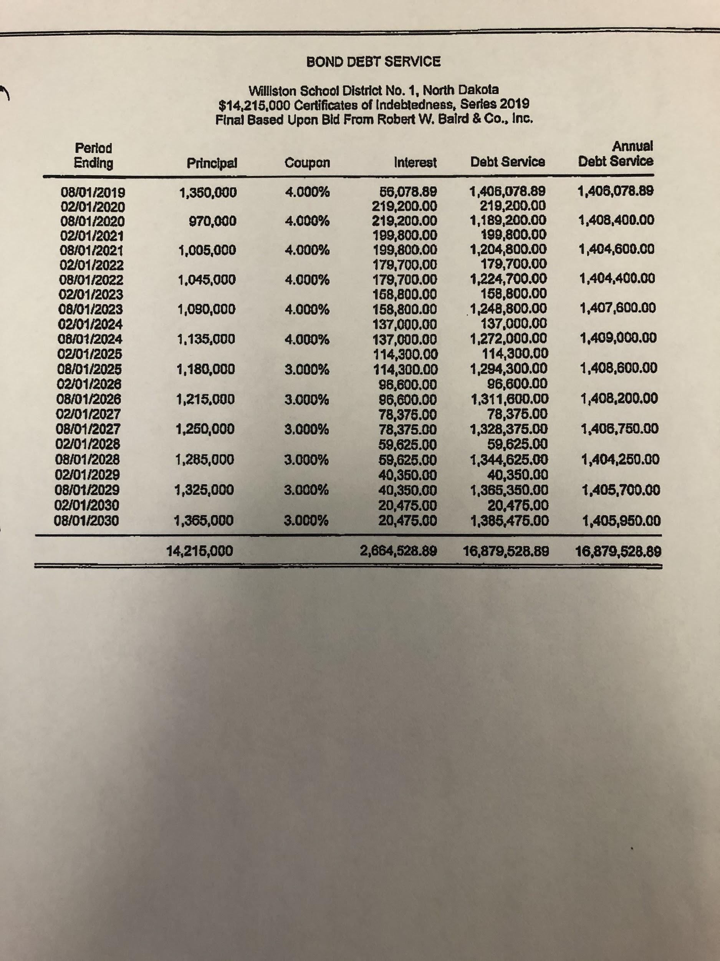
BUILDING FUND

WPSD #1 Series 2016A

Series 2015C

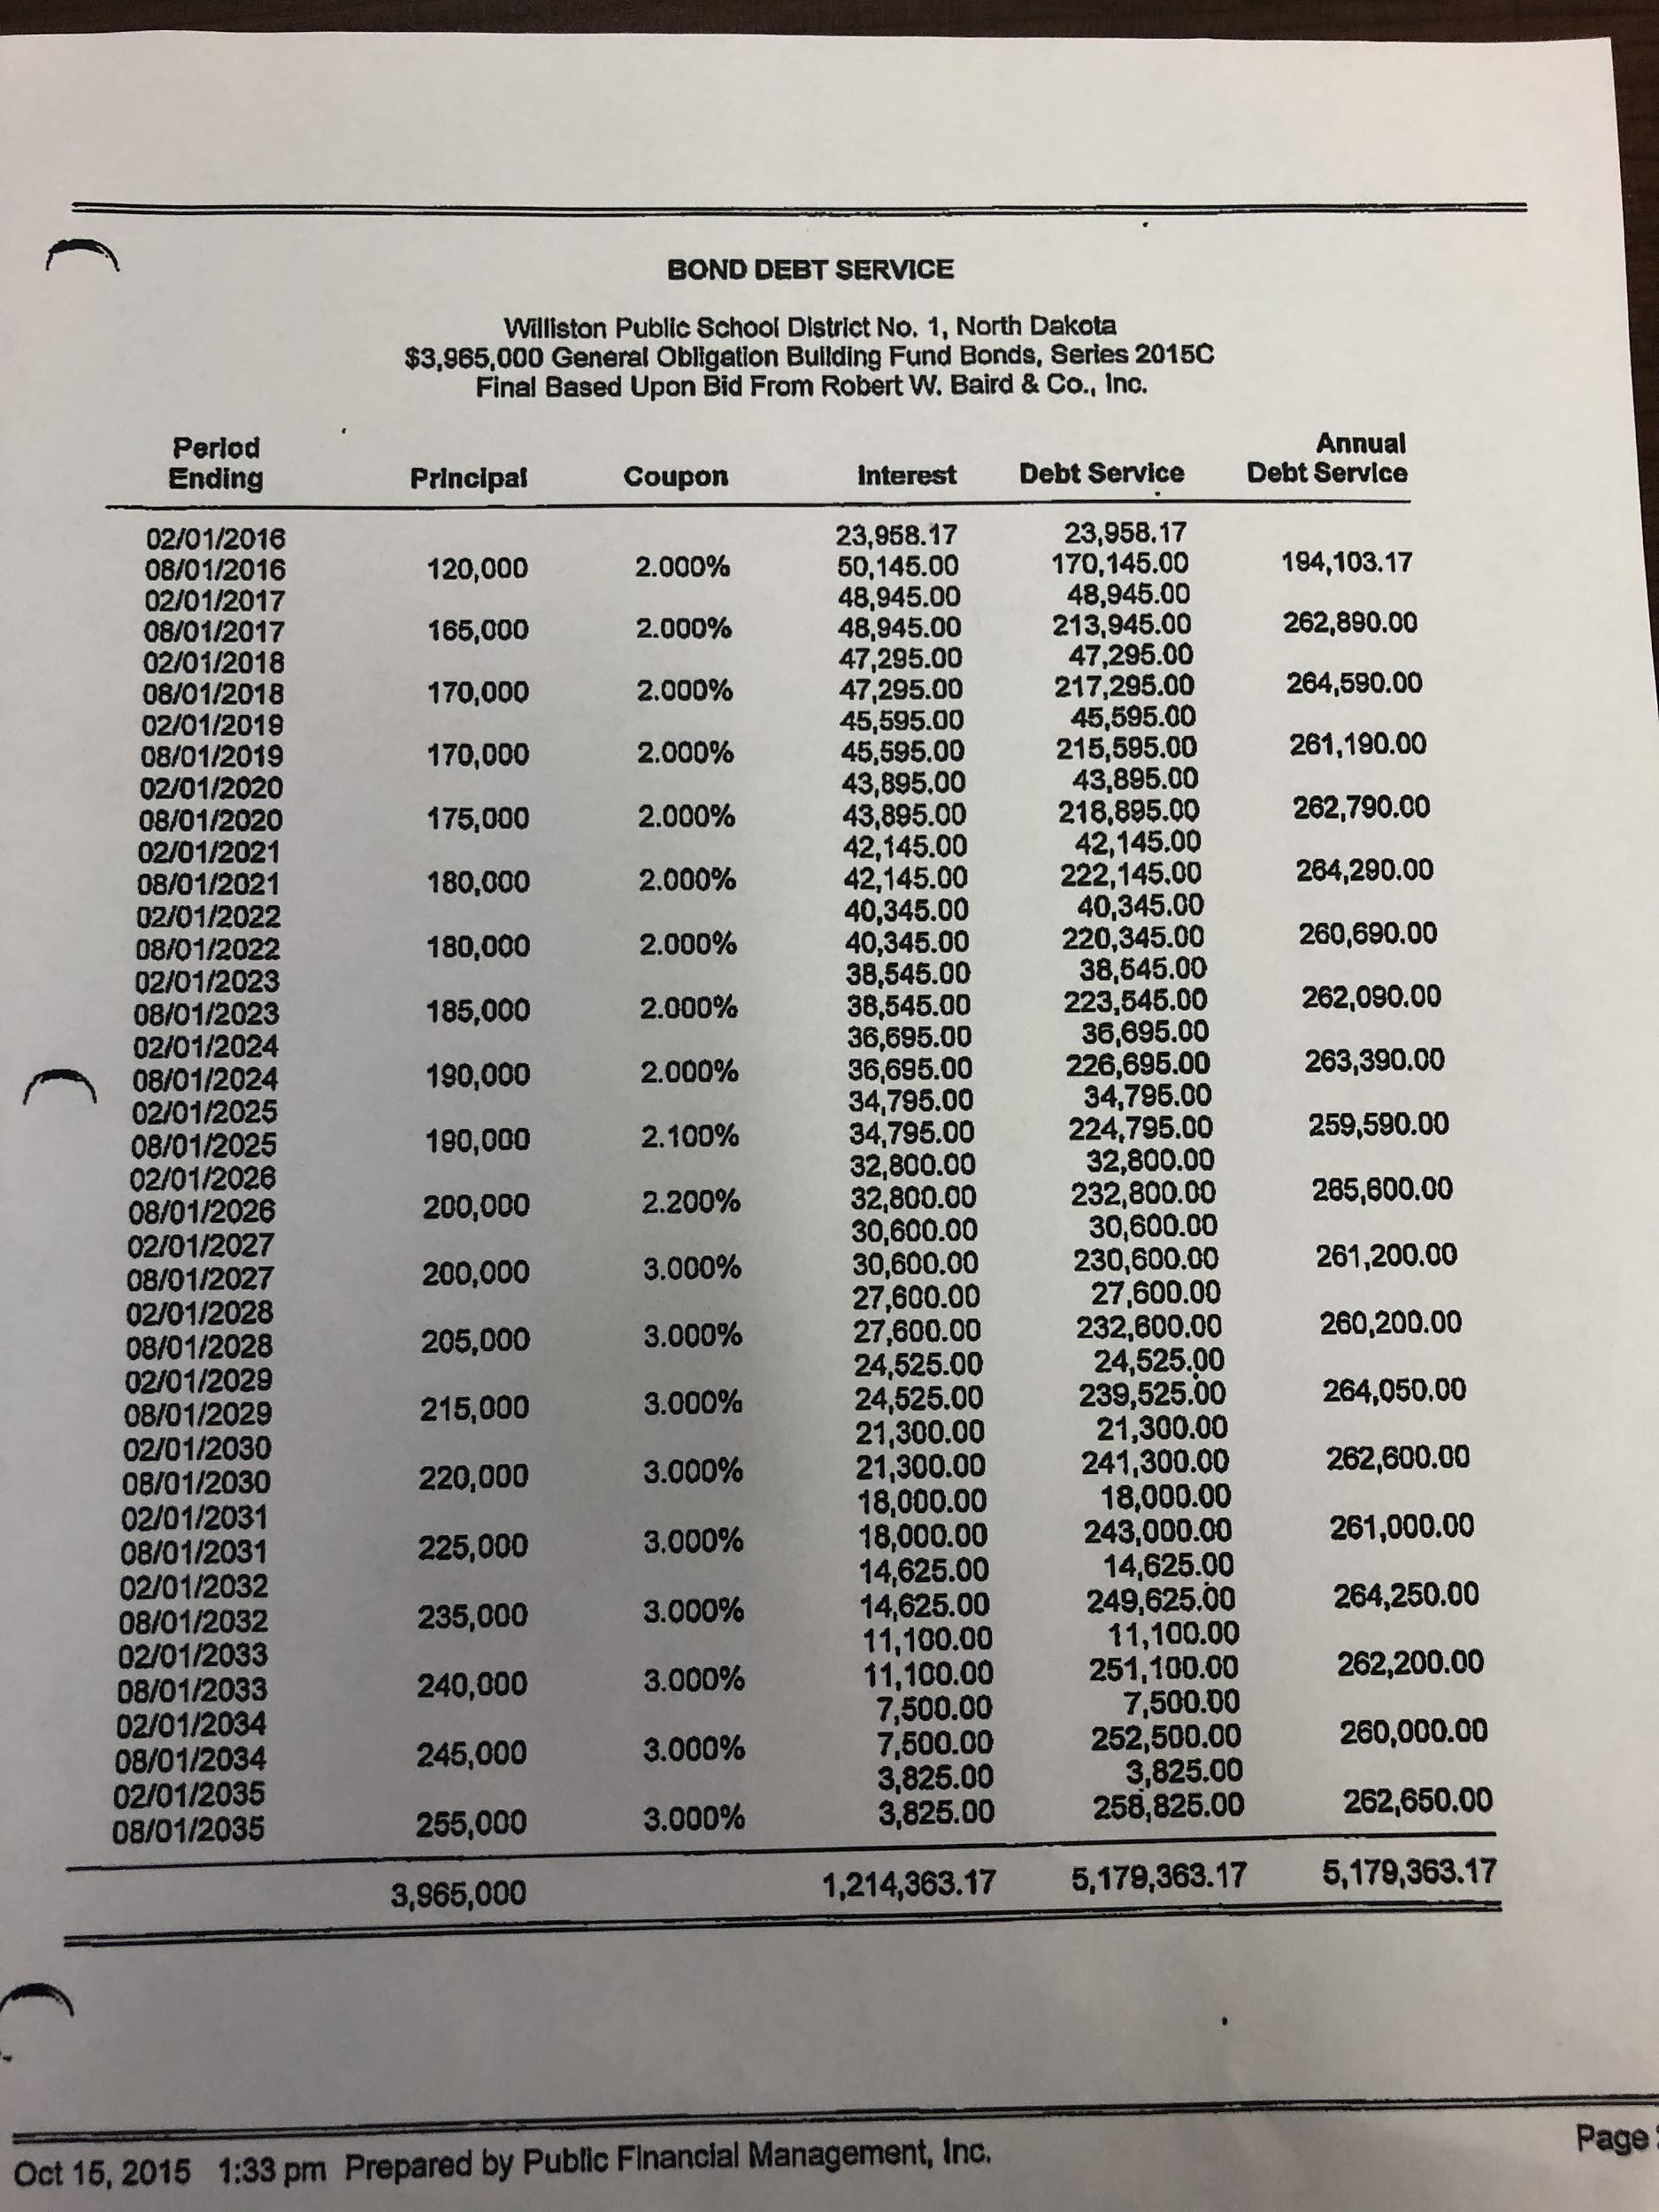
D8
Series 2017A 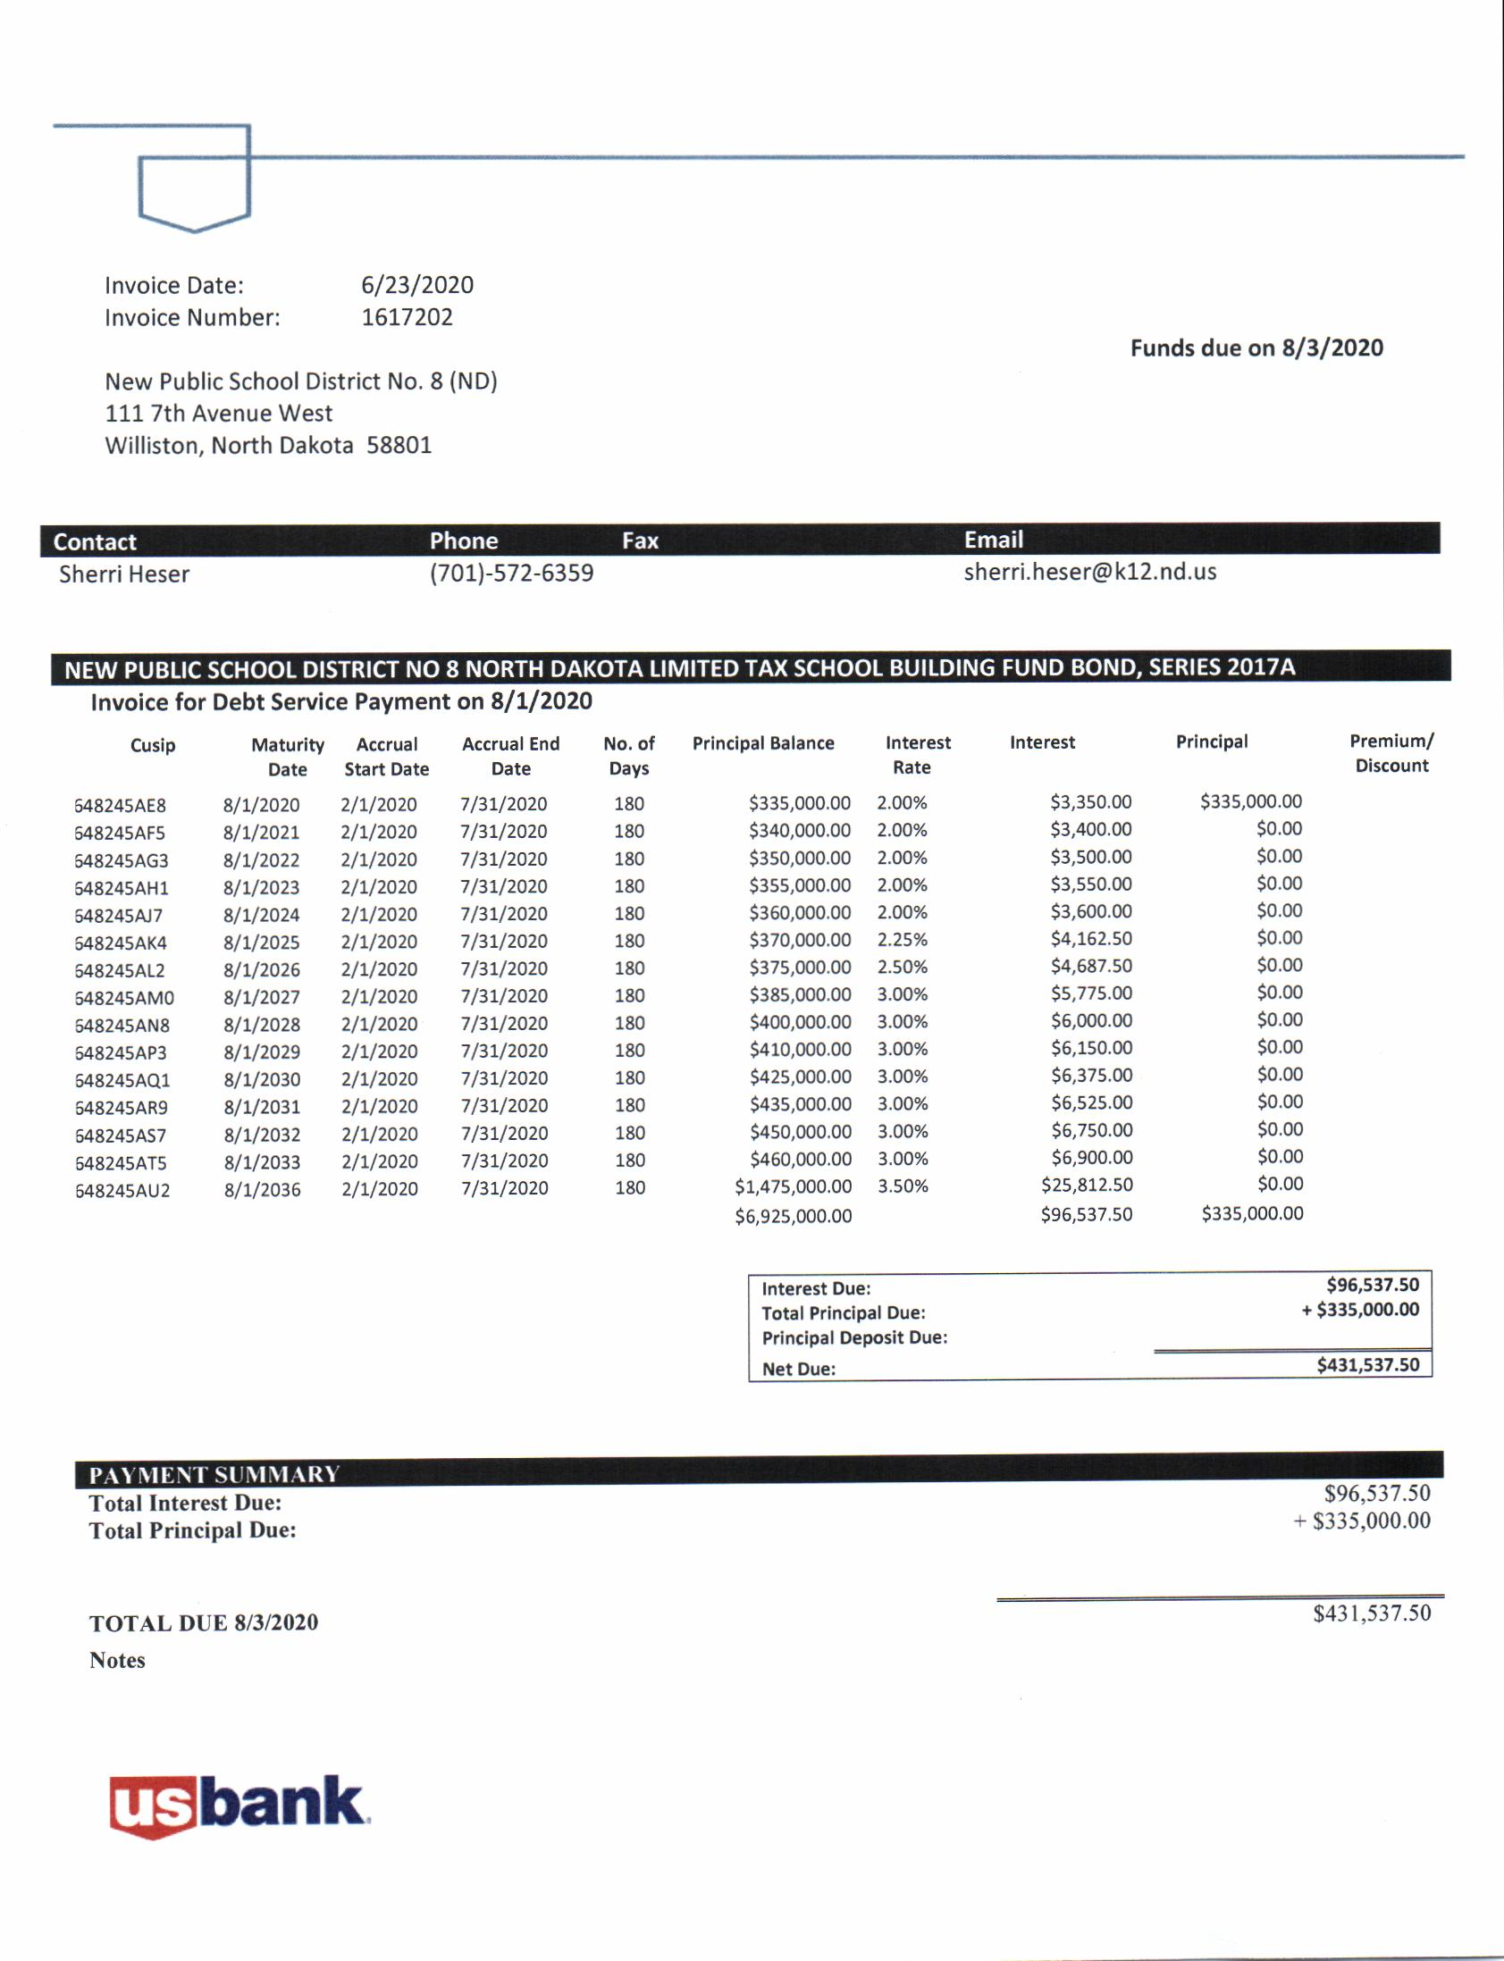

Series 2017B
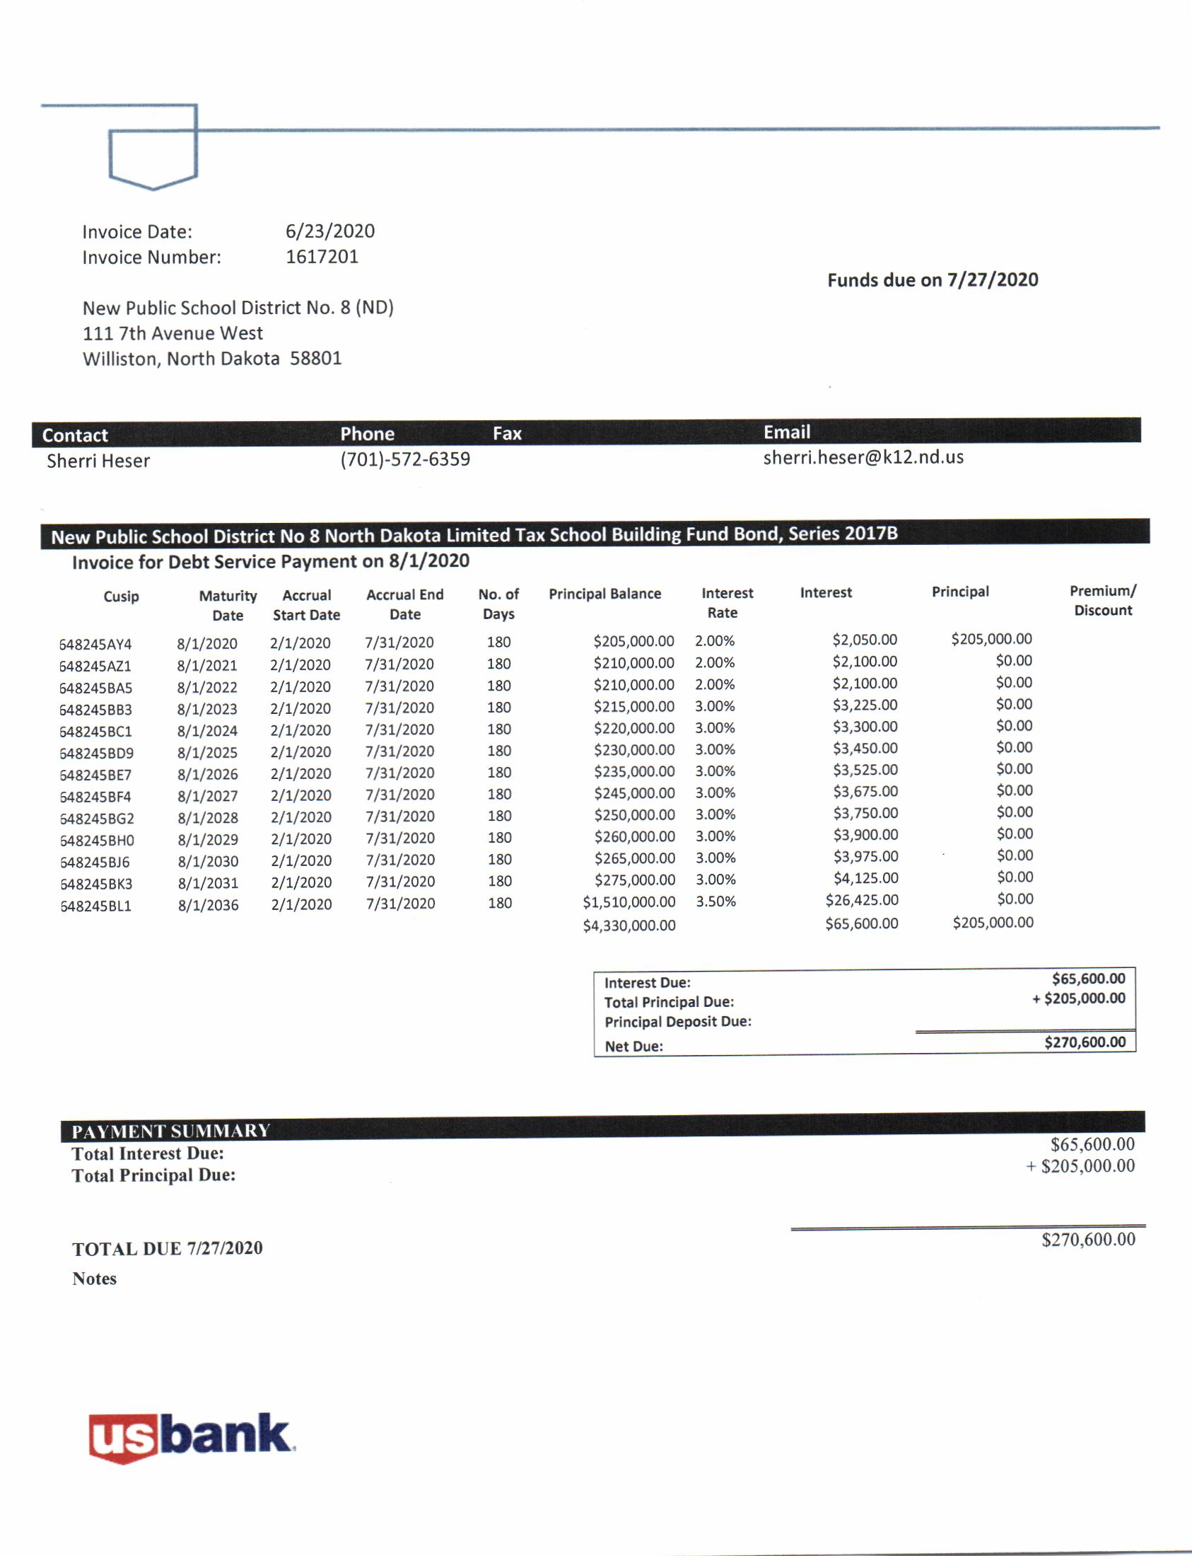

SINKING & INTEREST

WPSD #1
Series 2011

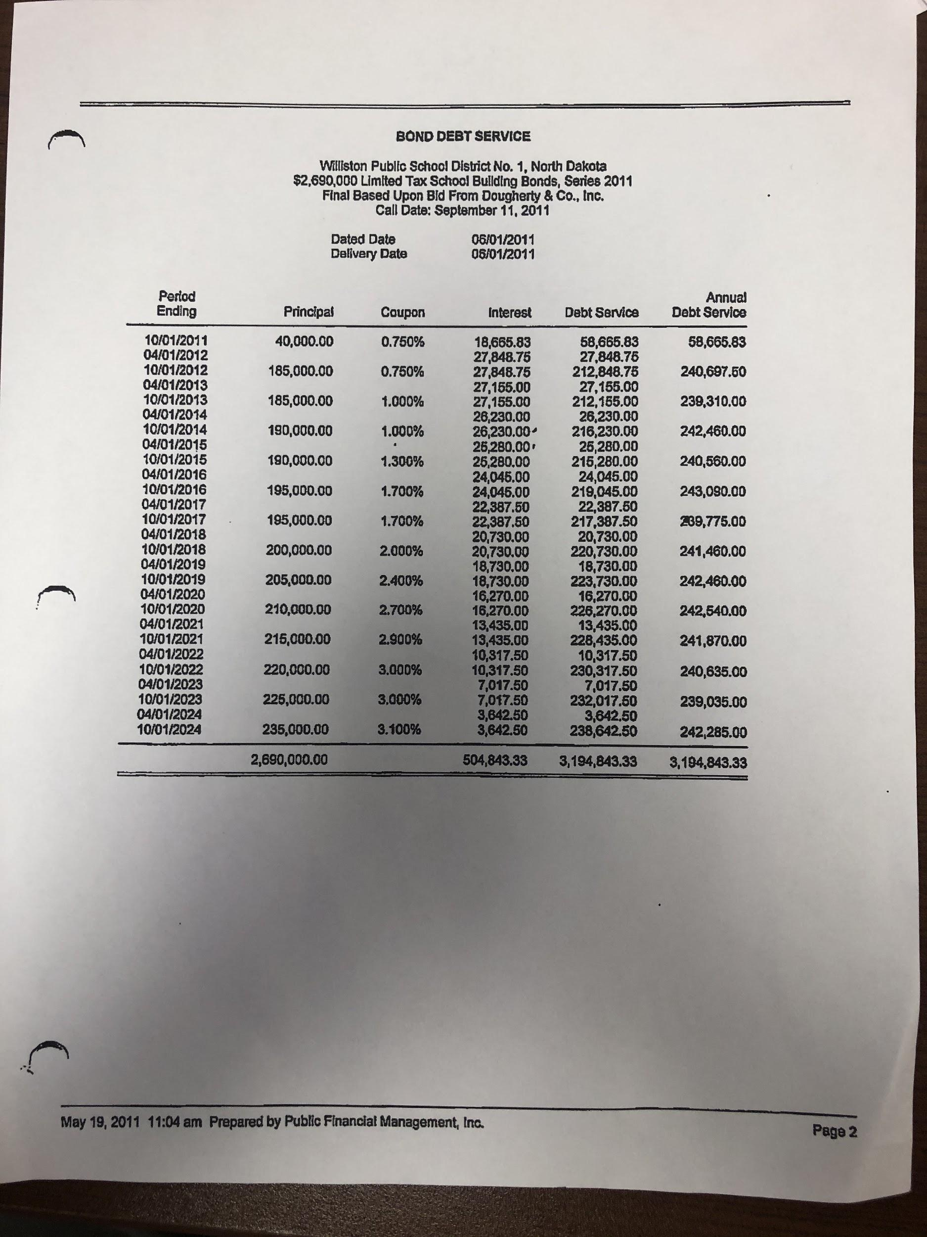
Series 2015A 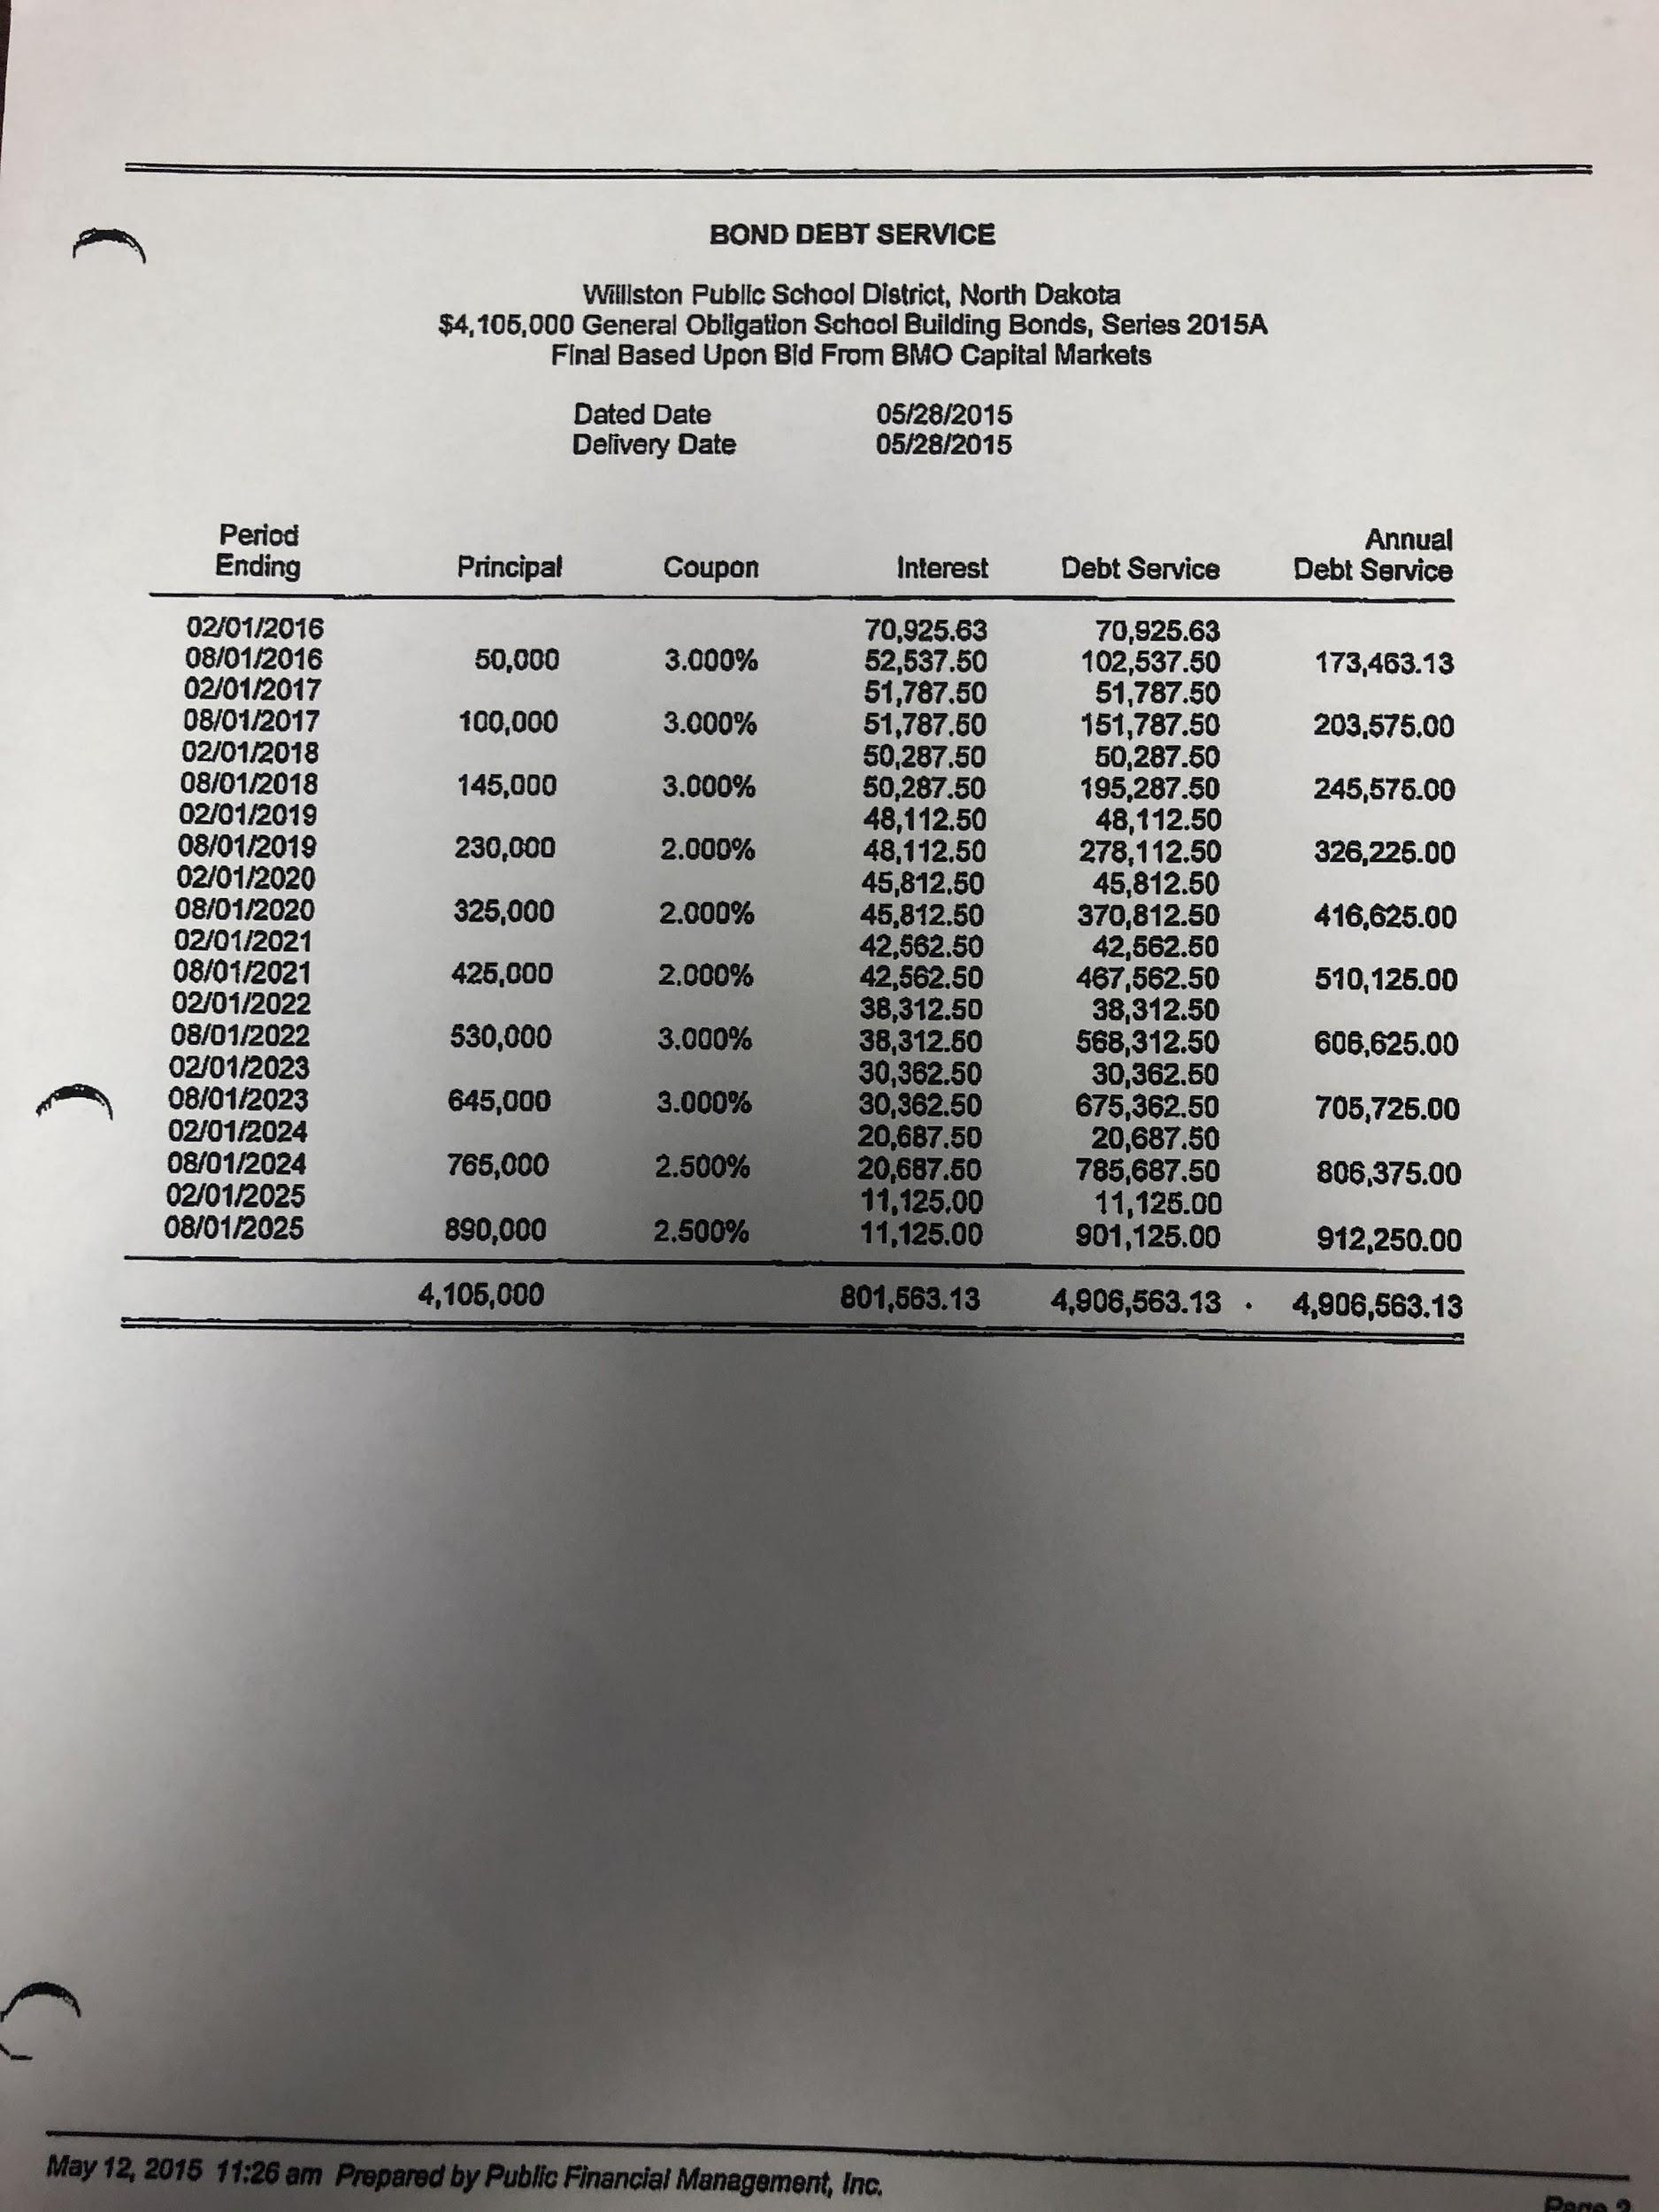

Series 2014

2017 School Construction Loan

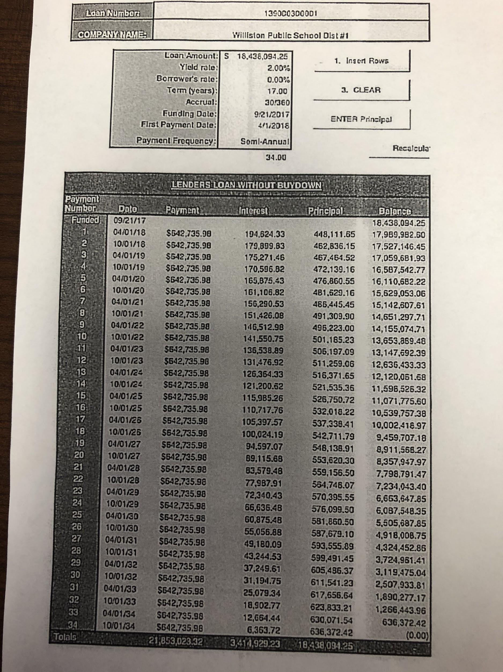
Disposition of Assets

The ending fund balances of all fund groups from WPSD #1 and D8 on June 30, 2021, will be deposited into the appropriate fund groups of Williston Basin School District #007.

Assumption of Liabilities

Williston Basin School District #007 will assume all liabilities of the former WPSD #1 and D8 school districts.

Disposition of Property

Unless otherwise described in this plan, ownership of all property, including but not limited to school-owned land, buildings, building contents, vehicles, instructional supplies, materials, and
equipment owned by WPSD #1 and D8 will become property of Williston Basin School District #007 on the effective date of the reorganization.

Proposed Budget

The proposed budget, as shown below, of Williston Basin School District #007 will generally reflect the revenue and expenditures required to operate WPSD #1 and D8 in its current configuration.

2021/2022 | Beginning Balance | Mill Levy | Local Projected | State Projected | Federal Projected | Other Projected | Revenue Projected | Expenditures Projected | EFB Projected
General Fund | $6,589,543 | 70 | $16,016,619 | $41,950,000 | $1,300,000 | $8,998,000 | $68,264,619 | $68,264,619 | $6,589,543
Building Fund | $16,535,583 | 10 | $2,288,088 |  |  |  | $2,288,088 | $2,288,088 | $16,535,583
Misc. |  | 12 | $2,745,706 |  |  |  | $2,745,706 | $2,745,706
Special Assessment | $23,000 | 3 | $686,426 |  |  |  | $686,426 | $686,426 | $23,000
Sinking & Interest | $420,000 | *19.69 | $2,334,093 |  |  |  | $2,334,093 | $2,334,093 | $420,000
Special Reserve | $1,700,000 | 0 |  |  |  |  |  |  | $1,700,000
Total | $25,268,126 |  |  |  |  |  | $77,006,169 | $77,006,169 | $25,268,126
Debt |  |  |  |  |  |  |  | Payment | Balance
General Fund | $11,895,000 |  |  |  |  |  |  | $1,389,000 | $10,890,000
Building Fund | $19,498,000 |  |  |  |  |  |  | $2,369,527 | $17,773,000
Sinking & Interest | $30,155,882 |  |  |  |  |  |  | $2,547,590 | $28,134,128
Total Mill Levy |  | WPSD #1 - 114.69  D8 - 95
Taxable Valuation WPSD #1 |  | $118,542,060
Taxable Valuation D8 |  | $110,226,792
Taxable Valuation Combined |  | $228,808,852

*Former WPSD#1 residents will have an additional 19.69 mills based on the valuation of the former district.

Appendices
- Property Legal Descriptions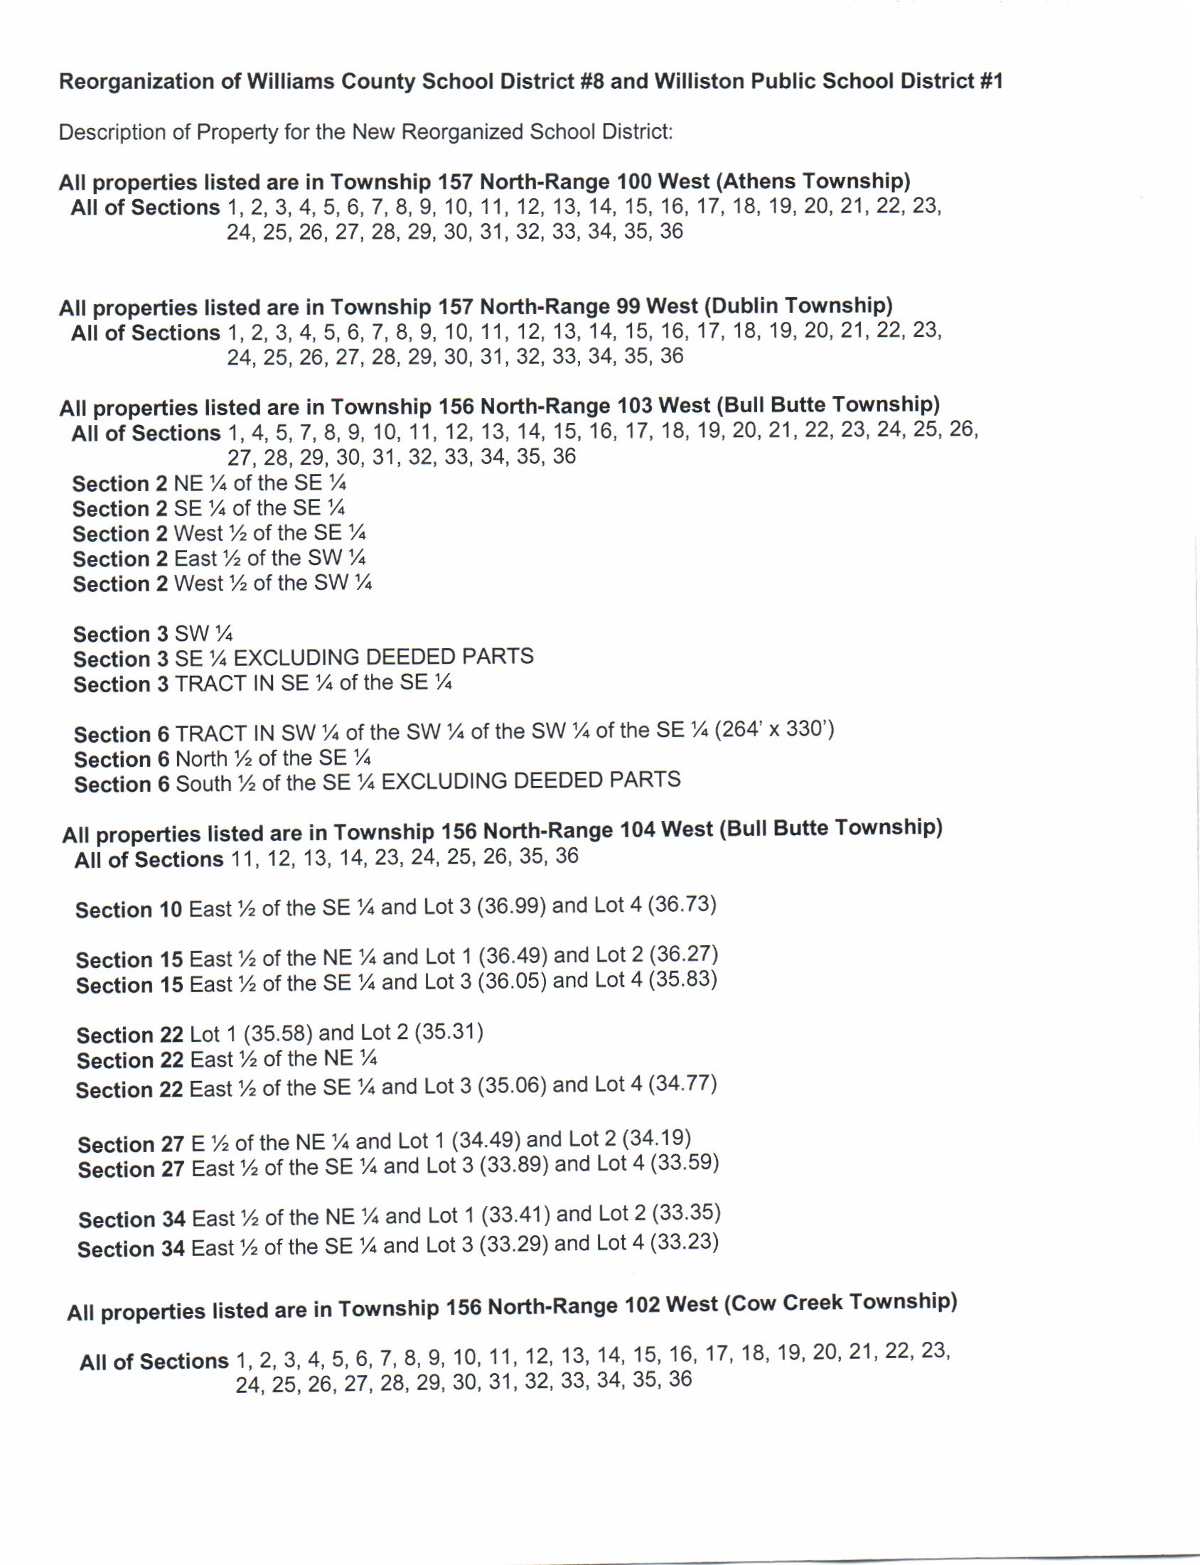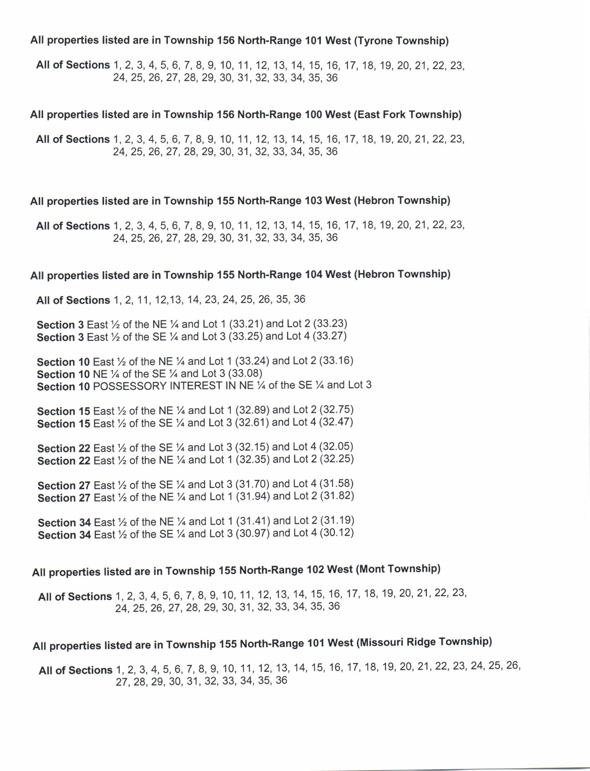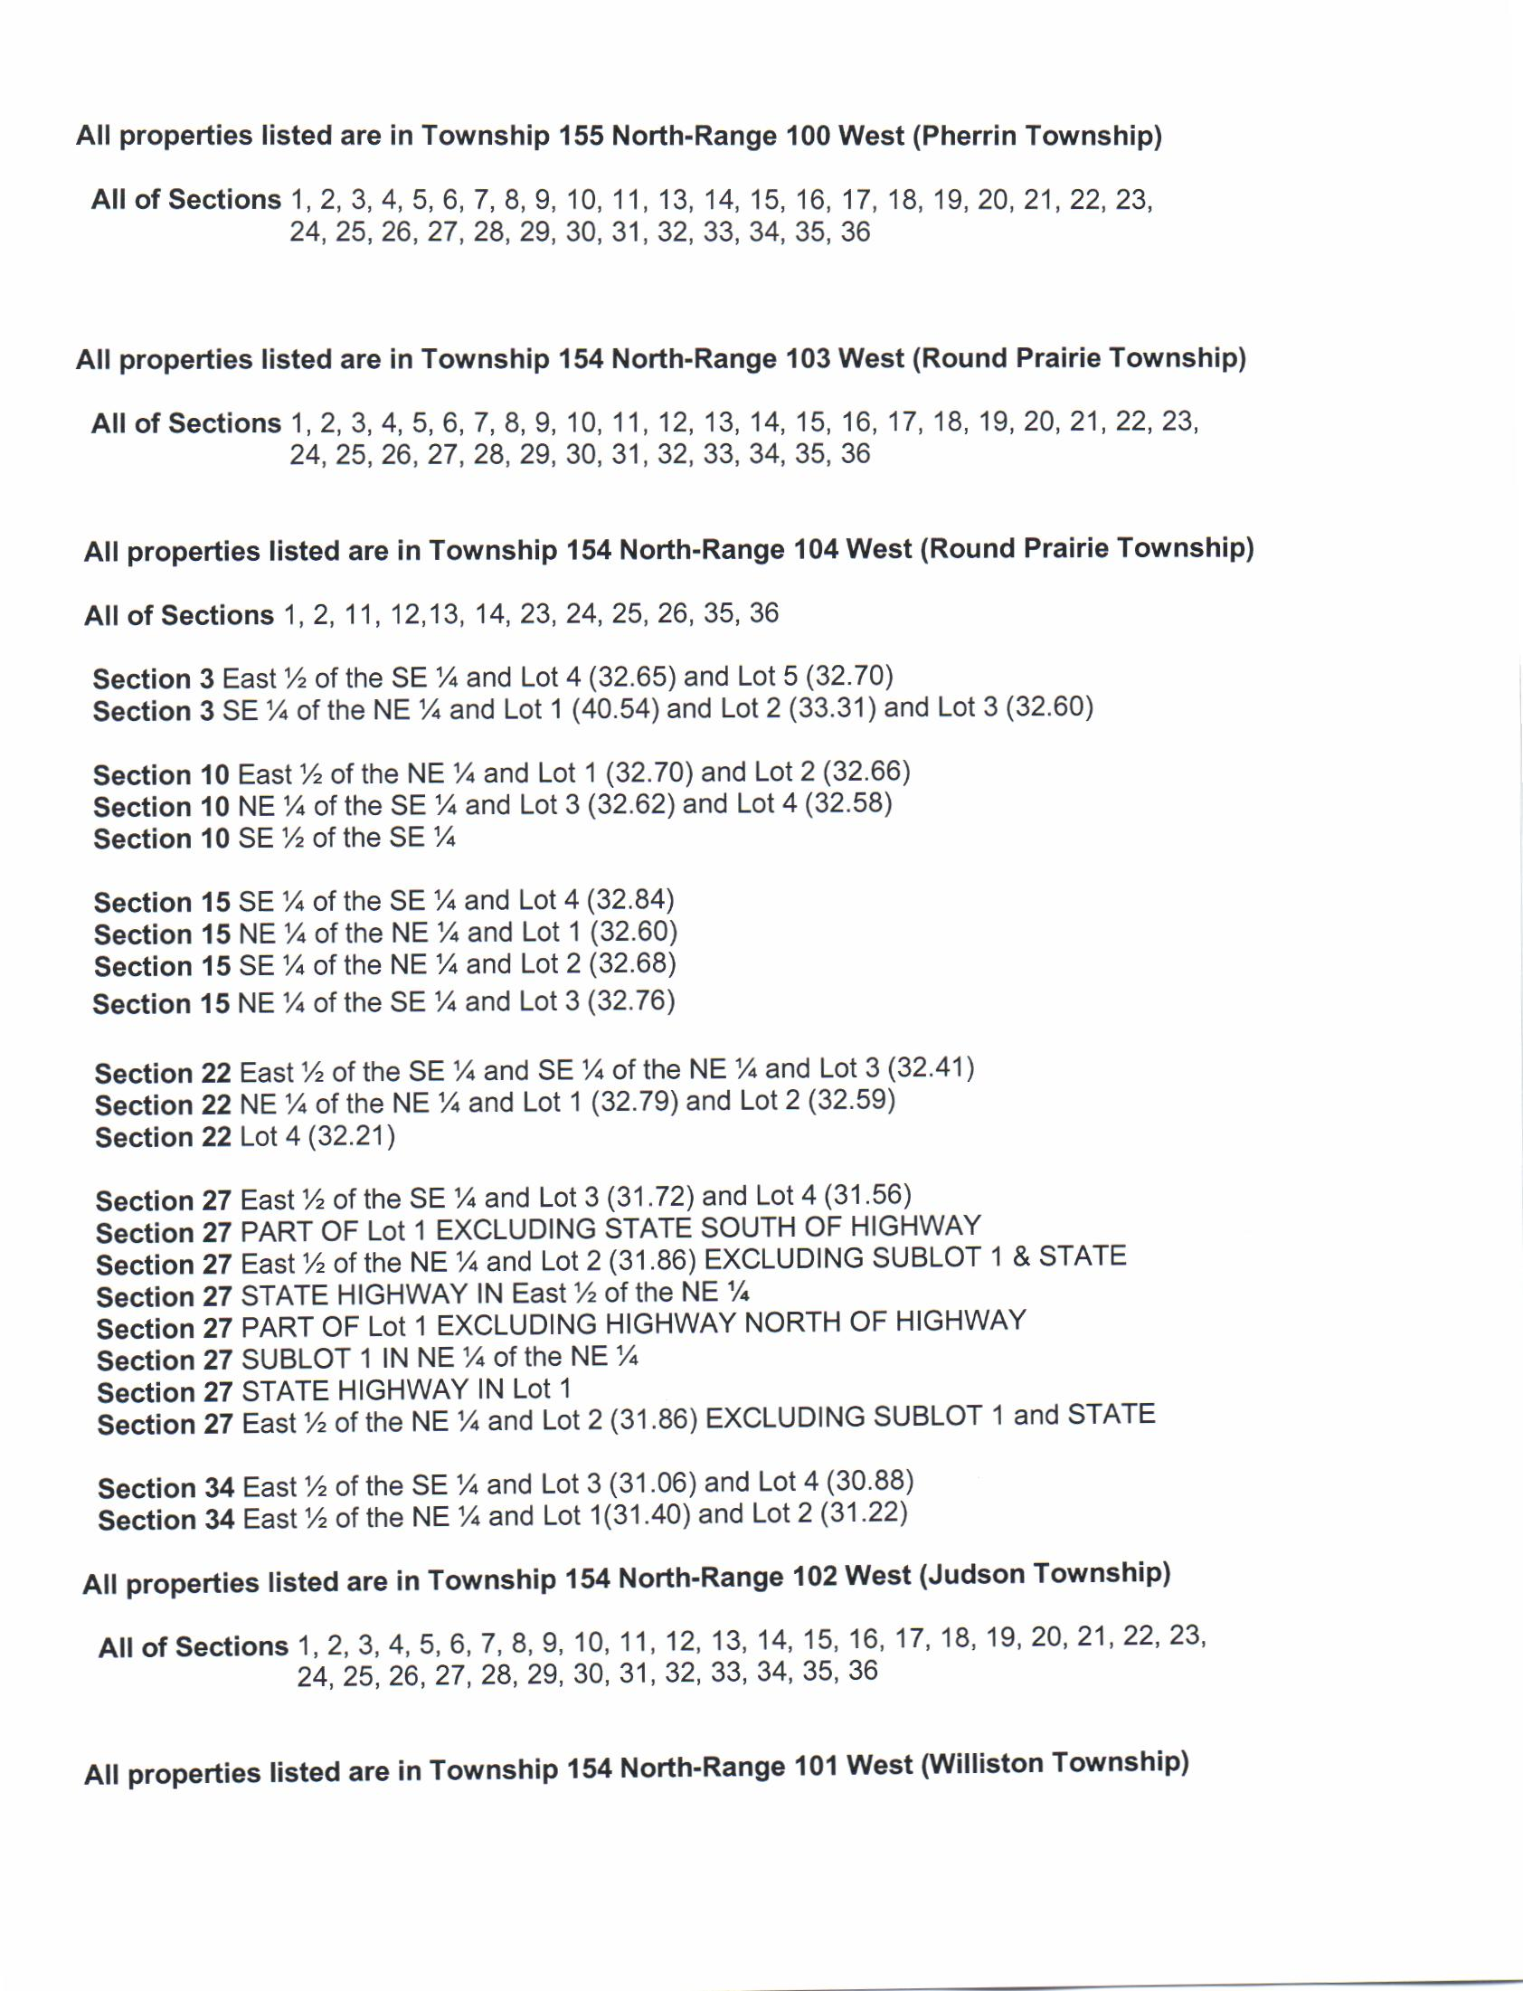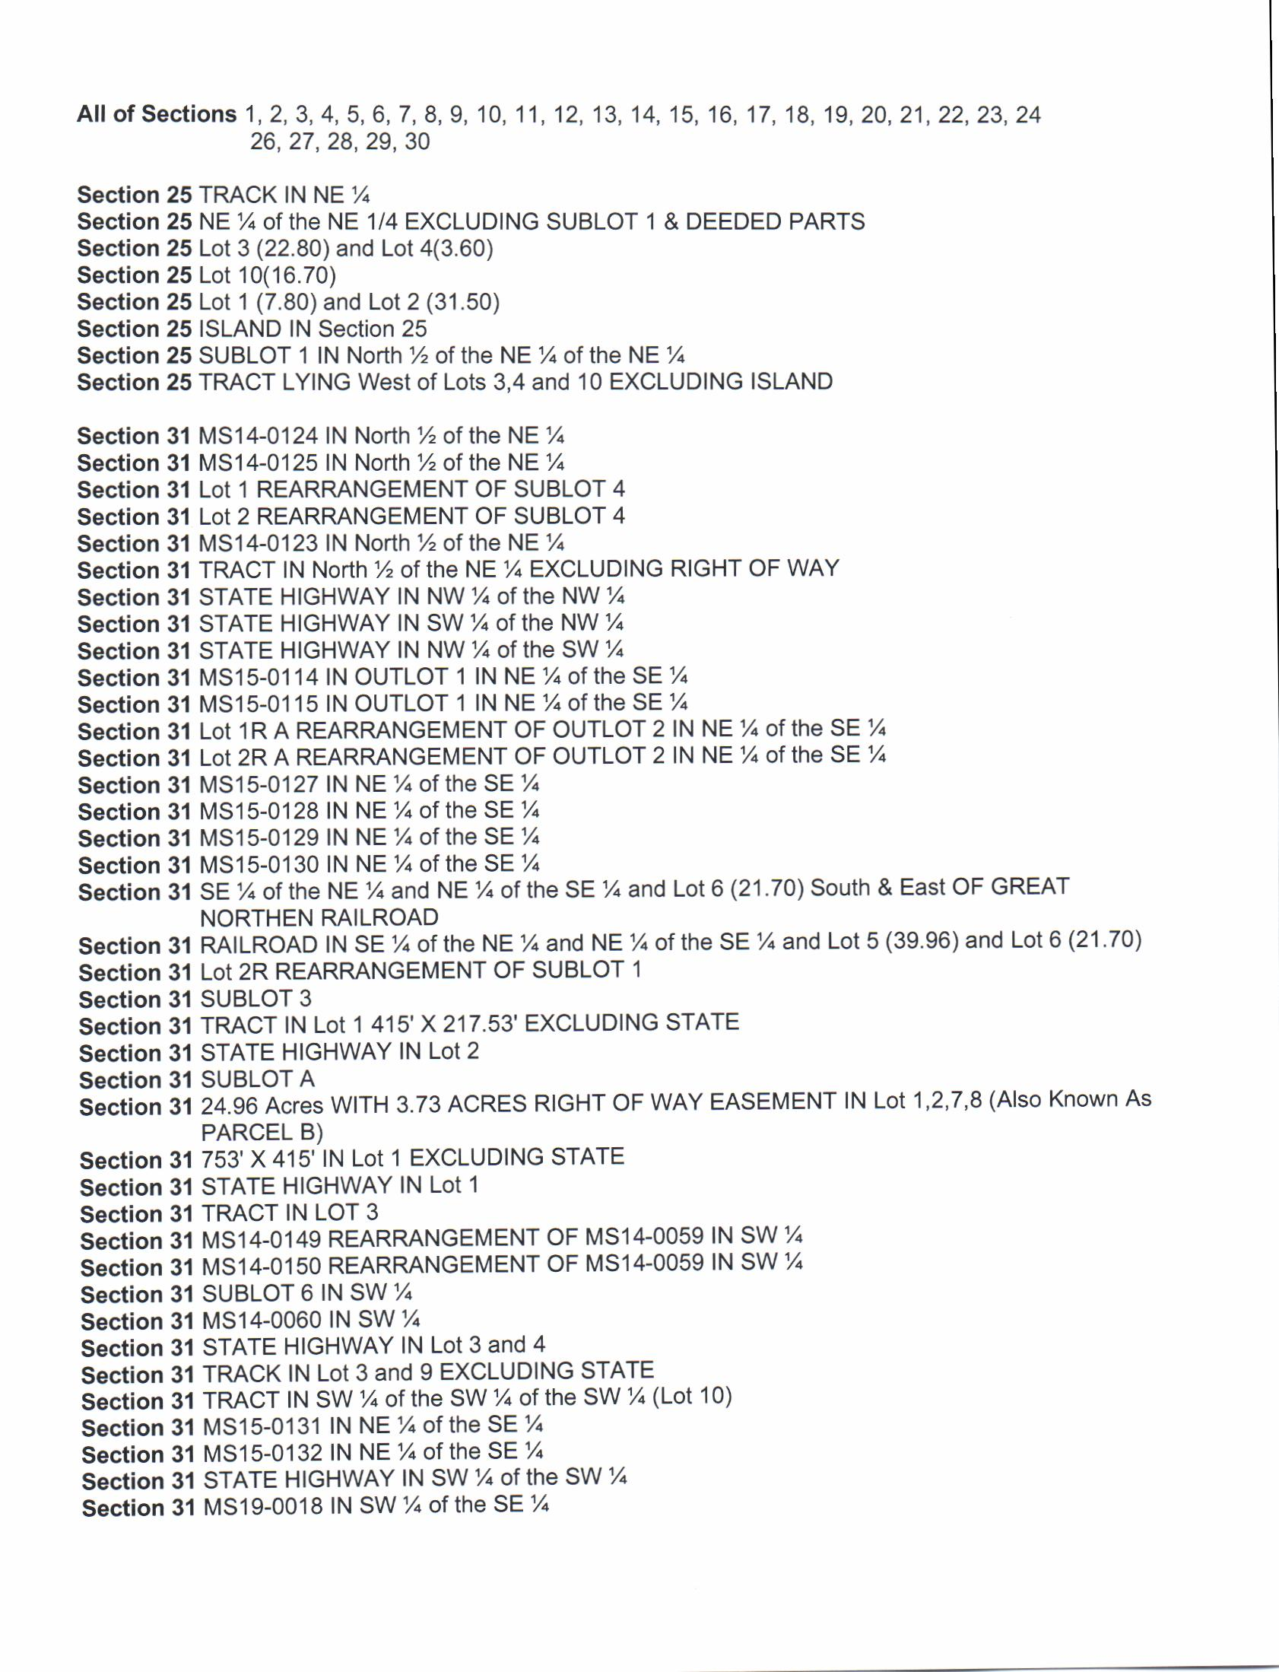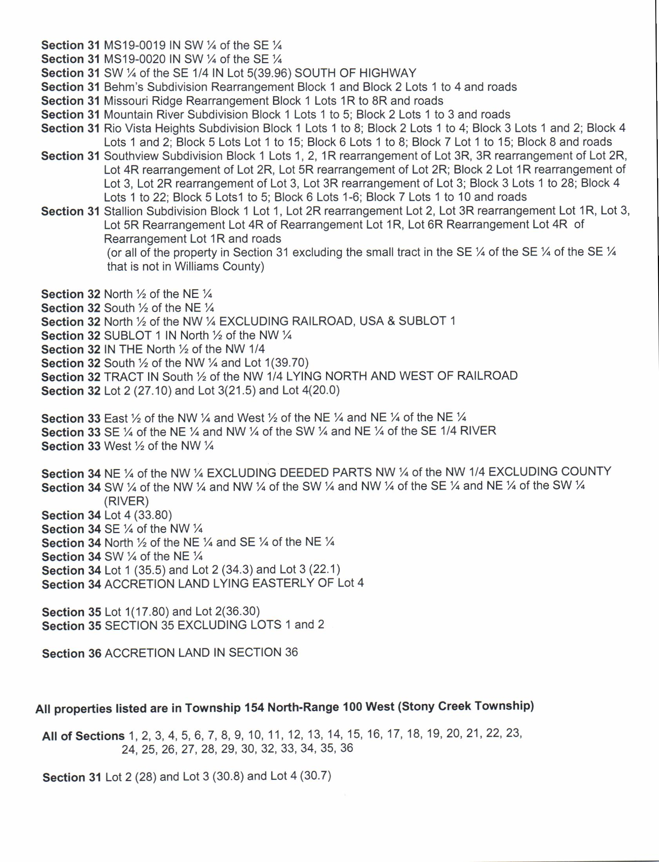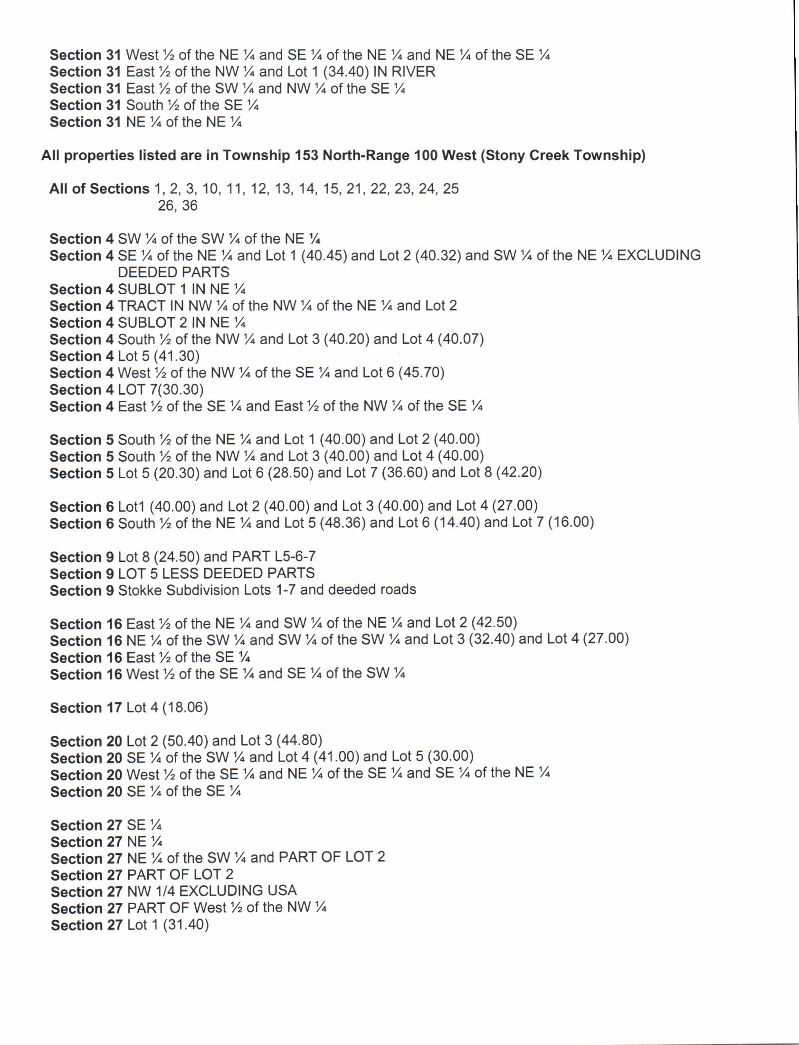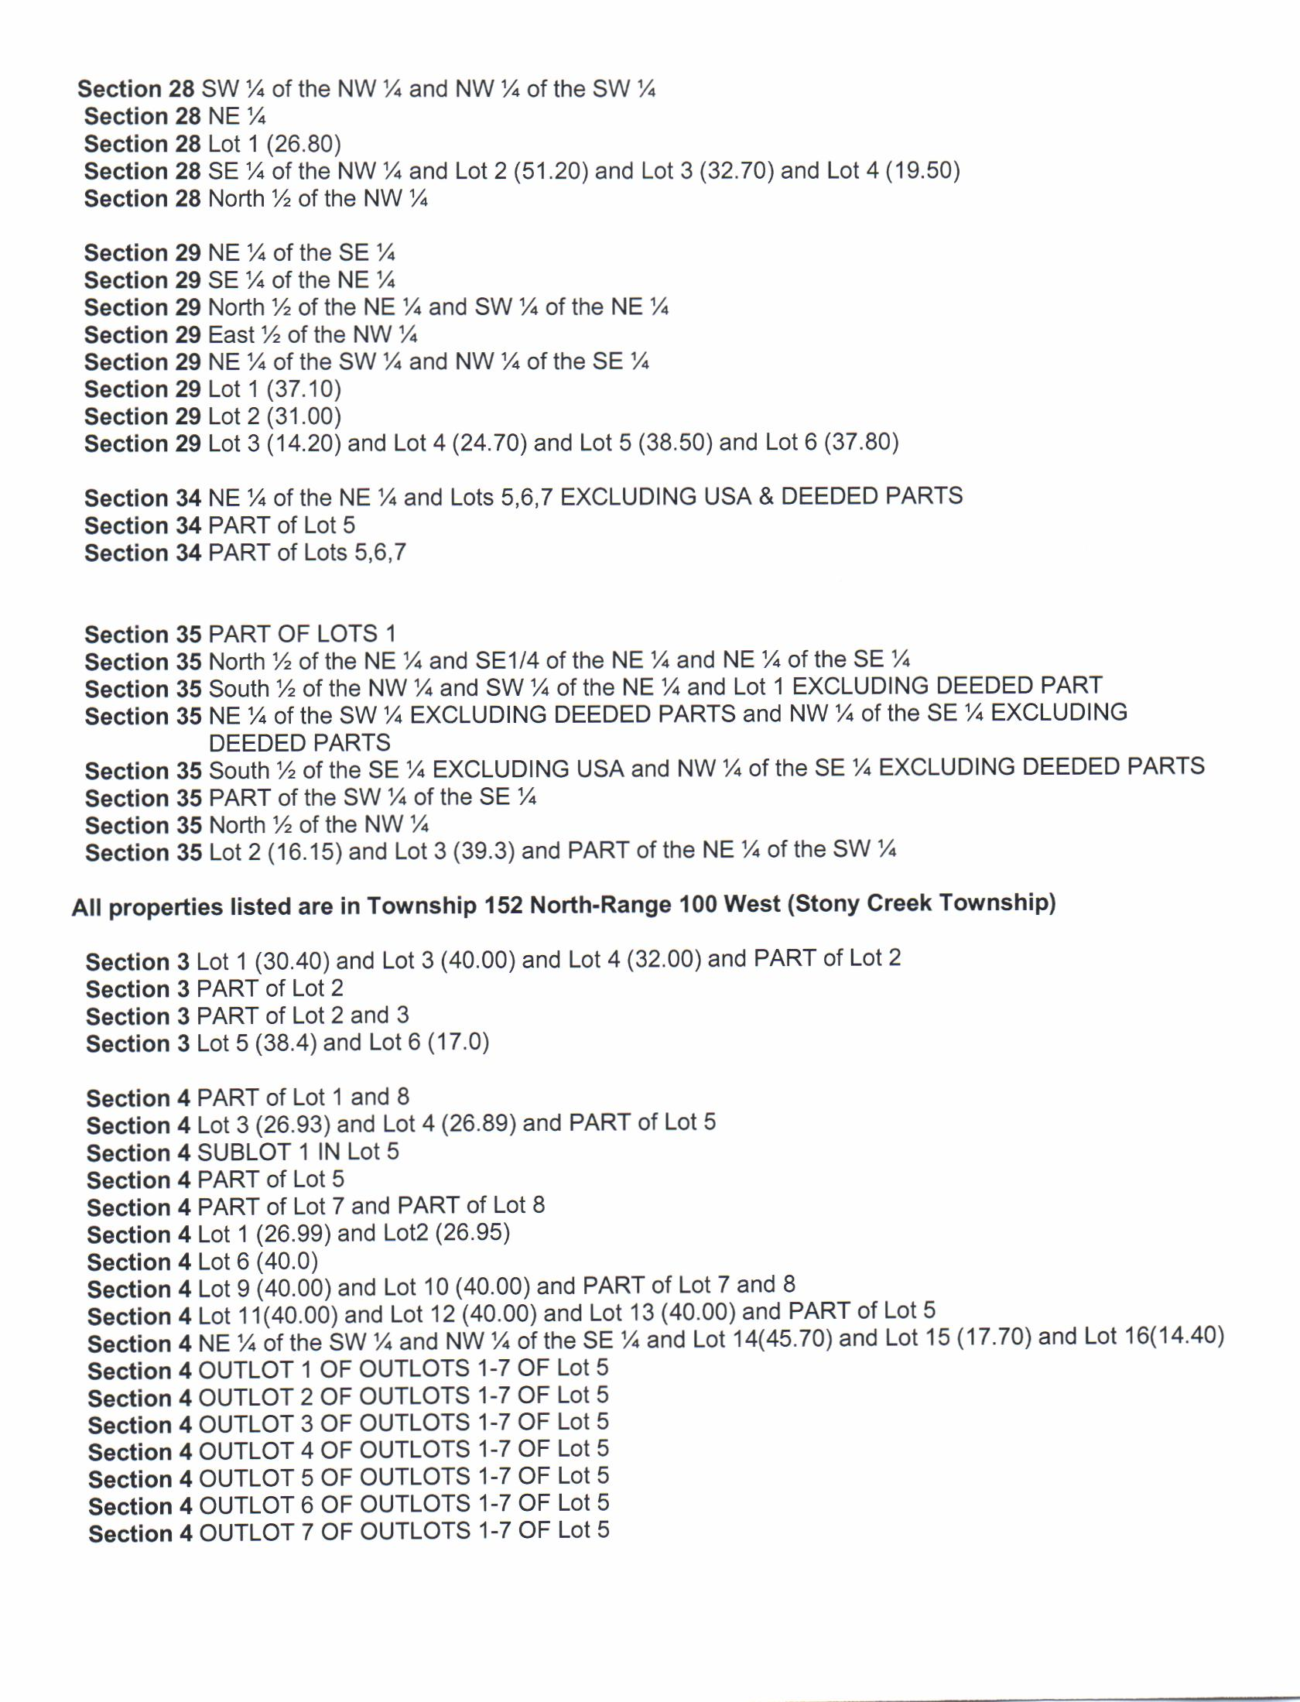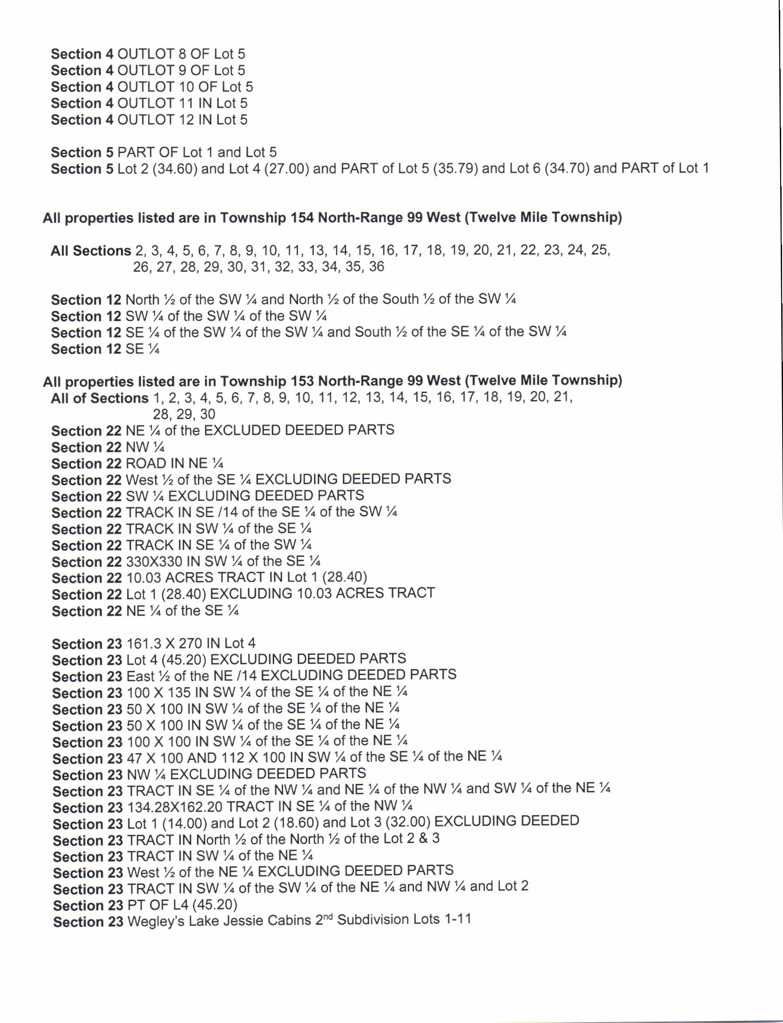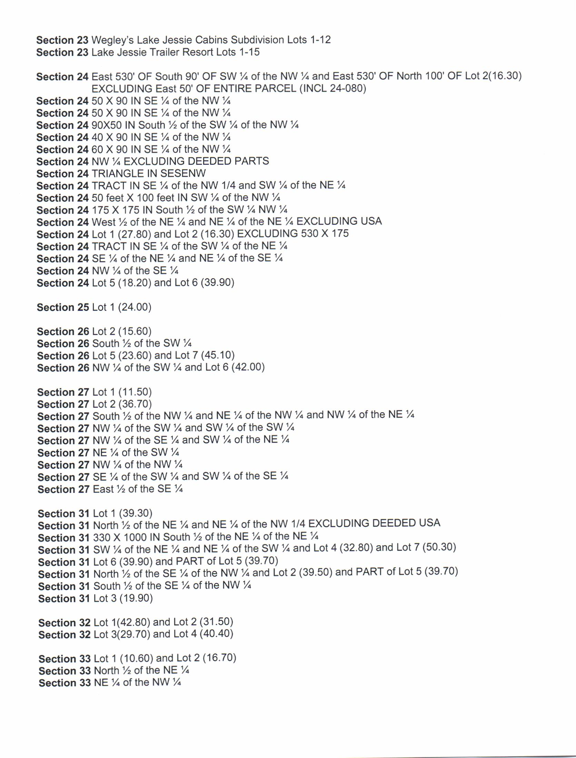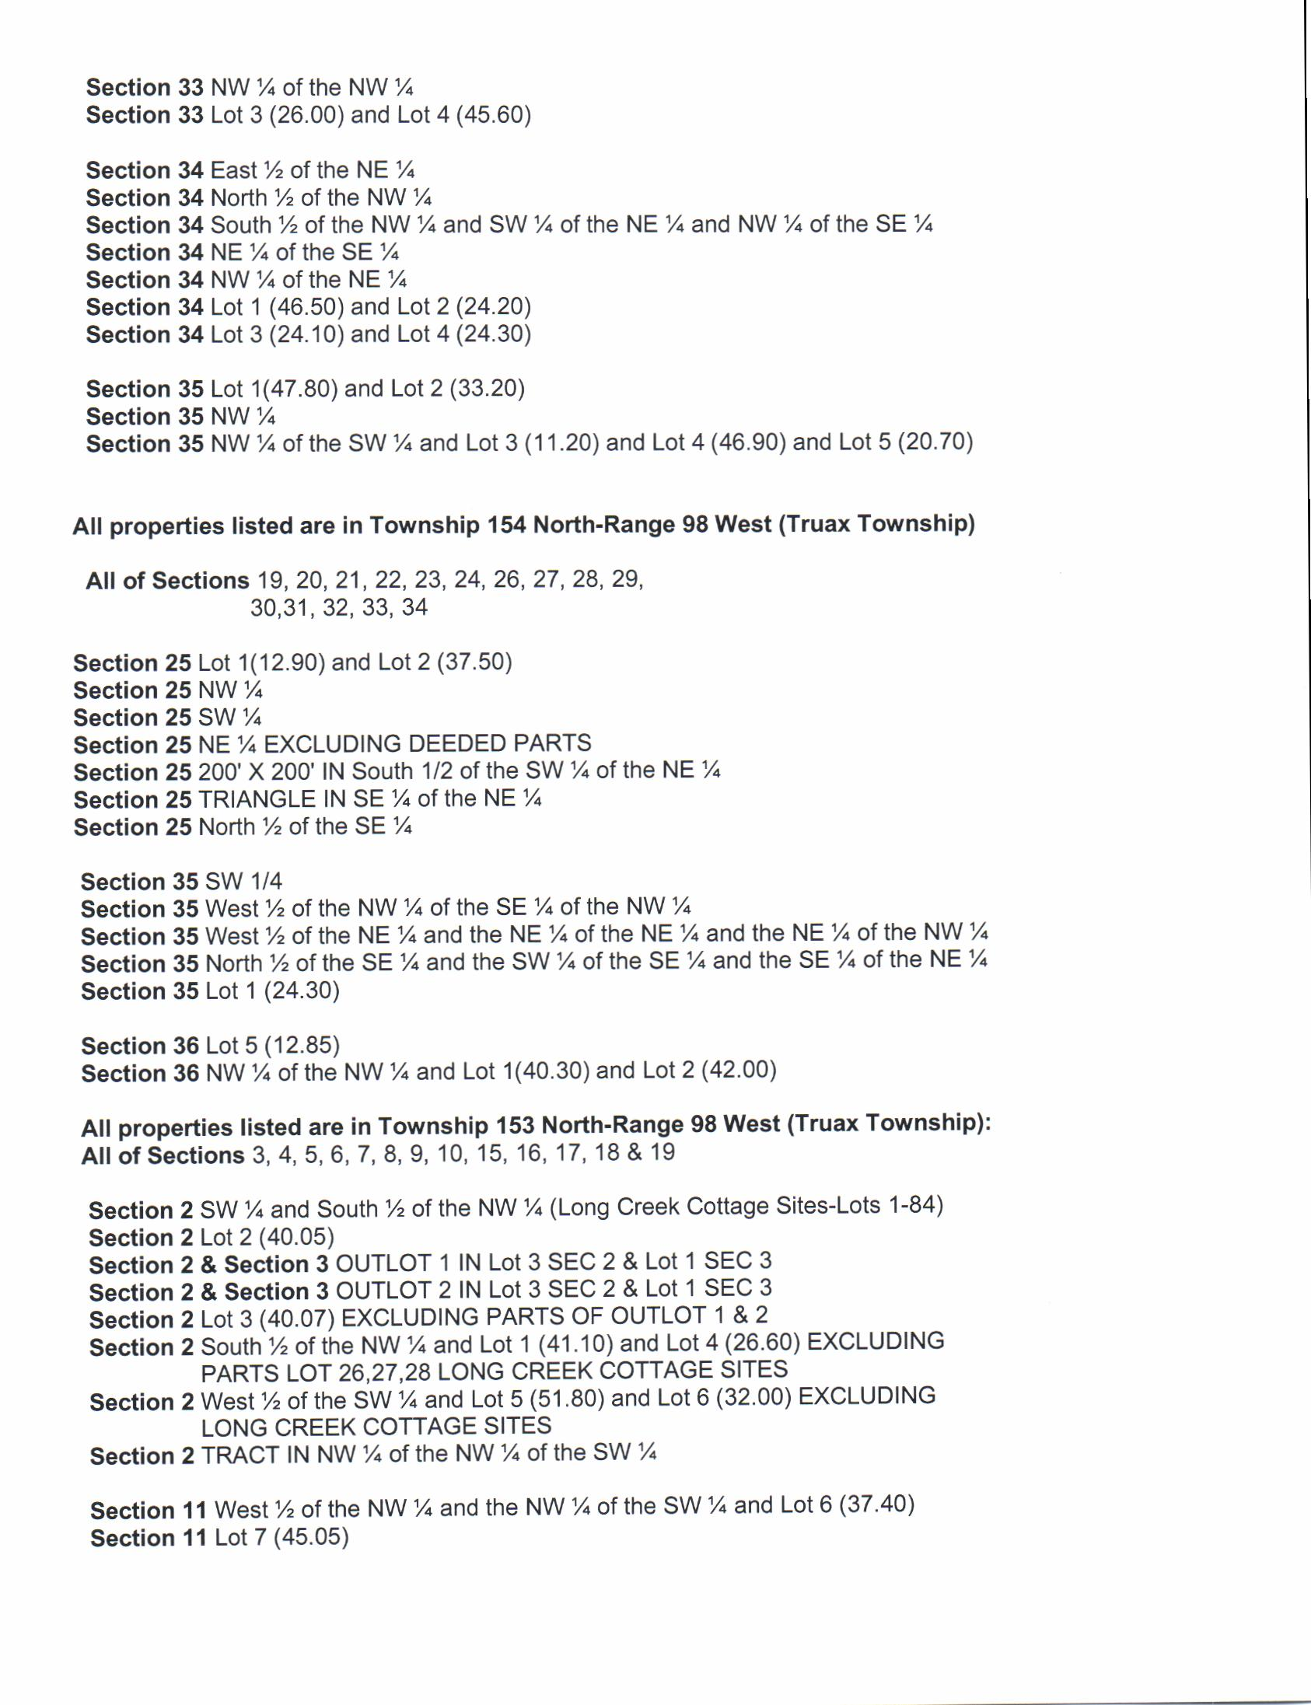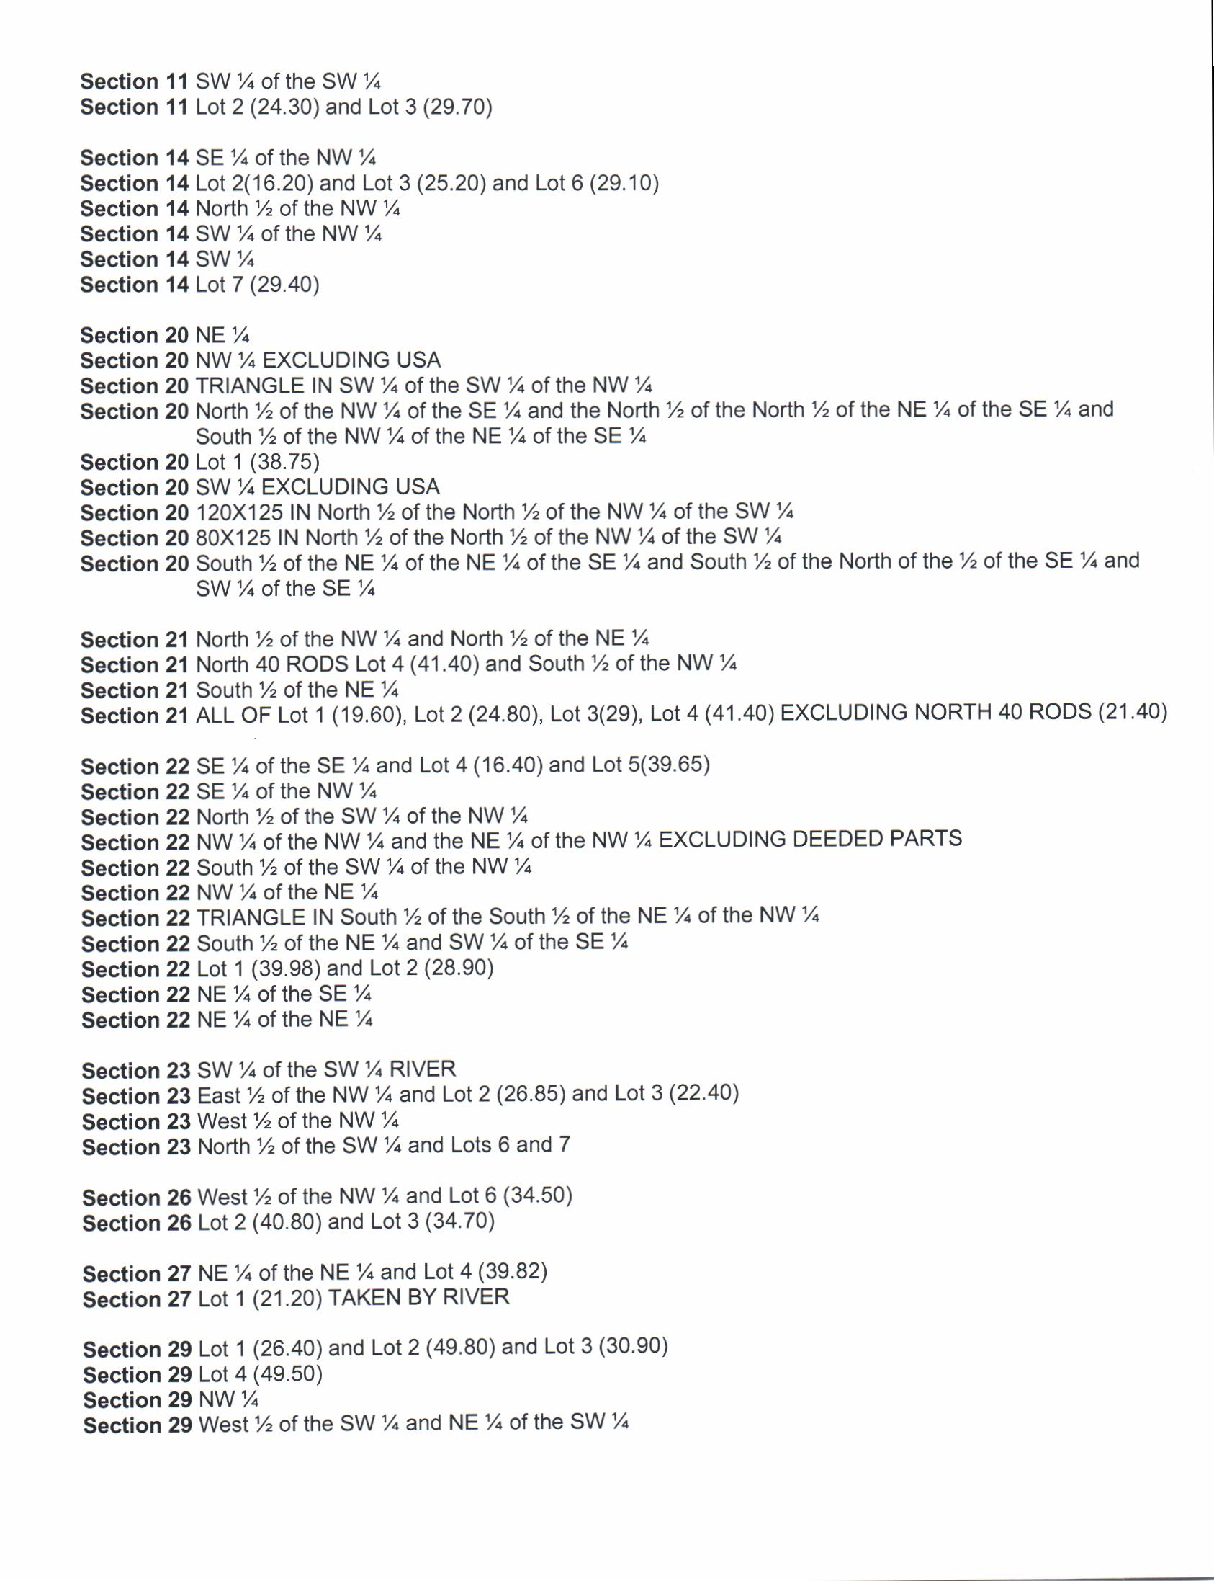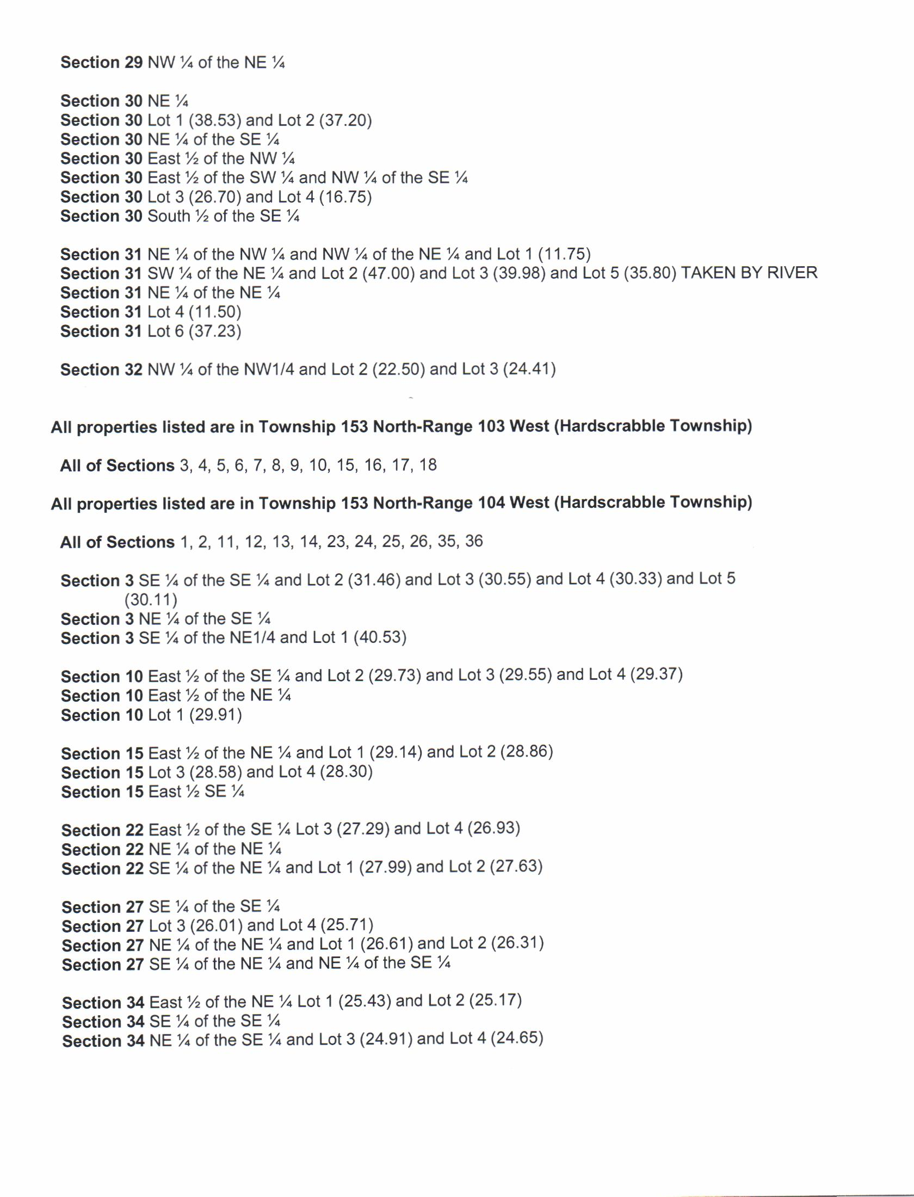

- Williams County Reorganization Committee Hearing Minutes
- Williston Public School District #1 Board Voting Record
- Williams County School District #8 Board Voting Record
- County Hearing Notices
- Preliminary 2020-2021 Certificate of Levy
