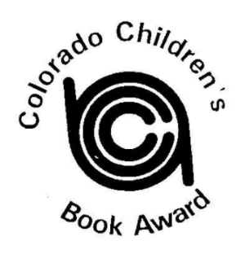 2020-2021 Book Challenge
1st Semester
1st and 2nd Grades
Select seven Colorado Children’s Book Award Picture Book Winners or Nominations
Must be in your reading range set by your teacher.

Select the row you want to complete.
You may go across, up and down or diagonally.

Pick from the activities given to you completing one for each book.
You can do each activity only once for this bingo card.

FREE  CHOICE | BOY | HISTORY | SCARY/  MONSTER | FAIRY  TALE | SCHOOL | ANIMAL
GIRL | HISTORY | FREE CHOICE | DOG | IF YOU GIVE A.. | SCARY/  MONSTER | FAIRY TALE
FAIRY TALE | SCHOOL | SCARY/  MONSTER | ANIMAL | FREE CHOICE | DOG | FREE CHOICE
BOY | FREE CHOICE | FAIRY TALE | CAT | DOG | SCHOOL | SCARY/  MONSTER
ANIMAL | IF YOU GIVE A.. | BOY | FREE CHOICE | SCHOOL | GIRL | HISTORY
CAT | HISTORY | ANIMAL | FAIRY  TALE | SCARY/  MONSTER | IF YOU GIVE A.. | FREE CHOICE
DOG | FAIRY TALE | GIRL | SCHOOL | HISTORY | FREE CHOICE | CAT

