Kindergarten E-Learning Choice Board
OCTOBER
Please pick at least 2 activities each day to complete. Try to complete and explore new activities each day and then it is ok to repeat activities! Most importantly, HAVE FUN TOGETHER!

Row 1 | Listen to the book  Pete the Cat Firefighter Pete  tps://www.youtube.com/watch?v=_LXF_VFm1XQ  What was your favorite part of the story? Do you want to be a firefighter? Why or why not? | Scholastic Clifford’s My Big World:  https://mybigworld.scholastic.com/issues/2020-21/100120.html  “Do You Want To Be A Fire-  fighter?”  Watch Videos and Play Game | Practice a fire drill at home with your family. Find a meeting location outside for everyone to meet at once they safely leave the house.  Check the batteries in your smoke alarms to make sure they work.  Practice how to stop, drop, and roll if your clothes were to catch on fire. | Scholastic Let’s Find Out:  https://letsfindout.scholastic.com/issues/2020-21/100220.html  “Do You Hear the Fire Truck?”  Watch Videos and Play Game | Sing and act out the song “Hurry Hurry Drive the Firetruck”  https://www.youtube.com/watch?v=aD3LZe7IoOo  Make your own tasty fire truck snack with this recipe:  https://www.enchantedlearning.com/crafts/edible/firetruck/
Row 2 | Scholastic Clifford’s My Big World:  https://mybigworld.scholastic.com/issues/2020-21/100220.html  “How Does a Pumpkin Grow?”  Watch Videos and Play Game | 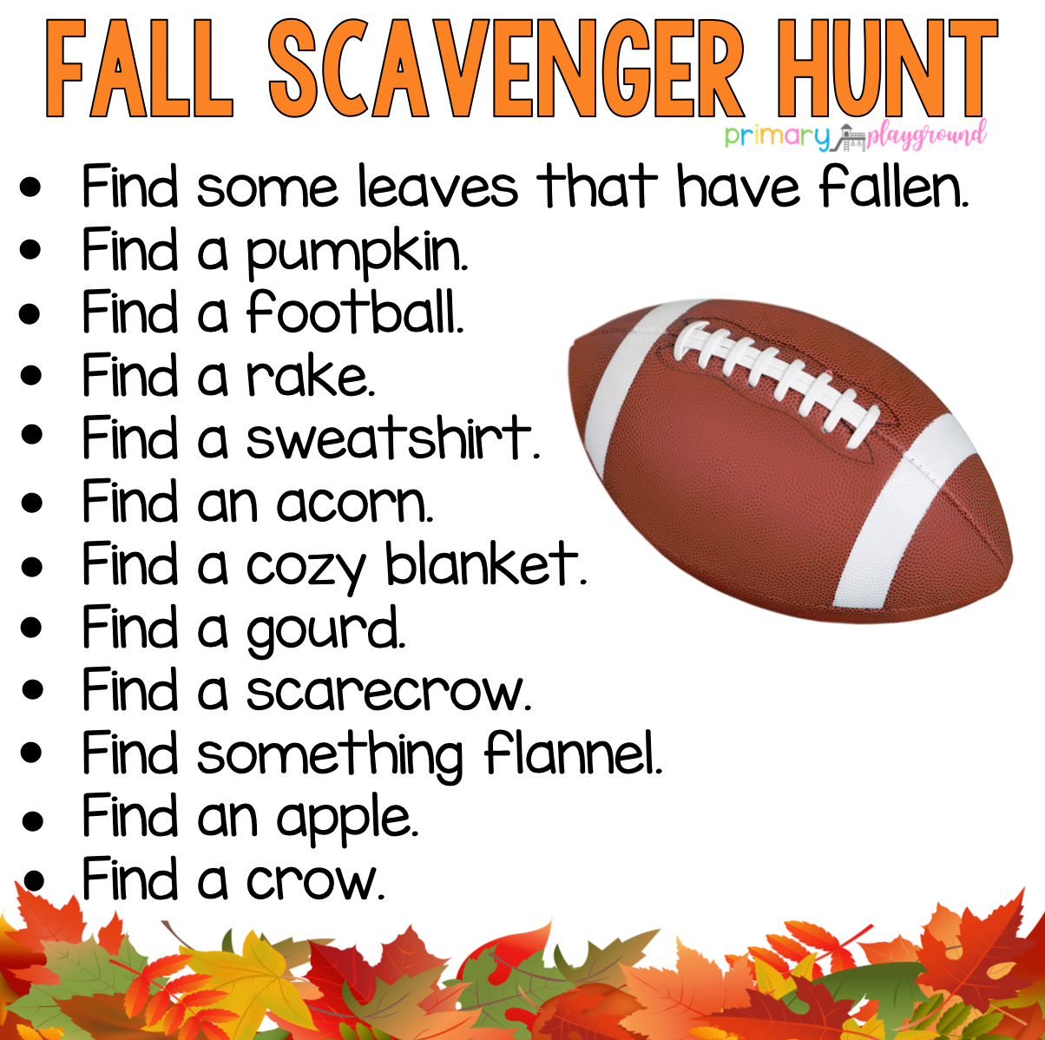 | Explore the alphabet game on Starfall  Starfall Main Image ABCs Index  Practice saying the alphabet with the Jolly Phonics sounds and actions | Have a grown-up read you a book. Talk about the different parts of the book….front cover, back cover, title page, and talk about what the author and illustrator do. Help your grown-up turn the pages and show them where to start reading on each page. | Create your own dance routine/  workout to one of your favorite songs!  Invite a family member to dance with you!  Have fun singing and dancing together! Feel your heart beating fast! Awesome workout!
Row 3 | Shape Shadow Match  https://www.education.com/game/match-sight-words  Try to draw or create shapes with playdough. | Listen to “Five Little Pumpkins”  Act it out and identify rhyming words in the poem.  https://www.youtube.com/watch?v=cm1qvX1ygOo | 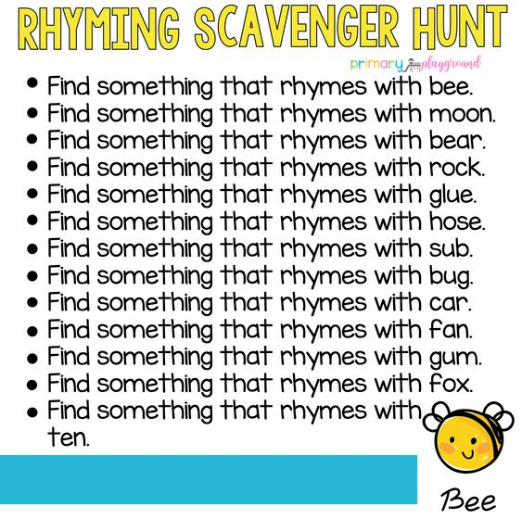 | Scholastic Let’s Find Out:  https://letsfindout.scholastic.com/issues/2020-21/100220.html  “Parts of a Pumpkin”  Watch Videos and Play Game | Missing Number Activity:  Write the following on a sheet of paper, on a wipe off board, or out on your driveway with sidewalk chalk and have your child fill in the missing number….  1, ___,3  5, ___,7  2, ___,4  3, ___,5
Row 4 | Alphabet Mud Puddle Game:  https://www.education.com/game/alphabet-mud-puddles/  Write the letters in the alphabet like this:  Aa Bb Cc Dd Ee……….  (and so on) | Use a dice to practice the skill of subitizing (saying the number out loud as soon as you roll the dice without having to count.  Example………  Your child would say three without counting the dots.  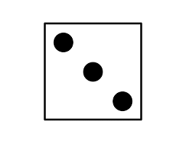 | Scholastic  Let’s Find Out:  https://letsfindout.scholastic.com/issues/2020-21/100420.html  “Sing a Song of Autumn”  Listen and Read magazine, Watch Videos, enjoy the Dance Break, and Play Game  Go for a walk with your grown up and look for signs of autumn! | “”Write your numbers 1-20 as best as you can!  Count by 10’s to 100  Sing along with” The Big Numbers” song:  https://www.youtube.com/watch?v=e0dJWfQHF8Y | Scholastic Let’s Find Out:  https://letsfindout.scholastic.com/issues/2020-21/100320.html  “Election Countdown”  Watch Videos and Play Game

Daily Tasks:
*Complete 1 or 2 pages in monthly Math Journal
*Complete 1 page in the Jolly Phonics Journal (write the letter, circle the letter in words, color picture)
*Review the Jolly Phonics Sound Book (name the letter, produce the sound, and make the action)
*Practice printing first and last name with only the first letter of each name printed with a capital letter
*Read a book with a family member. What is the setting? Who are the characters? What happened at the beginning, middle, and end of the story? Did you like the book? Why?
*Count objects with 1 to 1 correspondence:
*Count to 100 and beyond
*IXL Math for 15 minutes
*Go for a short wellness walk with a grown up
*Play a game, make a puzzle, or have fun playing with toys: be creative and have fun and clean up when you are finished playing!

Kindergarten Standards
Develops Alphabetic Awareness Understands How Print Works
Demonstrates Comprehension of a Story Read Aloud Learning Sounds That Letters Make
Talks With Others Attempts to Scribble/Write Letters
Listens and Responds to Others Learning to Follow Directions
Is Learning to Count Learning About Shapes
Separates Objects by Similarities and Differences Learning that Objects Can Be
Measured
Learning to Manipulate Objects with Hands and Fingers Shows Persistence
Makes Explanations about Science

Life Skills
Participates Willingly in Class Respects School and Classroom Rules
Listens to and Follows Directions Works Cooperatively
Initiates Own Play Activities Asks for Assistance When Needed
Respects Peers/Adults Is An Attentive Listener
Makes Appropriate Choices During Free Time Responsible for Personal Belongings
Responsible for Personal Hygiene Speaks in Complete Sentences
Demonstrates Self Control Plays Well With Others

