MCC Schools Census 2020 Help
(And a gift!)

Greetings MCC Schools parents! Have you completed the 2020 Census for your residence? If not, we can help!
What’s more…we’ll give you a $5 gift card for doing it!

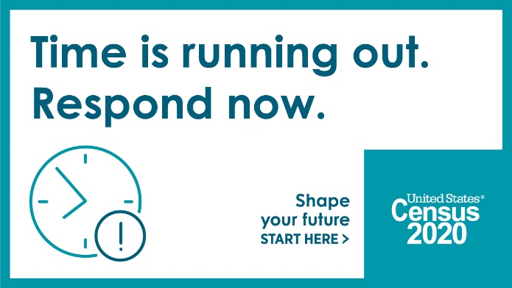
Mason County Schools are supporting the 2020 Census by encouraging school families to complete their online census questionnaire before the September 30 deadline.

The Scottville Area Senior Center, which is part of MCC schools, is partnering with us to offer census assistance.

Please call the senior center at 757-4705 to request assistance.

You can receive help in two ways:
- The center staff will make an appointment to help you at a table outside the senior center—observing proper virus protections.
- Or, if you prefer, a representative from the center will be glad to come to your home with a computer tablet to help you fill out your online census form.

We’ll get everything ready—all you have to do is answer the questions!
Think it’s complicated? Actually, it’s nine questions and takes about 10 minutes.

The more of us in Mason County respond to the census, the more we’ll benefit from funding for our local schools, roads, senior programs and more.

Please call 757-4705 to let us arrange an appointment at your convenience.
We will follow all health safety precautions.

Thank you.
Mason County Central Schools

