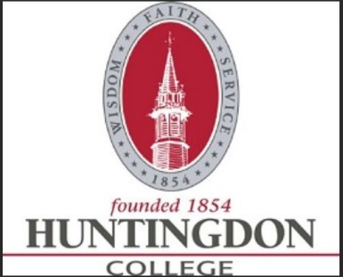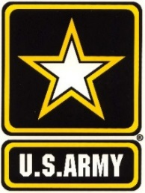

HUNTINGDON COLLEGE ARMY ROTC SCHOLARSHIPS

3yr and 2yr Scholarships

WHAT IS ROTC?
The Army ROTC Program is a college elective program that allows you to learn basic leadership skills while attending traditional college courses.

COMMON QUESTIONS:

- Do I have to go to Basic Training? NO!!!
- Do I have to wear a uniform every day? NO!!! You only wear a uniform during your ROTC class.
- How many hours is ROTC? ROTC classes are 1 to 2 hours, one day a week and we meet for physical training 4 mornings per week for 1 hour.

WHAT DOES THE SCHOLARSHIP PAY?
- Full Tuition and Fees OR Room and Board at $5,000 per semester ($10,000 per academic school year). Cadets can only choose one or the other.

- $600 a semester for books ($1200 per year).

- Monthly STIPEND of $420 per month excluding summers. This monthly stipend is also offered to those who are non-scholarship cadets.

INCENTIVES
- **$12,000 each semester that the student is enrolled in and taking the Huntingdon Army ROTC program
(**Subject to change each semester pending the college setting the amount. For information on this get with your admissions office for more details.)

FOR MORE DETAILS call Mr. Joe Masarik on my cell at (334)715-1440, or call our main office number at (334)244-3528, or email at jmasarik@aum.edu. You can as well contact Huntingdon’s admissions office directly for any questions.

Face Book: https://www.facebook.com/aumarmyrotc/posts/1569241276482326
Army ROTC: https://www.goarmy.com/rotc.html

