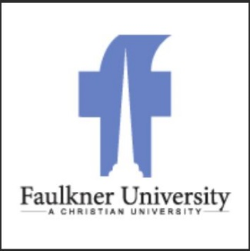

FAULKNER UNIVERITY ARMY ROTC SCHOLARSHIPS

3yr and 2yr Scholarships

WHAT IS ROTC?
The Army ROTC Program is a college elective program that allows you to learn basic leadership skills while attending traditional college courses.

COMMON QUESTIONS:

- Do I have to go to Basic Training? NO!!!
- Do I have to wear a uniform every day? NO!!! You only wear
a uniform during your ROTC class.
- How many hours is ROTC? ROTC is 1 to 2 hours, one day a
Week and meet for physical training 4 mornings per week for 1 hour.

WHAT DOES THE SCHOLARSHIP PAY?
- Full Tuition and Fees OR Room and Board at $5,000 per semester ($10,000 per academic school year). Cadets can only choose one or the other.

- $600 a semester for books ($1200 per year).

- Monthly STIPEND of $420 per month excluding summers. This monthly stipend is also offered to those who are non-scholarship cadets.

FOR MORE DETAILS call Mr. Joe Masarik at (334)715-1440, or call our main office number at (334)244-3528, or by email at jmasarik@aum.edu

Face Book: https://www.facebook.com/aumarmyrotc/posts/1569241276482326
Army ROTC: https://www.goarmy.com/rotc.html

