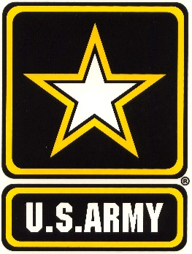

ASU ARMY ROTC SCHOLARSHIPS & INCENTIVES
ROTC Scholarships

WHAT IS ROTC?
The Army ROTC Program is a college elective program that allows you to learn basic leadership skills while attending traditional college courses.

COMMON QUESTIONS:

- Do I have to go to Basic Training? NO!!!
- Do I have to wear a uniform every day? NO!!! You only wear a uniform during your ROTC class.
- How many hours is ROTC? ROTC is 1 to 2 hours, one day a week for classroom instruction and we meet for physical training 4 mornings per week for 1 hour.

WHAT DOES THE SCHOLARSHIP PAY?
- Full Tuition and Fees OR Room and Board at $5,000 per semester ($10,000 per academic school year). Cadets can only choose one or the other.

- $600 a semester for books ($1200 per school year).

- Monthly STIPEND of $420 per month excluding summers. This monthly stipend is also offered to those who are non-scholarship cadets.

- NURSING STUDENTS – Will get an additional one time $600 Nursing Stipend to buy needed equipment.

INCENTIVES
- FREE BASE LEVEL ROOM ONCE YOU ARE APPROVED FOR THE ARMY SCHOLARSHIP (IF ROOMS ARE AVAILABLE)

ROTC WEBSITES
www.goarmy/rotc
https://www.troy.edu/armyrotc/

FOR MORE DETAILS call (334)715-1440, Troy’s ROTC Department at (334)670-5623, you can email us at armyrotc@troy.edu, or just stop by our office located at 720 Elm Street, Troy, AL 36082

