Canvas Login from Any Device (Not Phone)

Step 1:
- Open Google Chrome on your device
- Click on the blue “Sign In” button in the upper right hand corner.
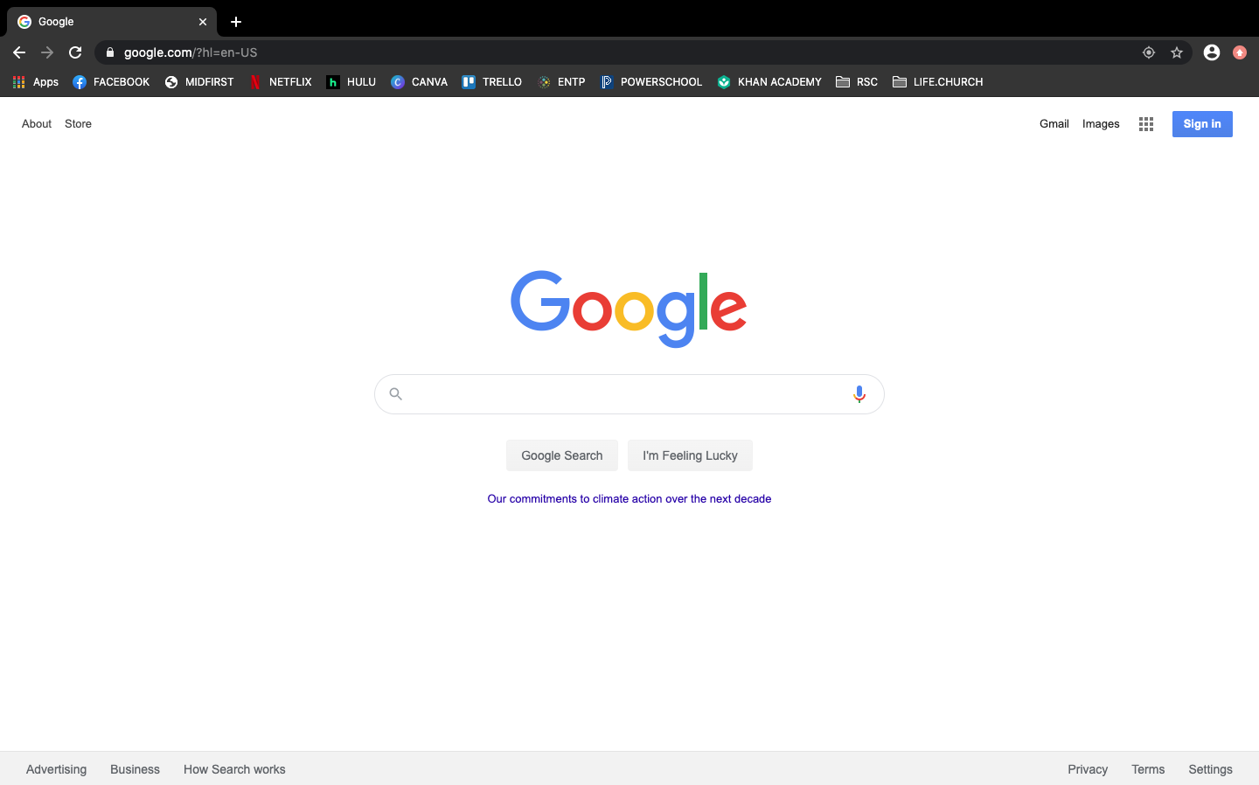
Step 2:
- Fill in your username. It will (usually) be your first name and Google number, ex. Jude3729. This is also the first part of your school email. School email is firstnameGooglenumber@mid-delonline.net. Example: jude3729@mid-delonline.net
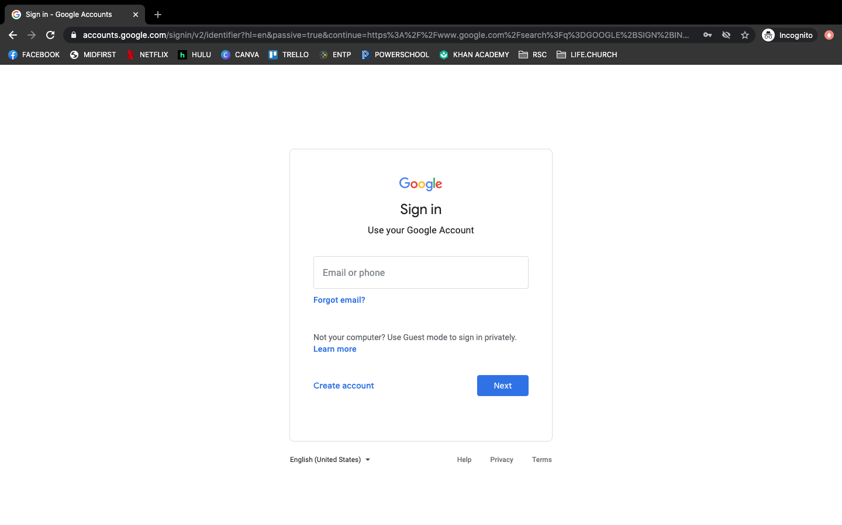
Step 3:
- Press “Next” and enter your password.
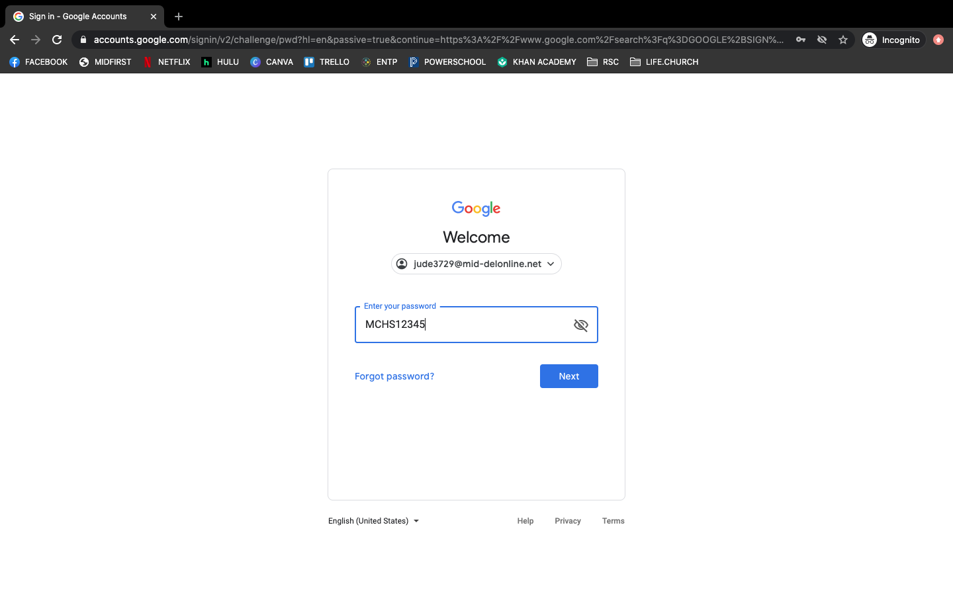
Step 4:
- If you have not set up your password yet, then your password is “password”.
- If you used “password”, then you will have to set a new password.
Recommend a secure password that you do not use for other accounts.
We recommend using MCHS followed by your Student ID Number.
- Once you enter your password, you will be logged into Google.
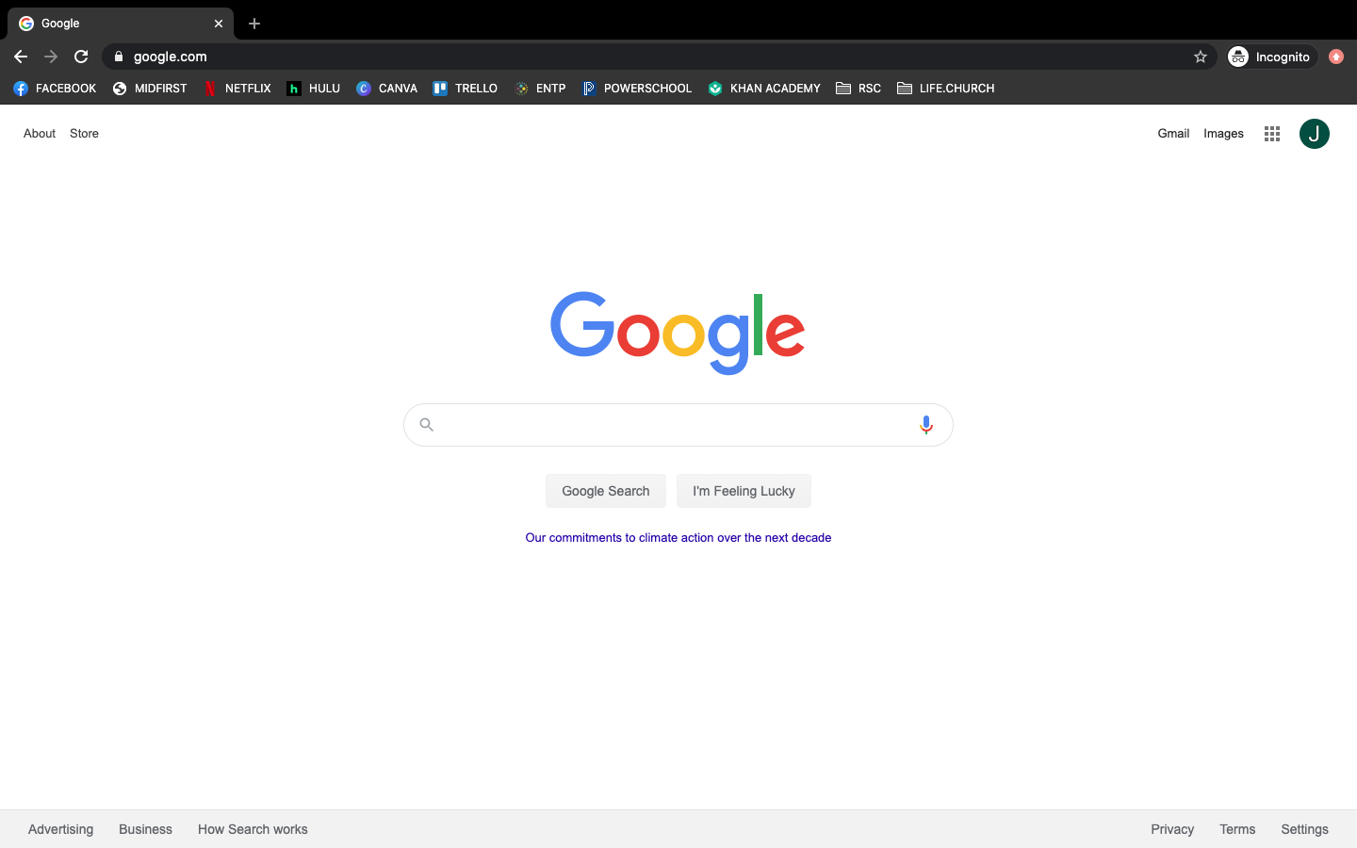
Step 5:
- Once you have logged into Google, click on the “waffle” icon (the 9-square grid near the top right of the page)
- 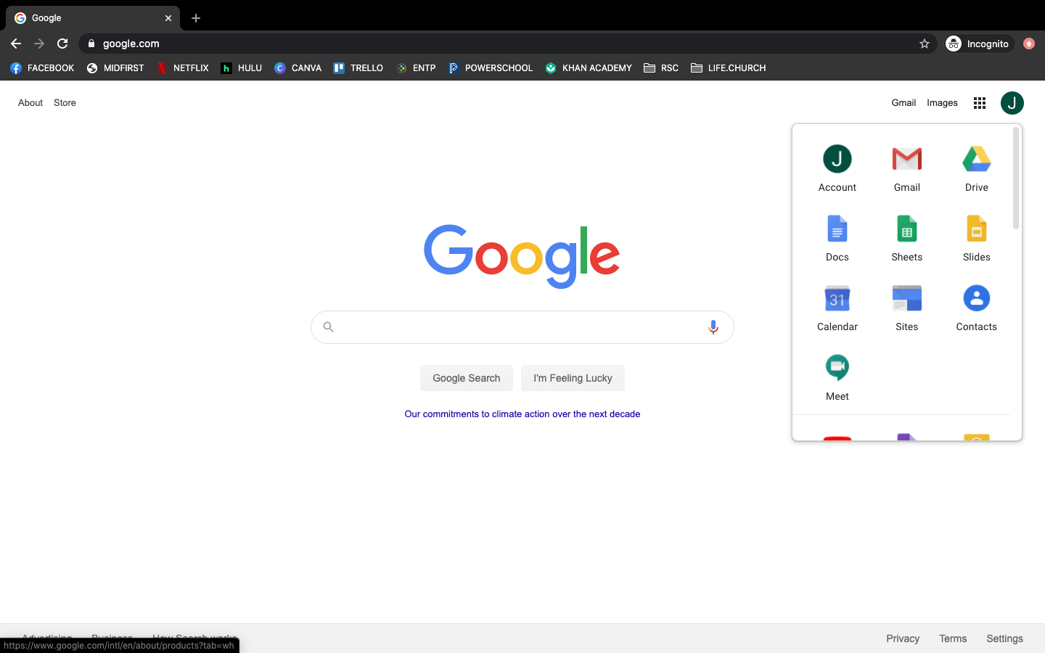

Step 6:
- Scroll down until you see Canvas.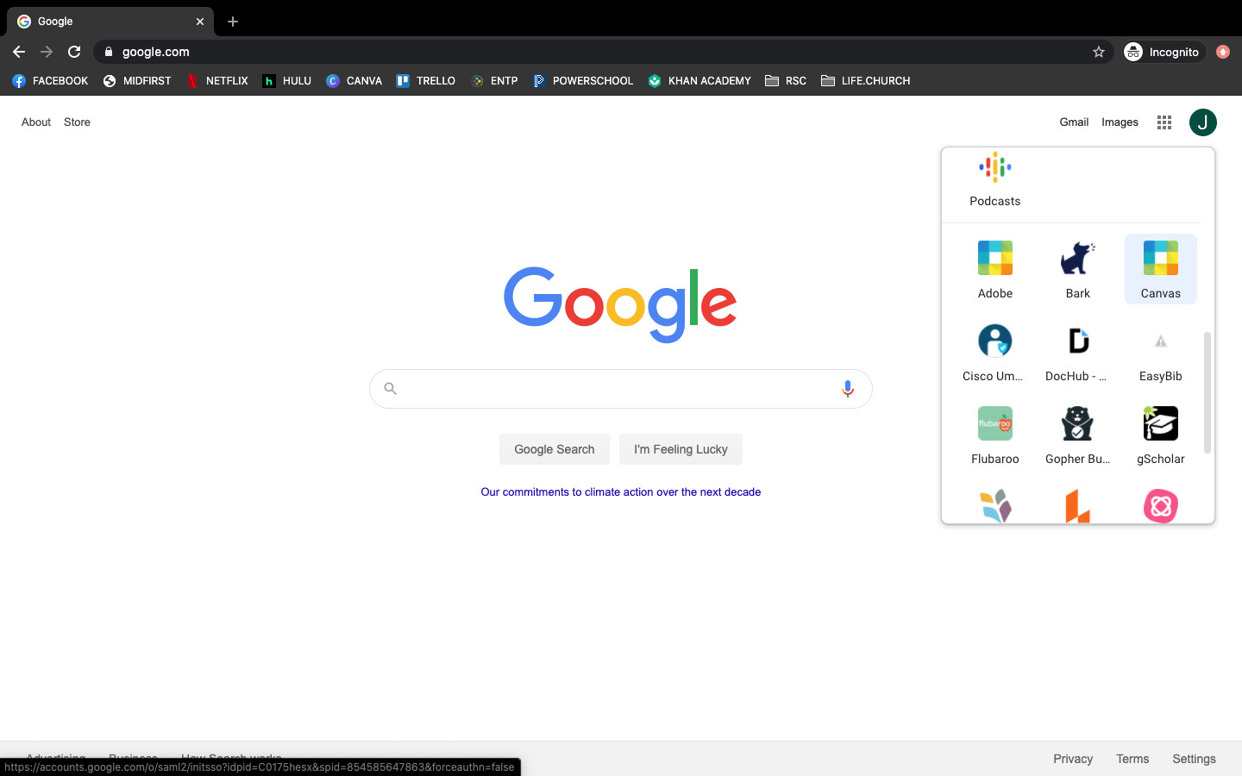
Step 7:
- Click on the Canvas button to log into your Mid-Del Canvas account.

- Once you are logged into Canvas, you will see a screen that has all of your classes listed.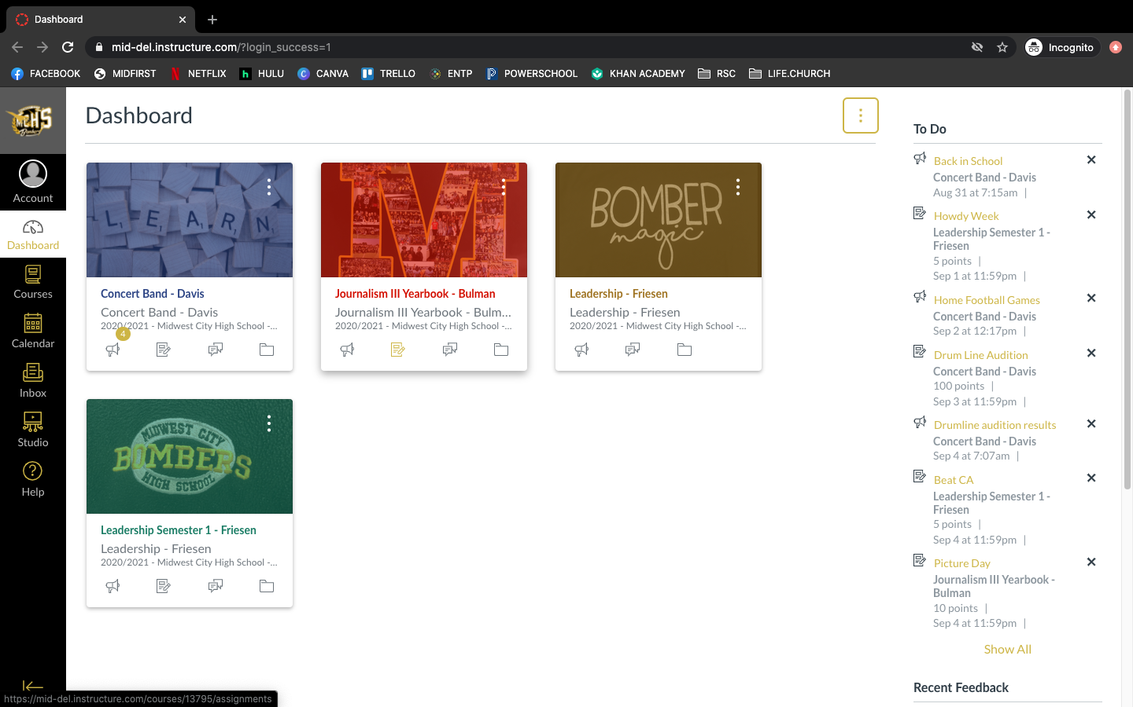

Step 8:
- Click on a course.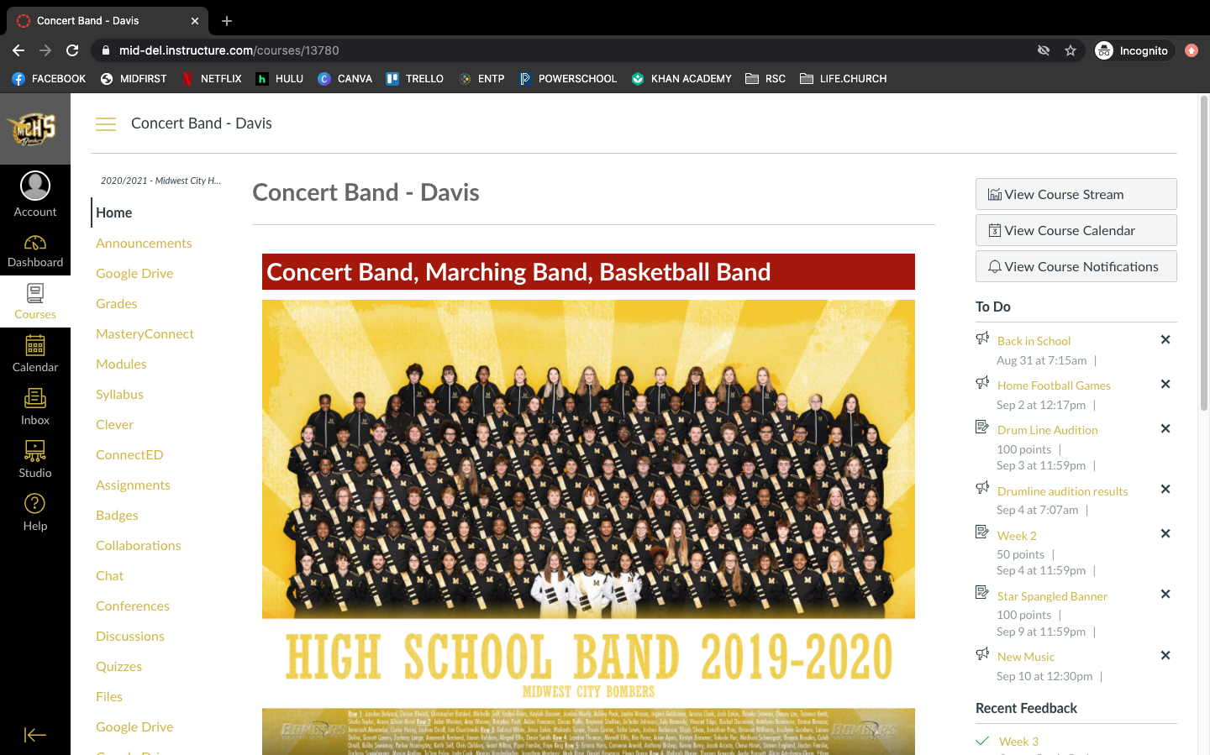
Step 9:
- On the menu on the left side of the screen, click on the “Modules” Option. 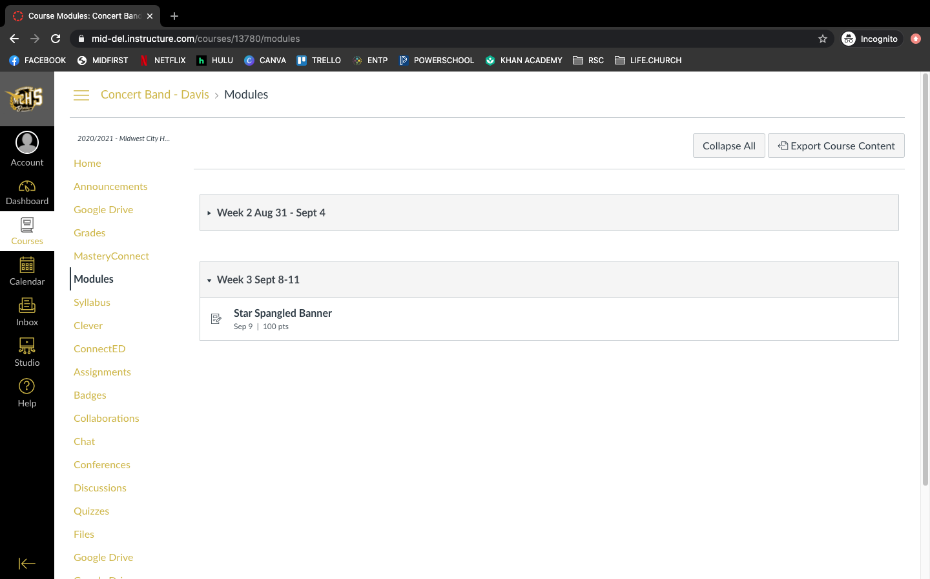
- This is where you will be able to view individual assignments and their due dates.

