September is National Suicide Awareness month
Did you know Suicide is the second leading cause of death for young people between ages 10 to 24.
If you or someone you know is in an emergency, call The National Suicide Prevention Lifeline at 800-273-TALK (8255) or call 911 immediately.

https://suicidepreventionlifeline.org/
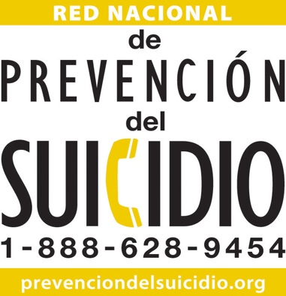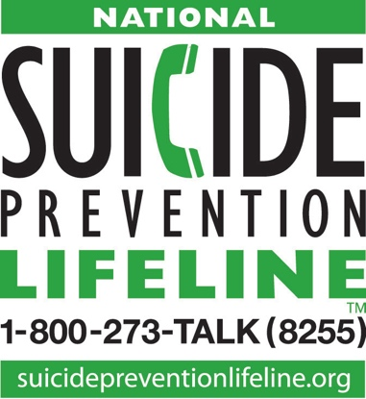
Call the NAMI Helpline at
800-950-NAMI
Or in a crisis,
text "NAMI" to 741741

