Creating Classes for My BrainPOP
You will need a My BrainPOP teacher account in order to create classes. If you need help creating a My BrainPOP teacher account, please see the step guide Creating a My BrainPOP Teacher Account.

1) Go to www.brainpop.com, www.brainpopjr.com, or www.brainpopesl.com and click on the LOG IN button in the upper right-hand corner of the screen. | 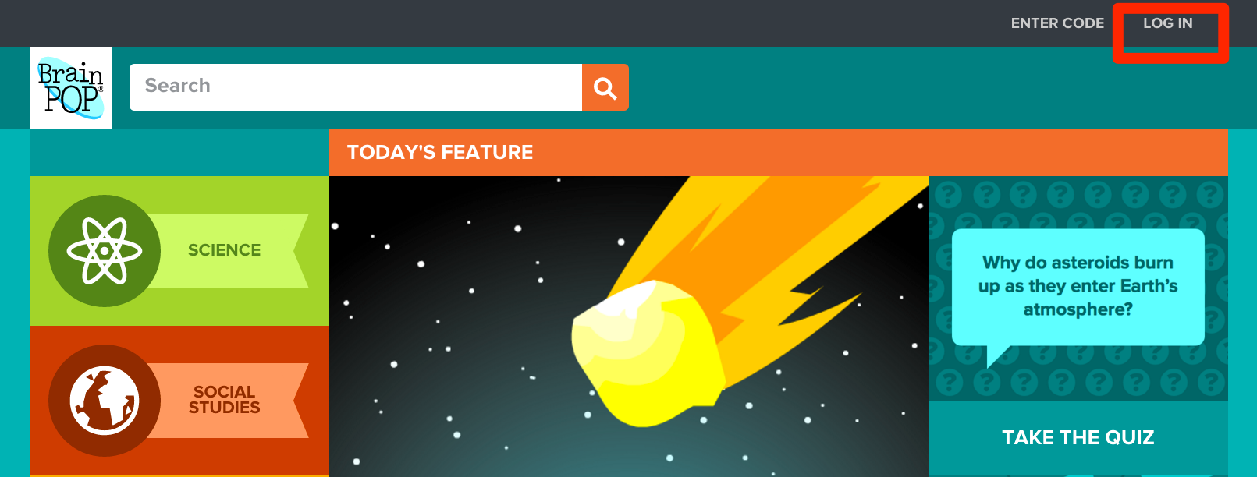  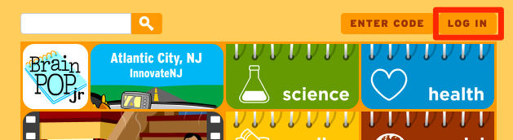
2) Enter your personal My BrainPOP username and password - not your school’s. | 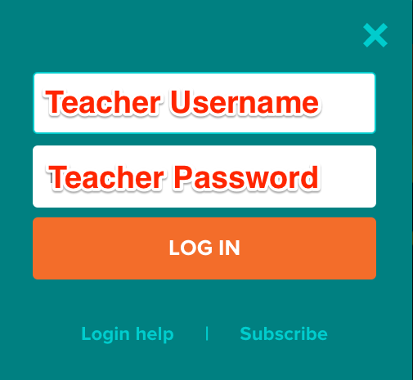  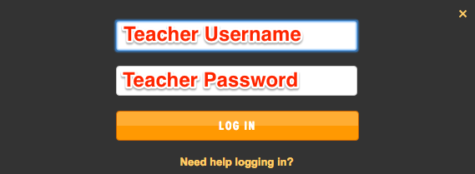
3) When you’re logged in to BrainPOP, you’ll now see a MY CLASSES button at the top of the screen. Click this button and move to step 5.  When you’re logged in to BrainPOP Jr. or BrainPOP ESL you will see a MY BRAINPOP button. Click this button and move to step 4. | 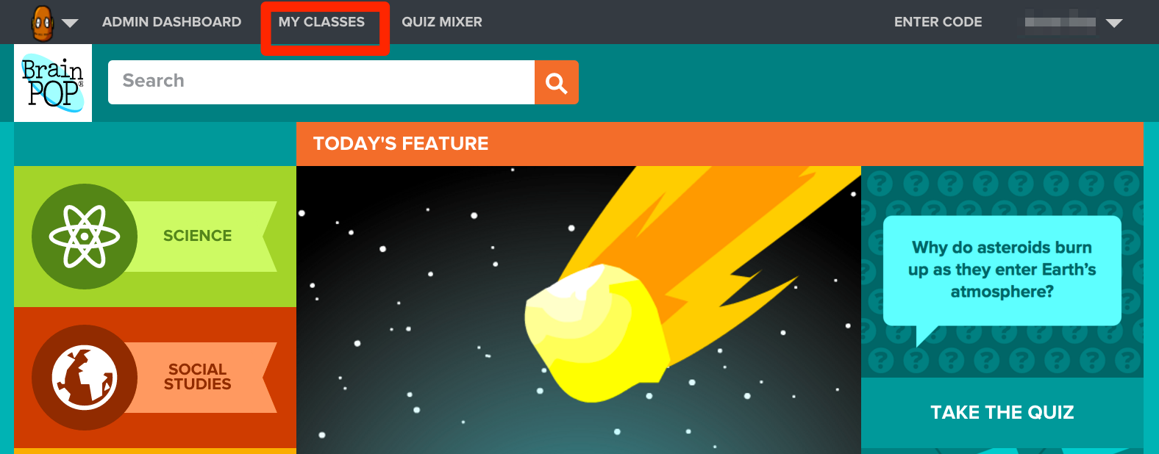  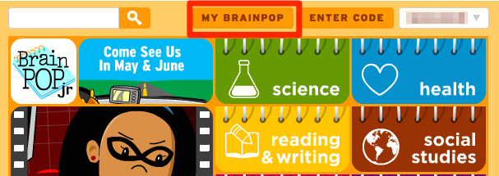
4) BrainPOP Jr. and BrainPOP ESL users only: Clicking on the MY BRAINPOP button will reveal MY CLASSES. Click MY CLASSES. | 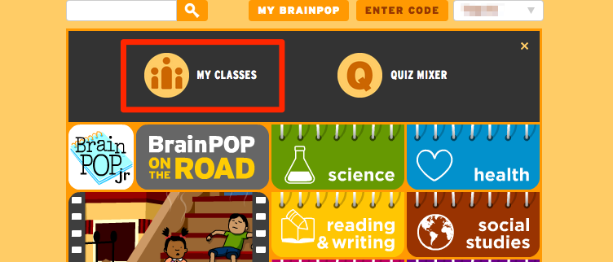  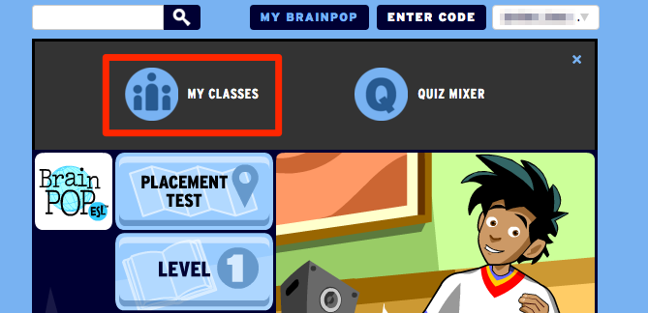
5) If you’ve never created a class before, you’ll be taken to a quick tour. You're welcome to skip that tour and start creating your class right away. You can also advance through the tour at your own pace using the left arrow, then create a class at the end of it. | 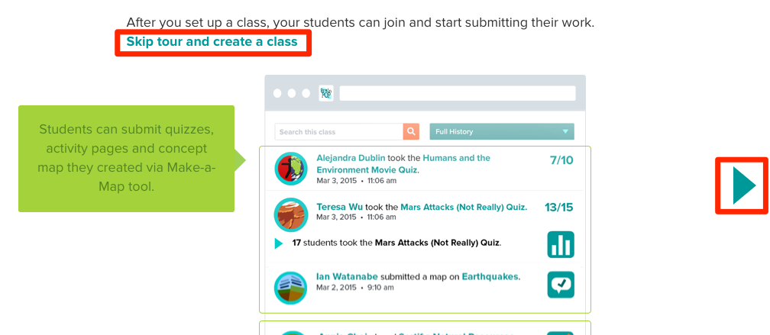  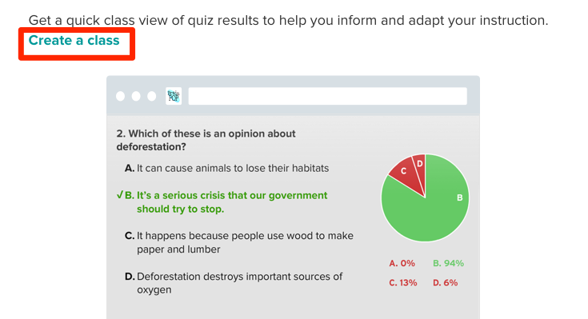
6) In the CLASS NAME box, create a title for your class. It should be similar to what would appear on a school schedule list.  In the CLASS CODE box, give your class a unique nickname, with no spaces. It should be relatively easy to remember and something that’s appropriate to share with your students. If what you enter is already in use, you’ll be prompted to try another one. | 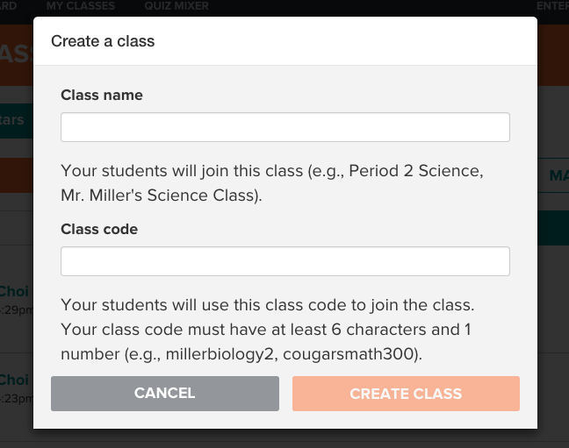
7) To have students join your class, see our Creating a My BrainPOP Student Account.

©BrainPOP. All rights reserved.
For information on BrainPOP trademarks & copyrights, visit brainpop.com/trademarks.

