Creating Assignments With My BrainPOP
You will need a My BrainPOP teacher account in order to create assignments. For help creating a My BrainPOP teacher account, please see the step guide Creating a My BrainPOP Teacher Account.

1) Go to brainpop.com or brainpopjr.com and click on the LOG IN button in the upper right-hand corner of the screen. | 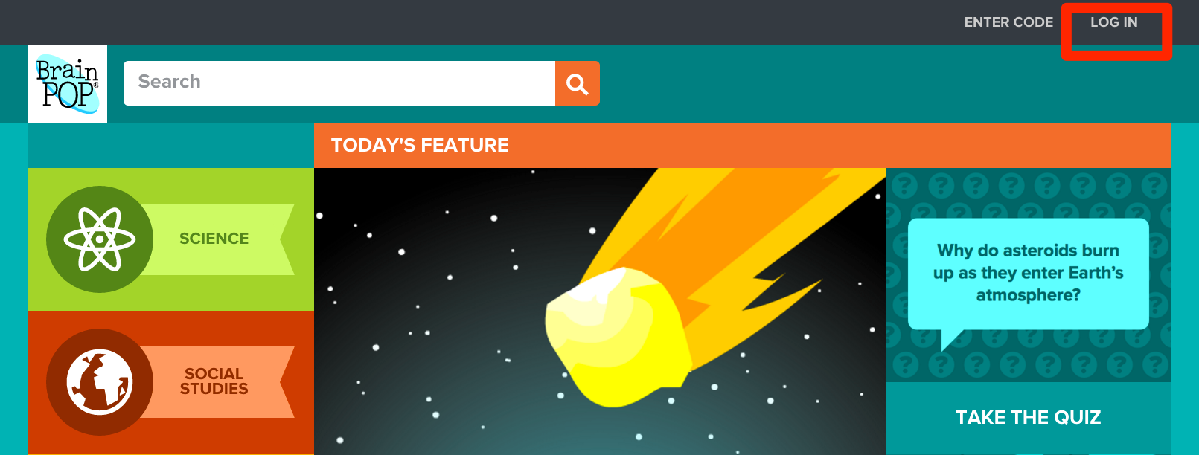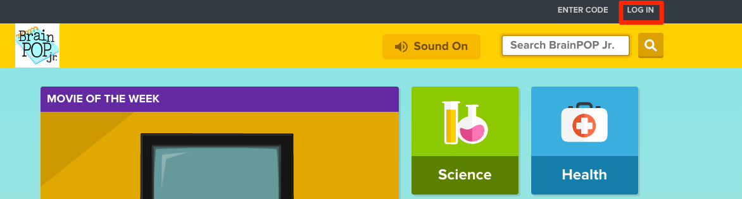
2) Enter your personal My BrainPOP username and password - not your school’s. | 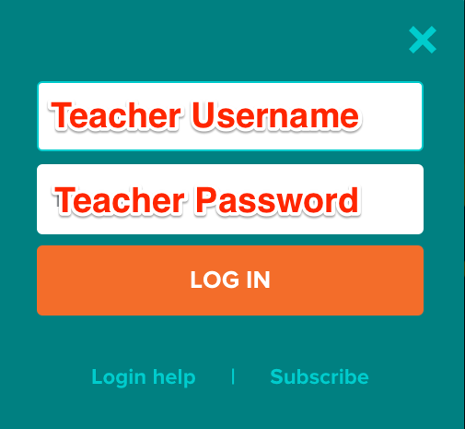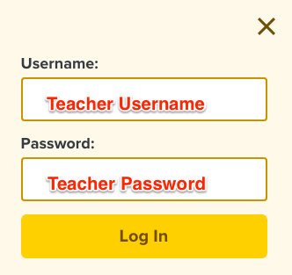
3) To assign a task to students, navigate to a topic you want your students to work on, select the feature you want to assign, and click the ASSIGN button.  You can assign nearly everything on BrainPOP and BrainPOP Jr., including quizzes, concept maps, individual activity pages, games, and the FYI. | 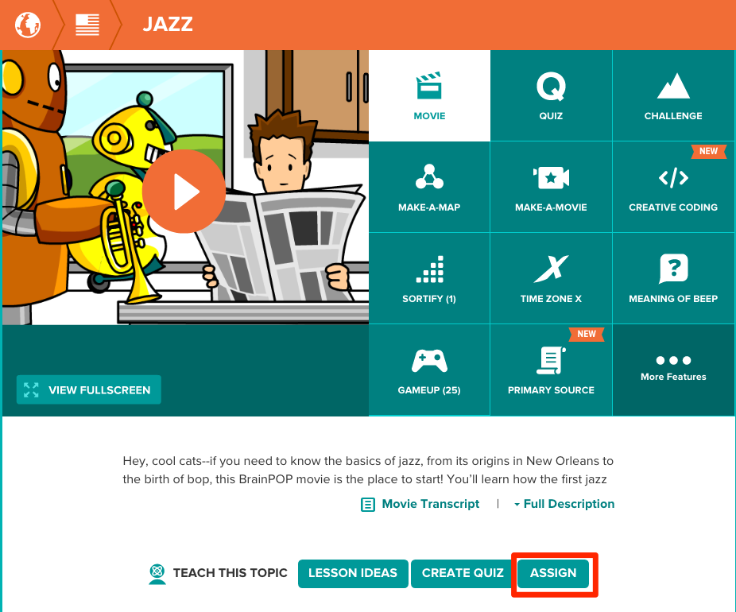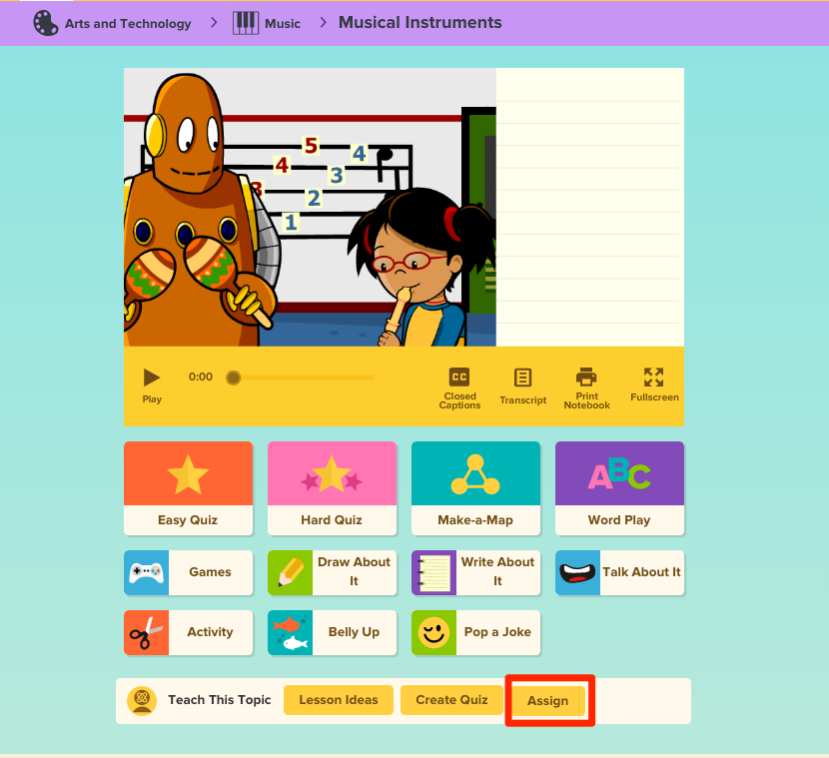
4) You can just assign one movie or feature, like a quiz, or you can open the Assignment Builder to add more to the assignment.  We’ll walk you through assigning one movie or feature first. | 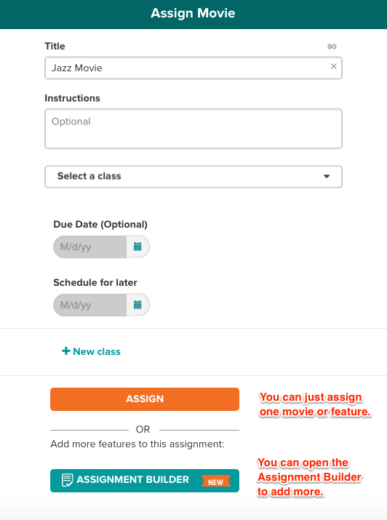
5) Select the class whose students will be completing the assignment. Choose whether you’d like to assign it to the entire class, or only to specific students.  You can also change the title of your assignment, provide instructions, set a due date, or schedule when the assignment will be sent to the students.  To assign this to more than one class, click + NEW CLASS.  When you’re finished, click ASSIGN. | 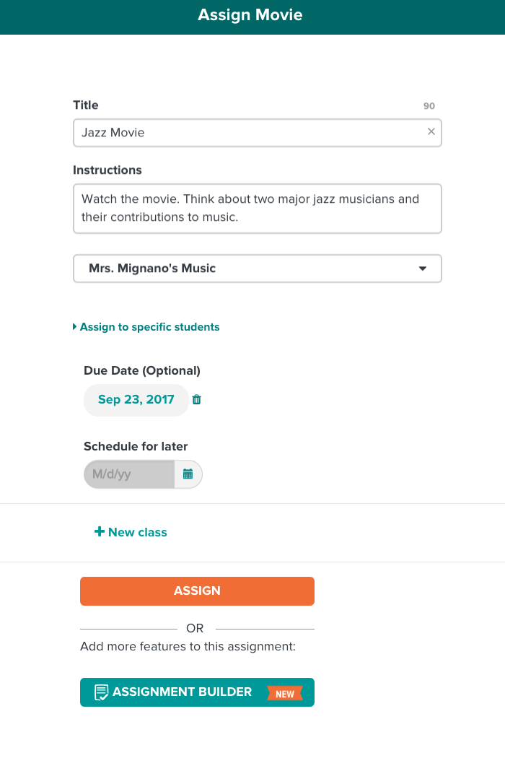
6) You’ll receive a message confirming that you’ve done so successfully. | 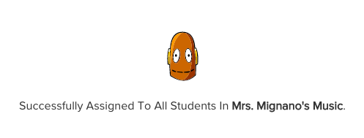
7) If you want to combine different tasks into one assignment, click ASSIGNMENT BUILDER. | 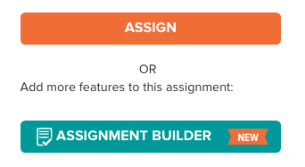  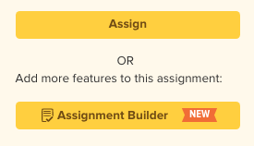
8) The tool will load all the topic’s available features.  Select the features you want in your assignment.  To add features from other topics, click on ADD TOPIC. | 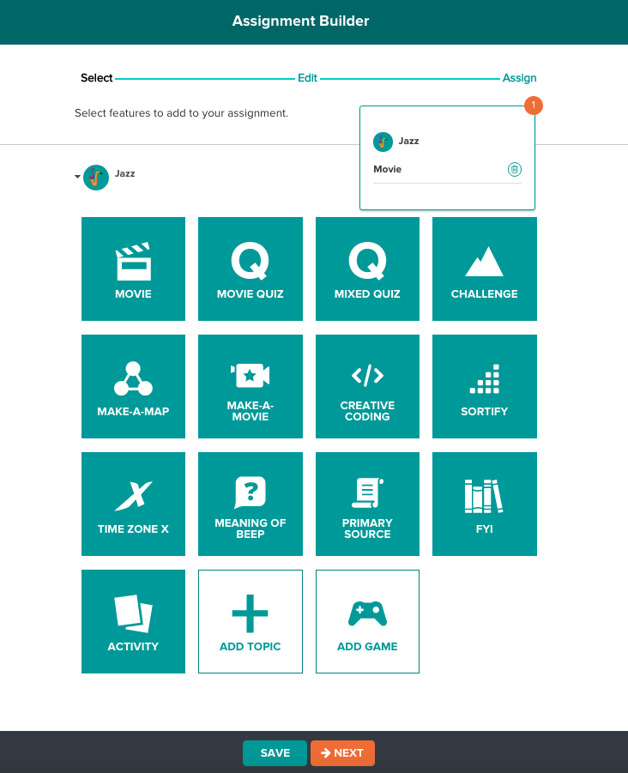  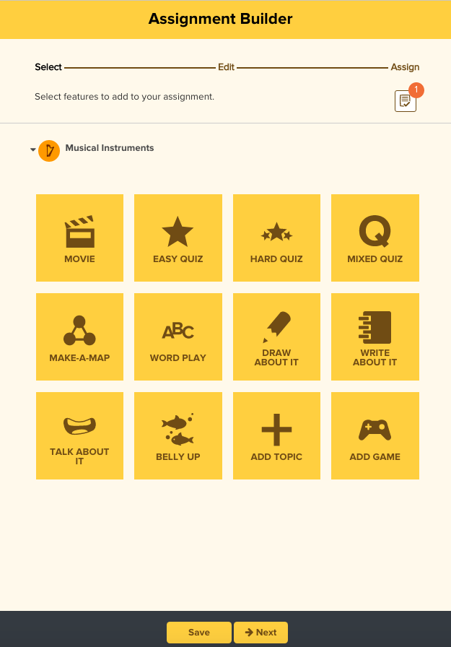
9) Select the topics and related features you’d like to add. They will load automatically.  You can include a combination of BrainPOP and BrainPOP Jr. topics if your school subscribes to both sites. | 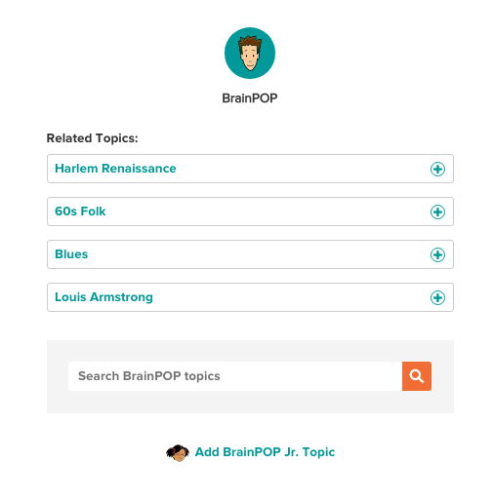  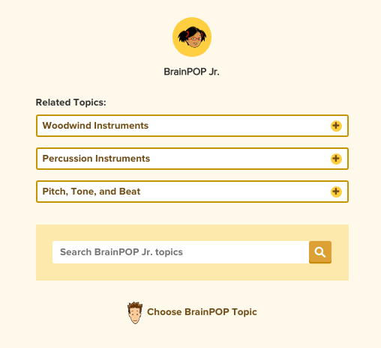
10) After you’ve selected the topics and features you’d like to include, you can reorder them by clicking and dragging. To remove an activity, click the TRASH CAN icon to the right.  Click NEXT. | 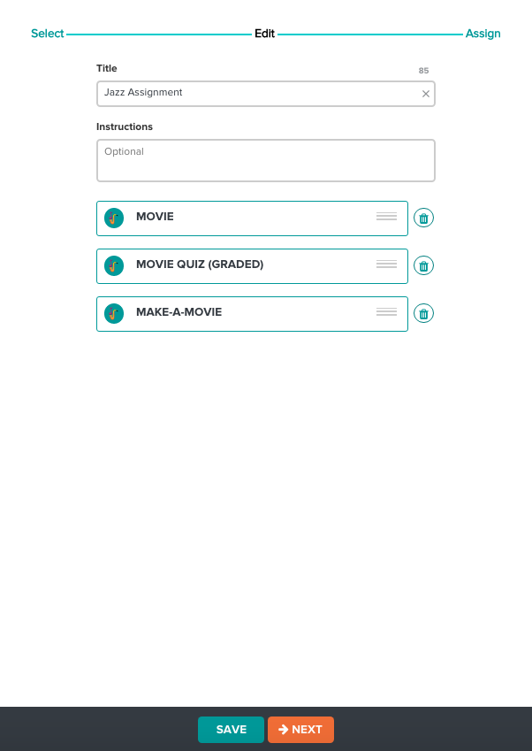
11) Confirm the assignment’s details and click ASSIGN. | 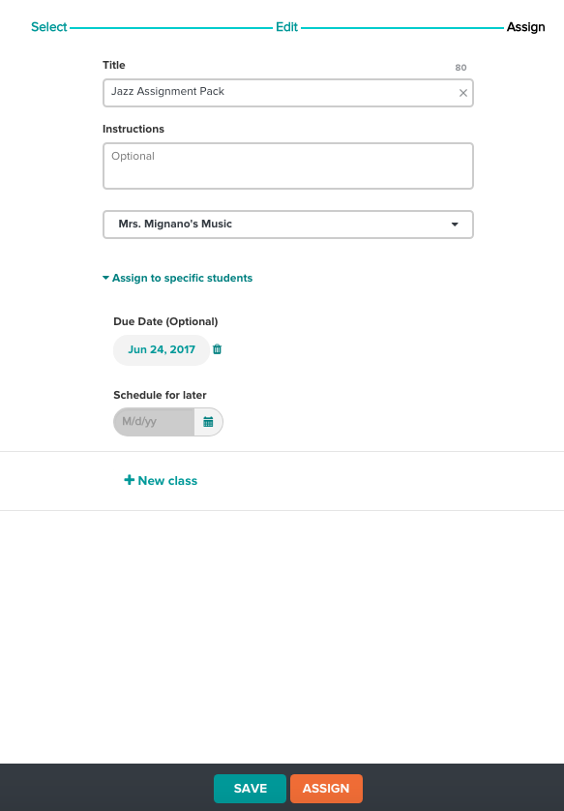
12) To manage your assignments, click the ASSIGNMENTS button at the top of the screen. | 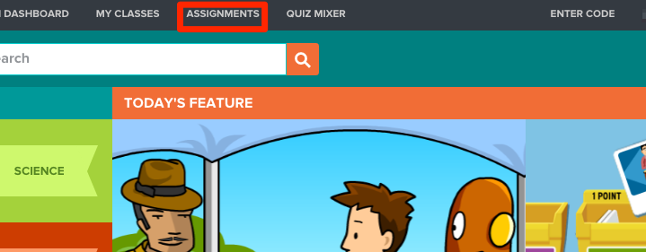  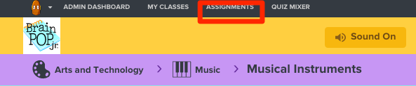
13) To see an assignment’s details, click the small BLUE ARROW that appears to the left of the topic at hand.  To assign the task to a new class or students without making any changes, click ASSIGN TO NEW CLASS.  To update the due date or assignees, click on the class name or the PENCIL icon. | 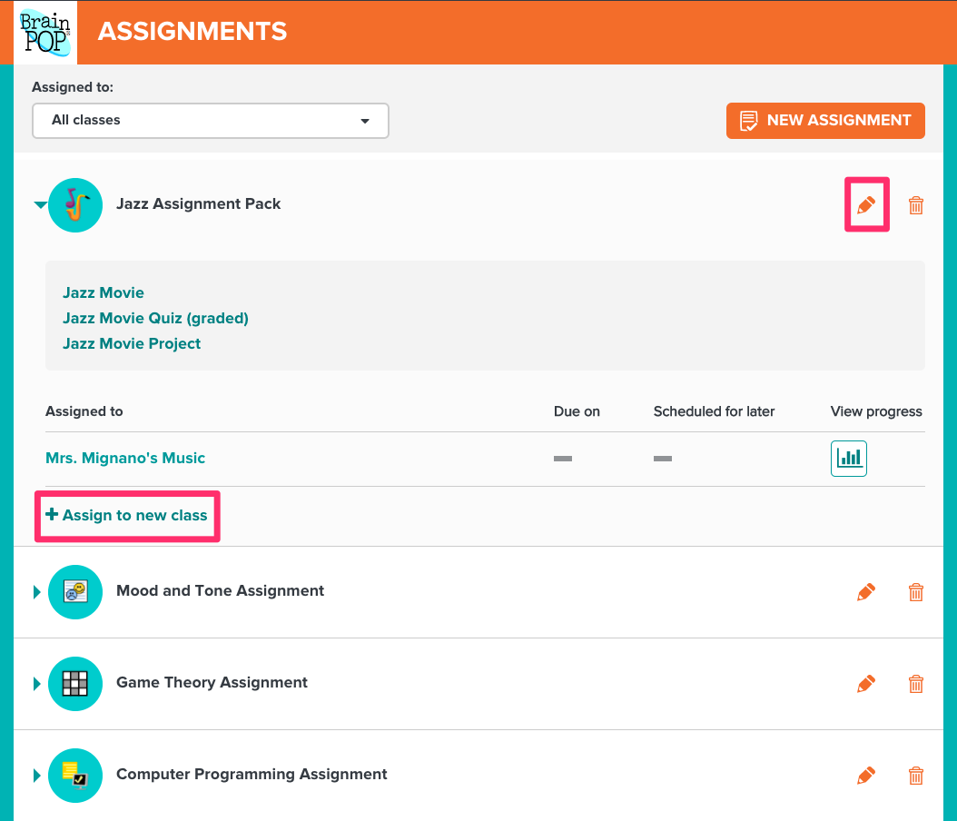
14) After making the desired changes, click the UPDATE button.

15) You’ll receive a message confirming that you’ve updated the assignment. | 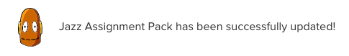
16) To see class progress on an assignment, click on the GRAPH icon. | 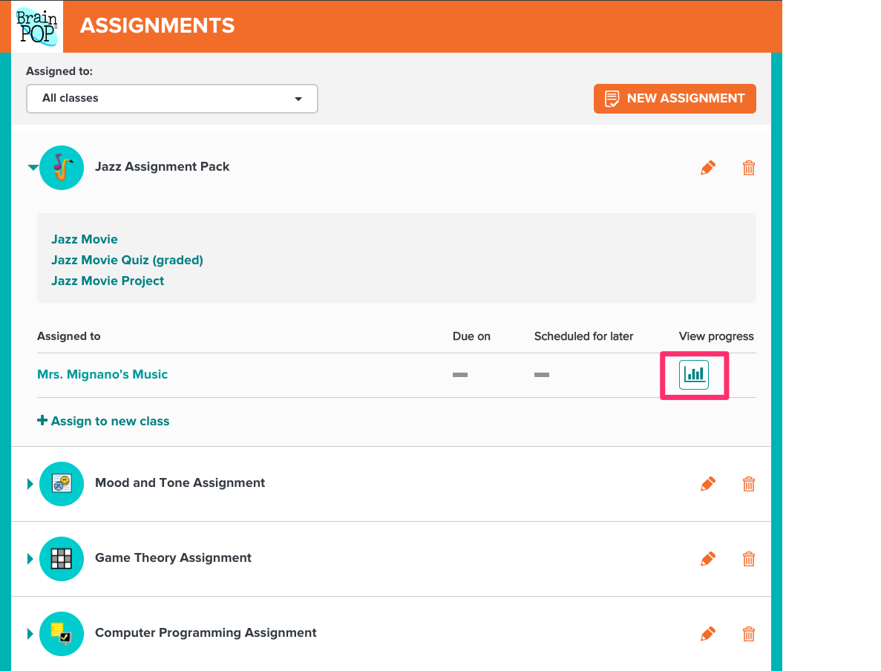
17) You’ll see a chart showing who has completed the assignment, who are in progress, and who have not submitted any work.  If there’s a quiz in your assignment, you’ll see the scores here. For quizzes and certain games, you can click on the GRAPH icon to view a class summary of students’ answers or gameplay.  You’ll be able to click on the speech bubble icon to review and give feedback on work. | 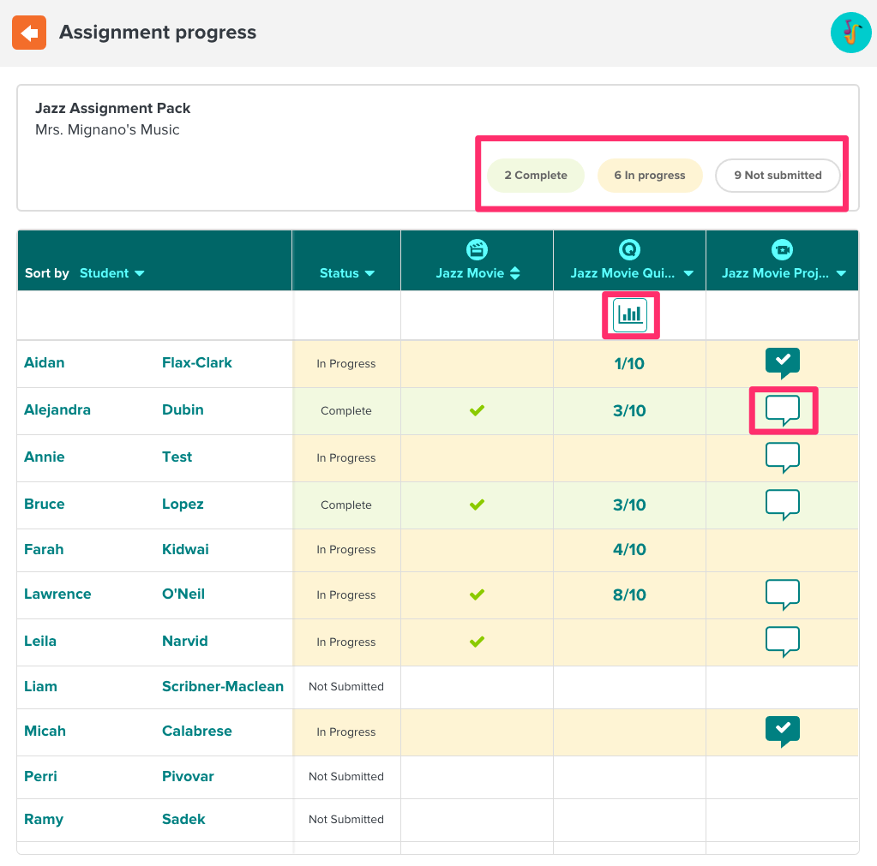
18) To complete the assigned tasks, students will need to log in to BrainPOP or BrainPOP Jr. with their individual usernames. | 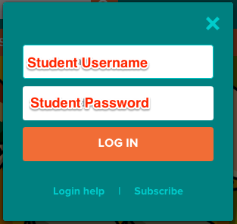  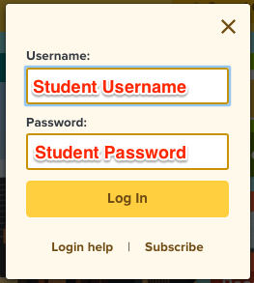
17) Upon logging in, students will receive an alert in the upper right hand corner letting them know they have assignments to complete.  To access their assignments, students can either click GO TO MY BRAINPOP in the alert box, or click MY BRAINPOP at the top of their screen. | 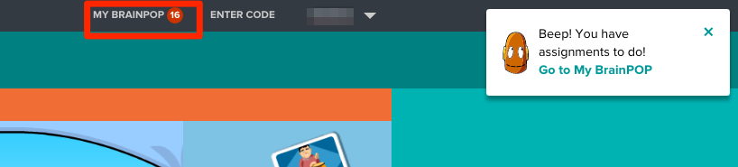
18) From the My BrainPOP feed, students will then click the ASSIGNMENTS button. Here they’ll see a list of all assignments, both upcoming and overdue. Students can still submit work if it’s overdue.  To complete their assignments, students will click the blue link next to each topic icon.  When students watch an assigned movie or take an assigned quiz, their activity will be submitted to you automatically.  When working on features like concept maps or SnapThought written reflections, students can manually submit work when they’re ready - these will not be submitted to you automatically. | 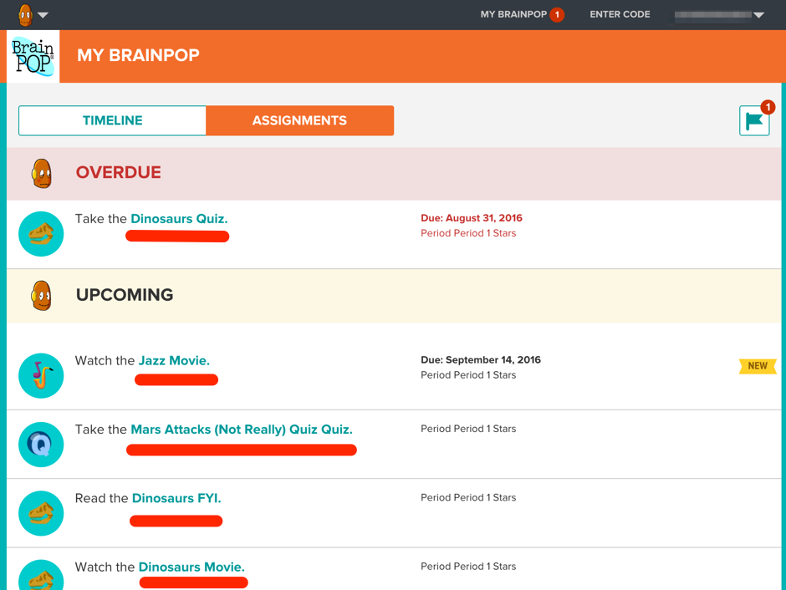

©BrainPOP. All rights reserved.
For information on BrainPOP trademarks & copyrights, visit brainpop.com/trademarks.

