Creating a My BrainPOP Teacher Account
To begin, you will need an “educator code” that will connect your new
personal account to your specific school. To get your “educator code,”
ask the BrainPOP contact at your school or go to www.brainpop.com , www.brainpopjr.com or www.brainpopesl.com and click ENTER CODE.
Select WHAT’S A CODE, then NEED HELP GETTING AN EDUCATOR CODE?, and BrainPOP’s system will help you find it.*

When you have the “educator code,” follow the directions below.
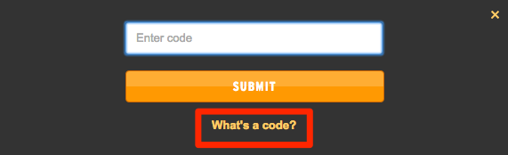

Educator Code ____________

1) Go to www.brainpop.com or www.brainpopjr.com and click on ENTER CODE. | 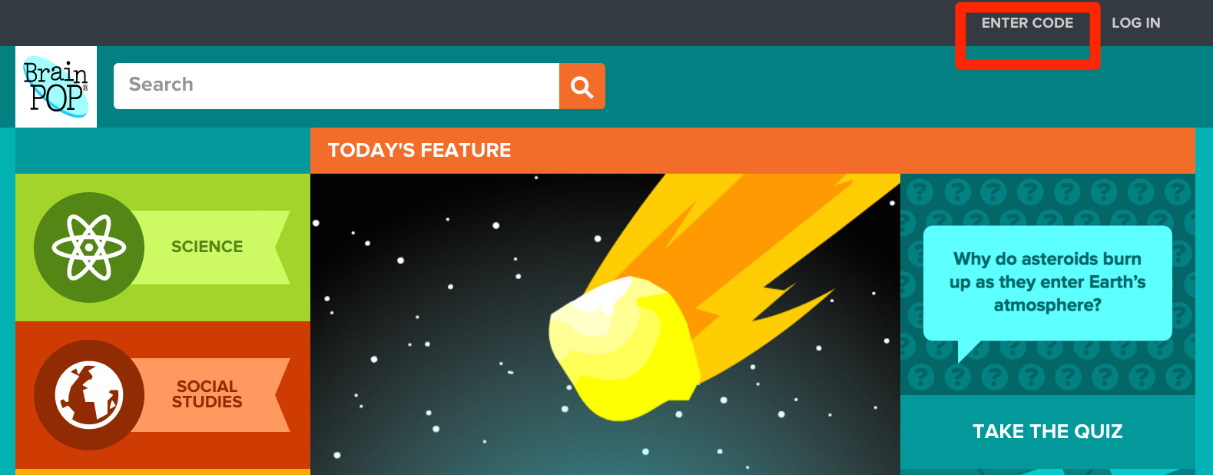  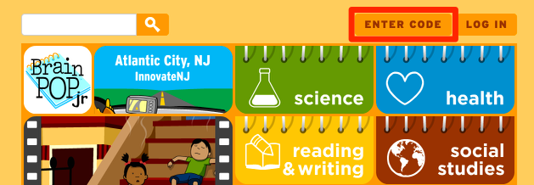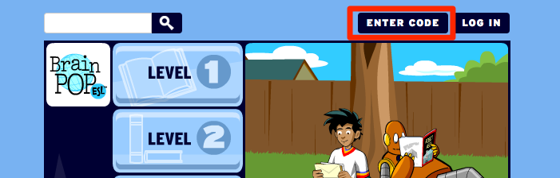
2) Enter your educator code in the box. | 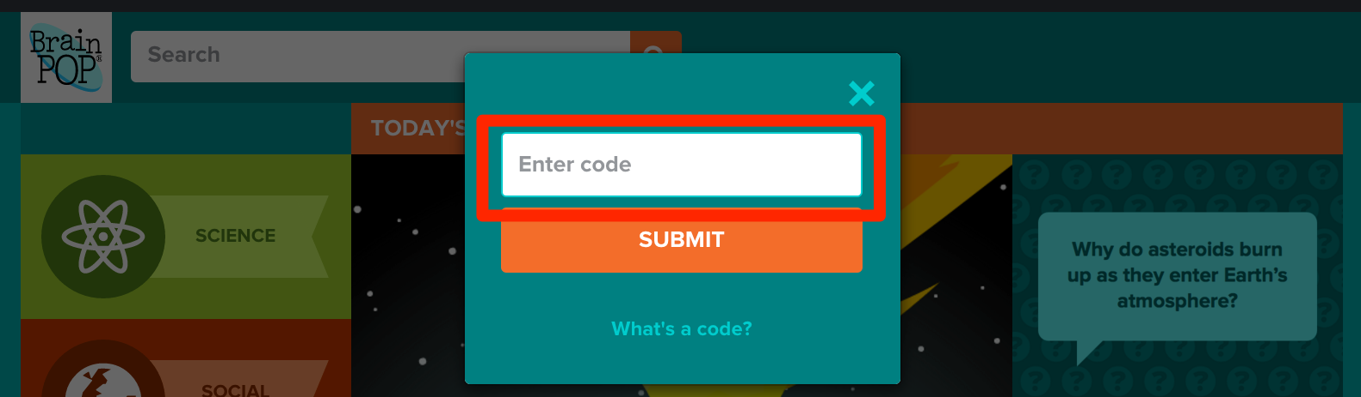  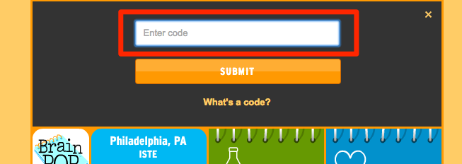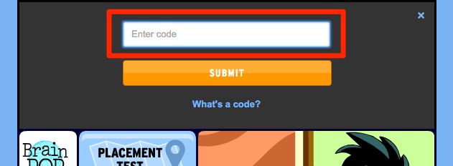
3) You’ll be prompted to complete the registration form to create your own account.  If creating a new account, complete the form and then click Create Account. A verification email will be sent to the email address you provided.  If you already have a My BrainPOP account associated with a different school, you may continue to use it; you’ll just need to relink it to your new school. To do so, simply click LOG IN and follow the prompts. | 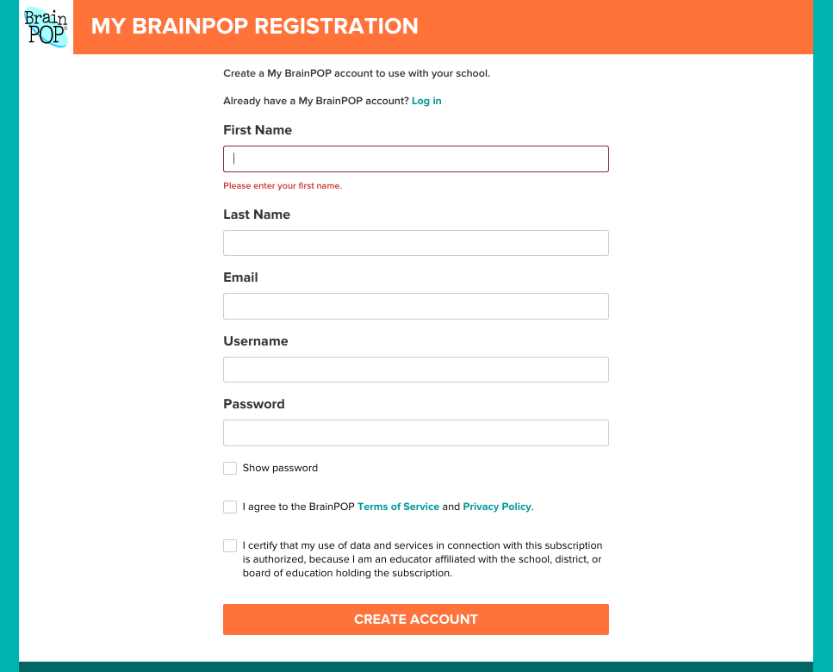
4) Verification emails often land in spam folders, so be sure to check there if you do not receive the email in your inbox. | 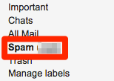
5) After activating your personal account, be sure that’s the one you log in with. Do not use the school’s generic username and password or you won’t be able to access all of My BrainPOP’s features. | 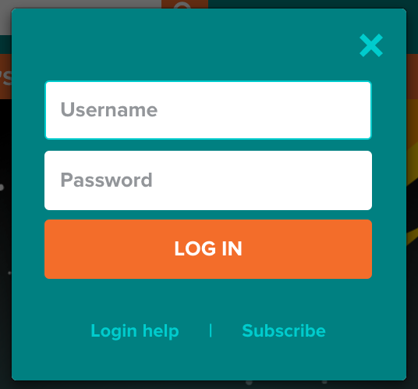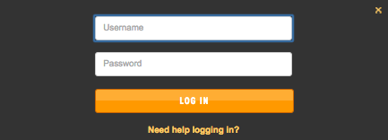
*If you have trouble obtaining your educator code or need assistance, don’t hesitate to email: mybrainpop@brainpop.com or call our help line at 866.542.7246.

©BrainPOP. All rights reserved.
For information on BrainPOP trademarks & copyrights, visit brainpop.com/trademarks.

