Creating a My BrainPOP Student Account
Students can join multiple classes with one My BrainPOP username.
1) Go to www.brainpop.com, www.brainpopjr.com, or www.brainpopesl.com and click on the ENTER CODE button in the upper right-hand corner of the screen. | 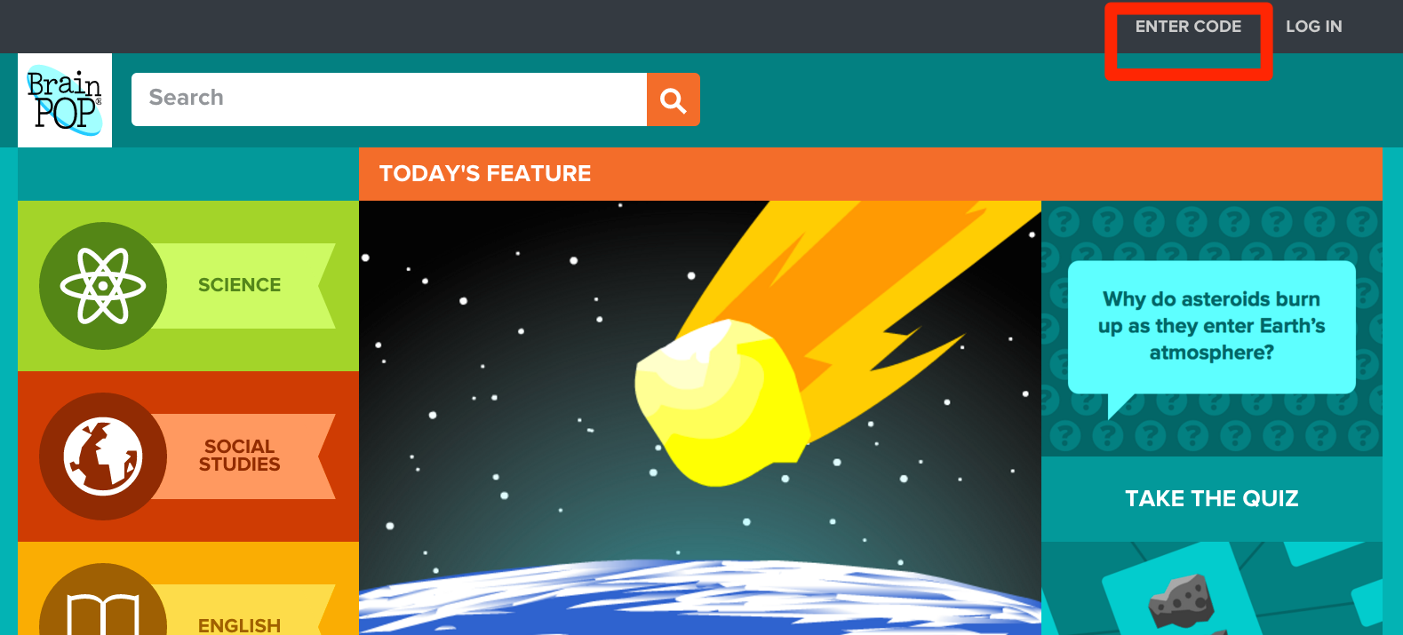  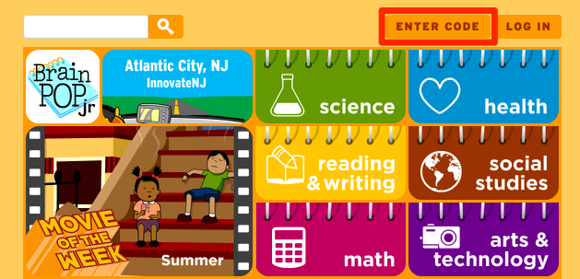  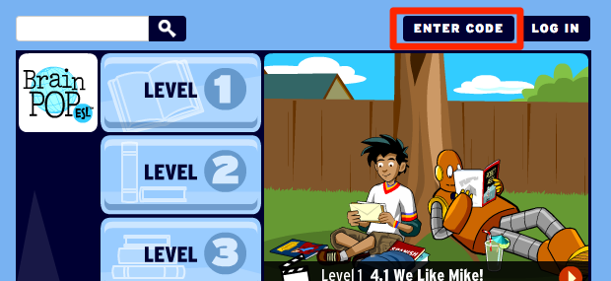
2) Enter the class code. | 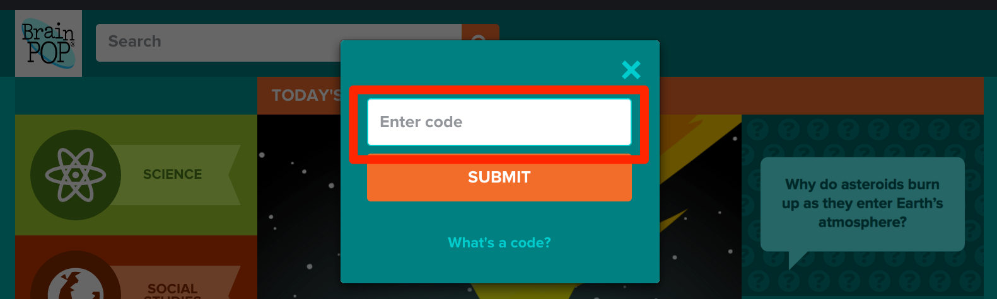  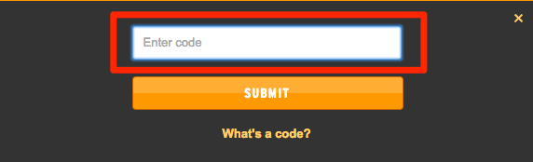
3) If a student has already created a My BrainPOP account with another teacher, they should not create a new one. Instead, they should sign in using their existing username.  If a student does not yet have a username, click SIGN UP NOW! | 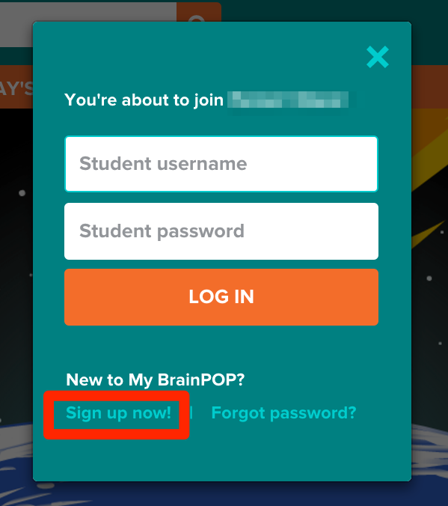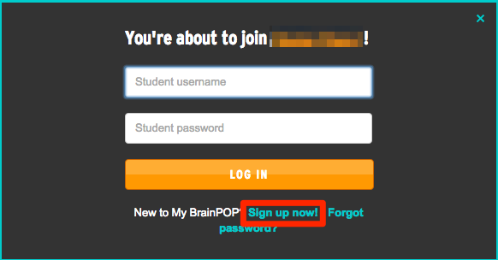
4) Students will select a username and password. If the username they choose is already in use, they'll receive an error message.  They'll also be prompted to enter their first and last name, and select a security question and image in case they forget their password.  Student accounts do not require the entry of an email address.  To finish creating an account, students must check the box agreeing to our Terms of services and Privacy Policy. | 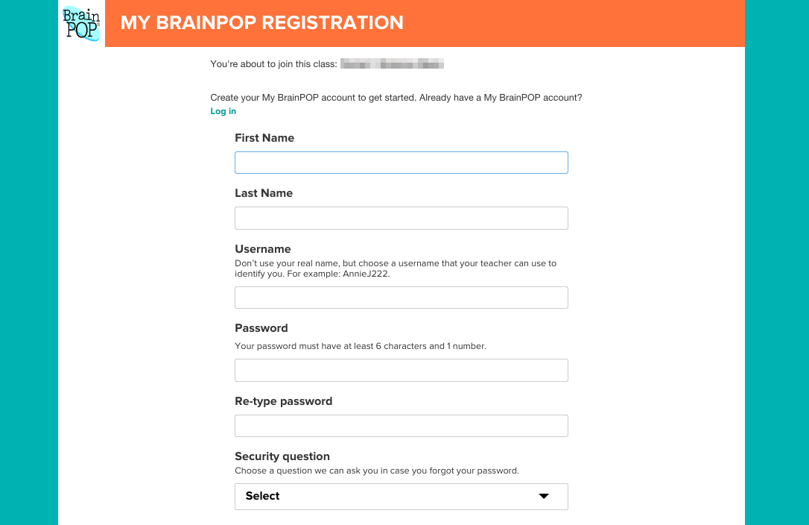
5) When a student has finished creating their account, they’ll receive a confirmation message. | 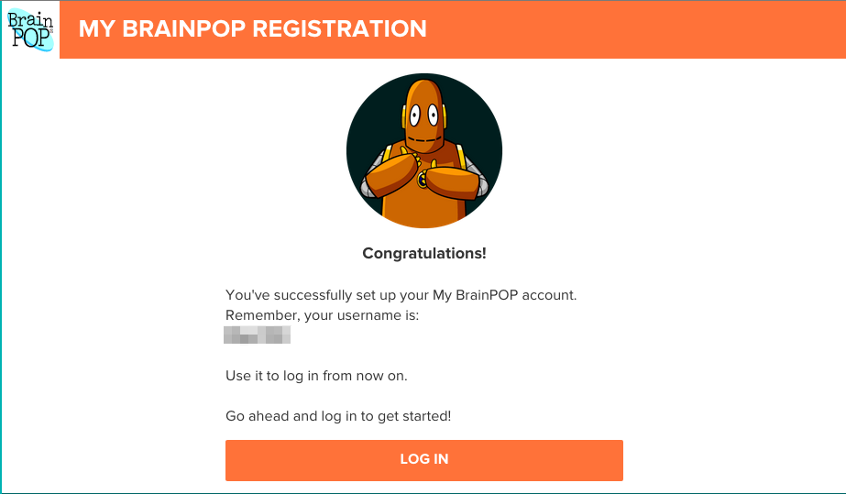
©BrainPOP. All rights reserved.
For information on BrainPOP trademarks & copyrights, visit brainpop.com/trademarks.

