Belt/Centerville Cross Country

2020 Schedule

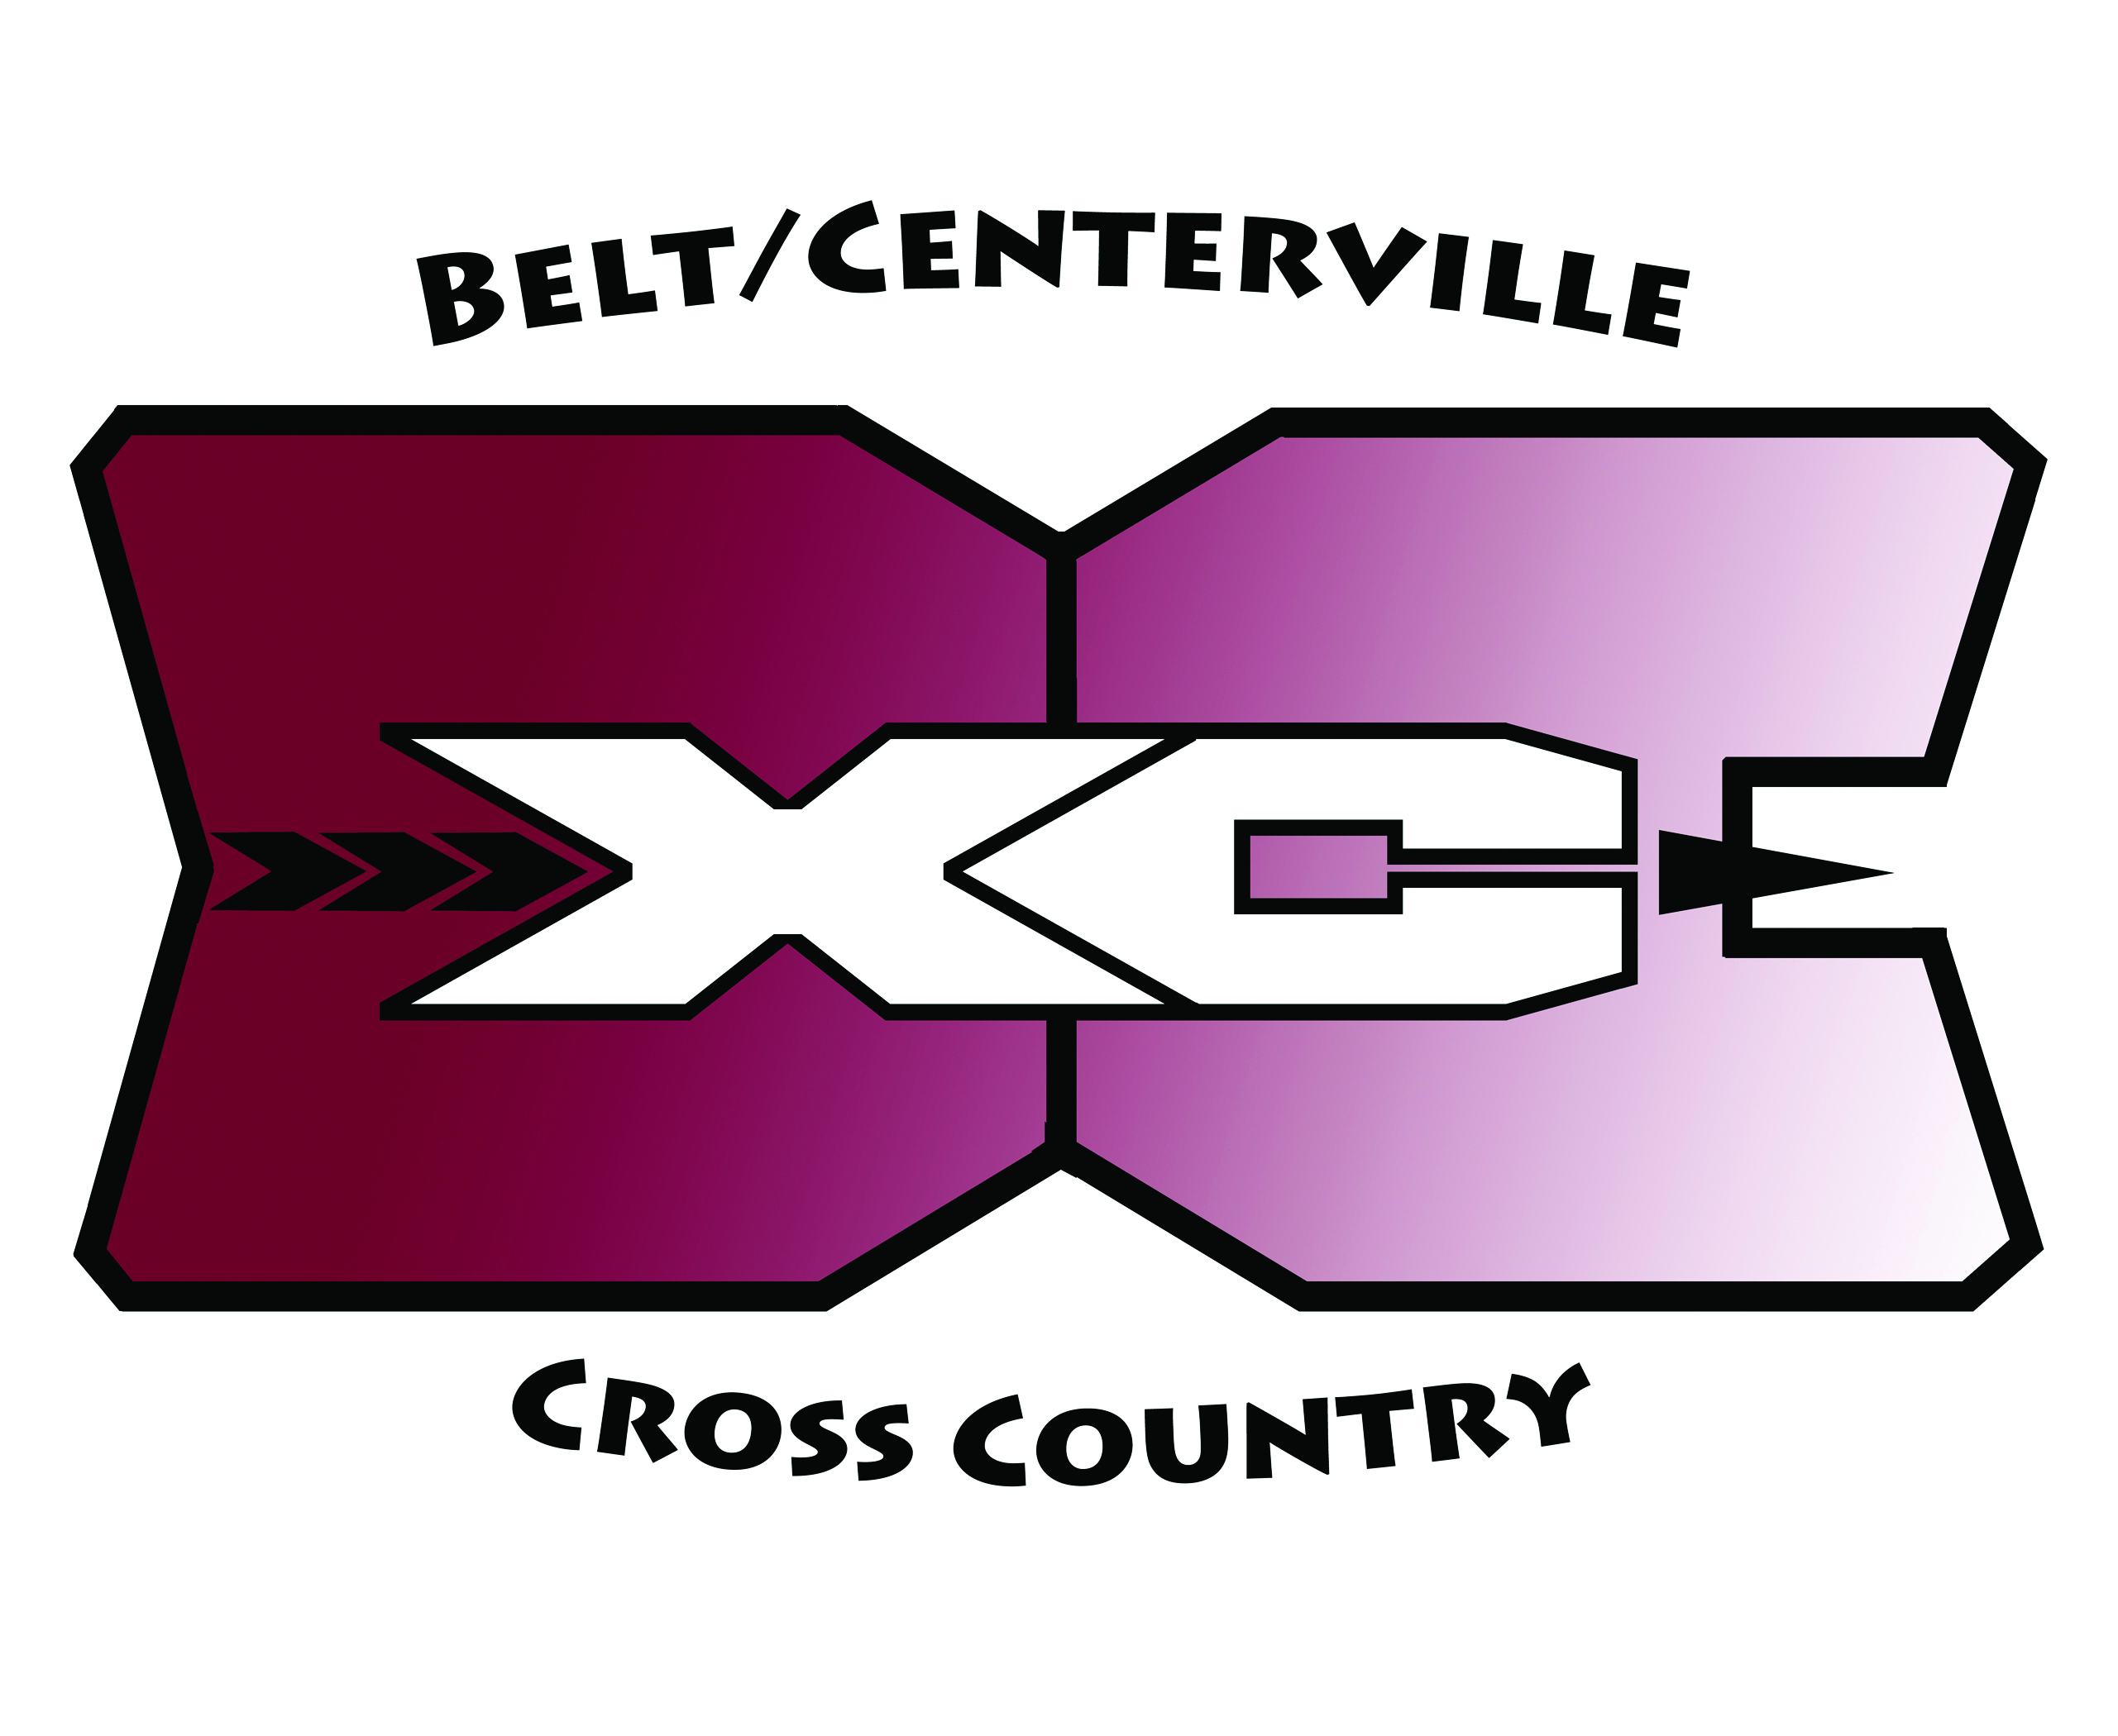

VARSITY TIME DESTINATION C-VILLE BELT
Friday, Aug. 14th TBA First Day of Practice TBA TBA
Friday, Sept 4th 3:30 PM Cut Bank 11:30 AM 12:15 PM
Friday, Sept. 11th 12:00 PM Havre 6:30 AM 7:15 AM
No Meet Scheduled Yet
Saturday, Sept. 26th 11:00 AM Centerville N/A 8:30 AM
Tuesday, Sept. 29th 10:30 AM Lewistown 8:00 AM 8:30 AM
Saturday, Oct. 3rd Cascade
Saturday, Oct. 10th ??? Townsend ??? ???
Friday, Oct. 16th ??? Sunburst ??? ???
Saturday, Oct. 24th Girls Race 5 Kalispell (State) Leave on Friday
Boys Race 7

JUNIOR HIGH
Friday, Aug 14th TBA First Day of Practice TBA TBA
Friday, Sept 4th 5:00 PM Cut Bank 11:30 AM 12:15 PM
Saturday, Sept. 26th 10:00 AM Centerville N/A 8:30 AM
Monday, Sept 28th 4:15 PM Great Falls – Lyons Park 2:30 PM 3:15 PM
Tuesday, Sept. 29th 1:30 PM Lewistown 8:00 AM 8:30AM
Saturday, Oct. 3rd Cascade
Monday, Oct. 5th 4:15 PM Great Falls – Jaycee Park 2:15 PM 3:00 PM
Friday, Oct. 9th ??? Townsend ??? ???

Dates and times subject to change.

8/31/2020 Updated

