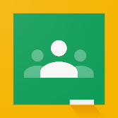
Google Classroom: A Quick-Reference Guide for Students & Parents

Logging In
- Click on the Google Chrome browser icon
- Type www.google.com in the web address bar
- Click on “Sign In” in the upper right hand corner
- Enter your username and click “Next”
- Enter your password and click “Next”
- Click on the 9 square “Google Suite/Apps” icon in the top right corner and select the Google Classroom icon
- Click on the class you want to view
Navigating Google Classroom
- The “Class Menu” icon in the top left corner lets you switch between classes
- “Stream” shows general announcements and a discussion board
- The “Upcoming” box on the left side of the page shows upcoming assignments
- Click “Classwork” to see assignments and resources for your class
- “Topic” shows how the assignments have been sorted; click on a topic to view the assignment
- Read and follow all directions for submitting the assignment.
OVER
Google Icons to Know
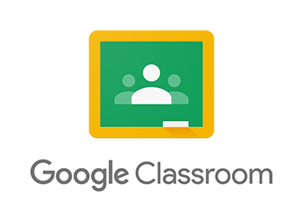

The Google virtual classroom

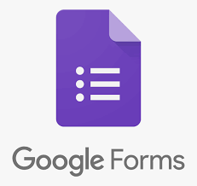
Saves files created in Google Forms, Google Docs, & Google Slides

Google Meet allows teachers and students to have video conferences.

Google forms can be completed on-line. They may be multiple choice, fill-in the blank, or short answer.

Google Slides is a presentation program that works like Power Point.

