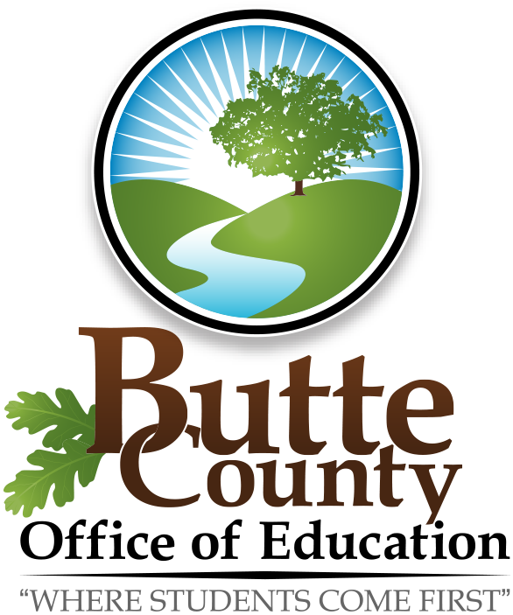
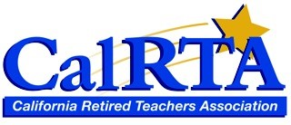

YOUR PARTNER IN PENSION PROTECTION div32.calrta.org

Division 32, CalRTA in partnership with Butte County Office of Education continues to show their support for California’s students and current credentialed educators by co-sponsoring 40, $100.00 Grants. We know first-hand the challenge of today’s economy and what having very limited funds means to educators. The grant money is to be used, at the discretion of the recipient, for his or her project.

Grant awardees are selected by a drawing and will receive a letter of congratulations. Her/his principal and district superintendent of schools will receive a letter as well. Butte County Superintendent of Schools, or designee, and CalRTA Division 32 will present checks to each recipient at her/his staff meeting in coordination with the site principal.

If you wish to apply for this grant, please complete the following short application and submit it by mail or email from September 1 through September 29, 2017, to:

Georgianna Light
951 Royal Drive
Chico, CA 95973-2035 hglight@comcast.net

This grant application is also located at div32.calrta.org from 9/01/2017 – 9/29/2017.

CalRTA and Butte County Office of Education Teacher Grant Application

PRINCIPAL’S NAME ___________________________________ PHONE: ____________________________

EMAIL ADDRESS: __________________________________________________

NAME ________________________________________________________________________________________

SCHOOL AND DISTRICT ___________________________________________________________________

HOME ADDRESS ____________________________________________________________________________

PHONE NUMBER ______________________________ EMAIL ADDRESS ____________________________________

PRESENT CREDENTIALED POSITION __________________________________________________________________

(Over)
DESCRIBE HOW YOU PLAN TO USE THIS MONEY:

Teacher Grant Ltr 2017 2018

