Dear Red Hawk Families,

As you know, USD 415 will start their school year next week. Kindergarten, 5th and 9th grade students will start on the 2nd, while all other students will begin on the 3rd. While we are starting our year in the on-site mode and in our buildings, we want to share plans related to the hybrid mode for future reference and planning.

The hybrid instructional model is designed to alleviate crowding in our school buildings. This is done by creating two cohort groups and assigning when each group would physically attend their school building. Should it become necessary to utilize the hybrid mode, your student(s) will be in one of two cohorts; red or blue. These cohort groups will attend school on different days while in the hybrid mode. Much care has been taken to ensure that students of the same household attend in the same cohort. The attendance for each cohort is as follows:

Red Cohort: Students will attend school in the buildings on Monday and Tuesday. They will learn online at home Wednesday through Friday. Normal school hours will apply.

Blue Cohort: Students will attend school in the school buildings on Thursday and Friday. They will learn online at home Monday through Wednesday.

Wednesdays during hybrid mode:

Designated students will be asked to attend in their buildings on Wednesday mornings. You will be notified by school personnel if your student is designated. Lunch will be served for those students. Students who are attending on-site on Wednesday will leave the school buildings at 12:30. They will learn online at home for the remainder of the day. All other students will learn online for the entire school day.

Busses will run their normal routes on all days except Wednesday. On Wednesdays, busses will transport only designated students as described above.

Food Service/Meals- Please see the attached Food Service Plan for details.

Please contact your child’s school if you have a question or concern regarding the hybrid mode.

Sincerely,
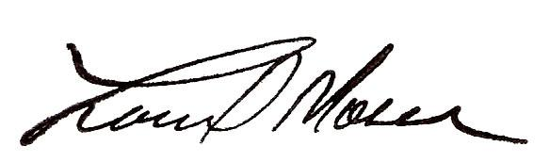
Lonnie D. Moser, Superintendent

**Your Student(s) will be in Red Cohort: see above

USD 415 Food Service Plan

