Dear families, once you’ve a chance to log into Alma, it’s time to use Alma Start in order to provide important information for the 2020-2021 school year! This document will walk you through the 2 important steps.
Step 1- Connect your Alma account to Alma Start.
Let’s get “START”ed! Your first step is to log in to your Alma dashboard. When you log into Alma for the first time, you will see a message to “Connect your Alma Start Account” -- once you connect the accounts this alert will disappear. Click on the “connected accounts” button in the Alma Start window from your dashboard.
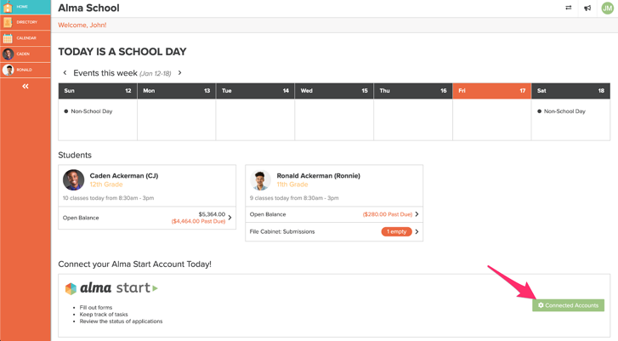

Next, you’ll see your connected account tab within your preferences. Click “connect account” -- don’t worry that you don’t have an account yet, we are going to take care of that next and then they’ll be connected!
Will I have to remember another login?
- Nope! Once you connect the accounts, you’ll see notifications for forms to be completed in Alma Start directly in your school dashboard. You’ll also be able to access Alma Start by visiting connected accounts within your settings. You’ll only need to login to Alma moving forward.
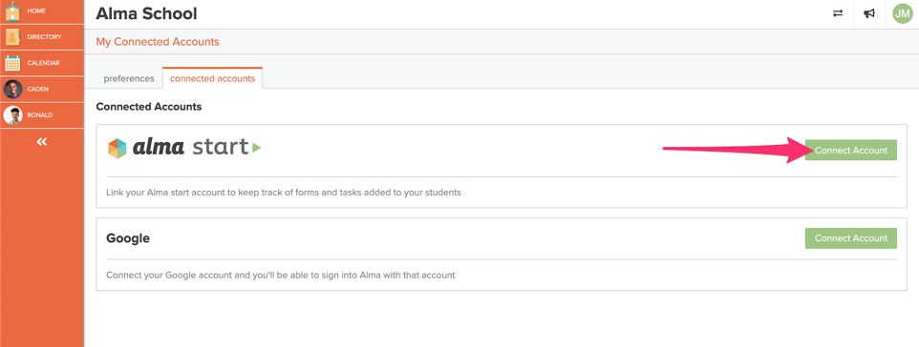

Next, you’ll see a pop-up on your screen to Connect an Alma Start account. If you already have one you can sign in or click on the “create account” link.
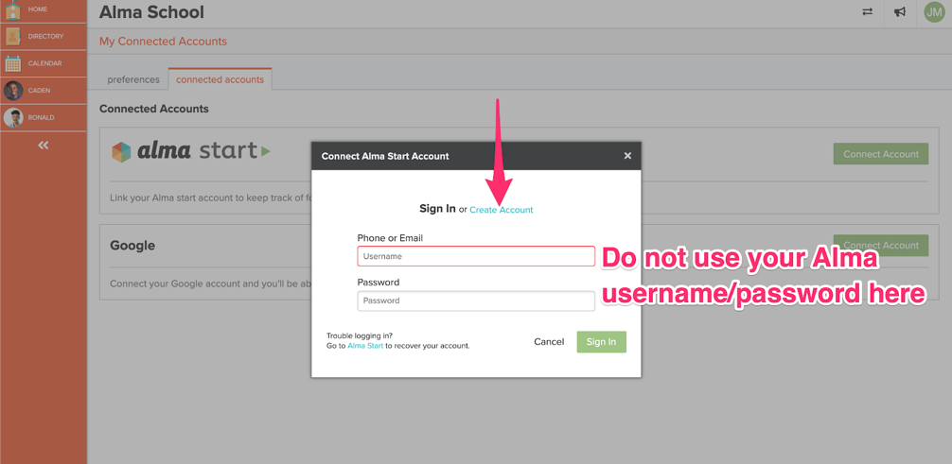
After clicking on “create account” you’ll be taken to this screen, your email address will be automatically pulled from your Alma profile. If you have multiple emails on your Alma profile, choose your primary email from the drop-down and then click the green “create account” button.
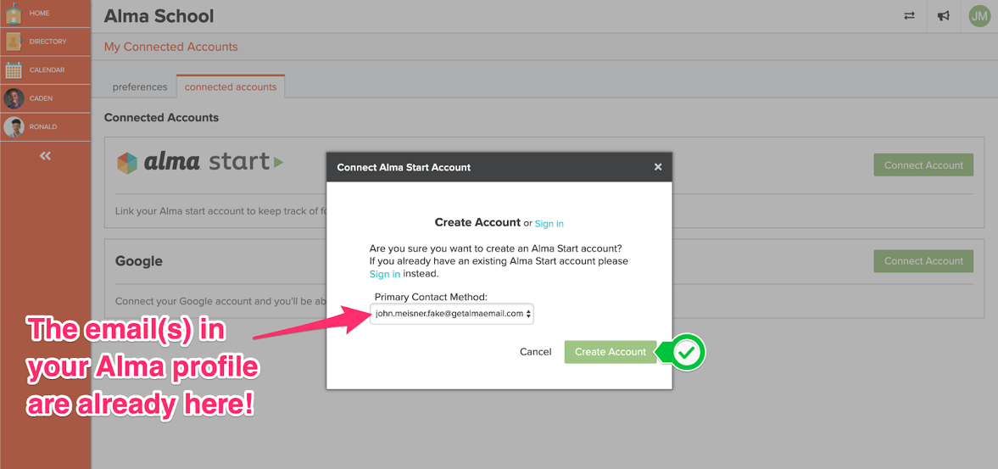
That’s it! You are all set! You’ve got an Alma Start account and it’s linked to your Alma account. You can go there now and see if there are any forms needed for your students.
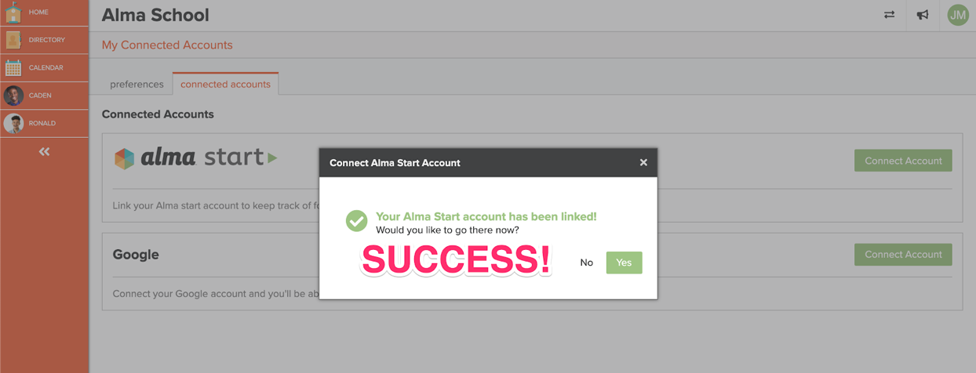

You can navigate to Alma Start at any time by going to “settings” > “connected accounts” and then clicking on “go to Alma Start” or by clicking on “Alma Start Forms and Tasks” beneath your student(s).
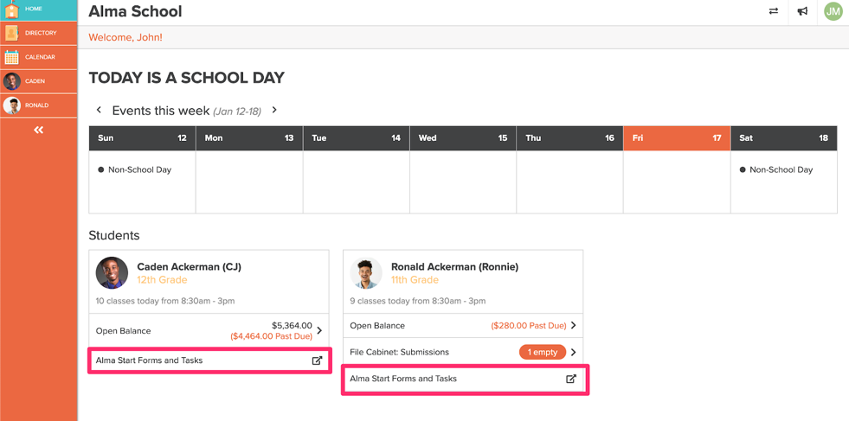
Get to Alma Start by clicking on “Alma Start Forms and Tasks.”
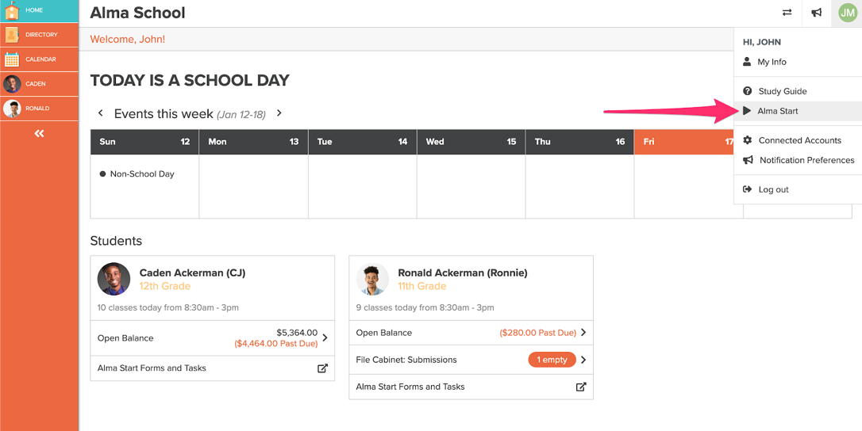
Get to Alma Start through your settings.
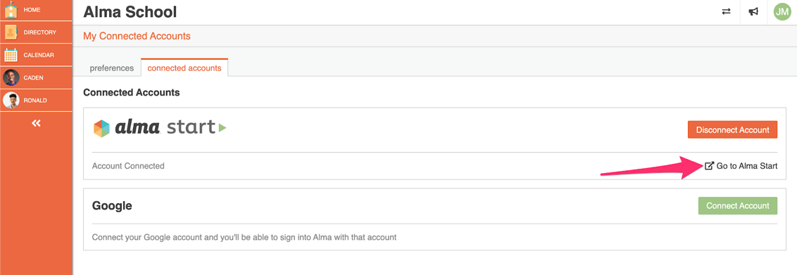
Click on your Initials → Connected Accounts. You can access Alma Start or disconnect your account.

Step 2- Complete our registration forms and update your contact information
If your student is already enrolled in the school, and you are using Alma Start to fill out forms (such as pre-registration for next year, permission slips, information updates, etc), you’ll be able to navigate to Alma Start directly from your dashboard.
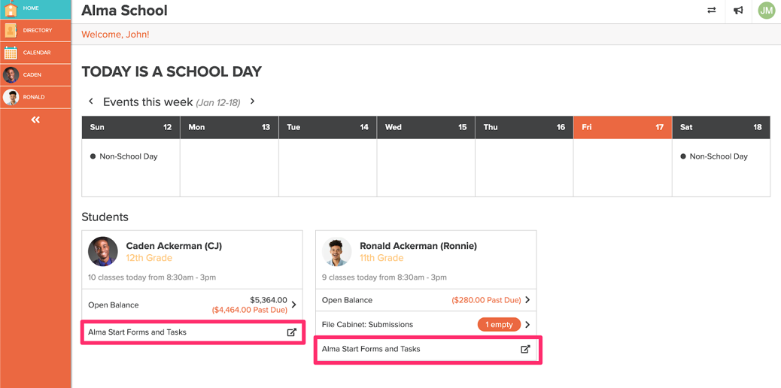

Let’s walk through completing a form assigned by your school in Alma Start. We’ll use Ronnie as our example.

Finding Available Forms and Tasks for Your Student
First, we will click on “Alma Start Forms and Tasks” under Ronnie’s name on the parent dashboard. Alma Start will open in a new tab (so you can easily return to Alma if needed) and you’ll see your student(s) listed on the left. Click on your student’s name, double-check their name is displayed in the center of the screen, and then click the green “get started +”.
In order to make sure you are seeing the correct process, you’ll need to select the current school year and then your student’s grade level. If your student is currently enrolled at the school, the grade will fill in once you select a school year (you still have the option to change the grade level).
Once you’ve selected a year/grade you’ll see any forms you need to complete. It’s time to update Ronnie’s information for his senior year! Click on the form and then click the green “apply” button to begin.
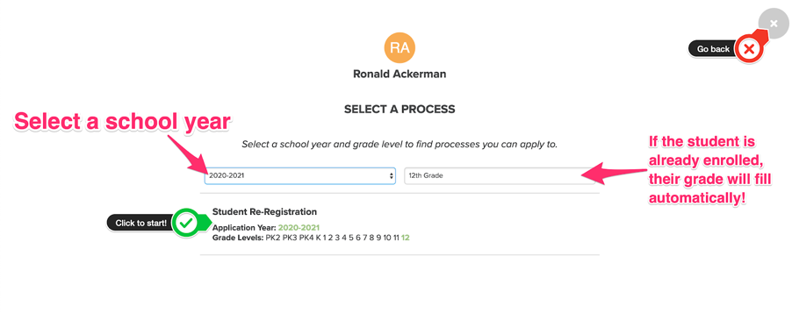

Complete Forms and Tasks Associated with a Process
The items listed in blue are your to-do list. We have two items to complete. Click anywhere on that line to start completing the student information form.
- The process year and the grade Ronnie will be in during that school year.
- The name of the process.
- The various tasks/forms your school is asking you to complete.
- The number of tasks/forms you need to complete.
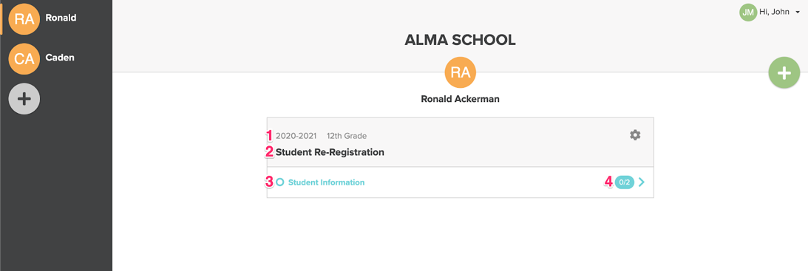
You’ll be taken into this specific form; the light grey checkmarks let you know that this item needs to be completed. Click where it says “tap to begin.”
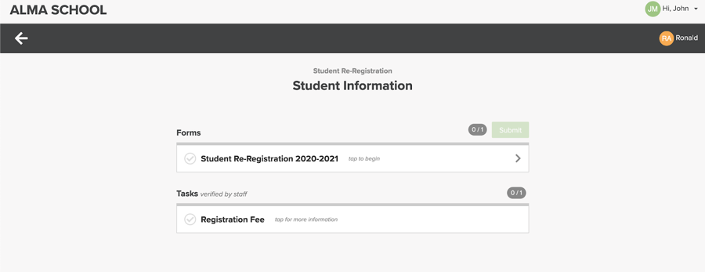
Within each form, you’ll see the sections that you need to complete. Click “save” to save your progress; this is useful if there are multiple sections within the form.

Submit Forms & Tasks
Once you have completed all forms and tasks within the process you’ll see a green “submit” button. When you are sure that all the information is complete and correct, click “submit”!
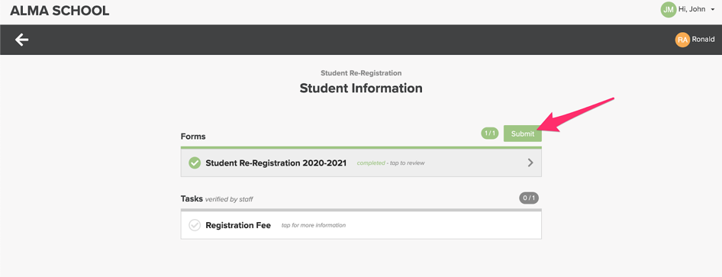
You’ll be asked to confirm that you want to submit. Once you submit the form you CANNOT go back and edit any of the information.
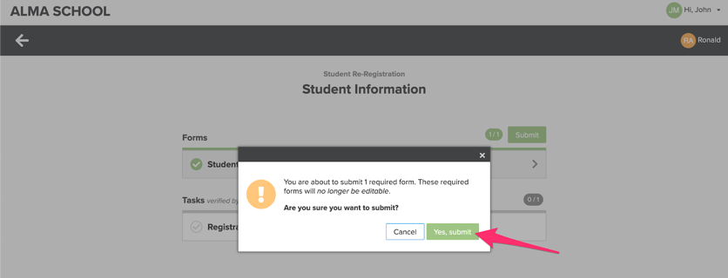
After the forms are submitted you’ll see the status change on the Alma Start page for that process. If there is an internal review portion for this process, you’ll see that your student has entered that stage and that there is nothing for you to do!
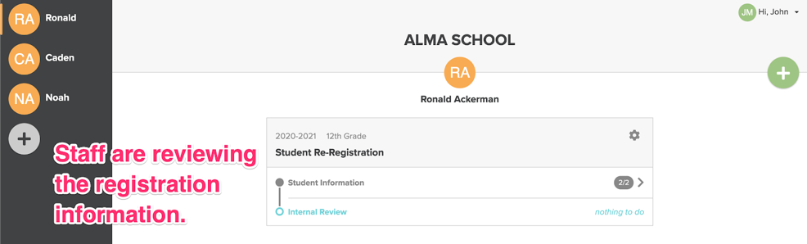
Once the review is complete (or if there wasn’t a review needed for this process), you will see a new area called “Outcome Actions” -- these are similar to the section of a form label “office use only” or “to be completed by staff”. There’s nothing else you need to do here but you can check back at any time to see if there are any updates from the school!
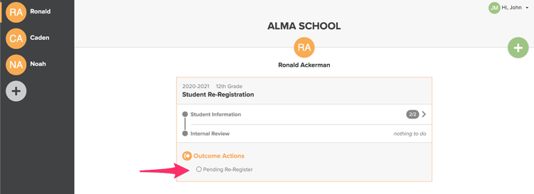

Outcome Actions: School Reviews Forms
Once the school has processed your forms, you’ll see an update within Alma Start (and get a notification that the stage is complete)! In our example, there’s now a checkmark that the SIS (Student Information System) was updated!
