Italy ISD High School
First day and week instructions for virtual parents only

FOR ALL VIRUTAL LEARNERS 3RD-6TH GRADE.

The expectation for the first day and the first week of school is to make all students aware of the learning procedures. How to and where to login, what the expectations are, and safety procedures. We know there will be schedule changes and we will all be working the first week of school to get all the wrinkles smoothed out. Please be patient and kind while we all deal with these unprecedented times. We want you to know that Italy ISD has been and will be working tirelessly to ensure we can provide the best learning atmosphere that we can provide your children.

On the first day of school and for the first week of school, students need to login into their chrome books with their school email and password. If the student does not remember their email or password please send an email to the Italy Help desk at italyhelpdesk@italyisd.org. After they login to the chrome book they will go to their Google Classroom from their email. See example A.
Example A
The student opens up Chrome browser, and in the top right corner you will see their name and Italy ISD. Just to the left of their name you will see 9 dots. If you click on the nine dots you will see the different Google APPS that the student has access to. One of the Apps is Google Classroom. See example B.
Example B
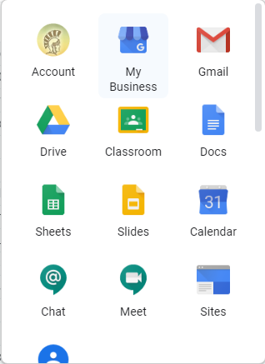
After the student opens up Classroom you will see the different classes that the student is enrolled in. The Teachers create the classes and add the students to the appropriate class. All the student needs to do is click join on each of the classes listed in their Google Classroom and they are automatically in class.
Now, after they join the class they will see more specific instructions for each class on what the next steps will be. They need to follow the teacher’s instructions to begin learning how they are going to connect to Google Meets for the virtual learning. Google Meets is what we are going to use for virtual learning as well as some Zoom meetings. We prefer that all teachers use Google Meets as it is incorporated into the Google Suite for Education with their Google Classroom. See example C
Example C
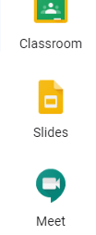
Google Meets is in the same location as Google Classroom. For Virtual Leaners, the teacher will have specific instructions for these students as well as the Google Meets Links that the student will use to join the class. The Students will have different Google Meets Links for each of their classes. The links are unique to the class and the teacher who is running the class.
For Example:
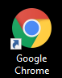
The student will login in to the Chromebook and open the chrome browser which looks like this:
After they open their Google Classroom and click on the first
Class of the day, they will then look at their assignments, this is where they will find the Google Meets Link. It will tell them what time to click on the link. At the appropriate time the student will click the link and join the class. The teacher will then take attendance and ensure that all students are present, both virtual and physical. The teacher will then proceed to instruct the class. All assignments will be assigned through Google classroom and will be expected to be turned in via Google Classroom. All Work will be expected to be turned in at the same time for both virtual and in person students.

I am going to list examples below of the different Google Apps and what they look like.

Example Google Classroom: This is what a class will look like, it will say Join for students, and for teachers it will say Accept.
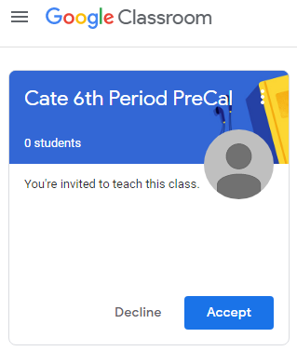

Example of Google Meets: This is what Google meets will look like, it will automatically join the meeting when the student clicks on the link. You can also join the meeting with the meeting code that will be attached to the Link in the students’ assignments from the teacher in Google classroom.
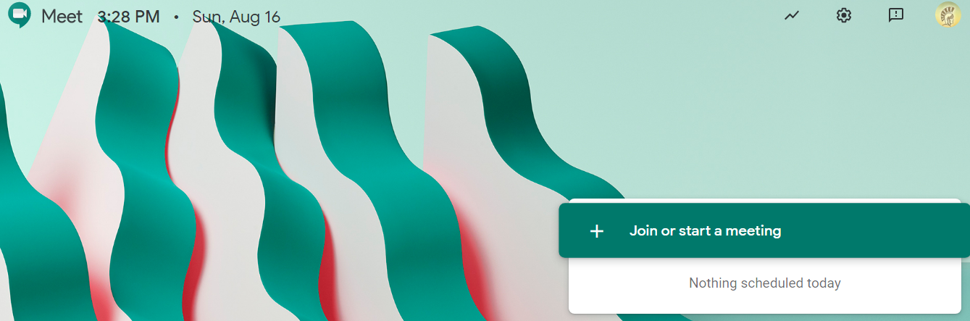

Example of Google Apps that are found by clicking on the 9 dots next to the students name in Chrome in the top right hand corner of the screen. The student has full access to all the apps listed in the drop down menu when you click on the 9 dots. There are more there than shown in the pic below.
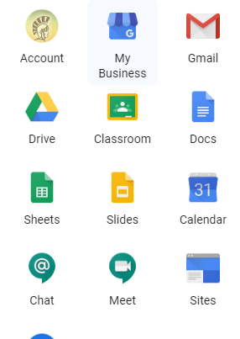
Remember if you need help after logging into google classroom you can get help from the teacher with in Google Classroom by sending messages to the teacher. If you can’t get into google classroom or logged into the chrome book, then you need to contact the Italy ISD Help Desk at italyhelpdesk@italyisd.org.
Schedules will be passed out on the first day of class. Schedules will be posted to virtual students Google classroom.

Virtual *Technology pickup for 3rd-6th students will be Wednesday, August 19 from 9 a.m.-2 p.m. in the front of Stafford Elementary *Lunches will be available to pick up or purchase in front of the Italy HS cafeteria from 11:00-11:30 a.m. daily *3rd-6th students are expected to participate live with their teacher throughout the posted scheduled times on google classrooms each day.

High School Chrome book pick up for Grades 7th-12 for virtual learners can be picked up at the high school starting tomorrow. We will also have after hours pick up as well. The time for that will be posted tomorrow.

The link to pay Chromebook fees online is this: Scroll to the bottom of the page after you click the link.
http://www.italyisd.org/student-enrollment-italy-isd-residents

