Kindergarten E-Learning Choice Board
Weeks of 9/1-9/3 and 9/8-9/11
Please pick at least 2 activities each day to complete. It is ok to repeat activities and explore! Most importantly, HAVE FUN TOGETHER!

Row 1 | Listen to The Kissing Hand. When you are done listening, discuss how you feel about starting school. How are you the same and different from Chester?  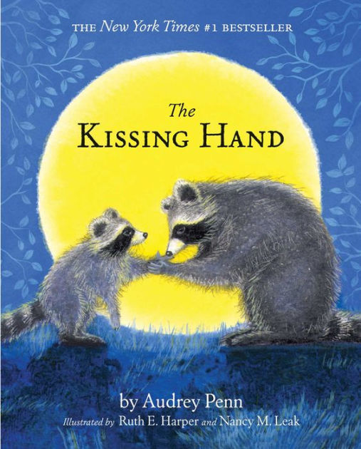 | Find a book and pick a fun place to read with someone.  Could be inside or outside! | Go for a walk! What do you see, hear, smell, feel? | Writing Activity  What’s on your mind today? Draw a picture.. Have an adult write your words for you and date your entry. | Listen to "Why Do People Wear Masks" Have a discussion about why people wear masks. Have an adult take a picture of you wearing your mask and email it to your teacher..
Row 2 | Make playdough with an adult.  Use the playdough to create shapes, letters, numbers, or anything else you can think of. Use child safe scissors to cut playdough into different shapes or roll playdough into a log and snip it into small pieces. Click picture for link to recipe.  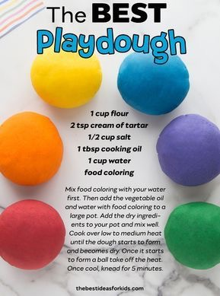 | Help your child understand their different feelings. Draw an outline of a face and use playdough to create a variety of emotions.  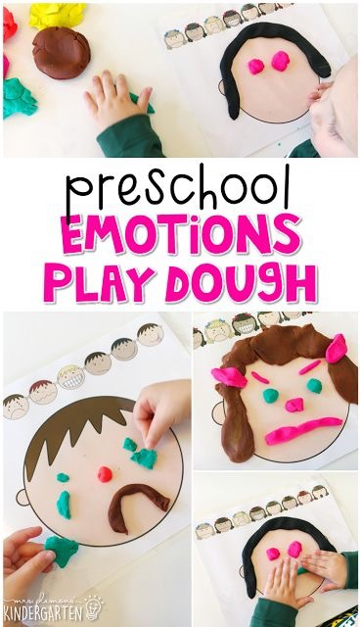 | Watch and Play Sesame Street: Name That Emotion with Murray! | I Spy Shapes  Watch this video video, pause after each shape and find that shape in your house! | Listen to Wash My Hands with Jack Hartmann. Practice washing your hands with soap and water! Don’t forget to count to 20 while washing!
Row 3 | Go on a “Back to School” scavenger hunt with your child!  Back to School  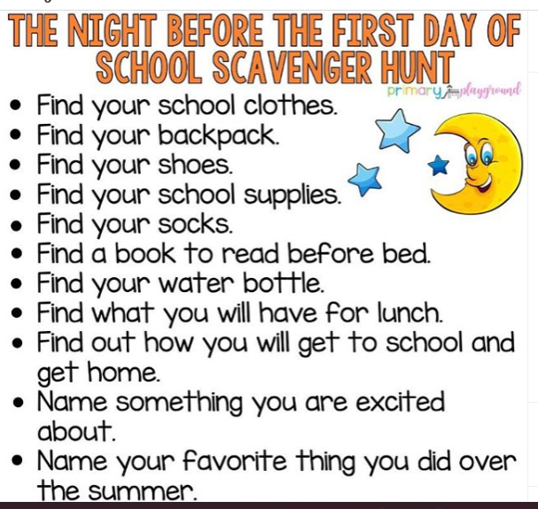 | Practice writing your first and last name. You can use paper and pencil, markers, crayons, sidewalk chalk, etc. Make sure only the first letter is capitalized. | Watch Daniel Tiger  "Won't You Sing Along With Me?"  Ask your child the questions listed.  If you would like, complete the “Play Together” activities | Play your child’s favorite game with them or play with your child with their favorite toys! Have him/her help you clean-up, sort, and put the game or toys aways when you are done! | Use finger paint or shaving cream to practice writing your name, numbers, letters, shapes, etc.

Kindergarten Standards
Develops Alphabetic Awareness Understands How Print Works
Demonstrates Comprehension of a Story Read Aloud Learning Sounds That Letters Make
Talks With Others Attempts to Scribble/Write Letters and Words
Listens and Responds to Others Learning to Follow Directions
Is Learning to Count Learning About Shapes
Separates Objects by Similarities and Differences Learning that Objects Can Be Measured
Learning to Manipulate Objects with Hands and Fingers Shows Persistence
Makes Explanations about Science

Life Skills
Participates Willingly in Class Respects School and Classroom Rules
Listens to and Follows Directions Works Cooperatively
Initiates Own Play Activities Asks for Assistance When Needed
Respects Peers/Adults Is An Attentive Listener
Makes Appropriate Choices During Free Time Responsible for Personal Belongings
Responsible for Personal Hygiene Speaks in Complete Sentences
Demonstrates Self Control Plays Well With Others

