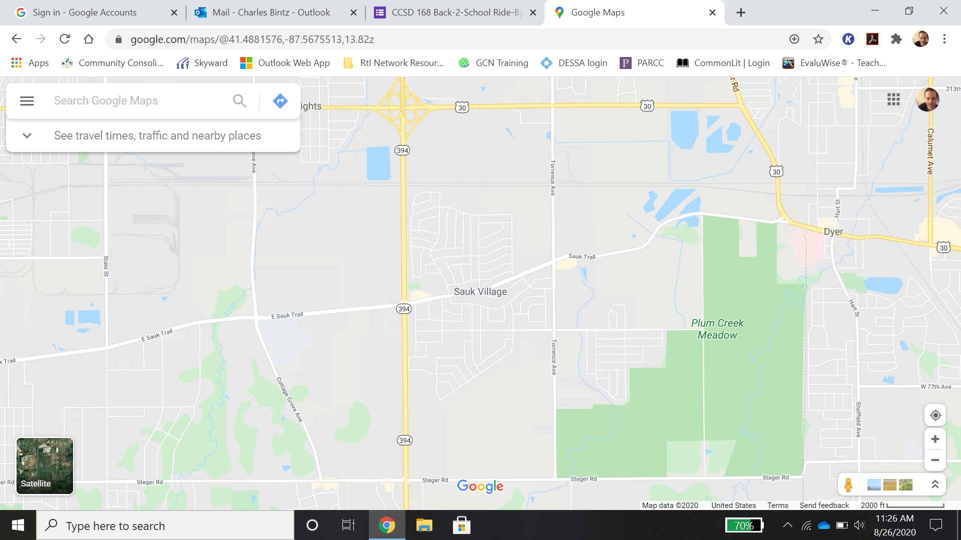

Parade will be traveling by Candlelight and Carlisle Estates around 5:00 pm.

Our last stop of the Parade will be off of Eastbrook Drive at 5:45 pm before our return to Wagoner.

Parade will be traveling through this area around 5:25 pm.

Parade Starts at 4:00 pm from Wagoner and move through the surrounding area.

Parade will be traveling near Strassburg around 4:30 pm.