Helpful Hints for Parents: Using the Parent Portal
Memorial Elementary School
2020-2021

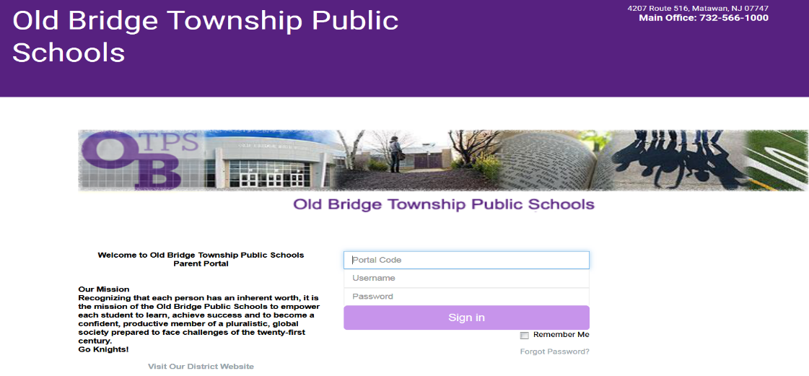

- Parent Portal URL (web address) is: http://www.fridayparentportal.com/oldbridge

- The Parent Portal icon is also located on the Memorial School website. Follow these steps to locate the Parent Portal icon:
- On the Memorial School home page, click on MENU, shown with 3 bars

- When you click on “MENU” you will see the Parent Portal icon, shown below.

- Click on the Parent Portal icon and it will open up to the Parent Portal.
- To login and access the Parent Portal, you will need to enter 3 items for your child:
Portal Code / Username / Password and then click on the purple “Sign in” button.
- The main office at Memorial School provides parents/guardians with a Parent Portal letter that has the generic codes. Please contact the main office with any questions.

- The following information is accessible on the Parent Portal:
Homepage Grades
Homework Contacts
Calendar Documents
Schedule Correspondence
Daily Attendance My Account
Gradebook District Info
Progress Reports Logout

- Use the Virtual Backpack icon: Located in the Menu, next to the Parent Portal icon.
- Please check daily for current notices and parent updates.
- When you click on the Virtual Backpack icon, you will see the following sections:
- Special Education PTA Flyers: Includes membership forms, events & calendar for SEPTA
- Parent Correspondence: Includes forms, letters and procedures
- Community Flyers: Includes community related information and events
- Curriculum: Includes a curriculum overview for each grade level, K to 5
- PTA Correspondence: Includes all PTA information and events

