Flute
Welcome to band!
How to be successful:
- Turn in 400 Practice Minutes every Quarter- signed by a parent.
- Ask for help!
- Practice with a friend!
All instrument cases MUST be labelled with student’s name!
What you need to get:
- Flute
- Essential Elements for Band Book 1 Flute
- Make sure your flute has a Tuning rod
- You will want a cleaning swab- these can be made from a piece of towel or cloth if it didn’t come with one.
- 2 Pocket Folder for your music book and band music, with a pencil.
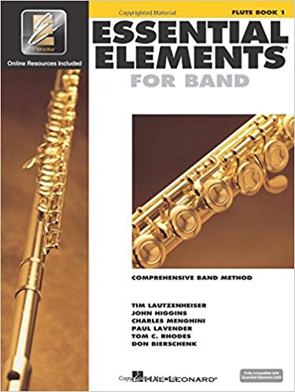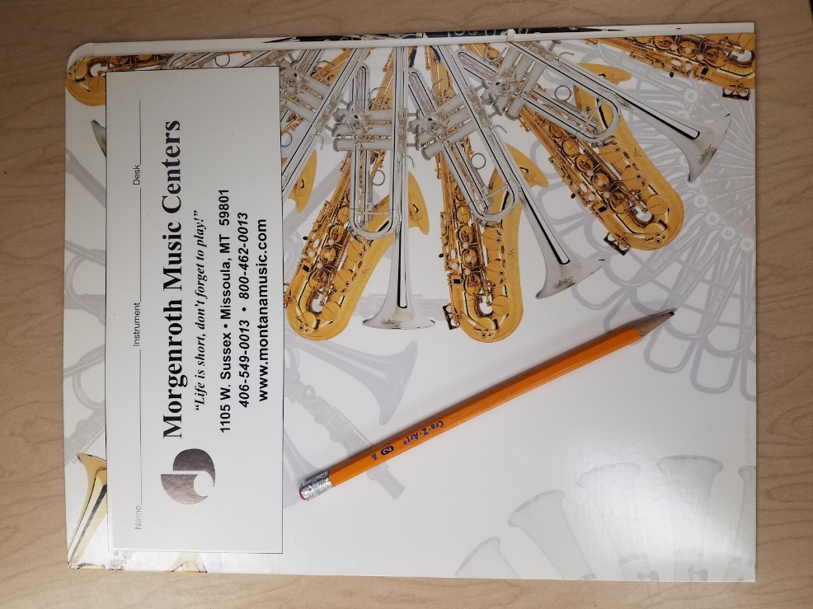
Band Showing night is September 2. See next page for details about local music stores.
Local Music Stores
Main music store in town for supplies, new and used instruments and repairs.

- Morgenroth Music Center
  - 1105 W Sussex Ave, Missoula, MT 59801
  - (406) 549-0013
- Music Medics
Used Instrument rentals/purchases and repairs
  - 333 SW Higgins Ave, Missoula, MT
  - (406) 549-0889
- Electronic Sound and Percussion
  - 819 S Higgins Ave, Missoula, MT
Percussion Supplies
  - (406) 728-1117

Band Instrument Showing Night and Information Meeting
September 2 at 6 and 7 PM
Intermediate Gym
Band showing night is an opportunity to obtain supplies for your student without driving into town. We host Morgenroth, but they provide all the supplies. We will also tell families all about band, what to expect, and what our expectations are for students.

We highly recommend taking the time to find a used instrument before this night, and taking it in to a music shop to make sure it is ready to play. Morgenroth brings a few used instruments- but they mostly offer new instruments through the RENT-TO-OWN program.

*All band parents must attend band showing night for the information provided about band!
Thank you!!!
Elaina Blass
Blasse@ftsd.org
John Nelson
NelsonJ@ftsd.org
Karolei Lydell
KaroleiLydell@ftsd.org

