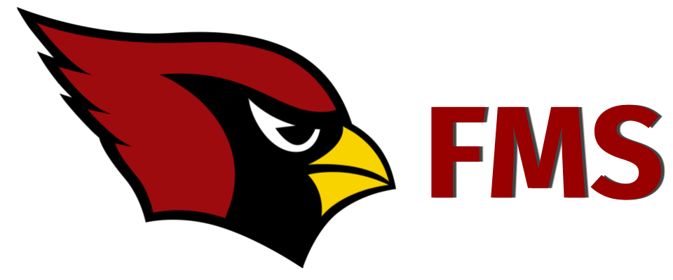
2020-2021
Farmington Virtual Academy
Parents,

We are excited and ready to serve our students this year both on and off campus. Below are some important dates for our virtual students:

Date/Time | Event | Details
Wednesday, August 19, 2020  2:00 p.m. | *Virtual Learning  Orientation/  Meet and Greet | Zoom Link  (Will be emailed by the virtual teacher.)
Thursday, August 20, 2020  9:00 a.m.- 2:00 p.m. | **Virtual Learning  Device Distribution | Curbside Chromebook pick up
Monday, August 24, 2020  8:00 a.m. | First Day of Farmington Virtual Academy- FMS | Students should log into Buzz/Lincoln Learning at 8:00 a.m.
*Zoom meetings will be recorded and made available for those unable to attend live.
**Due to high demand-- devices are provided to households with limited access to technology.

At Farmington Middle School we are committed to building relationships while providing all of our students with quality educational experiences whether from a distance or in-person. We look forward to learning virtually with you in this new method of delivery!

FMS- Virtual Academy Team

