Needville ISD COVID-19 Triage:
PLEASE RETURN THIS FORM TO THE REGISTERED NURSE FOR YOUR CAMPUS

Needville Elementary Needville Middle School
PHONE: 979.793.4308 PHONE: 979.793.3027
FAX: 979.793.2299 FAX: 979.793.7665

Needville Junior High Needville High School PHONE: 979.793.4250 PHONE: 979.793.5158
FAX: 979.793.4575 FAX: 979.793.5590
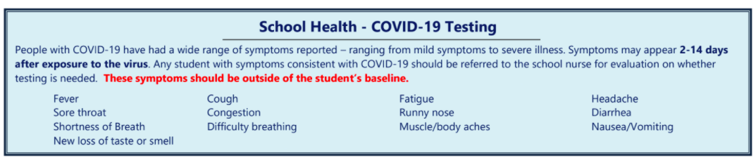

Name: _________________________________________ Date: ____________ Time: _______

SECTION 1: Presenting symptoms:

Patient presents with the following symptoms:

- Fever (100.4 or higher)  - *Cough (new uncontrolled cough that causes difficulty breathing, for students with chronic allergic/asthmatic cough, a change in their cough from baseline)  - Shortness of breath  - Difficulty Breathing | - Sore throat  - Runny nose/congestion  - Chills  - New lack of smell or taste  - Muscle pain  - Nausea or vomiting  - Headache  - Diarrhea

- Other: _________________________________________________________________

*If coughing, does the student have asthma? If so, follow his/her asthma action plan. If the student is having severe difficulty breathing, shortness of breath, difficulty speaking or lips are blue call 911.

When did symptoms begin? _____________________________________________________

Clinical Findings
Temp: _____ ℉ SaO2: ____% RR: ____bpm HR: ______bpm BP:____/_____
Notes: ___________________________________________________________________________

Nurse Signature: __________________________________________________ Date____________

Section 2: Close Contact/ Potential Exposure
  - Had close contact (within 6 feet of an infected person for at least 15 minutes) with a person with confirmed COVID-19
  - Had close contact (within 6 feet of an infected person for at least 15 minutes) with person under quarantine for possible exposure to COVID-19
  - Traveled to or in an area where the state health department is reporting large numbers of COVID-19 cases, and or a state that the TX Dept. of Health currently recommend that you quarantine for 14 days

Parents notified to pick up their child and refer to their Primary Medical Provider at: ___________
TIME

An individual presented to the health clinic with symptoms that would require him/her to stay home and to refer to their medical provider regarding potential testing for COVID-19. Please ensure the following criteria are met prior to returning to school.

Return to School Guidelines
Situation |  | Returning to School
 | If a symptom was present, but no positive test, or no evidence of exposure.  Students or staff with potential exposure must be checked by school nurse prior to return. | The student will be excused from school until symptom-free for 24 hours, without fever reducing medications. Request a note from your medical provider indicating the student may return to school or have them complete this form.
 | Positive for COVID-19 or possible exposure/close contact | The individual may return to school when the following are met:  - 10 days have passed since symptoms first appeared -OR- 14 days have passed since possible exposure.  - fever-free for 24 hours, without the use of fever-reducing medication  - Symptoms have significantly improved

Return to school date: ______________ Diagnosis: ____________________________

Restrictions: _________________________________________________________

Additional information: ________________________________________________

Printed Name: _______________________________________Contact Number: ________________________

Health Care Provider Signature: ___________________________________________ Date_______________

