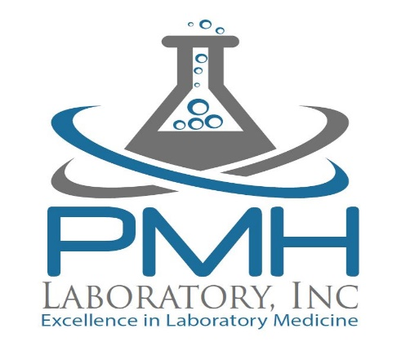

AUTHORIZATION
To Disclose COVID-19 Diagnosis or Exposure

I Understand that the Americans with Disabilities Act, the Family and Medical Leave Act, the California Confidentiality of Medical Information Act, and other privacy lasws prohibit my employer from disclosing my medical/health information. In the interest of the health of my co-workers and others with whom I may have had contact on my worksite, however, I authorize Chilton I.S.D., Human Resources Department and/or senior management to disclose to employees at my worksite and to others, i.e., clients, visitors, customers, whom I may have encountered at my worksite, that I have tested positive for the COVID-19 virus or that I have been exposed to the virus by being in close contact with someone who is believed to be infected with the virus. PMH Laboratory, Inc. advised me that I am not required to do so and that there would be no adverse consequences to my employment if I chose not to do so. Further, Chilton I.S.D. did not seek to coerce or pressure me to permit the disclosure.

In disclosing this information, (employer) will take reasonable measures to keep my name and identity confidential to the extent possible, though I recognize that circumstances may require identifying me as the infected or exposed individual in order to properly warn others so they may take precautionary measures and help prevent further speread of the virus, and that there are times when it is not possible to inform others they may have been exposed to the virus without them learning that it was through contact with me.

This authorization expires 30 days from, the date this document was signed, after which Chilton I.S.D. will no longer be authorized to disclose this information. I have been advised that I have a right to receive a copy of this authorization.

________________________________________ ________________
Signature of Individual (Employee) Date

________________________________________
Printed Name of Individual (Employee)

