EMPLOYEE ACCESS CENTER GUIDE

Table of Contents
Section 1  About the Employee Access Center (EAC) | Page 2
Section 2  Logging into EAC | Page 3
Section 3  Employee Tasks | Page 5
-Demographic Information | Page 5
-Additional Information | Page 5
-Payroll Checks | Page 6
-Salary and Benefits | Page 6
-Leave Information | Page 6
-Print W2s | Page 6
-Tax Information | Page 7
-Deductions and Benefits | Page 7
-“What If” Paycheck Calculator | Page 7

Section 1

About the Employee Access Center (EAC)
  - The Employee Access Center web portal provides on-line services to active employees of a School District. Employees can view their personal information via the internet through a web browser. Currently, access to EAC can only be accomplished while being on the internal school district network.

EAC Main Features
- View Employee Demographics
- View Degree and Certification Information
- View and Print Payroll Check history information (can be printed or downloaded as PDF file)
- View Employee Salary and Benefits
- View Leave Banks/Attendance absence detail
- View and Print W2’s for current and prior years.
- View Tax Information
- View Active Deductions and Benefits

Section 2 Logging into EAC
  - The EAC web portal is located at http://eac.efinanceplus.k12.ar.us
- In the Database dropdown box select: XXXXXXX School District
- The first time you attempt to login you will need to click on the Forgot your Password button.
- In the Email Address or User ID: text box, enter your own District email address.
- Enter your Social Security Number using the format ######### (no hyphens) and click on the Submit button.
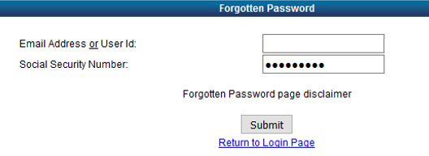
- Check your School email. You should have an email titled Password Recovery from the user youremailaddress@schools.XXX
- Copy the password in the email and return to the Forgotten Password site and click on Return to Login Page.
- In the Database dropdown box select: XXXXX School District
- Type in your school email address which will be your User ID.
- Paste the Password from the email and click the Login button.
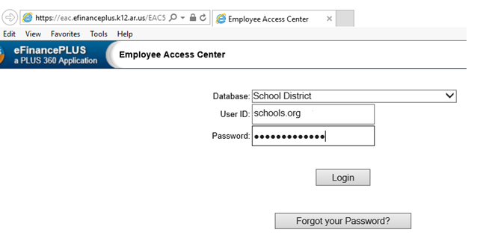
At this point, you will be instructed to change your password.
- Please enter the password sent via email by your administrator into the Old Password text box.
- Type a new password and then retype the new password. Password requirements are as follows:
• Minimum password length: 10
• Maximum password length: 19
• Minimum lowercase characters: 1
• Minimum uppercase characters: 1
• Minimum Digits: 1
• Minimum special characters: 0
• Allowed special characters: None
• Disallowed characters: All the special characters and punctuation’s (including @!#$% *& etc.)
• Password dictionary: none
• Password History: 6
• Username cannot be part of the password

- Click on the Change Password button
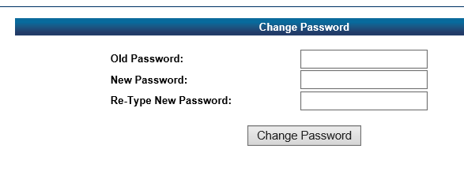
- When your password has been updated successfully, you will be able to view the following functions in the next section.

Section 3: Employee Tasks
  - Each of the following items will be found underneath the Employee Task menu on the left hand side of your screen.

Demographic Information
Upon logging into EAC, the first screen you will see is the Demographic Information area. This screen displays the personal information that the district has on file for you such as address, email address, department, birthdate, hire date, etc.
If you see an inaccuracy, please contact the Human Resources Department.

Additional Information
Click on the Additional Information heading. Here you can view Job Skills and Other Interests, Education Information, and Certifications.

Payroll Checks
Click on the Payroll Checks heading. This screen displays the option to view your current payroll check as well as previous checks. You can sort the payroll checks by the following headings: Check Number, Check Date, and Net Pay. Click on the Check Number link to view a copy of the details for that particular payroll check.

Salary and Benefits
Click on the Salary and Benefits heading. This area will show current salary information as well as details for your active deductions and fiscal year to date information for those deductions. If you would like to print this page, click on the “Remove Menu for Printing” link at the bottom. This will open a new browser tab. Then click on your internet browser File menu, and then choose the Print option.

Leave Information
Click on the Leave Information heading. This area will show a calendar view of times that you have taken leave from the District. Click on Leave Banks in order to see your leave balances as of your last posted payroll check. You also have the option of expanding each leave type by clicking on the downward arrows under the Show Leave Detail column. This will display historical leave information for that type of leave over the length of your employment.

Continuing Education
This section does not apply to the XXXXX School District.

Print W2s
Click on the Print W2s heading. This area will show available years in which you can print a copy of your W2. Click on the year heading link. This will open a new browser tab. Then click on your internet browser File menu, and then choose the Print option.

Tax Information
Click on the Tax Information heading. This area shows current tax information related to state and federal taxes. Printing forms for either a W-4 or an AR4EC is available here. Click on the form links to be taken to the form area. This will open a new browser tab. Then click on your internet browser File menu, and then choose the Print option. Please note the following descriptions for each Filing Status:
S | SINGLE
M | MARRIED
O | OTHER
M0 | MARRIED ZERO
S0 | SINGLE ZERO
M1 | MARRIED 1 DEPENDENT

Deductions and Benefits
Click on the Deductions and Benefits heading. This area will display active deductions and benefits. Information about each deduction is provided by stating portions paid by employee and employer as well as year to date amounts.

“What If” Paycheck Calculator
This area is under development and not fully usable at this time.
Click on the “What If” Paycheck Calculator heading. This area is simply an area where you can adjust number of exemptions and additional withholdings as well as adding an additional pay line to imagine different net pay scenarios. The “What If” feature is designed to provide estimates and should not be relied upon to calculate exact taxes, payroll or financial data.

