What does it take to move somebody’s heart?
When I was a boy, I remember vividly that my tears or smiles were enough to change my parents’ and grandparents’ heart. When my baby sister came, everything changed. It was harder to get their attention in the same way. I realized later on that once you gain someone’s heart, you cannot lose it easily. I learned that getting attention is not the same as having a place in someone’s heart. Because in knowing this, we need to ask ourselves how we can move God’s heart. Are we trying to get God’s attention in order to move God’s heart with our prayer life?
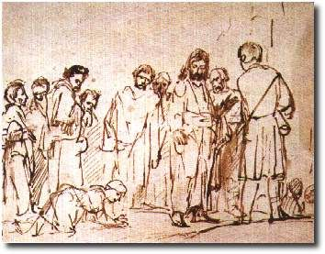
Today’s Gospel tells us a beautiful story of a woman and her faith. A Canaanite woman, who begs Jesus for the healing of her daughter, gains not only Jesus’ heart, but also his attention by saying, “Lord, help me!” Jesus’ answer might seem tough at first when he says that, “I came for the lost sheep of Israel,” making clear that his primary mission was the House of Israel. Since this woman is not part of the House of Israel, it is clear that she needs to get Jesus attention, and therefore, his heart.
As a good Jew, Jesus uses the word “dog” to refer to the Canaanites and their pagan practices. She was outcast and excluded Normally, for someone who wants only attention and that person is called “dog”; that would be the end of the conversation. But the Canaanite woman persists and acknowledges both her condition and her people and persists with the petition by saying, “Please, Lord, for even the dog eat the scraps that fall from the table.” The scraps are enough. Her love comes across in her humility. She understands that miracles are undeserved gifts from God, just like existence itself. Do we pray with the humility of one asking for underserved gifts, like the Canaanite woman, or as one who feels entitled to our request? We learn from this woman how to be persistent in prayer and to be open recipient to God’s graces.
How can we be like the Canaanite woman? We can do this through persistent prayer, while ask ourselves if we pray only to get attention or to posses God’s heart.
What would our answer be if God’s answer is silence because something in the world, such as society or science, doesn’t allow what we are asking for? How do we that?
As we enter deeper in today’s liturgy, I would like to invite you to think for a second: What is the deepest prayer in your heart today? Not a prayer (words) to get attention, but one that can change and move God’s heart. Just imagine Jesus answering and granting the Canaanite woman’s desires and prayers. What a joy! Imagine Jesus praising her faith! Wouldn’t you like to be in her place? If your answer is YES, then you need to persevere in prayer. Are you willing to persevere in making your petition if it is not answered right away?
How are you going to pray? For whom? You could pray for a loved one who is ill or separated from God, as the Canaanite woman did. Perhaps your prayer would be more personal, asking God to strengthen us for our own struggles during the coming week. However, we do it, let's tell God that we truly believe in him and trust that he can make the crucial difference in our lives and in the lives of those around us. Jesus never turns a deaf ear to the cries of our hearts. Amen.

