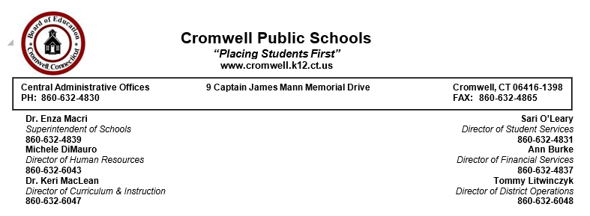

Dear Cromwell Families and Staff,

I hope this message finds you and your family well. The District Reopening Schools Webinar is posted below. You should have received the Executive Summary from your individual school on August 3rd. If you have not received it, please go to your school’s website or contact your school principal.

The full individual schools reopening plans will be emailed to you on August 14th and posted on the school website. All questions for school administrators should be submitted to the school Covid emails, which are listed below if needed, no later than August 17th at 12:00 p.m. School webinars will be posted the evening of August 19th. You will be notified from your school once the webinars have been posted.

Thank you for submitting your questions to the District Covid email. If your question pertained to an individual school it was forwarded to the school for response.
chs-covid19@cromwell.k12.ct.us
cms-covid19@cromwell.k12.ct.us
wis-covid19@cromwell.k12.ct.us
ecs-covid19@cromwell.k12.ct.us
Please click here for the District Reopening Schools Webinar

Sincerely,
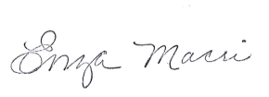
Enza Macri, Ed.D.
Superintendent

