Family Night at the Book Fair!
Our book fair will be open from 5-8 on Thursday May 18th for any family that would like to come shop with their child as families will not be able to shop during scheduled class time.
Listen to a story by the Rotary Club and get a coupon for $3 off your purchase at the book fair! The PTO will also be selling pizza and water! Grab a book to read while enjoying your pizza and sharing the love of reading with your children! We hope to see you there!
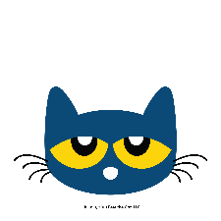

Spring Book Fair Classroom Schedule:
**Please note: We have been advised by Scholastics that we must charge Sales Tax. The PTO has decided to take on the cost of Sales Tax for students during their scheduled class time. Sales Tax will be charged on family night. Because of this we will be rounding up to the nearest dollar on all purchases. This will go towards All For Books which helps buy books for our Library and Classrooms. Any questions please contact ptojtps@gmail.com**
Time | Monday 5/15 | Tuesday 5/16 | Thursday 5/18 | Friday 5/19
9:00 – 9:25 | Cincogrono | Mancl | Schell | Daley
9:30 – 9:55 | Mineo | Abreu | Plourde | Mauro
10:00 – 10:25 | Longo | Richo | Ramsey | Rua
10:30 – 10:55 | Perrelli | Kulmann | Schweyer | White
11:00 – 11:25 | Conroy | DeSantis | Kaczmarczyk | ------------
11:30-1:00 | Lunch | Lunch | Lunch | Lunch
1:00 – 1:25 | Nolan | Caprari |  | -------------
1:30 – 1:55 | Stentiford | Stevens |  | Warycha
2:00 – 2:25 | Metcalfe | Hurlburt |  | Lambo
2:30 – 2:55 | Milo | Baker |  | --------

*Preschool parents please check with your child’s teacher for the exact day they will be shopping*

