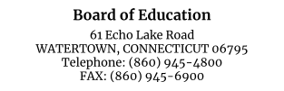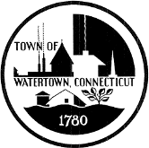

September 28th, 2022
Dear Parent(s)/Guardian(s),

The Watertown Public Schools are committed to a well-rounded education that focuses on cultivating both the academic and social emotional needs of our students. Over two decades of research has helped us understand the important role social and emotional skills play in each child’s success in school, in the community, and, eventually, in higher education and the workplace. Skills such as demonstrating self-control, persisting at challenging tasks, making good decisions, and working well in groups are all necessary to being successful students and adults.

During the months of October, February, and May, teachers and counselors will complete a short screening assessment called the DESSA that collects how often students have demonstrated specific life skills in the past month. After completion of the DESSA Screener, your child’s teacher may be prompted to complete a longer assessment to further explore your child’s unique skills and how to best support her/him within the classroom.

The DESSA assessment is approximately one minute in duration and completed by a student’s teacher or counselor. Attached is an FAQ.

Sample DESSA questions include:
- How often did the child keep trying when unsuccessful?
- How often did the child offer to help somebody?
- How often did the child get things done in a timely fashion?
- How often did the child work well in groups?
The purpose of the DESSA is to identify which life skills students have already learned and what skills students should continue to develop. The information collected by the DESSA screener helps teachers identify opportunities where they can teach/ encourage specific social emotional skill development.
Our goal is to ensure that all students are continuously developing the skills they need for lifelong success.

The DESSA is published by Aperture Education and is utilized by hundreds of school districts and afterschool programs nationwide and is an approved CT data privacy entity.

If you would prefer your child not be included in the DESSA screener, please sign below and return this form to your student’s school principal by Wednesday, 10/05/2022

I do not wish my child to be included in the DESSA this year and would not like my child’s social and emotional skills assessed by the school through this screener.

______________________________ _____________
Parent/Guardian Signature Date

