Ladies Adult S | Ladies Adult M | Ladies Adult L | Ladies Adult XL | Ladies Adult 2X | Total $
Small | Medium | Large
X Large | 2X | 3X/4X (indicate)
Youth Small | Youth Med | Adult Small | Adult Medium | Adult Large | Adult X-Large
Youth Large | Youth Large | Youth XL | Adult 2X | Adult 3X | Adult 4X
Youth Small | Youth Med | Adult Small | Adult Medium | Adult Large | Adult X-Large
Youth Large | Youth Large | Youth XL | Adult 2X | Adult 3X | Adult 4X
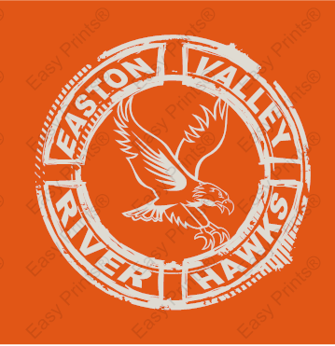
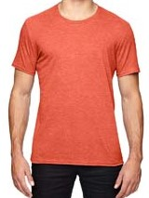
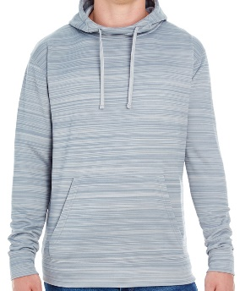
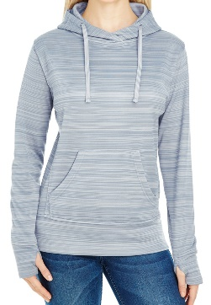
Name/Address/Number: School Preference for delivery: Miles Preston
Make checks payable to Easton Valley School and deadlines are 1st of each month with delivery around the 15th.
GILDEN SWEATSHIRT OPTION
TOTAL $
Item C: Gilden Antique Orange tee. Youth Small-AXL $10. Adult 2X $12. Adult 3X-4X $15 (ADULT in BOLD)
TOTALS $
Item B: Mens (regular fit) J America hoodie. Mens AS-AXL $30. A2x-A4x $32.
Item A: J. America ladies brand hooded sweatshirts. Adult small-AXL $30. Adult 2X $32. Available in Gilden hoodie option. Sizes youth small-youth large $18, Adult small-Adult XL $22. Adult 2X-4X $25.
Large back design
C
Front upper left design
B
A

Hoops
EVHS

