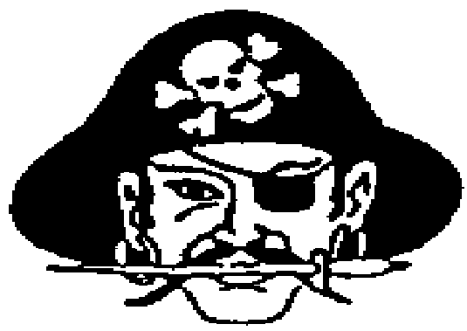**Elwood Public Schools**

“Home of the Pirates”

ACKNOWLEDGEMENT OF RECEIPT – 2020/2021

Student Handbook, Alcohol/Drug Policy, Policy Concerning Internet Use by Students, Student Fees Policy, Injury and Illness Procedure, Elwood Public School Photo Release Permission Form

# Student __________________________________________ Date __________________

**­­**

**__X___** The student and parent signatures on this receipt acknowledges that you and your child who is a student attending Gosper County School District No. 30 (Elwood Public Schools) have received notice and have read each of the following policies listed in the student handbook (Located in the Student’s Planner), the standards of conduct associated with the unlawful possession, use, or distribution of illicit drugs and alcohol on school premises or as part of any school activities, the Policy concerning Internet use by students and are aware of the penalties if these policies are violated.

**__X___** The student and parent signatures on this receipt acknowledges that you and your child acknowledge that if the student loses their planner, tears it apart, or write inappropriate remarks on or in the planner, paste pictures or other items over the handbook section the student will be required to purchase a new one from the office for $5.00.

_______ I Give my permission for Elwood Public Schools to use my Child’s picture for publications related to school.

________ I DO NOT Give my permission for my child’s picture to be published.

Please sign, date and return this form indicating whom we should contact in case of illness or injury and as acknowledgment that you have read the student handbook and are aware of the policies of Elwood Public School.

_________________________________________________________________________

**Student Signature**

_________________________________________________________________________ **Parent or Guardian**

**Both Signatures are required.**

**Elwood Public Schools**

**“Home of the Pirates”**

**2020-2021 INFORMATION SHEET**

**Student Acknowledgment & Illness/Injury Procedure Consent**

**Student Name _______________________________________ Grade_____________________________**

**Parents/Guardians’ Name________________________________________________________________**

**Home Address_______________________________________ Home Phone #______________________**

**Mailing Address (if different) _____________________________________________________________**

**Parent Email Address __________________________________________________________________**

**Date of Birth _____________________**

**Ethnicity: (Please check the box that best describes your ethnicity)**

**_____ African-American _____ American-Indian _____Asian _____ Caucasian**

**_____ Hispanic _____ Pacific Islander _____ Other**

**If my child becomes ill or is injured while at school or at a school sponsored activity, please contact:**

* + - 1. **Parents/Guardians - Father Phone # _________________ Mother Phone #______________**
      2. **Other - _________________________________________________ Phone #______________**

**If unable to contact any of the above mentioned, we herein authorize the school officials to take whatever action is necessary in taking care of our child.**

**Family Doctor _____________________________________________Phone #______________________**

**Hospital __________________________________________________Phone #______________________**

**Family Dentist _____________________________________________Phone #_____________________**

**Comments:________________________________________________________________________________________________________________________________________________________________________________________________________________________________________________________**