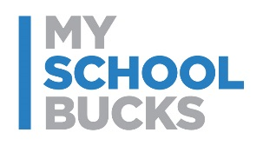

Skip the cash! Pay for meals online

July 22, 2020

To the parents of Schley County Students,
To help ensure the health and safety of all our students and staff, we ask that parents please consider funding their student’s meal account online through MySchoolBucks. This will help minimize the amount of cash/check deposits that need to be handled throughout the day, which allows us to focus on serving meals as fast and efficiently as possible.
Create your free MySchoolBucks account to conveniently and securely add money to your student’s meal account online or with the mobile app. With MySchoolBucks you’ll also be able to view cafeteria purchases, check your student’s balance, and receive low balance alerts.
Get Started Today:
- Go to myschoolbucks.com or download the mobile app
- Create your free account and add your students using their school name / student ID
- Add funds using your credit / debit card or electronic check
Note: For each transaction, you will be charged a program fee of $2.49
- Set up automatic payments and never forget to send in lunch money again

If you need assistance with your account, you can find helpful how-to videos and answers to commonly asked questions by visiting myschoolbucks.com. Or, you can contact MySchoolBucks directly by logging into your account to start a chat conversation or give them a call at (855) 832-5226.
Thank you,
Tracey Johnson,
Schley County School Nutrition

