Inola Public Schools

2020-2021
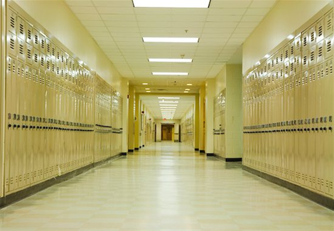 | 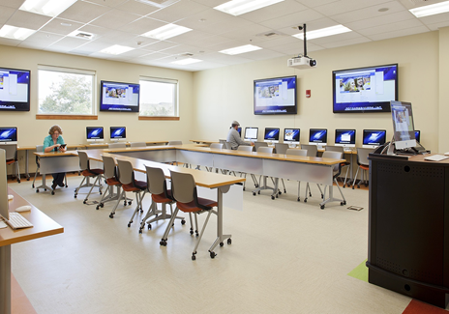 |  |  | 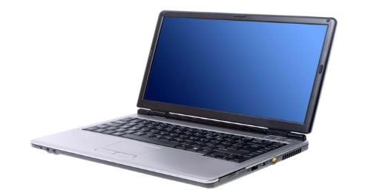
All on Site | Blended Learning |  |  | All Online

Learning Options
Below are the options for the 2020-2021 school year. Students and their guardians will choose which option will work best for their family. If guardians and students want the blended or online option, they will be contacted by school to discuss this possibility.
Guardians can email which Option they want their child enrolled in at the email address below. If the school does not get a preference from the guardian, they will be enrolled automatically in the traditional plan.
- Elementary: elemenrollment@inola.k12.ok.us
Option 1
Traditional School
Option 2
All Online
- Remain an Inola Student.
- Accessible anywhere a student has internet.
- Flexible schedule.
- 24/7 online access to online classes.
- Supervised by Inola faculty.
- Chromebook provided.
- Participate in school events,
- Students and guardians will be required to fill out an application for Options 2.
- Remain an Inola Student.
- Social interaction with peers and teachers.
- Access to all school facilities.
- Technology and Chromebooks will still be utilized in the classroom.
- Participate in school events.

