Registration begins August 28th
Deadline to register: September 15th
For students of Schnell Elementary, grades 4-5
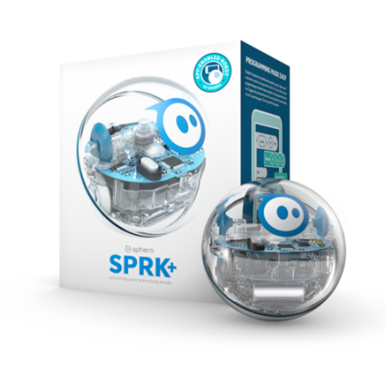
LEGO CODING & PROGRAMMING CLASS
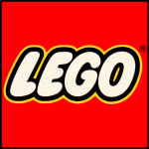

In this new after school enrichment class, your child will learn the basic principles of programming and coding using an innovative Sphero SPRK+® robot and Lego creations. These hands-on activities will allow your child to collaborate with other users around the globe and foster a love of robotics and new technology.

When: Class begins Tuesday, October 3rd, 2017 from 3:15-4:15pm
How Long: Class is every Tuesday for six weeks. Dates are: 10/3, 10/10, 10/17, 10/24, 10/31, 11/7
Where: Room 3B
Who: Beth Peterson, Lego Coding/Programming Instructor and 5th grade teacher at Schnell Elementary School
Cost: $20
Important Notes: Spaces are limited and available on a first-come, first-served basis. Early registration is recommended. Registration forms are located in the school office.

