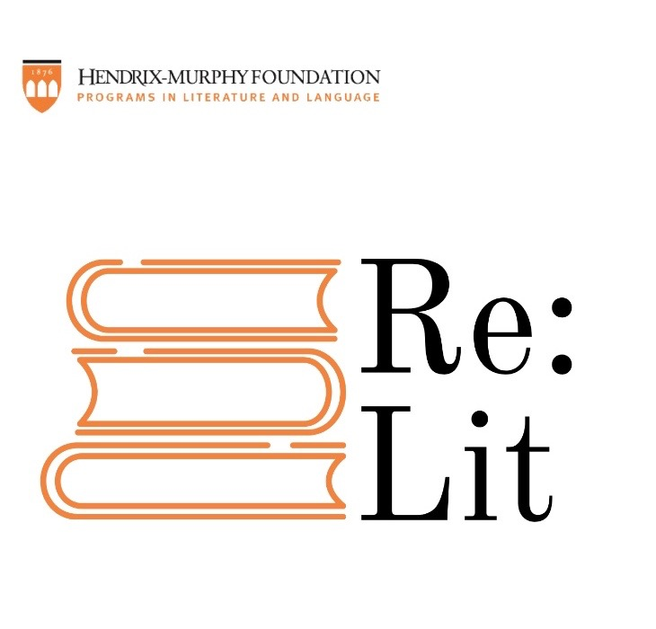

A podcast of the Hendrix-Murphy Foundation
Where literature and language are always topical

Season 1, Episode 1: The Voices of People of Color in Contemporary Literature
with guests Mary Ingabire ’20 and Adaja Cooper ’23
hosted by Danielle Kuntz ’23

Works referenced in this episode:

Angelo Geter, “Praise” https://poets.org/poem/praise?mc_cid=67bf7a5045&mc_eid=8440977a40

Joy Harjo, “Praise the Rain”
https://www.poetryfoundation.org/poems/141848/praise-te-rain

Elizabeth Alexander, “Praise-Song for the Day”
https://www.poetryfoundation.org/poems/52141/praise-song-for-the-day

Audre Lorde, “Hanging Fire”
https://www.poetryfoundation.org/poems/42580/hanging-fire

Claudia Rankine, from Citizen, I
https://poets.org/poem/citizen-i

