Annual Employee Contribution Campaign
August 16th – September 22nd, 2017
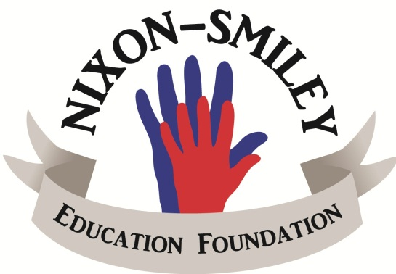
Your gift helps fund the
Innovative Education Grants

Select an Option:

- I, __________________________, authorize Nixon-Smiley CISD to deduct

$_____ from my regular scheduled payroll for 10 months (October to July) for a

total amount of $_____.
If employment with NSCISD ends, I authorize any unpaid balance to be deducted from my final check. This authorization will remain in effect until I give the Human Resources Dept. notice via email or other written method indicating my desire to cancel this deduction.
SIGNATURE: _______________________________DATE:_____________

- My tax deductible gift of $______________for the 2017-2018 school year for

the Nixon-Smiley Education Foundation is enclosed.
Make checks payable to NSEF. Return form and check by September 22nd.

SIGNATURE: _______________________________DATE:_____________
Thank you for your voluntary contribution.

